NATIONAL INSTITUTE OF TECHNOLOGY SURATHKAL

IT-254 WTA Lab

Assignment-3b

Submitted By-
Akshay B Bistagond
191EC203

JAVASCRIPT ADVANCED

1. For the HTML4 form you created as part of earlier exercise.

Modified Form Output:-
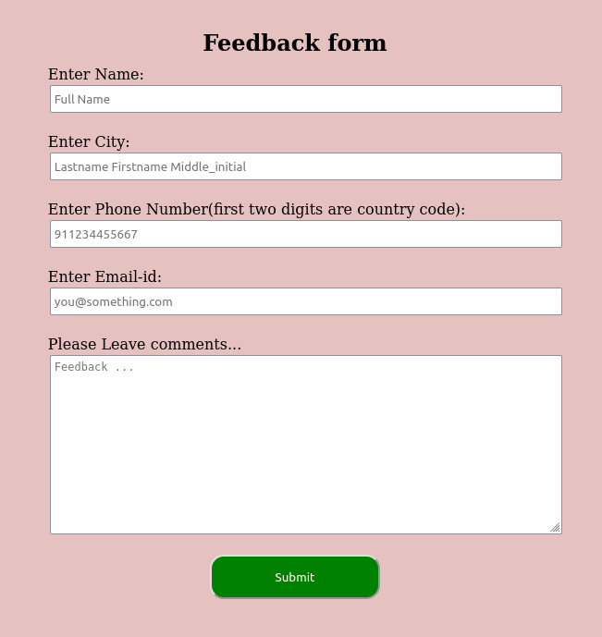

Use event-driven programming with Javascript to handle user events in scenarios like -
a) For the fields that collect the user’s name, phone number etc, ensure valid inputs, by using a script to determine if:
-Name provided is legal or not, depending on the required pattern, which is
Last_name, first_name, middle_initial
Also, the first and last names cannot have more than 10 characters.
Cell phone number is in the correct format - + country_code mobile_no
Validation code:-

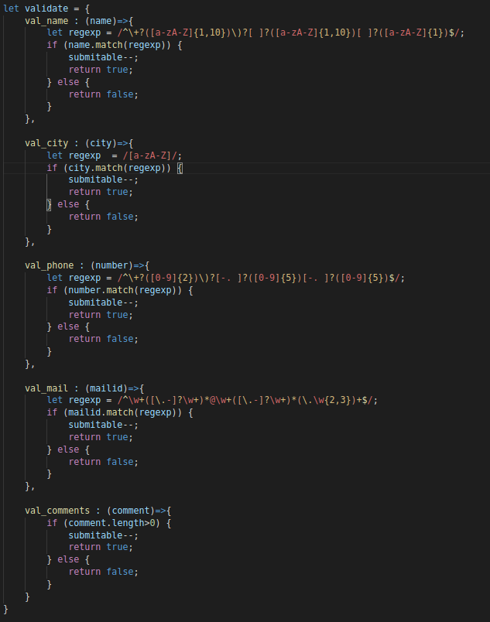
Automatically provide feedback messages as the user moves from one field to another. Display appropriate feedback messages with colour coding (use external CSS )to give feedback to the user if data typed does not follow required format, and on how to correct it.

Code :-
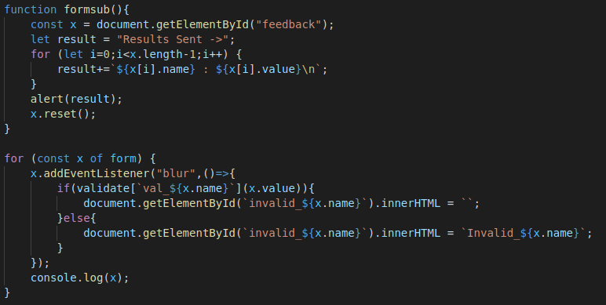

b) Display the total amount for items bought based on quantity selected as it is entered in each field. User must not be able to edit the content of the text field where the total amount is displayed.
Output :-

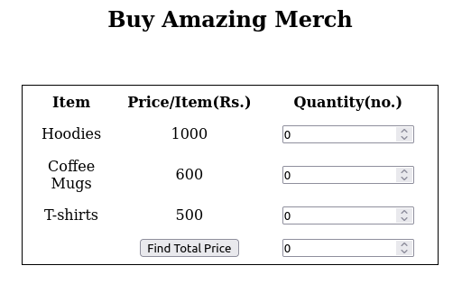

Code :-
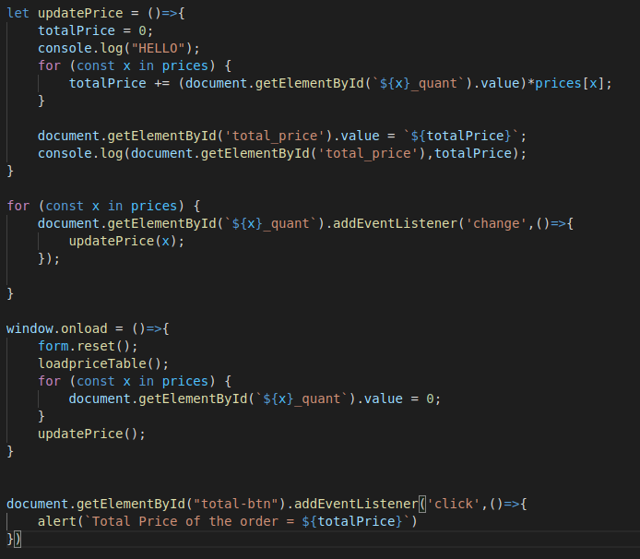
c) The user clicks the button provided.
Code :-

