FinTrack – Personal Finance Tracker  
Project Report

# Abstract

FinTrack is a professional and user-friendly personal finance tracker web app developed using Python (Django) and Bootstrap. It enables users to monitor income, track expenses, and manage their monthly budget with ease. The platform offers secure user authentication, graphical dashboards, and real-time balance tracking in Indian currency (₹), making personal finance management simple and effective.

# Major Modules

1. **User Authentication**

* This module provides secure access to the platform through user registration and login functionalities.
* It includes password hashing, session management, and user data validation.
* The interface ensures only authenticated users can view or manipulate financial data.

• **Income Management**

* Users can add, update, and delete income records.
* Each income entry can be categorized (e.g., Freelancing, Salary, Investments).
* A dynamic table displays all entries with total income calculated in real time.
* Allows for better tracking of diverse income sources and financial planning.

• **Expense Management**

* Allows users to input and manage daily or monthly expenses.
* Expenses can be categorized (e.g., Food, Travel, Shopping, Utilities).
* Entries can be filtered and analyzed, helping users identify spending habits.
* It supports editing or deleting entries for accurate data control.

• **Dashboard Module**

* The central feature of the app, it displays graphical representation of financial data.
* Provides bar charts for income vs expense trends.
* Pie charts show category-wise expense breakdown.
* Real-time balance is calculated and displayed based on income and expenses.
* Offers a user-friendly, interactive view of financial health.

# Minor Modules

• **Profile Management**

* Users can update their profile information such as name, email, and username.
* The module includes a personalized section to view and track individual transactions and history.
* Ensures the user data is up-to-date and manageable through the interface.

• **Budget Tracker**

* Enables users to set monthly budget goals.
* Visual indicators (progress bars) help track how much of the budget is used.
* Helps in maintaining financial discipline and saving objectives.

• **Admin Panel**

* Provided by Django's built-in admin module.
* Facilitates backend access for developers or admins to view, manage, and moderate all user and financial data.
* Enables easy debugging, maintenance, and data management through the admin interface.

• **Currency Formatter**

* Ensures all financial values are displayed in Indian Rupees (₹) rather than default dollars.
* Enhances the localized feel and relevance for Indian users.

• **Category Management**

* Lets users customize their own income and expense categories.
* Increases personalization and better classification of financial activities.

• **Analytics Enhancer**

* Future provision to integrate AI-based insights like monthly savings suggestions or unnecessary expense alerts.

# Tools & Technologies Used

| Tool | Purpose |  
|--------------|-----------------------------|  
| Python | Backend logic |  
| Django | Web framework |  
| Bootstrap | Responsive front-end design |  
| Chart.js | Data visualization |  
| SQLite | Default database |  
| Git & GitHub | Version control |

# Database

- SQLite3 (can upgrade to PostgreSQL)  
- Tables: Users, Income, Expenses  
- Each record linked via ForeignKey to user

# ER Diagram

User  
│  
├── Income (user_id)  
│  
└── Expense (user_id)

# Description

FinTrack empowers users to manage their finances through:

- A secure login and signup system  
- Addition and deletion of income/expense entries  
- Instant balance calculation (in ₹)  
- Visual analytics via graphs and pie charts  
- Editable user profile section  
- Clean and responsive interface inspired by fintech platforms like Groww and Jupiter

# Screenshots

1. Login / Signup Interface

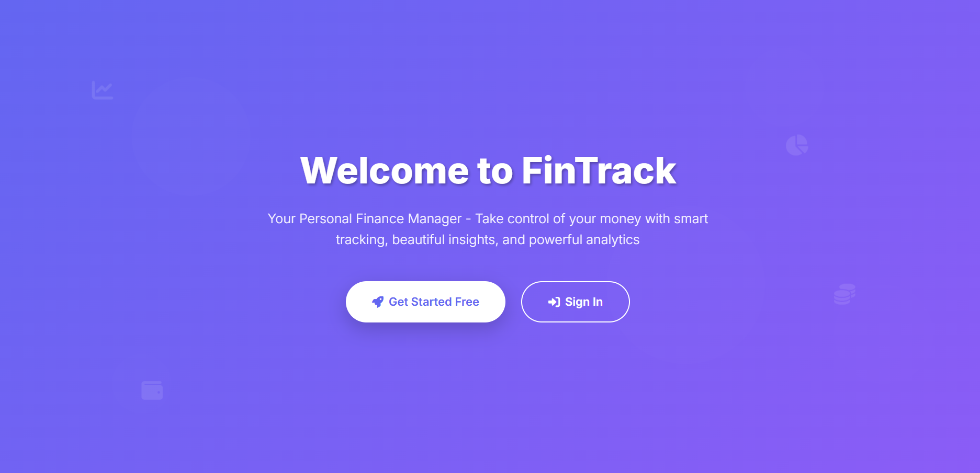

2. Dashboard with Graphs

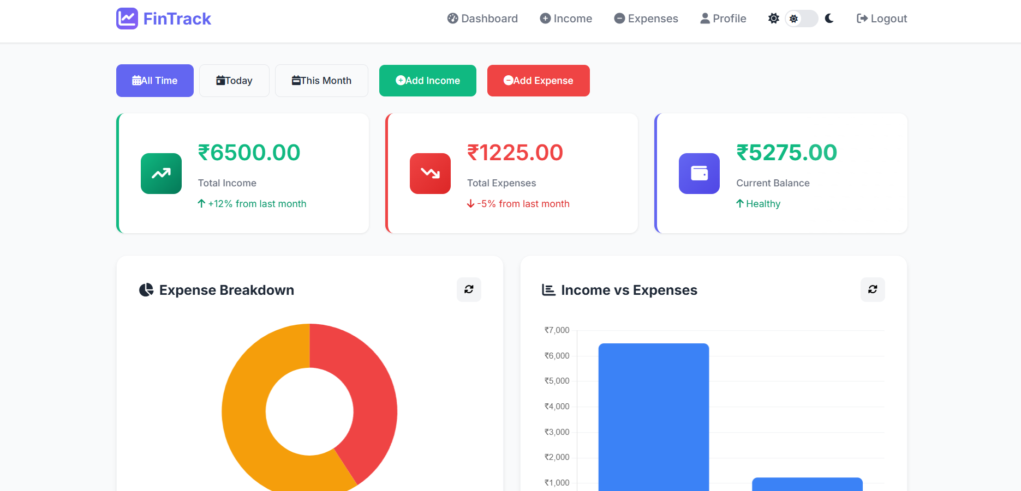  
3. Add Income/Expense Page

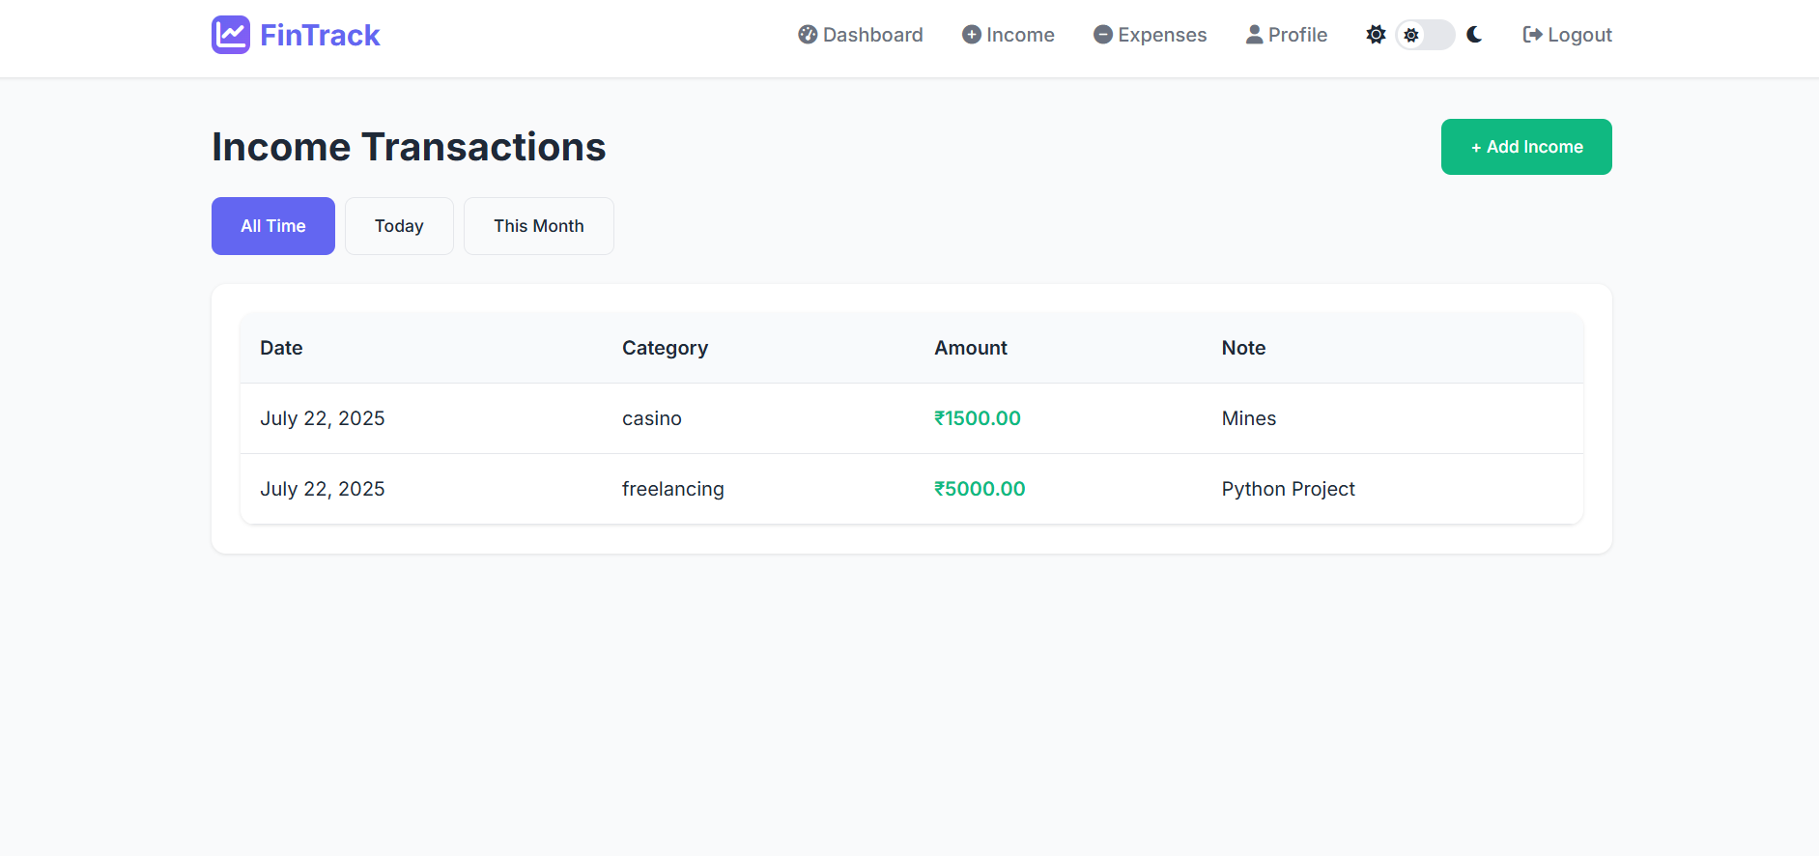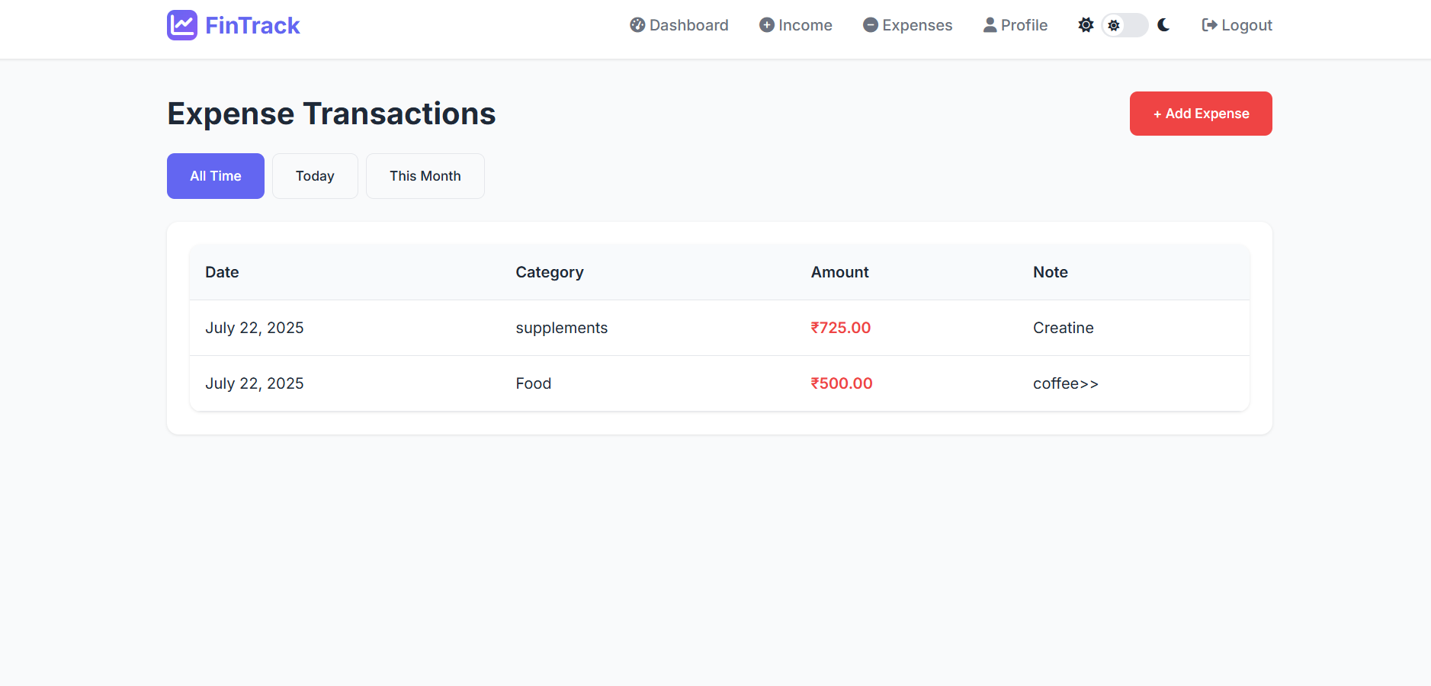  
4. User Profile Section

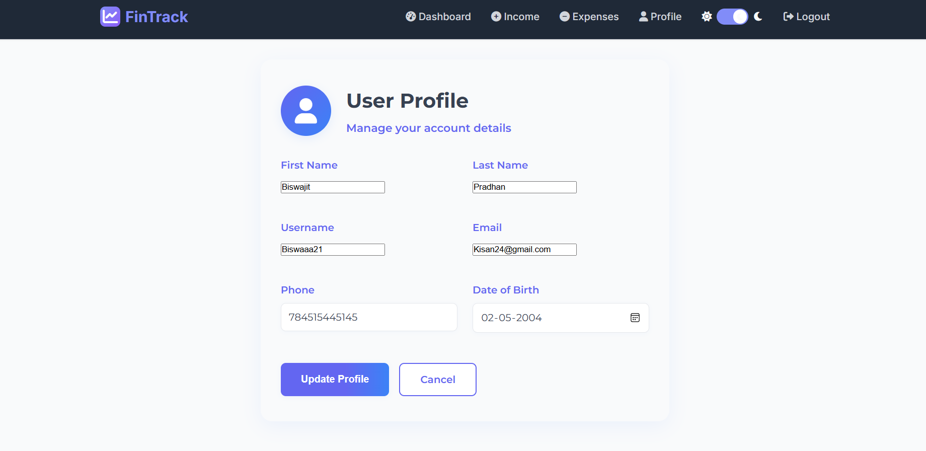

5. Real-Time Balance and Budget Overview

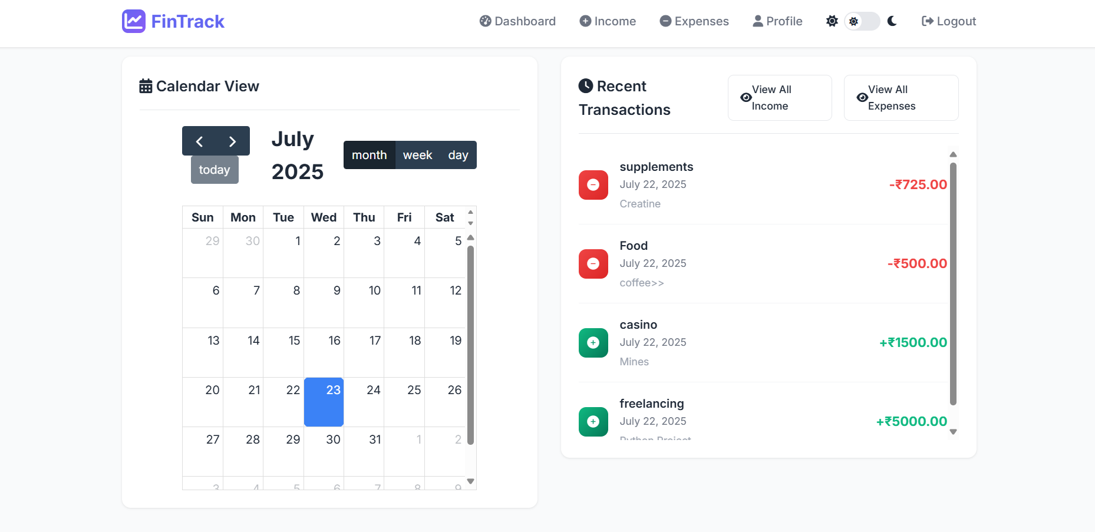

# Feature Enhancements

- OTP-based signup  
- Dark mode toggle  
- PDF report download  
- Currency selection (multi-country support)  
- AI-powered budget suggestions  
- Notification for due dates

# Conclusion

FinTrack is a user-friendly and efficient personal finance tracking web application tailored for Indian users. It allows individuals to manage their income, expenses, and budgets through a clean and responsive interface. The use of Django ensures strong backend security, while Bootstrap and Chart.js provide a modern frontend and clear data visualization.

With features like real-time balance updates, customizable categories, and profile management, the app delivers a smooth user experience. Its modular design also makes it scalable for future enhancements such as notifications, downloadable reports, or AI-based insights.

Overall, FinTrack serves as a practical solution for personal financial management and demonstrates effective use of web development tools in solving real-life problems.