Practical-01

Aim:- Structure of C Program.

Code:-

#include<stdio.h>
// Header file > stdio stand for Standard Input , Output.

/*If we use Turbo C and CodeBlocks we must include
conio.h header file...> conio stands for Console I/O.
*/

int main() // This is the main Function...
//Compiler starts executing instruction from main function
{

return 0; // return type > here is return 0 Because out main // function’s type is int.
}

Practical-02

Aim:- Implement Basic C Programs using scanf() and printf()

Code:-(Printf)

#include<stdio.h>

int main(){

printf("This sentence prints as it is");
// \n …. New line
return 0;
}
Output:-
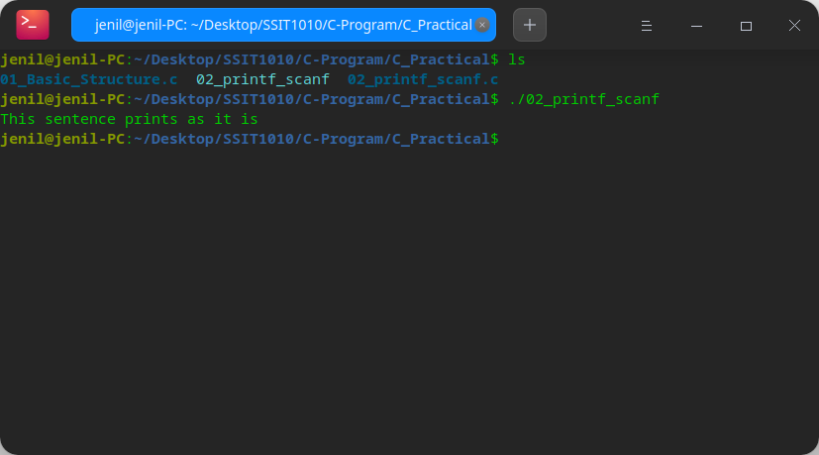
Code:-(Scanf)
#include<stdio.h>
int main(){
int A;//Variable Initialization

printf("Enter the value of A : ");
scanf("%d",&A);
printf("Value of A is %d\n",A);
/*
%d for Integers
%f for Real Number(Float)
%c for Character
*/

return 0;
}
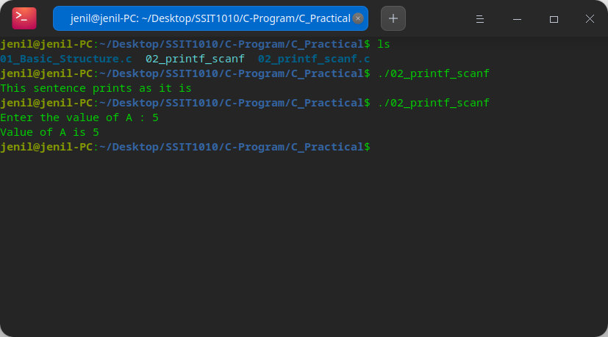
Output:-
Practical-03

Aim:- Implement Basic C Programs to demonstrate different types of operators.

Code:- (Arithmetic operator)
#include<stdio.h>
// Arithmetic operators
int main(){
/*
+(Sum),-(Sub),*(Multiplication),/(Division)
%(Modulo)....reminders.
*/
//varible init.. and Declaration.
int Sum, Sub, Mul, Div, Mod;
int A= 10;
int B = 25;
//Operations
Sum = A+B;
Sub = A-B;
Mul = A*B;
Div = A/B;
Mod = A%B;
//Print Statements
printf("Sum of given two number is %d \n",Sum);
printf("Subtraction of given two number is %d \n",Sub);
printf("Multiplication of given two number is %d \n",Mul);
printf("Divison of given two number is %d \n",Div);
printf("Modulo(Reminder) of given two number is %d \n",Mod);
return 0;
}
Output:-

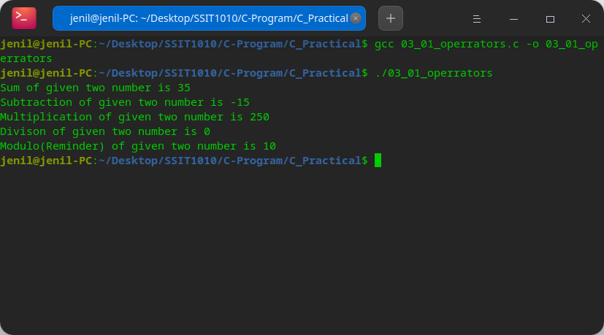
Here we use gcc command to compile the .c extension file. After this command compiler creates [File_name].exe (executable) file automatically….
Code:-(Increment Decrement)

#include<stdio.h>

int main(){

int a, b;//Var initialization

//take input from user
printf("Enter your first Number: ");
scanf("%d",&a);
printf("Enter your second number: ");
scanf("%d",&b);

// Increment/Decrement operators
int post_increment, post_decrement;
int pre_increment, pre_decrement;

pre_increment = ++a; // (first calculate a+1 and then print it)
post_increment = b++; // (first Print and then Calculate a+1)
pre_decrement = --b; // (first calculate a-1 and then print it)
post_decrement = a--; // (first Print and then Calculate a-1)

printf("i am pre increment %d\n",pre_increment);
printf("i am post increment %d\n",post_increment);
printf("i am pre decrement %d\n",pre_decrement);
printf("i am post decrement %d\n",post_decrement);

return 0;
}

Output:-

Explain:- Let First Number take X and second Number is Y. So X = 5 and
Y = 25……

X’s pre_increment is 6 (5+1) so now X’s value is 6..
Post increment means first print and then increase value by adding 1..
so in this case first print Y’s value and then Y’s value will update..(26)

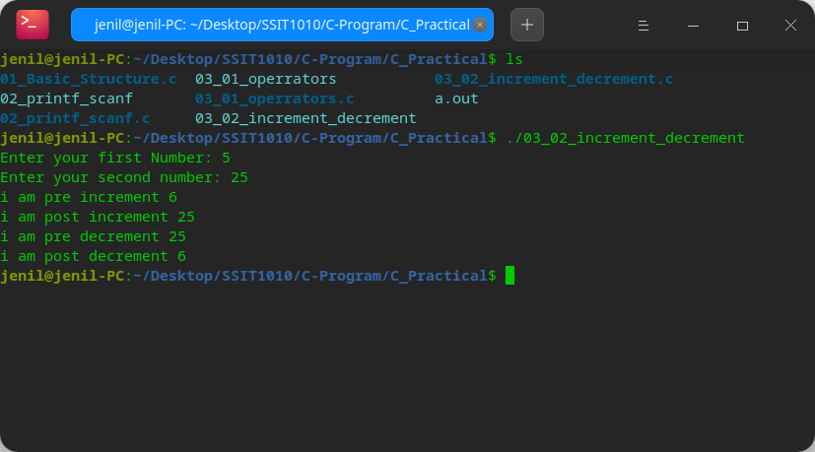
Y’s pre_decrement is 25 (26-1) so now Y’s value is 25..
Post decrement means first print and then decrease value by deduct 1..
so in this case first print X’s value(6) and then X’s value will update..(5)

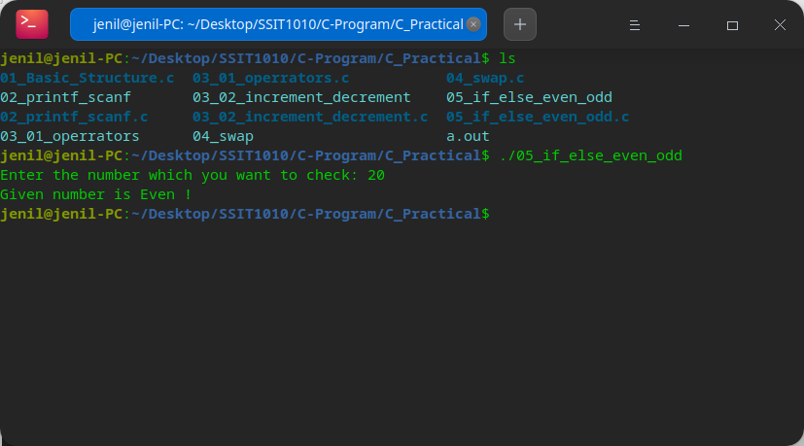
Practical-04

Aim:- Swap two Numbers using third variable

Code:-
#include<stdio.h>

int main()
{
int x, y;

x = 10;
y = 20;

int temp = x;

x = y;
y = temp;

printf("After Swapping: x = %d, y = %d\n", x, y);

return 0;
}

Output:-

Explain:-

- first of all store x’s value in third variable(temp).
- So the value of temp is 10.
- now store y’s value in variable x.
- So the value of x is become 20 and y is also 20
- now store temp’s value in y.
- So that value of y become 10(same as x).

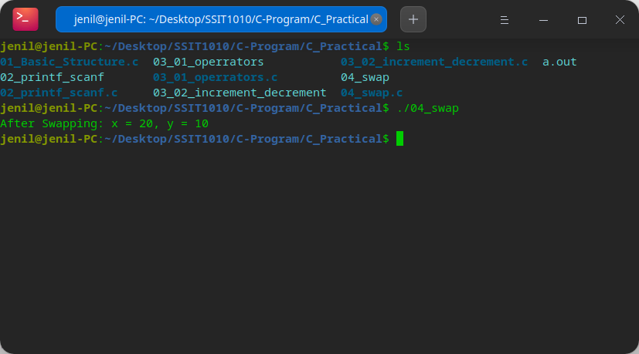
Practical-05
Aim:- Implementation in C for conditional statement: if()...else{}

Code:-

#include<stdio.h>

int main(){

int Number;

printf("Enter the number which you want to check: ");
scanf("%d",&Number);

if (Number%2 == 0)
{
printf("Given number is Even !\n");
}
else
{
printf("Given Number is Odd (Not Even)! \n");
}

return 0;
}

Code:-
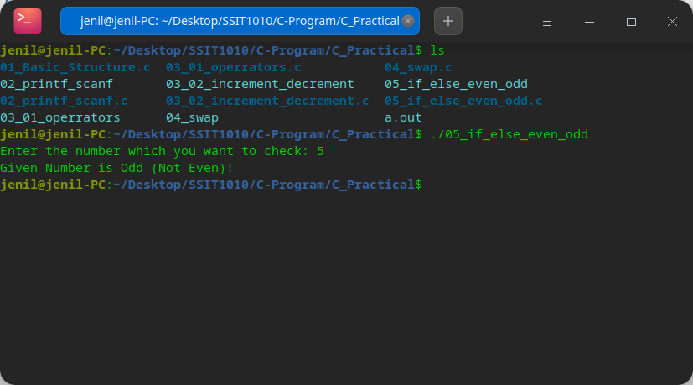Output i: for odd number
Output ii: for even number

