Practical: 01

Aim:- Ordered and Unordered List

Code-01:-

<!DOCTYPE html>
<html lang="en">

<head>
<meta charset="UTF-8">
<meta name="viewport" content="width=device-width, initial-scale=1.0">
<meta http-equiv="X-UA-Compatible" content="ie=edge">
<title>Lists</title>
<style>img {
border: 5px solid #555;
border-radius:37px ;
}
</style>
</head>
<body>
<ul type="circle">
<img src="01.jpg" height="100px" width="100px">
<li>This is first item of unordered list <strong>Pav Bhaji</strong></li>
<img src="02.jpg" height="100px" width="100px">
<li>This is second item of unordered list <strong>Pani Puri</strong></li>
<img src="03.jpg" height="100px" width="100px">
<li>This is third item of unordered list <strong>Locho</strong> </li>
</ul>
<hr>
<ol type="a">
<img src="01.jpg" height="100px" width="100px">
<li>This is first item of ordered list <strong>Pav Bhaji</strong></li>
<img src="02.jpg" height="100px" width="100px">
<li>This is second item of ordered list <strong>Pani Puri</strong></li>
<img src="03.jpg" height="100px" width="100px">
<li>This is third item of ordered list <strong>Locho</strong> </li>
</ol>
</body>
</html>

O/P 01:-
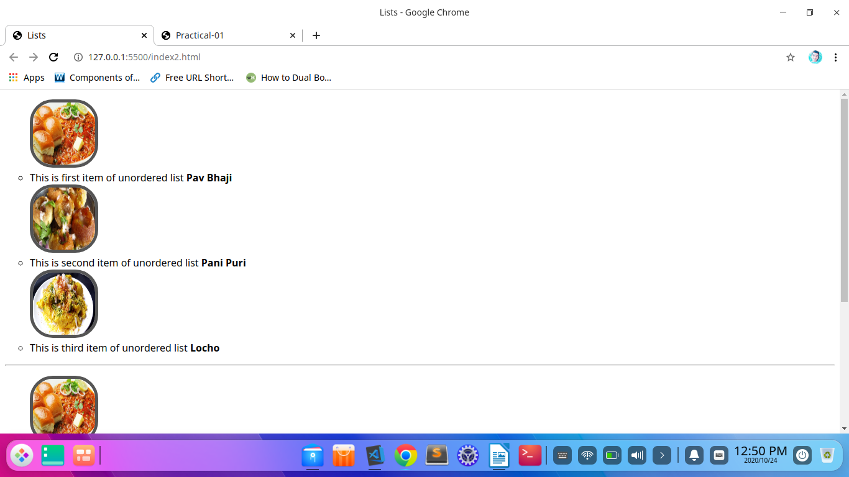
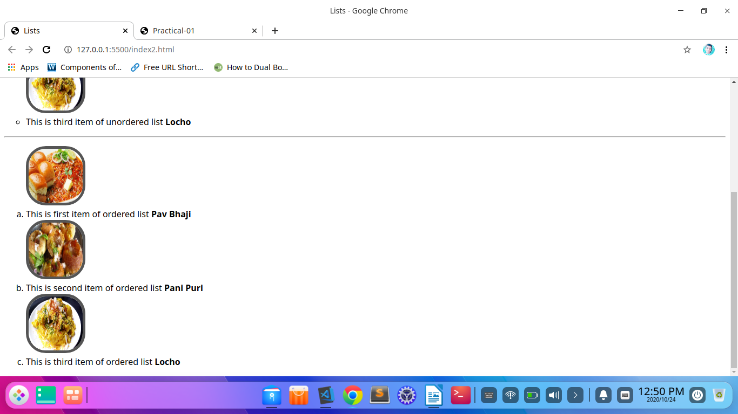
Code 02:-

<!DOCTYPE html>
<html lang="en">

<head>
<meta charset="UTF-8">
<meta name="viewport" content="width=device-width, initial-scale=1.0">
<meta http-equiv="X-UA-Compatible" content="ie=edge">
<title>Lists</title>
<style>
img {
border: 5px solid #555;
border-radius:37px ;}
</style>
</head>
<body>
<ul type="square">
<img src="01.jpg" height="100px" width="100px">
<li>This is first item of unordered list <strong>Pav Bhaji</strong></li>
<img src="02.jpg" height="100px" width="100px">
<li>This is second item of unordered list <strong>Pani Puri</strong></li>
<img src="03.jpg" height="100px" width="100px">
<li>This is third item of unordered list <strong>Locho</strong> </li>
</ul>
<hr>
<ol type="I">
<img src="01.jpg" height="100px" width="100px">
<li>This is first item of ordered list <strong>Pav Bhaji</strong></li>
<img src="02.jpg" height="100px" width="100px">
<li>This is second item of ordered list <strong>Pani Puri</strong></li>
<img src="03.jpg" height="100px" width="100px">
<li>This is third item of ordered list <strong>Locho</strong> </li>
</ol>
</body>
</html>

O/P 02:-
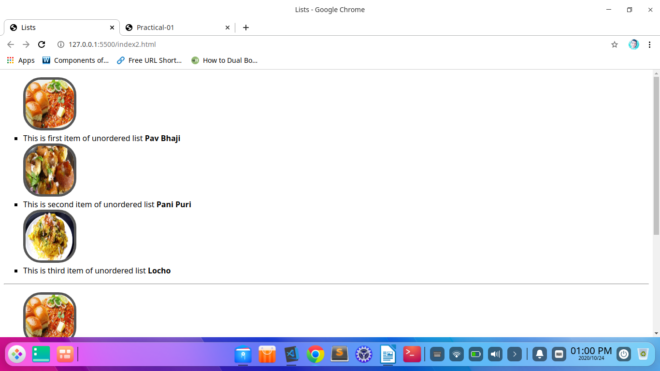
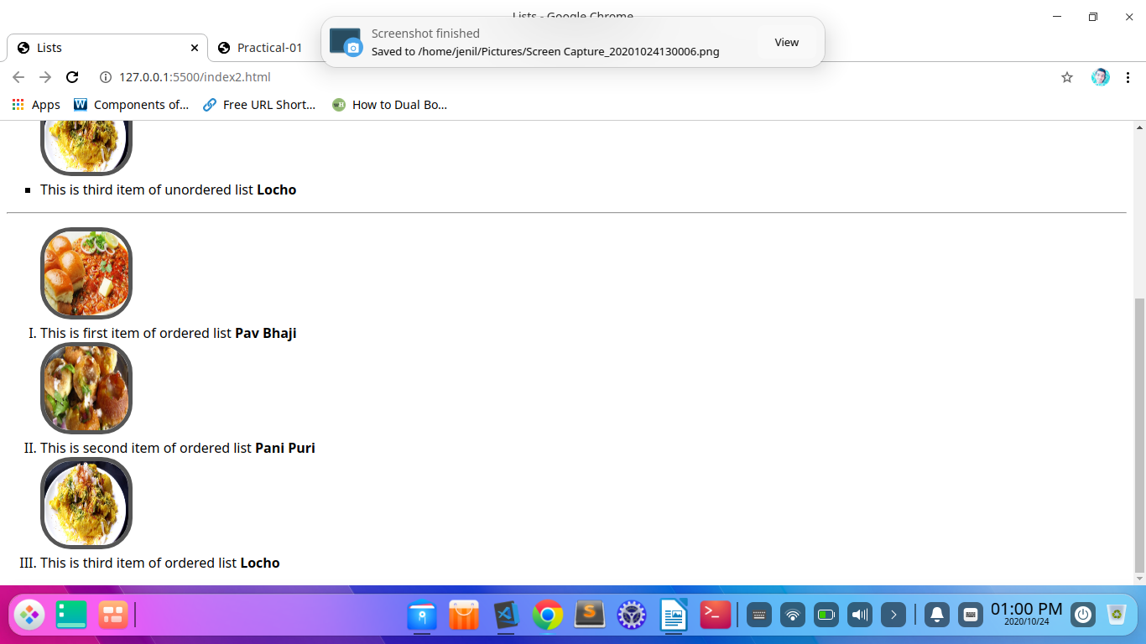

Code : 03(dl and dd Tag)

<!DOCTYPE html>
<html lang="en">
<head>
<meta charset="UTF-8">
<meta name="viewport" content="width=device-width, initial-scale=1.0">
<title>Practical-01</title>
<style>
img {
border: 5px solid #555;
border-radius:37px ;
}
#sub_heading{
text-decoration: solid;
text-emphasis: none;
font-weight: 100;
font-family: 'Times New Roman', Times, serif;
}
</style>
</head>
<body>
<div>
<center>
<h4 id="sub_heading">P P Savani Menu list</h4>
<h1>Practical-01</h1><hr>
</center>
</div>
<div class="item">
<center>
<img src="01.jpg" height="200px" width="200px">
<h2>P P Savani special Pav Bhaji</h2>
<dl>Lorem ipsum dolor sit amet consectetur adipisicing elit. Aut, animi quae! Rem, deleniti. Molestias, voluptate quas error aperiam pariatur neque.</dl>
<hr align="center" size="3px" width="266px">
</center><br>
</div>
<div class="item">
<center>
<img src="02.jpg" height="200px" width="200px">
<h2>P P Savani special Pani Puri</h2>
<dl>Lorem, ipsum dolor sit amet consectetur adipisicing elit. Libero hic odio sequi officiis fugit cum ipsam asperiores recusandae quod? Quaerat!</dl>
<hr align="center" size="3px" width="266px">
</center><br>
</div>

<div class="item">
<center>
<img src="03.jpg" height="200px" width="200px">
<h2>P P Savani special Locho</h2>
<dd>Lorem ipsum dolor sit amet consectetur adipisicing elit. Natus ab sit optio perferendis delectus doloremque tenetur itaque ut error numquam.</dd>
<dl>Lorem ipsum dolor sit amet consectetur adipisicing elit. Voluptates dolorum delectus ab quaerat dicta, fuga asperiores repellendus itaque iusto non?</dl>
<hr align="center" size="3px" width="266px">
</center><br>
</div>

<div class="item">
<center>
<img src="04.jpeg" height="200px" width="200px">
<h2>P P Savani special Mysore</h2>
<dl>Lorem ipsum, dolor sit amet consectetur adipisicing elit. Laudantium, obcaecati quo laborum dolore nisi aliquam? Delectus odit quia accusantium aspernatur?</dl>
<hr align="center" size="3px" width="266px">
</center><br>
</div>
</div>
</body>
</html>

O/P
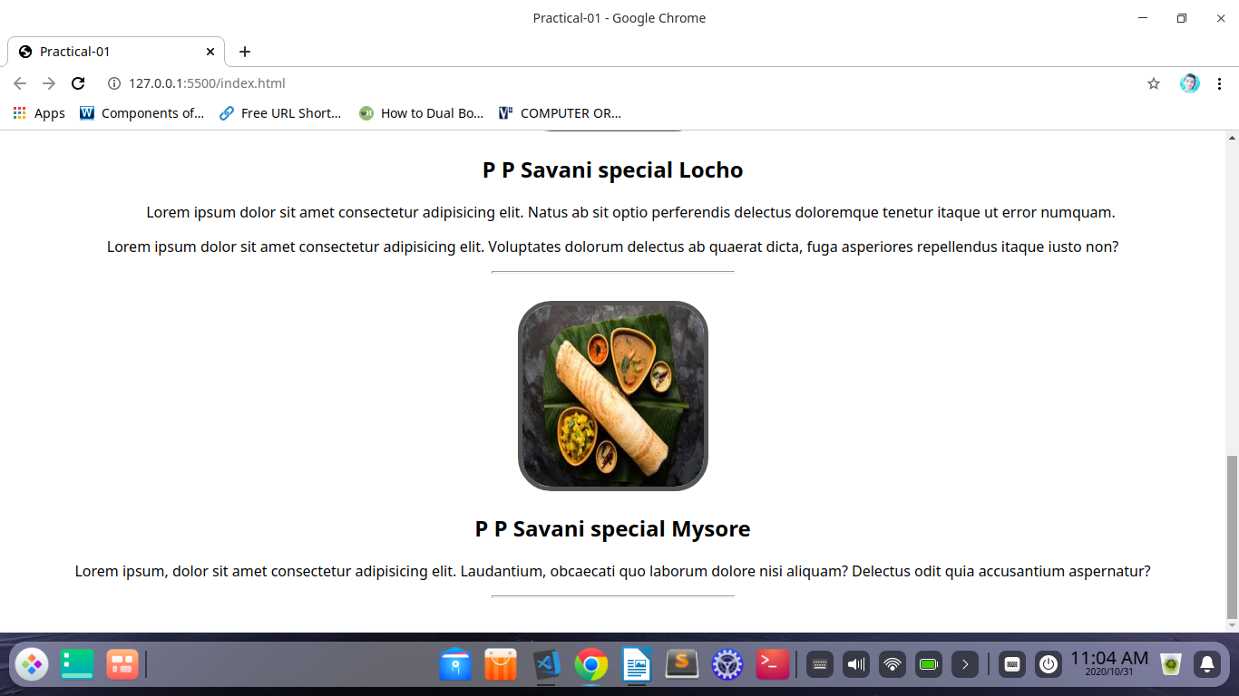
Code: 04 (Source tag)

<!DOCTYPE html>
<html lang="en">
<head>
<meta charset="UTF-8">
<meta name="viewport" content="width=device-width, initial-scale=1.0">
<title>Practical-01</title>
<style>
img {
border: 5px solid #555;
border-radius:37px ;
}
#sub_heading{
text-decoration: solid;
text-emphasis: none;
font-weight: 100;
font-family: 'Times New Roman', Times, serif;
}
</style>
</head>
<body>
<div>
<center>
<h4 id="sub_heading">P P Savani Menu list</h4>
<h1>Practical-01</h1><hr>
</center>
</div>
<div>
<center> <video width="320" height="240" controls>
<source src="01.mp4" type="video/mp4">
</video>
</center>
</div>
</body>
</html>

O/P:
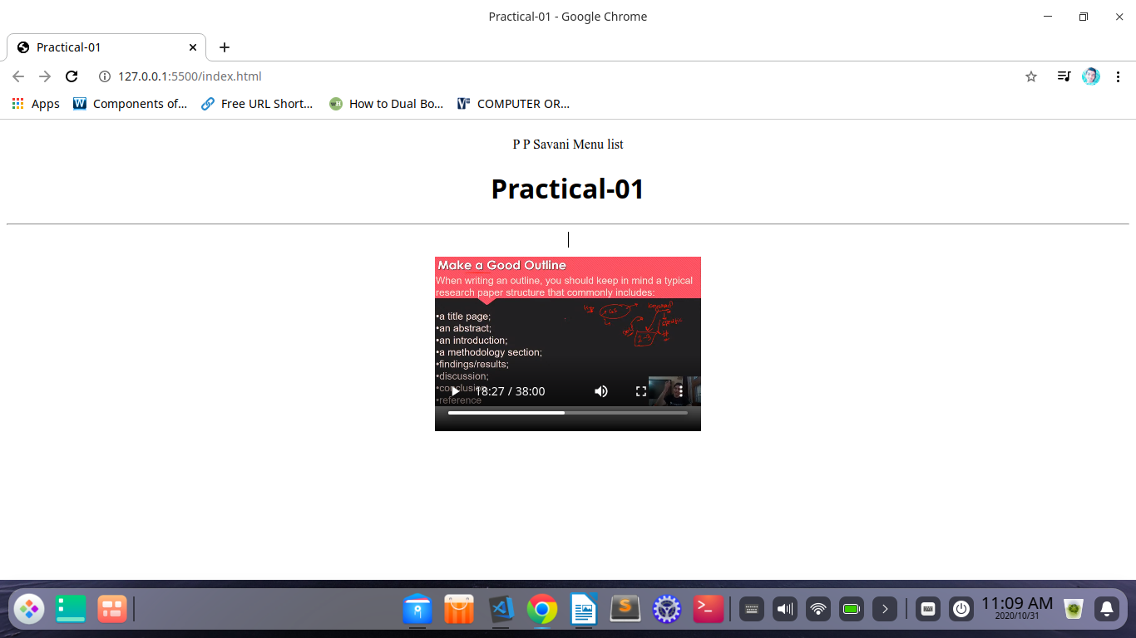
Code 05 : (bgcolor and font family)

<!DOCTYPE html>
<html lang="en">
<head>
<meta charset="UTF-8">
<meta name="viewport" content="width=device-width, initial-scale=1.0">
<meta http-equiv="X-UA-Compatible" content="ie=edge">
<title>Lists</title>
<link href="https://fonts.googleapis.com/css2? family=Henny+Penny&family=Syne+Tactile&display=swap" rel="stylesheet">

<style>
*{
font-family: 'Henny Penny', cursive;
font-family: 'Syne Tactile', cursive;
font-size: xx-large;
text-align: center;
background: linear-gradient(90deg, rgba(2,0,36,1) 0%, rgba(103,103,237,1) 0%, rgba(0,212,255,1) 100%); }
img {
border: 5px solid #555;
border-radius:37px ;}
li{
color:hsl(0, 95, 99);
background-color: rgba(2,0,36,1);
}
</style>
</head>
<body>
<ul type="square">
<img src="01.jpg" height="100px" width="100px">
<li>This is first item of unordered list <strong>Pav Bhaji</strong></li>
</body>
</html>

O/P:

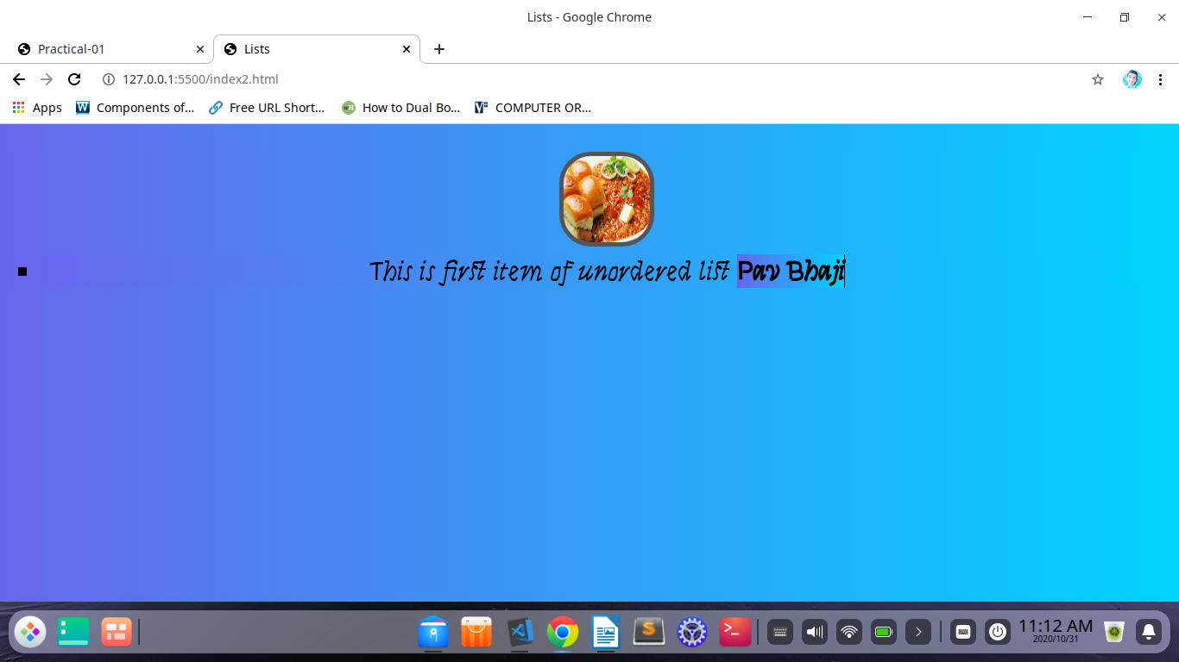

Code: 06 (Text area)

<!DOCTYPE html>
<html lang="en">
<head>
<meta charset="UTF-8">
<meta name="viewport" content="width=device-width, initial-scale=1.0">
<meta http-equiv="X-UA-Compatible" content="ie=edge">
<title>Lists</title>
<link href="https://fonts.googleapis.com/css2? family=Henny+Penny&family=Syne+Tactile&display=swap" rel="stylesheet">

<style>
*{
font-family: 'Henny Penny', cursive;
font-family: 'Syne Tactile', cursive;
font-size: xx-large;
text-align: center;
background: linear-gradient(90deg, rgba(2,0,36,1) 0%, rgba(103,103,237,1) 0%, rgba(0,212,255,1) 100%);
}
img {
border: 5px solid #555;
border-radius:37px ;}
li{
color:hsl(0, 95, 99);
background-color: rgba(2,0,36,1);
}
</style>
</head>
<body>
<div>
<center>
<h3>Text Area</h3>
<textarea rows="10" cols="50">
Text Here !
</textarea>
</center>
</div>
</body>
</html>

O/P
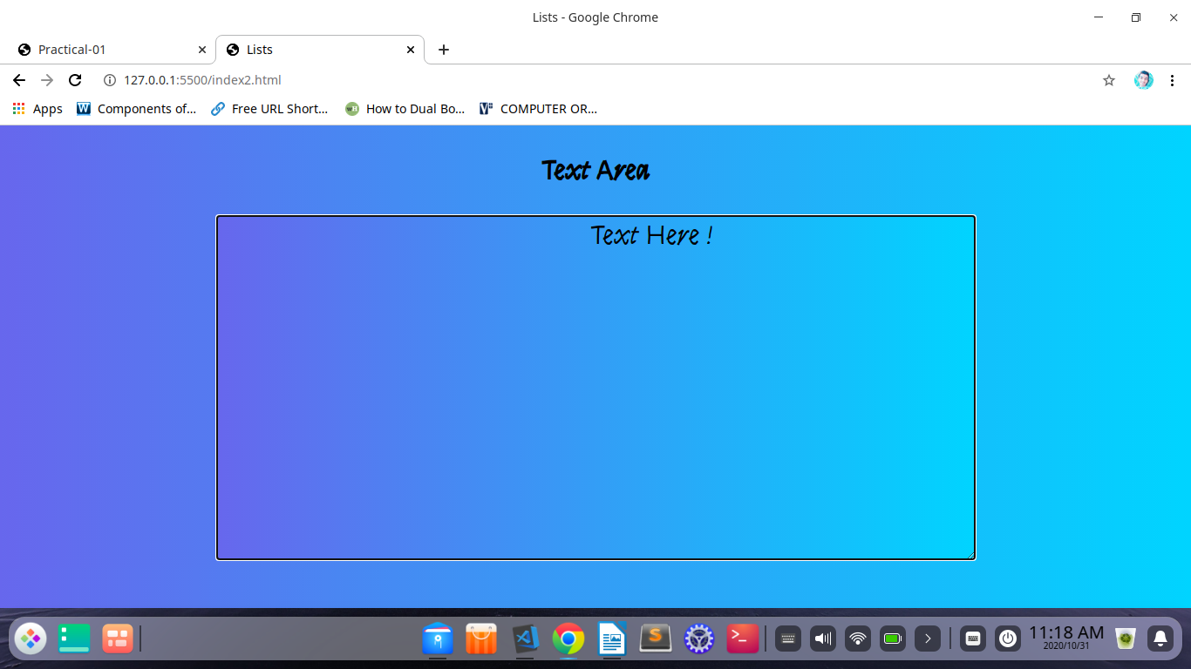
Code : 07 (Table)

<!DOCTYPE html>
<html lang="en">

<head>
<meta charset="UTF-8">
<meta name="viewport" content="width=device-width, initial-scale=1.0">
<title>Tables in HTML</title>
</head>

<body>
<table border="1">
<tr>
<td>Name</td>
<td>Branch</td>
<td>Year</td>
</tr>

<tr>
<td>Ruvel</td>
<td>Bsc.IT</td>
<td>First year</td>
</tr>
</table>
</body>

</html>

Output:

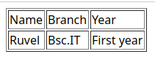
2 Rows and 3 Cols.
Code:7.1(bgcolor attribute)

<table border="1" bgcolor="yellow" >
<tr>
<td>Name</td>
<td>Branch</td>
<td>Year</td>
</tr>

<tr>
<td>Ruvel</td>
<td>Bsc.IT</td>
<td>First year</td>
</tr>
</table>

Output:
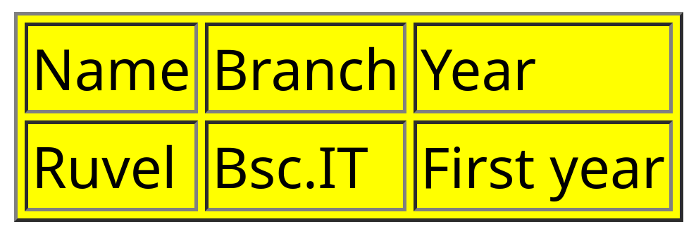

Code:7.2(background attribute)

<table border="1" background="https://www.ppsu.ac.in/img/logo.png" style="color: red;">
<tr>
<td>Name</td>
<td>Branch</td>
<td>Year</td>
</tr>

<tr>
<td>Ruvel</td>
<td>Bsc.IT</td>
<td>First year</td>
</tr>
</table>

Output:

Code:7.3(Caption attribute)

Code:

<table border="1" bgcolor="black" style="color: white;">
<tr>
<td>Name</td>
<td>Branch</td>
<td>Year</td>
</tr>

<tr>
<td>Ruvel</td>
<td>Bsc.IT</td>
<td>First year</td>
</tr>
<caption style="color: red;">Student Information</caption>
</table>

Output

