Aim: E-Commerce product page

Code:-
<!DOCTYPE html>
<html lang="en">
<head>
<meta charset="UTF-8">
<meta name="viewport" content="width=device-width, initial-scale=1.0">
<link rel="stylesheet" href="style2.css">
<link href="https://fonts.googleapis.com/css2? family=Antic+Slab&family=Lobster&display=swap" rel="stylesheet">
<title>Product-01</title>
</head>

<body>
<div class="product">

<header>
<hgroup>
<h1>Apple MacBook pro</h1>
<h4>The most amazing Laptop yet.</h4>
</hgroup>
</header>
<figure>
<img src="222579-4.webp">
</figure>
<section>

<h2>Specifications</h2>
<ul>
<li>Super perfomance with 16GB RAM</li>
<li>Powerful Processor Intel core i9</li>
<li>Large storage capacity 1TB SSD</li>
<li>Video perfomance with 4GB graphics</li>
<li>Retina display</li>
<li>Space Grey</li>
</ul>

<button>Buy Now</button>
</section>
</div>
</body>
</html>

O/P
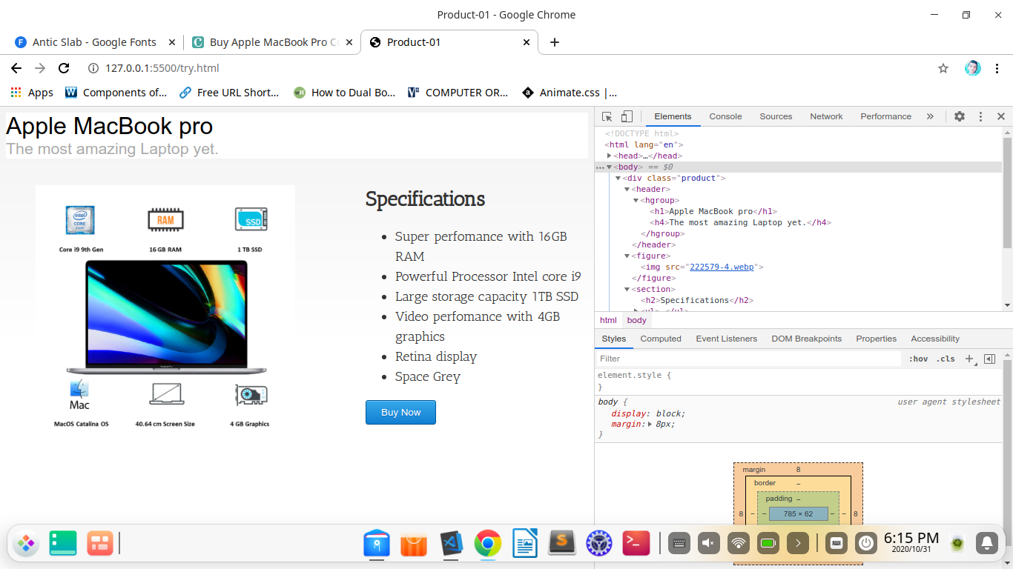
CSS
html {
height: 100%;
background: #f3f3f3;
background: -moz-linear-gradient(top, #f3f3f3 0%, #ffffff 50%);
}

.wrapper {
width: 650px;
margin: auto;
padding: 25px 0px;
}

h1, h4 {
font-family: Helvetica Neue, Arial, sans-serif;
font-weight: normal;
margin: 0;
}
h1 {
font-size: 24pt;
}
h4 {
font-size: 16pt;
color: #aaa;
}

header {
margin-bottom: 20px;
background: white no-repeat right center;
}

figure {
float: left;
}
figure img {
max-width: 350px;
}

section {
font-family: 'Antic Slab', serif;
font-size: large;
line-height: 150%;
float: right;
width: 300px;
color: #333;
}

button {
background: #36a9ea;
border: 1px solid #00599d;
color: #fff;
padding: 8px 20px;
border-radius: 3px;
box-shadow: 0px 1px 1px 0px rgba(0, 0, 0, .1), inset 0px 1px 0px 0px rgba(250, 250, 250, .3);
text-shadow: 0px 1px 1px #156cc4;
font-size: 10pt;
}
button:hover {
background: #2f90d5;
}

summary {
cursor: pointer;
font-size: 12pt;
outline: 0;
}
details {
margin: 20px 0px;
}

