ThreadWise Architecture and Delivery Plan
  - Four week implementation of the AI Learning Companion
Version 7.0 • 28 October 2026 • Four week capstone plan
Develop in GitHub Codespaces and deploy the reviewed release on AWS. One Lightsail server runs Streamlit, LangGraph agents, local MCP tools, an event worker, the embedding encoder and PostgreSQL with pgvector through Docker Compose. S3 holds private source originals and database exports. Cognito supplies learner sign in; Groq supplies external free tier inference.
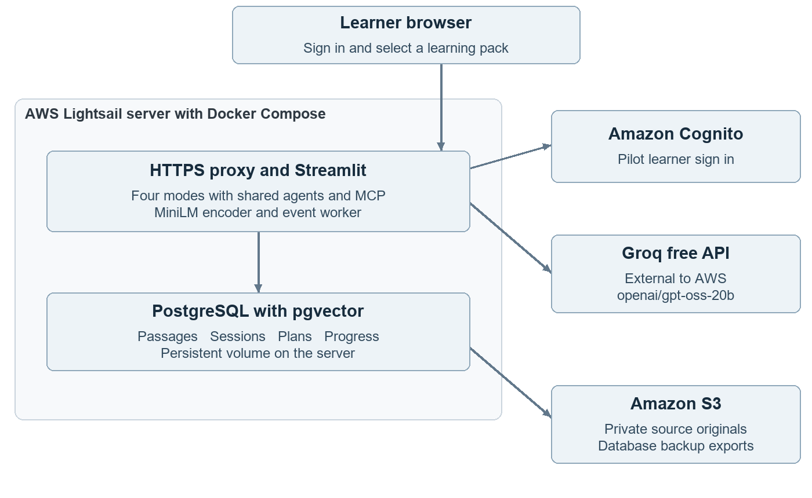
Figure 1 AWS deployment with external free inference and learning pack scoped access
Use the same container definitions in Codespaces and on Lightsail. The database has a persistent host volume; it is not exposed to the internet. Keep database and model access behind small adapters. The single server is a capstone tradeoff: the operator maintains it, and an outage affects both application and database. [R5, R6]

Scope changes in this revision
Version 7 adds Learn, Practice, Interview and Plan modes for general subjects and skills. Practice is capped at five questions; interviews have three main questions and one optional follow-up. One workspace and two reviewed packs share the existing MCP, skill, two agent roles, memory, approvals, events and evaluation CI. LangGraph is the selected orchestrator. CrewAI, n8n, alternative vector stores and a public API are rubric-dependent extensions.
Diagrams show the principal interactions, not every call. Query embeddings are generated by the same local encoder used at ingestion. No generative model runs on the AWS host; permitted question and source excerpts leave AWS for Groq.

Data and approved agent actions

Minimum data model
Record | Required information | Purpose
Workspace and learning pack | Workspace ID, pack/version, permitted learners, lessons, prerequisites and duration estimates. | Configure subjects and define authorized study items.
Source and passage | Workspace/pack IDs, source URL or S3 key, version, hash, lesson ID, text and vector. | Reproduce citations and filter retrieval to the approved corpus.
Plan and progress | Owner ID, item IDs, estimated minutes, state and version. | Save learner choices; distinguish self-reported completion from assessed mastery.
Proposal and approval | Exact changes, evidence, expected version, expiry, owner and reviewer. | Bind confirmation to the precise operation shown to the learner.
Learning session | Owner, pack version, mode, turns, question schema, rubric, evidence IDs and feedback. | Resume practice or interview without exposing hidden keys or another learner’s data.
Run and audit event | Run ID, checkpoint, tool result and idempotency key. | Resume safely and prevent duplicate updates.

Tool sequence
Tools are search_lessons, read_lesson, get_progress, propose_study_plan, propose_progress_update and apply_approved_change. The agent selects read tools based on the request. A mode selector routes Learn, Practice and Interview to bounded prompt templates using the same read tools; session transitions and question limits are controlled by application code. Missing time or goal information triggers clarification. Proposed plans contain valid lesson IDs, cited resources and labelled time estimates.
Persist the proposal before asking for approval. On approval, validate the authenticated owner, proposal ID, expiry and expected record version. Apply the change and its audit event in one database transaction with an idempotency key. A rejected, stale or repeated request must not cause an unintended write.

Application state and isolation
Store durable plans, progress and approval state in PostgreSQL. Streamlit session state is only a UI convenience. Reruns and repeated button clicks must not repeat actions. Store workflow checkpoints by owner and run ID, and test restart/resume. Never cache learner-specific results in a shared cache without an owner-specific key.
Map the authenticated subject to an allowlisted learner and learning pack permissions. Enforce workspace, pack and owner filters in every tool and citation fetch. Learning pack IDs suggested by the model cannot grant access. Keep development ports private. Source text is untrusted evidence, never authority to run tools or approve writes. Exclude secrets and private reasoning from logs.

Practice and interview workflows

One interface with four modes
The learner selects a learning pack and mode, then enters a topic, goal and preferred explanation level. Keep the source panel, chat components, retrieval service, model adapter and authentication shared. A learning pack is a versioned collection of permitted material, not necessarily a formal course. One operator imports two packs; public uploads and open-web crawling are deferred.

Practice workflow
Retrieve passages for the selected objective. The Planner generates up to five questions using a typed schema: item ID, type, objective, difficulty, wording, optional choices, expected answer, explanation and evidence IDs. MCQs have four distinct choices and exactly one keyed answer; short answers have expected concepts and accepted alternatives. The Reviewer checks each key against retrieved evidence and flags ambiguity or unsupported content.
Validate schema, allowed passage IDs, distinct options and question count in code. Permit one regeneration and review of failed items; if still invalid, show fewer questions with an explanation. Serve only the learner view before submission or explicit reveal; keep keys and explanations on the server. After submission, compare MCQ choices deterministically and offer reference answers or formative short-answer feedback with citations. No score marks a lesson complete.

Interview workflow
Generate and review three main questions from one topic and the selected level. Ask one at a time, wait for the learner response and use the Reviewer to compare it with reference concepts and cited passages. Allow one follow-up in the entire session, selected from a concrete gap in an answer. It counts toward the four-question session maximum. End with strengths, specific gaps and one suggested learning activity.
Feedback states what the answer did or did not cover, accepts equivalent valid answers and gives a source-supported improvement. Empty or insufficient answers receive an invitation to retry or skip, not an invented diagnosis. Do not infer personality, confidence, employability or examination readiness. No voice, video, live coding or resume-based evaluation is included.

State and consent
Store owner-scoped session checkpoints, turns and feedback for resume under a visible session-history notice. Keep generated keys out of client payloads, shared caches and ordinary logs. Session observations do not alter approved goals, plans or completion records. A learner may explicitly propose a progress or plan update from feedback; the existing approval transaction applies. Pin each session to a pack version and stop for review if that version is withdrawn.

Agent roles tools skills and memory
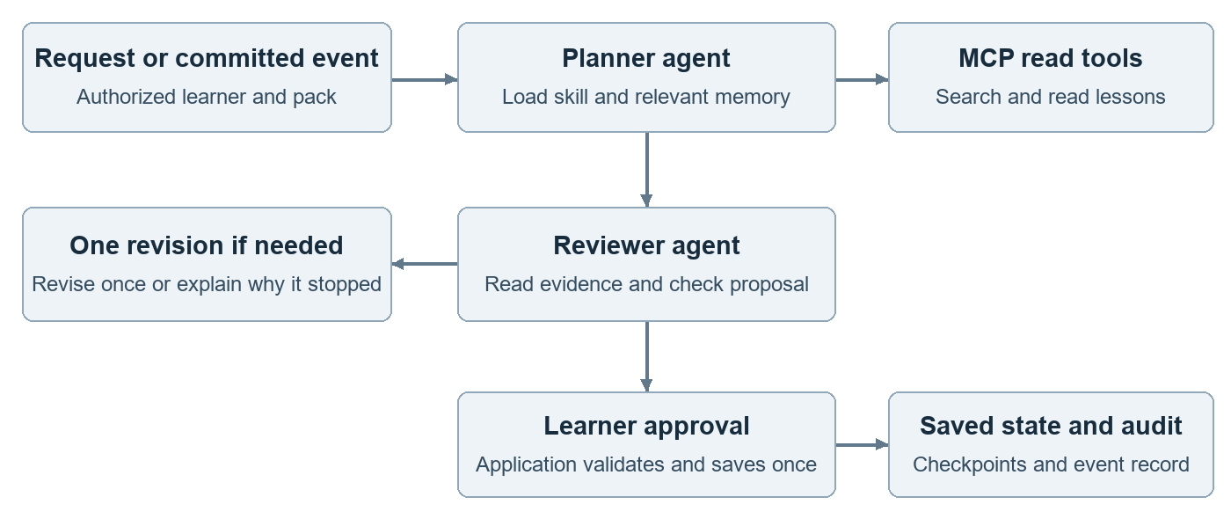
Figure 2 Bounded agent collaboration before learner approval

Two agents with an explicit handoff
LangGraph coordinates two role-specific agents with separate prompts, message state and tool allowlists. The Planner decomposes the goal, reads evidence and drafts a plan or mode-specific questions. The same two roles serve all four modes; no additional autonomous agent or framework is added. The Reviewer retrieves cited passages and checks the output against its mode rubric. For plans and generated questions it returns accept or revise; for learner answers it produces formative feedback. Model approval never authorizes a database change. Permit one revision and one final review, then stop if unresolved. Neither agent can approve a write. Both may use the same Groq model; agreement is not independent proof of correctness. [R16]

MCP and a reusable planning skill
Use an MCP client and local stdio server subprocess, not a function merely labelled MCP. For each run, bind trusted learner and pack context outside model arguments, enforce enrollment in every tool and use read-only database permissions. Close the subprocess after the run; log protocol evidence and test denial of an unauthorized pack. No public MCP endpoint is required. Keep writes inside the application; the MCP server cannot commit plan or progress changes. Log tool names, scoped source IDs, results and errors. [R14]
Create a versioned study-planning skill with SKILL.md metadata, instructions, a plan schema and reviewed examples. The application discovers its metadata and loads the selected skill for planning; record its version in each run. Demonstrate reuse for both learning packs. Tool permissions remain enforced in code, regardless of skill text. [R15]

Memory and verification
Short-term memory holds the current conversation and task state. Long-term memory stores learner approved goals, plans and progress. Episodic memory records previous proposals and learner-confirmed feedback by owner and pack. Raw practice or interview scores remain session observations; only explicitly saved preferences or progress enter long-term planning memory. Retrieve only relevant, bounded episodes; never infer mastery from completion. Persist checkpoints for restart. Reflection means an evidence-backed critique followed by bounded revision, not storage of private model reasoning.

Event automation and evaluation CI

Completion events create suggestions
When a learner approves a progress update, commit progress, audit event and an outbox event in the same PostgreSQL transaction. A small worker on the same Lightsail server claims pending events. For learners who enabled next-step suggestions, it invokes the same Planner and Reviewer workflow and saves a pending proposal. The learner sees it in the app and must approve it separately. No email, calendar update or automatic plan replacement is included.
Use event IDs and a unique event-to-proposal key to prevent duplicate effects. Track pending, processing, completed and failed states; use a lease for crash recovery and bounded retries. Recheck enrollment and record versions before processing and before applying a proposal. Treat delivery as at least once; test a crash after proposal creation and before acknowledgement. A schema change or quota failure must leave the event recoverable.

Continuous integration and release evaluation
Use GitHub Actions on pull requests and pushes to reviewed branches to run schema, retrieval-fixture, practice-key visibility, interview state, authorization, approval and event tests. Keep test fixtures and expected results in version control. Clearly label replayed model outputs as fixtures: passing them verifies plumbing, not current live model quality. Store the test report as a CI artifact. [R17]
Before a release, manually trigger a bounded live Groq evaluation on trusted code using protected secrets. Run the held-out set once configuration is frozen, audit judge disagreements and retain results with prompt, skill, corpus and model versions. A missing live run is INCONCLUSIVE, not a pass. Do not expose keys to untrusted pull requests. Check Actions allowances separately from the free LLM allowance.

Additional acceptance evidence
Check | Required evidence
MCP and skills | A real protocol call and denial case; skill selection and version visible in both pack runs.
Agent handoff | Separate role traces; Reviewer detects a seeded invalid plan; revision limit terminates.
Memory | A follow-up uses saved feedback; another learner cannot retrieve it; restart restores state.
Events | Duplicate delivery, crash recovery and revoked enrollment produce no unauthorized or duplicate plan.
CI and releases | A deliberately failing control blocks the check; a live report supports the final decision.

Also require mode checks for question limits, one keyed MCQ answer, hidden keys, one follow-up maximum, pause/resume, blank answers, conflicting evidence and pack withdrawal. These are required feature checks in addition to the ten action-control tests. Report every scenario outcome; do not imply that a feature name or a diagram constitutes implementation evidence.

Model access retrieval and Codespaces

Generation model
Initial model: openai/gpt-oss-20b served by Groq. It supports tool use and structured output. It is an OpenAI open-weight model accessed through Groq, not through a paid OpenAI API account. Validate access and output quality with a small smoke test before relying on it. Store GROQ_API_KEY in Codespaces secrets and later in the host’s secret configuration. [R1]
Check current model availability and actual account quotas during week 1. Free tier limits apply across the provider account allocation; several learner sessions can exhaust them. One agent turn may make multiple requests. Stay on the free plan with no automatic paid upgrade or fallback. AWS deployment does not provide free model credits. [R2, R3]
Bound context, output, retries and tool steps. Use a cap of eight model calls and four tool rounds per run, including both roles, retries and one revision. Also cap an entire interview session at 12 model calls and four learner questions; enforce both the per-run and session limits in application state. Permit one active inference run per deployment, releasing the slot while waiting for learner input. Tune only after measurement; exceeding a cap pauses or ends generation without changing plans or progress; preserve a resumable session checkpoint and explain the limit. On rate limiting, use bounded backoff and show a retry message while preserving state. Run evaluation in small batches. Use personal keys for individual development and one operator managed key for the shared pilot; do not multiply keys to bypass quotas.

Embeddings and ingestion
Use sentence-transformers/all-MiniLM-L6-v2 locally for both passages and queries. Its vectors have 384 dimensions; inputs beyond 256 word pieces are truncated by default. Split by headings and the model tokenizer, with a small overlap, keeping each encoded input within the limit. Pin the model revision and record it in the corpus manifest. [R4]
Ingest only approved English learning material initially. Preserve paragraph, section and page references before chunking. Cache unchanged vectors by source hash. Publish a new pack version atomically and exclude superseded or deleted passages; test one content update. Use a pgvector vector(384) column and cosine search, with server enforced workspace, authorized learning pack and version filters. Start with exact vector search; compare it with a hybrid of PostgreSQL keyword search and vector results using rank fusion. This is the required retrieval improvement; reranking is an extension. [R5]

Portable development environment
Provide a devcontainer, pinned Python dependencies, a PostgreSQL/pgvector container and setup, import, test and reset commands. Cache the embedding model once, and measure cold-start time and memory. Precompute corpus vectors during ingestion; the deployed app still needs the query encoder. Compose runs the app and database; a production override adds the HTTPS proxy. Package the encoder in the image or a persistent cache.
Use one Codespace across weekly branches after committing work. Use versioned migrations and checkpoint-specific reset procedures when moving backwards. Stop idle Codespaces and remove unused ones after saving work: included compute and storage allowances are limited. “Free inference” does not mean unlimited development compute. [R8]

Four weekly implementation milestones
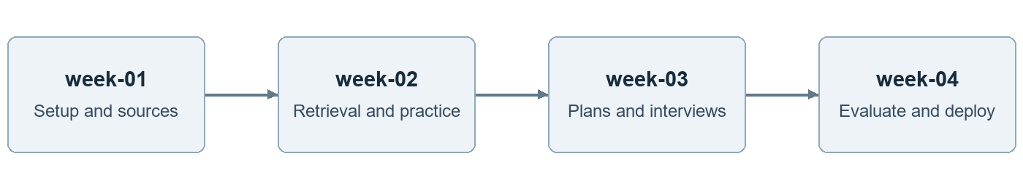
Figure 3 Each branch adds functionality to the approved previous week
Branch | Build | Acceptance evidence
week-01 | Codespaces, pack and session schema, source manifests, 36 evaluation cases, model smoke test, Learn baseline and AWS scaffold. | Clean startup; ten pilot questions; record baseline, model access and initial latency.
week-02 | MiniLM, hybrid retrieval, citations, MCP reads, planning skill and reviewed five-question Practice across two packs. | Retrieval comparison, MCP trace, skill reuse, content update, pack isolation and practice-key checks.
week-03 | Bounded Interview, Planner and Reviewer, memory, approvals, one completion event, checkpoints and authentication. | Interview feedback and cap checks, handoff, approval and recovery; AWS pilot with Cognito.
week-04 | Freeze features; CI regression, four-mode live holdout, judge audit, recovery, release and curriculum demonstration. | Release criteria reviewed; restore tested; release tag, operating guide and demo ready.

Branch and learner workflow
Create week-02 from the accepted week-01 tip, then repeat for weeks 3 and 4. Review each branch against its predecessor. Publish immutable tags such as cohort-01-week-02-v1. Keep main as the stable course guide; deploy only a reviewed release. Propagate fixes forward and publish new tag versions rather than rewriting learner baselines.
Learners use repository copies or forks that retain all weekly branches. Keep instructor solutions and learner submissions distinguishable. Each milestone includes an exercise, expected behaviour and evidence to submit. Copilot assists coding; learners remain responsible for explaining the implementation and verifying generated work.

Preparation and ownership
Before the engagement, the developer prepares the environment, source pack and starter MCP, Cognito, outbox and CI adapters. A reviewer labels evaluation cases and protects the holdout. Learners implement and test the features. Nominate an operator for the final deployment and its account limits. Agree weekly hours and team size. Keep one planning skill, two agents, one event type and fixed session limits. Reuse UI and schemas for the added modes. Extend the timeline or agree a reduced scope if prepared components are unavailable; do not compress evaluation into the final day.
By the end of week 3, complete the Lightsail pilot using measured startup memory, database connectivity and concurrent sessions. Verify Cognito login and learning pack access checks. Leave week 4 for evaluation, recovery and deployment fixes; the operator prepares AWS configuration before this milestone.

Evaluation dataset and release criteria
Prepare 36 human-reviewed scenarios before implementation expands. Use 24 for development and protect 12 for the final holdout. Select cases across both learning packs, with each mode represented in each pack. A scenario is a request, a five-question practice set, a scripted interview session or a constrained plan, as shown below. Preserve these denominators in reports.
Mode | Development | Holdout | Required case coverage
Learn | 8 requests | 4 requests | Holdout: three answerable and one unsupported. Development includes level changes and conflicting passages.
Practice | 6 sets | 3 sets of 5 | 15 holdout items: mix MCQs and short answers; both packs, alternative answers and ambiguous distractor checks.
Interview | 6 sessions | 3 sessions | Three main questions and one follow-up in each scripted holdout session: 12 feedback turns plus three final summaries.
Plan | 4 requests | 2 requests | Different time budgets, prerequisites and existing progress; both packs.

Version each case with pack and source hashes, objective, expected behaviour, reference concepts, supporting passage IDs and rubric. Interview scripts include correct, partially correct, incorrect and blank answers plus valid alternatives; distribute these over the 12 turns. Development cases also test insufficient evidence, prompt injection and quota interruption. Authored learner responses are labelled test fixtures, not actual user data.
Gate | Proposed acceptance threshold
Learn and retrieval | All four holdout requests pass correctness, relevance, level and uncertainty checks. Mean Recall at 5 at least 0.80 on answerable cases with labelled passages.
Citation support | At least 90% of audited factual claims supported across all modes; report counts by mode. Any material unsupported claim is a failure regardless of the aggregate.
Practice | All 15 keys and explanations are factually correct and supported; at least 14 of 15 items pass the quality rubric on the next page.
Interview | All three sessions pass the feedback rubric on every feedback turn and final summary. No invented learner error or unsupported readiness claim.
Plans and controls | Both plans satisfy valid IDs, time and prerequisites. All ten action-control tests and all mode, MCP, memory, event and CI checks pass.

The ten action-control tests cover approve, reject, expired, stale, duplicate, restart, wrong owner, embedded instructions, wrong pack and revoked access. Test actual state and audit events. Keep functional checks distinct from live quality evidence.

Practice question and interview feedback rubrics

Practice item review
First apply hard checks: the question is answerable from the selected evidence, its key is correct, its explanation is supported and an MCQ has exactly one defensible answer. A wrong key, unsupported explanation or ambiguous correct option is a release failure. Code validates the schema and IDs; a human verifies semantic correctness.
Practice dimension | 0 Fail | 1 Adequate | 2 Strong
Clarity | Ambiguous or missing context. | Answerable but needs minor wording improvement. | Clear, self-contained wording.
Objective and level | Unrelated or unsuitable difficulty. | Relevant with some mismatch in level. | Tests the stated objective at the selected level.
Assessment value | Trivial clues, duplicate options or unusable expected concepts. | Useful but weak distractors or limited concepts. | Plausible distinct distractors or a clear short-answer concept rubric.

An item passes quality when every dimension is at least 1 and the sum is at least 5 of 6, after all hard checks pass. Require at least 14 of the 15 held-out items to meet this threshold. For a practice response, feedback must accept valid paraphrases and distinguish missing concepts from incorrect claims. Generated questions are practice material, not predicted or official exam questions.

Interview feedback review
Feedback dimension | What earns a pass
Accuracy and grounding | Every stated strength or gap matches the learner answer and reference evidence. Cite the source for factual corrections; do not penalize valid alternatives.
Actionable guidance | Identify a specific improvement and a relevant next step. For blank answers, offer a retry, skip or focused hint without inventing weaknesses.
Fairness and tone | Use constructive language at the selected level. Judge the response, not personality or employability; make no readiness or confidence claims.

Score each feedback dimension 0, 1 or 2: incorrect or absent, adequate, or precise and useful. Every turn and final summary must score at least 1 on every dimension and at least 5 of 6 overall. Accuracy also has a hard gate: any fabricated learner error or material unsupported correction fails the session. The final summary must reflect the observed turns and label limits when answers are missing.
During development, seed wrong keys, ambiguous MCQs, a correct alternative answer, unsupported criticism and overconfident interview summaries. Check whether the application Reviewer detects them and whether the final human assessment reaches the expected result. Agreement between two model roles is not quality proof.

Evaluator audit comparisons and release evidence

Independent human assessment
Humans review all holdout outputs, including all 15 practice items, 12 interview feedback turns and three interview summaries. The release evaluator is a separate model call from the application Reviewer and uses the written rubric, sources and reference concepts. Audit at least 12 judge ratings against human labels: four Learn outputs, four practice items and four interview feedback outputs. Use development outputs as needed to include failures and valid alternatives.
Record pass/fail agreement, per-dimension score differences, false passes and false failures. A second reviewer adjudicates disagreements when available; otherwise record the human reviewer and rationale. Same-model generation and judging can share errors. Human decisions govern the report; neither a model vote nor a mean score can override a hard failure.

Controlled comparison and cost evidence
Compare exact vector retrieval with hybrid vector and keyword retrieval on the same development cases, corpus and model. Report retrieval and answer quality separately. Preserve prompt and schema failure examples for every mode. Measure latency, tokens, calls and quota failures per request, practice set and complete interview; record cold and warm startup memory. Set performance targets from weeks 1 and 3 before the holdout.

Freeze and decision rules
Agree thresholds before final testing and freeze code tag, corpus hash, model ID, prompts, skill and rubrics. Run the holdout once against the frozen build. Report results by mode and learning pack with denominators and all failures. A changed build needs a new versioned evaluation; do not silently tune on holdout answers or present repeated attempts as independent tests.
RELEASE requires every agreed quality gate, deterministic control and deployment check to pass with complete live evidence. HOLD applies to any failed threshold or material correctness, feedback, authorization or duplicate-write defect. INCONCLUSIVE applies when quota failures or missing evidence prevent a decision and no known blocking failure already requires HOLD. This small pilot cannot establish universal accuracy or improved learning outcomes.

Four week delivery safeguards
Week 4 is reserved for evaluation, repair and release, with no new modes. Preserve the five-question practice cap and three-plus-one interview cap. Use prepared MCP, authentication, event and CI adapters. If week 3 is incomplete, first reduce the breadth of topics and visual polish; any feature deferral needs an explicit scope decision. Never remove human review, source checks or approval tests to meet the date.

AWS deployment and operating costs
Use one Linux Lightsail virtual server with Docker Compose for the capstone. Start sizing experiments around 4 GB RAM; this is a hypothesis until the app, database and encoder are measured together. Use an operator supplied hostname and HTTPS reverse proxy with WebSocket support. This plan describes deployment work; it has not provisioned any resources.
Component | Responsibility | Operating choice
Lightsail server | Streamlit, agent roles, MCP subprocess, event worker, encoder and PostgreSQL. | Persistent database volume; private container network; no public database port.
Amazon S3 | Approved source originals, manifests and database exports. | Private bucket, encryption, versioning and defined retention. No public source links for private material.
Amazon Cognito | Managed learner sign in through OIDC. | Precreate pilot users; disable public signup. Application checks enrollment separately.
Groq outside AWS | Generate explanations, practice, interview feedback and plan proposals. | Free tier only. Send permitted excerpts; bound concurrency and retries.

Access and deployment procedure
Use Streamlit OIDC with Cognito and validate the integration in week 1. Authentication identifies a user; learning pack authorization stays in the application. Keep secrets in restricted server configuration outside the repository. Limit SSH to the operator, expose only HTTPS and its HTTP redirect, and keep app and database ports internal. [R9, R10]
Build a pinned image from an accepted release tag, back up the database, apply migrations and run the production Compose configuration. Keep the previous image and a compatible backup. Upload source packs and backups from the operator environment using short lived AWS credentials; the runtime needs no S3 key for routine queries.

Recovery and maintenance
Export PostgreSQL daily during the pilot and before migrations. Store exports in private S3 with versioning and a retention policy; test a full restore. Treat the server volume as persistent storage, not a backup. The operator patches the server, rotates secrets and reviews bounded logs. Test restart, rejected approvals, quota exhaustion and a restored learner plan. [R7]

Budget and operational limits
Reserve USD 30–35 per month for one shared 4 GB pilot deployment. The next page itemizes the estimate, development allowances and exclusions. Verify region, server size and account eligibility before provisioning; assume no promotional credits. Record the account owner, budget target and cleanup date. [R6]
Set AWS Budget alerts and inspect actual charges. Alerts are not a hard spending cap. Retain needed backups and explicitly remove unneeded billable resources after the pilot. This single server has no high availability guarantee. RDS, autoscaling and shared multi-workspace hosting are later phases. [R11]

Cost breakdown and development allowances
Assume one shared AWS deployment, about five pilot accounts, two small learning packs, light traffic and a few GB of retained S3 data. These are planning assumptions, not measured capacity. Prices were checked on 26 October 2026; confirm the target region and account before launch. Figures below are USD per full month, before tax.
Component | Cost | Assumption or limit
Lightsail with public IPv4 | 24 | 4 GB Linux bundle; includes the host running app, database, encoder and worker. [R6]
S3 originals and exports | 1–2 allowance | A few GB, light requests and limited version retention. An estimate, not a fixed S3 tariff. [R18]
Optional snapshots | 1–3 allowance | 20–60 GB of billable snapshot storage at 0.05 per GB-month. [R6]
Cognito direct sign-in | 0 expected | Lite or Essentials includes 10,000 monthly active users per account or organization; other usage shares this allowance. SMS and email may cost extra. [R19]
Groq and local embeddings | 0 API spend | Free Groq quota only; local encoder uses host compute. Practice, interview, judge and agent calls share quota. [R3]

Total: USD 25–26 without snapshots or USD 26–29 with the snapshot allowance. Reserve USD 30–35 for the 4 GB pilot. An 8 GB server has a USD 44 base price, so reserve USD 50–55 if measurements require it. These reserves exclude the items below and are not enforced spending caps. [R6]

Codespaces CI and Copilot
GitHub Free personal accounts include 120 core-hours and 15 GB-month of Codespaces storage; Pro includes 180 core-hours and 20 GB-month. On a two-core machine, these equal 60 and 90 runtime hours respectively. Organization-funded Codespaces has no included free quota. Existing use, larger machines and retained storage reduce what is available for this project. [R8]
Use standard GitHub Actions runners. Public repositories have free standard runner minutes; private repositories use plan allowances, including artifact storage. Keep CI reports small and short lived. Use existing Copilot access; its subscription is excluded from this estimate and does not provide app inference or establish Codespaces entitlement. [R21]

Budget controls and project lifetime
The estimate excludes labour, taxes, new domains, GitHub overages, optional messaging and excess transfer. Develop before provisioning around week 3; billing for a partial month is prorated by instance lifetime. Stopped Lightsail servers remain billable. Back up required data before deleting unneeded resources, and check retained snapshots, storage and IP resources separately. [R20]
This is per deployment, not per learner. Ten independent pilots would require roughly ten hosting budgets; one shared pilot is not proven to support ten times the load. Set budget alerts, retain bounded logs and backups, and review charges weekly. Quota exhaustion pauses model work rather than switching to paid inference.

Curriculum mapping and remaining boundaries
This mapping uses the stakeholder supplied curriculum summary describing M2, M3 and M4 drafts. The original spreadsheets and complete M6 rubric have not been checked for this revision. These are planned demonstrations; acceptance requires evidence.
M4 topic | Implementation in this capstone | Acceptance evidence
1 Agent loop | Goal decomposition, tool observations, explicit stop conditions. | Trace of goal, tool results and bounded termination.
2 Connectivity | MCP lesson reads and reusable study-planning skill. | Protocol trace, least-privilege denial and skill reuse.
3 Memory | Conversation state, saved learner records and prior-plan episodes. | Feedback recall, owner isolation and bounded revision.
4 Multiple agents | Planner and Reviewer coordinated by LangGraph. | Role handoff and correction of a seeded bad proposal.
5 Workflow state | Persisted checkpoints, approval and validated writes. | Reject, stale, repeated and restart cases.
6 Automation | Approved completion event routed through an outbox worker. | Trigger, deduplication and crash recovery evidence.
7 Assembly | Structured audit trail and permission review. | End-to-end event journey with no unauthorized writes.

Named tools and advanced topics
The curriculum names CrewAI roles, CrewAI Flows and n8n. This plan implements their broad orchestration and event concepts using LangGraph and a worker; it does not claim those tools are used. Scheduled automation and A2A are discussion-only. If graded tool usage is mandatory, adapt one existing workflow using an instructor starter rather than build a second application.
M2 names FAISS, Qdrant, BM25, reranking, Langfuse and the /ask endpoint. The core uses pgvector, PostgreSQL keyword search and structured traces; a public FastAPI /ask adapter is optional. GraphRAG and managed-service comparisons remain conceptual. A relational prerequisite table is not evidence of GraphRAG. The assessor must decide which named tools or demonstrations are required.

Coverage across the other modules
The proposal maps M0–M6 to deliverables. Include Python and API work, Git, Copilot review, token budgets, versioned prompts, few-shot examples, prompt chaining and structured validation. Evaluation and AWS operations supply the M3 and M5 evidence; the integrated demonstration supplies M6.
Track each topic, artifact, test result and reviewer status. Mark it implemented, conceptual, deferred or awaiting rubric confirmation. Full compliance requires assessor resolution of the remaining boundaries.

Readiness and technical references

Before implementation expands
- Confirm workspace and content owners, content rights, ten pilot questions and a second learning pack.
- Verify Groq account access, model availability and limits; store the key securely and test tool outputs.
- Run the embedding encoder in a clean Codespace and confirm chunk lengths, vectors and memory use.
- Confirm the rubric, pilot users, AWS region, hostname, budget owner and Cognito configuration.

Before the final demonstration
- Complete live evaluation, judge audit, action controls and MCP, skill, handoff, memory, event and CI checks.
- Deploy the reviewed release; test authentication, restart, restore and quota handling.
- Deliver code, branch tags, skill package, MCP trace, corpus manifest, CI report, curriculum checklist and operating guide.
Version 7 broadens ThreadWise to a learning companion and adds bounded practice and interview modes with explicit rubrics. AWS, Codespaces and free external inference remain. Budget figures retain the 26 October planning basis; recheck prices and quotas before launch. Source selection and assessor acceptance remain pending. [R12, R13]

Official references
R1 Groq generation model
R2 Groq account rate limits
R3 Groq billing policy
R4 MiniLM embedding model
R5 PostgreSQL vector extension
R6 AWS Lightsail pricing
R7 Amazon S3 object versioning
R8 Codespaces allowances
R9 Streamlit OIDC authentication
R10 Cognito OIDC and managed login
R11 AWS Budgets
R12 Public starter course
R13 Starter course repository license
R14 MCP local subprocess transport
R15 Agent Skills format
R16 LangGraph orchestration
R17 GitHub Actions workflow triggers
R18 Amazon S3 pricing
R19 Amazon Cognito pricing
R20 Lightsail billing and deletion rules
R21 GitHub Actions billing allowances

