ThreadWise Project Proposal
  - AI Learning Companion for subjects skills and study goals
Version 7.0 • 28 October 2026 • Four week capstone plan
We propose ThreadWise AI Learning Companion as a four week capstone. It helps people understand learning materials, practise concepts, rehearse interviews and organize study time. One reusable application supports different subjects through reviewed learning packs. This proposal defines the bounded pilot, quality checks, delivery commitments and decisions needed before implementation.

Problem statement
Learning a subject or skill often involves searching several sources, understanding unfamiliar concepts, deciding what to learn next and tracking progress. This can become fragmented for someone studying independently, developing a professional skill, preparing for an examination or following a structured course.
ThreadWise combines explanations supported by source citations with guided practice, short interview simulations and personalized study plans. Learners specify their goal, available time and preferred explanation level. Agent workflows retrieve relevant evidence, check proposed outputs and suggest next steps; changes to saved plans and progress require learner approval.
The same core application can serve different subjects and learning contexts. The pilot uses one workspace and two small learning packs, with access controlled by the operator. An institution is an optional setting, not a prerequisite. Subject portability will be demonstrated on those packs; broad subject expertise is not assumed.
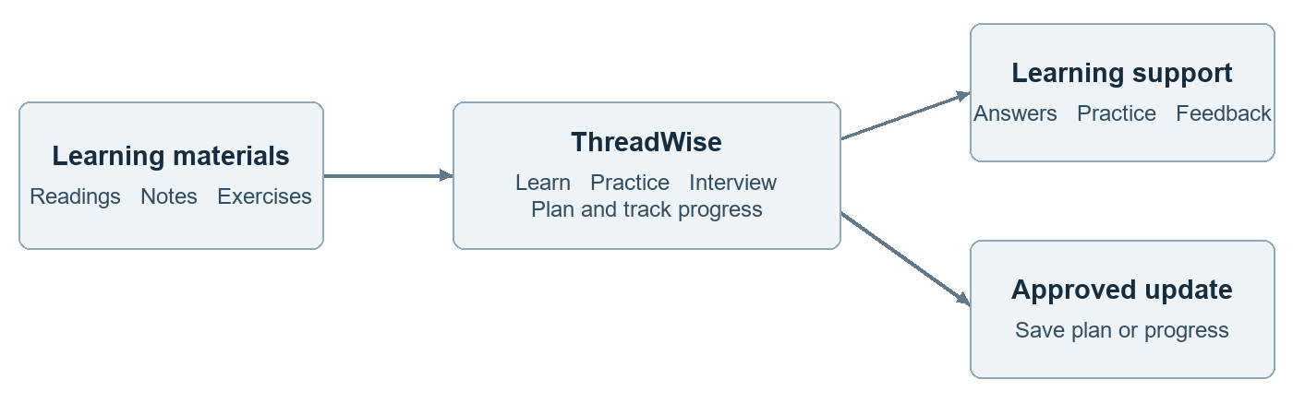
Figure 1 Selected materials support four learning modes and approved updates

Agreed direction
- Develop in GitHub Codespaces, with four cumulative weekly branches in GitHub.
- Use Python, Streamlit, LangGraph and PostgreSQL with pgvector; retain pgvector as the working choice. Alternative vector stores remain optional.
- Start with openai/gpt-oss-20b through Groq’s free API tier and a local MiniLM embedding model. No purchased LLM credits are assumed.
- Deploy on AWS. The proposed capstone setup is one Lightsail server, private S3 storage and Cognito sign in, with a deployment pilot during week 3.

Four bounded learner journeys
Mode | Example request | Pilot boundary
Learn | Explain retrieval using a beginner friendly example. | Cited explanations, examples and clarifying questions. Learner selects level; generated examples are labelled.
Practice | Give me five revision questions on this topic. | At most five MCQs or short-answer concept questions. Show suggested answers, reasons and citations after submission or explicit reveal.
Interview | Run a short interview on this topic. | Text only: three main questions and at most one adaptive follow-up. Provide evidence-based feedback and one next study suggestion.
Plan | I have three hours this week. What should I study? | Propose a plan within the time budget. Save plans and self-reported progress only after approval.

Personalization within the pilot
Use an explicit goal, beginner or intermediate explanation level, available study time and learner-approved progress. Adapt the wording and next activity using these inputs and the current answer. This is a transparent preference-based approach; the pilot does not diagnose mastery or predict examination or hiring outcomes.
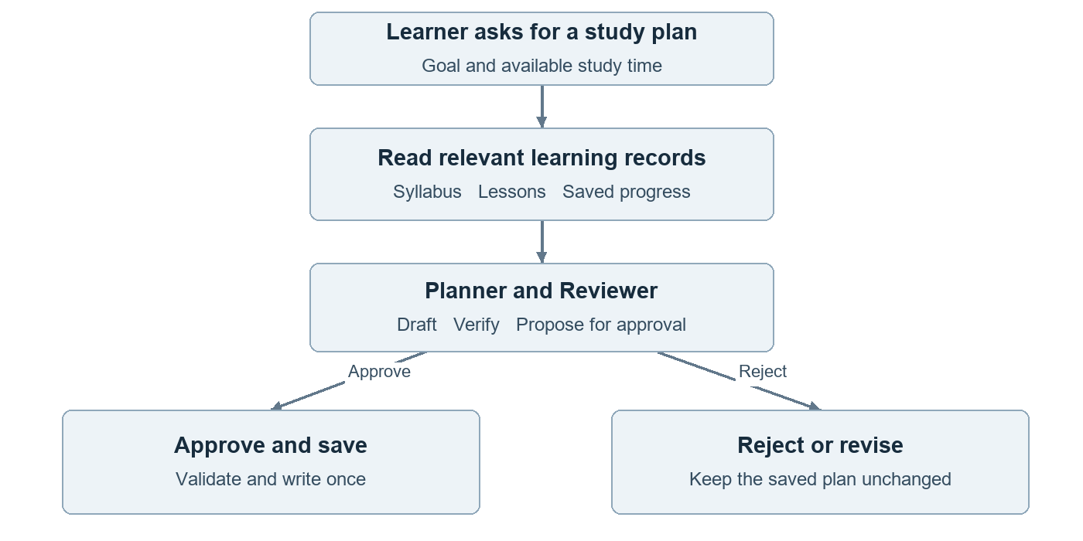
Figure 2 Retrieve learning context and review a plan before learner approval
A Planner and Reviewer share the retrieval service. For planning, the Planner loads a reusable skill, retrieves relevant memory and proposes activities; the Reviewer checks the result. Approved completion can trigger a pending next-step suggestion. Quiz results and interview feedback never mark lessons complete automatically.

Dataset scope and readiness
The product accepts reviewed learning packs in English text, Markdown and text based PDF. Each pack contains a topic outline, readings and exercises, plus a manifest of objectives, order, prerequisites and estimated duration. A formal syllabus is optional; a reviewer can map existing material into the manifest. Pilot with one primary pack and a small second pack from a different subject, about 10–20 short sections in total. Collection and validation are still pending.
Source | Purpose | Connection
Topic outline and objectives | Define scope and lesson sequence. | Workspace, pack, version, module and lesson IDs.
Lesson notes or approved readings | Support explanations and citations. | Each section maps to a lesson and objective.
Exercise instructions | Give learners actionable practice. | Exercise ID links to the lesson and prerequisites.
Approved FAQs | Clarify common questions. | Link each answer to its topic and source.
Learner progress | Personalize the next study step. | Learner ID and lesson or exercise ID; actual user-entered state.

Acceptance checks before feature expansion
- A reviewer confirms support for ten pilot questions, two study plans, a five-question practice set and one short interview with reference answers. Cover both packs before freezing the evaluation set.
- Preserve source title, file or URL, version, section or page and permitted use. Verify extraction against the original; exclude scanned documents requiring OCR from the first version.
- Give every source a pack and version. Review prerequisites and duration estimates. A second pack must load through configuration without code changes; retrieval must stay within the selected authorized learning pack.
- Keep instructor assessment keys and holdout references outside retrieval. Practice and interview expected answers are generated from permitted passages and kept server-side until the reveal or feedback step. Send only permitted excerpts to the external model provider.
Use authentic public or operator supplied material with reuse permission. A learning pack may address a subject, skill or examination topic; it need not belong to an institution. A public starter candidate is Unit 1 of the Hugging Face Agents Course; its repository includes an Apache 2.0 license. Preserve notices and check selected assets. A reviewer must source a second authentic pack to test portability. Test questions may be authored; course facts and learner completion must not be fabricated.

Why the dataset is simpler
Records connect through workspace, pack, topic and lesson IDs. Practice questions and interview turns also store source passage IDs, objectives and pack versions. An operator imports reviewed packs using a command and manifest; a full authoring portal is deferred. Supporting different subjects means configurable content and evaluation, not proven accuracy on every subject.

Delivery scope and stakeholder decisions
Week | Cumulative outcome | Review evidence
1 Foundation | Codespaces, reviewed packs, evaluation cases and basic Learn mode. | Clean startup, source rights, model access and baseline responses.
2 Retrieval and practice | Cited retrieval, MCP, planning skill and five-question practice. | Two packs, correct answer keys and retrieval comparison.
3 Agents and interview | Short interviews, plans, memory, approval and one completion event. | Feedback cases, control tests and authenticated AWS pilot.
4 Release | Freeze scope, run quality evaluation and complete deployment. | Per-mode results, judge audit, restore test and evidence index.

Four weeks assumes an instructor prepared environment, reviewed source pack and starter adapters for MCP, authentication, event handling and CI. Learners implement the connected workflow and explain the evidence. Agree weekly hours and group size before launch. Without the scaffold, extend the schedule or explicitly reduce coverage.

Included and deferred
Include one workspace, two small learning packs, the four bounded modes, approvals and authenticated pack access. Use one shared retrieval pipeline, two agent roles and one completion event type. Test with a small pilot of up to five accounts; simultaneous capacity must be measured. Content onboarding uses a reviewed manifest and import command.
Defer shared multi-workspace hosting, LMS integration, formal grading, full mock exams, voice or video interviews, code execution, open-web discovery, OCR and multilingual support. Practice feedback is formative and interview feedback concerns the answer; neither certifies ability. SageMaker is excluded. MCP and two agent roles are now core. Course-specific frameworks and advanced RAG demonstrations require a rubric decision; they are not silently counted as implemented.

Costs and decisions
Reserve USD 30–35 per month for one shared pilot deployment using a 4 GB Lightsail server. This includes a modest allowance for source storage and backups; it is an estimate, not a spending cap. Free Groq inference does not make AWS hosting free. Practice review and interview turns consume the same limited inference quota. The budget section states the assumptions and exclusions.
Confirm the pilot audience, source rights, external Groq processing, weekly effort, prepared components, quality thresholds, AWS owner, region, hostname and spending limit. If milestones slip, reduce topic coverage and polish; scope reductions require stakeholder agreement and must not remove quality or approval controls. The operator supplies the deployment scaffold. AWS has been selected; Lightsail sizing and the operating budget remain implementation decisions. No cloud resources have been provisioned.
Deliverables are the GitHub branches and release tags, working application, source manifest, evaluation dataset and report, deployment instructions and a short demonstration. The companion delivery plan supplies architecture diagrams and the technical checks.

Quality checks for all four modes
Prepare 36 reviewed scenarios: 24 for development and 12 held out until release. The holdout covers four Learn requests, three Practice sets, three Interview sessions and two Plan requests across both packs. It includes unsupported requests and scripted learner answers. These authored assessment fixtures test authentic source content; they are not presented as real learner records.
Area | What reviewers check | Proposed release gate
Learn | Correct explanations, relevant sources, suitable level and honest abstention. | All four holdout requests pass; at least 90% of audited factual claims have supporting citations.
Practice | Answer-key correctness, unambiguous wording, topic fit, useful distractors and supported explanations. | All 15 holdout keys correct; at least 14 of 15 questions pass the quality rubric. No material unsupported answer.
Interview | Feedback agrees with the answer and sources, accepts valid alternatives and gives useful next steps. | All three scripted sessions pass. No invented learner error, personality judgment or unsupported readiness claim.
Plan and actions | Valid lesson IDs, time and prerequisite constraints, explicit approval and safe recovery. | Both holdout plans satisfy hard constraints; all ten action-control tests pass.

Human review and evaluator audit
Review every holdout response, practice question and interview feedback output manually. Audit at least 12 LLM-judge ratings against human ratings, including four Learn outputs, four practice items and four interview feedback outputs. The judge runs separately from the application Reviewer; it assists assessment but cannot replace human review. Report disagreements, denominators and failures by mode and pack.

Evidence and release decision
Freeze the source versions, prompts, rubrics and code before the holdout. Compare vector retrieval with one hybrid retrieval improvement on development cases. Use deterministic tests for schemas, citations, approvals and state changes. Record latency, model calls, quota failures and memory usage for each mode, including a complete interview session.
A failed threshold or a material factual, answer-key, feedback or access-control defect requires HOLD. Missing live evidence requires INCONCLUSIVE. RELEASE requires every agreed gate and operational check to pass. These small samples support a capstone demonstration, not universal accuracy or proven learning gains. The delivery plan defines the detailed rubrics and test distribution.

Project budget and cost assumptions
Plan for one shared deployment, around five pilot accounts, two small learning packs and light traffic across the four bounded modes. Reserve USD 30–35 for a full month on a 4 GB server. This is a planning allowance checked on 26 October 2026, subject to the selected region and measured resource needs. It assumes no promotional credits.
Component | Monthly estimate | Basis
Lightsail Linux server | USD 24 | 4 GB RAM with public IPv4; app, database, agents and encoder share the server.
S3 files and database exports | USD 1–2 | Our allowance for a few GB, light requests and controlled backup retention.
Optional server snapshots | USD 1–3 | 20–60 GB of billable storage at USD 0.05 per GB-month.
Cognito learner login | USD 0 expected | Pilot direct sign-in within Lite or Essentials free allowances; messaging can cost extra.
Groq generation and judge | USD 0 within quota | Remain on the free tier; queue or pause when limits are reached.
Embeddings and libraries | No separate API fee | Run on the server; their compute is included above.

Estimated hosting is USD 25–26 without optional snapshots, or USD 26–29 with the snapshot allowance. The USD 30–35 reserve adds headroom. If testing requires the 8 GB server, its base cost is USD 44 per month; reserve approximately USD 50–55 for that configuration.

Development and excluded costs
Codespaces and GitHub Actions can stay within applicable included allowances. Check personal versus organization billing, machine size, runtime and storage; Copilot access does not establish Codespaces entitlement. Use existing Copilot access. Additional modes increase calls and testing effort; retain the cost reserve subject to measured usage. The estimate excludes development labour, taxes, new domain registration, GitHub overages, messaging and excess data transfer.

Four week engagement and ownership
Build in Codespaces first and create the AWS deployment around week 3 to reduce its lifetime. Keep the full monthly reserve until dates and sizes are fixed. Lightsail bills stopped servers too; after backing up required data, delete unneeded billable resources. Retained snapshots and storage can continue to cost money. This budget is per shared deployment, not per learner.
Name an AWS account owner, set budget alerts and review actual usage. Alerts are not a hard cap. Separate learner deployments multiply hosting costs; a larger shared cohort also needs load and model-quota testing.
AWS server and snapshot prices
AWS billing rules and resource cleanup
The companion delivery plan contains the component references and development allowance details. No purchase or cloud provisioning is performed by this document update.

Curriculum coverage and evidence
This mapping uses the curriculum summary supplied by the stakeholder, including the M2, M3 and M4 draft outlines described there. It is a planned evidence checklist, not proof that the product is implemented or that the programme assessor has approved it. The complete capstone rubric remains unavailable.
Module | Planned demonstration | Evidence to submit
M0 Foundations | Python, APIs, Git, Copilot, token limits and responsible data use. | Reproducible setup, commit history and content rights record.
M1 LLM engineering | Versioned prompts, few-shot examples, structured outputs and validation. | Prompt examples, JSON schema and failure cases.
M2 RAG | Ingestion, embeddings, hybrid retrieval, citations, freshness and access filters. | Source manifest, retrieval comparison and isolation tests.
M3 Quality | Answer, question and interview-feedback rubrics; judge audit and release decision. | Evaluation cases, disagreement analysis and RELEASE or HOLD report.
M4 Agentic core | MCP, skill reuse, Planner and Reviewer, memory, approval, recovery and events. | Trace of one complete journey and control test results.
M5 Operations | AWS, authentication, secrets, versioning, logs, CI and cost controls. | CI artifact, deployment guide and restore evidence.
M6 Capstone | Integrated reusable AI learning companion. | Working demo, weekly branches and evidence index.

One integrated demonstration
Show a cited explanation, a reviewed practice set and a short interview with feedback. Then request a study plan, inspect the MCP and agent handoff trace, approve the plan and confirm a lesson completion. The completion event generates a new suggestion for review. Restart the app and show that memory, proposals and audit records survive without duplicate updates.

Coverage boundaries to resolve
LangGraph demonstrates multi-agent orchestration and a small worker demonstrates event routing. This does not prove use of CrewAI, CrewAI Flows or n8n. pgvector does not demonstrate FAISS or Qdrant. Reranking, GraphRAG, managed-service comparisons, scheduling and A2A remain discussion or extension topics. Confirm tool-specific grading requirements before the cohort starts.
The project demonstrates the major concepts across M0–M6. It does not replace every module lab or guarantee every named tool is covered. The delivery plan records remaining gaps and the evidence needed for acceptance.

