**Artificial and Computational Intelligence**

**Assignment-5**

**Problem Statement**

Consider a ship is in the sea with citizens, the agent of the ship has been provided with the detailed Map and Distances of the cities. Find the optimal path where the agent can drop all the citizens to the destination and calculating the distance by applying a bi-directional search. Also, find the total path cost.

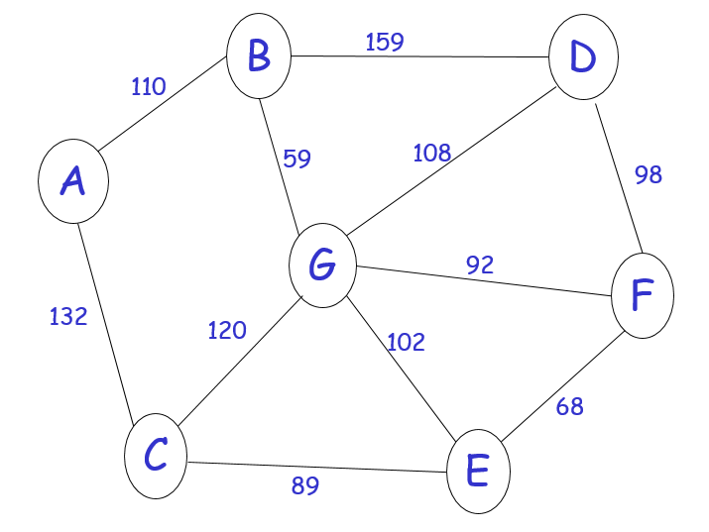

Note:

1. Explain the environment of the agent. [20% weightage]
2. If there exists a path, then find the path and cost. [20% weightage]
3. Implement the search algorithm to find the path that the agent can visit all the cities in the graph. [40% weightage]
4. Explain your strategy in bi-directional search. [20% weightage]
5. The starting point and the destination is to be obtained from the user as input.

**Instructions:**

* You are provided with the python notebook/file template which stipulates the structure of code and documentation. You are free to add as many code cells as possible. Use well-intended python code.
* The implementation code must be completely original.
* Please keep your work (code, documentation) confidential. If your code is found to be plagiarized, you will be penalized severely. Parties involved in the copy will be considered equal partners and will be penalized severely.