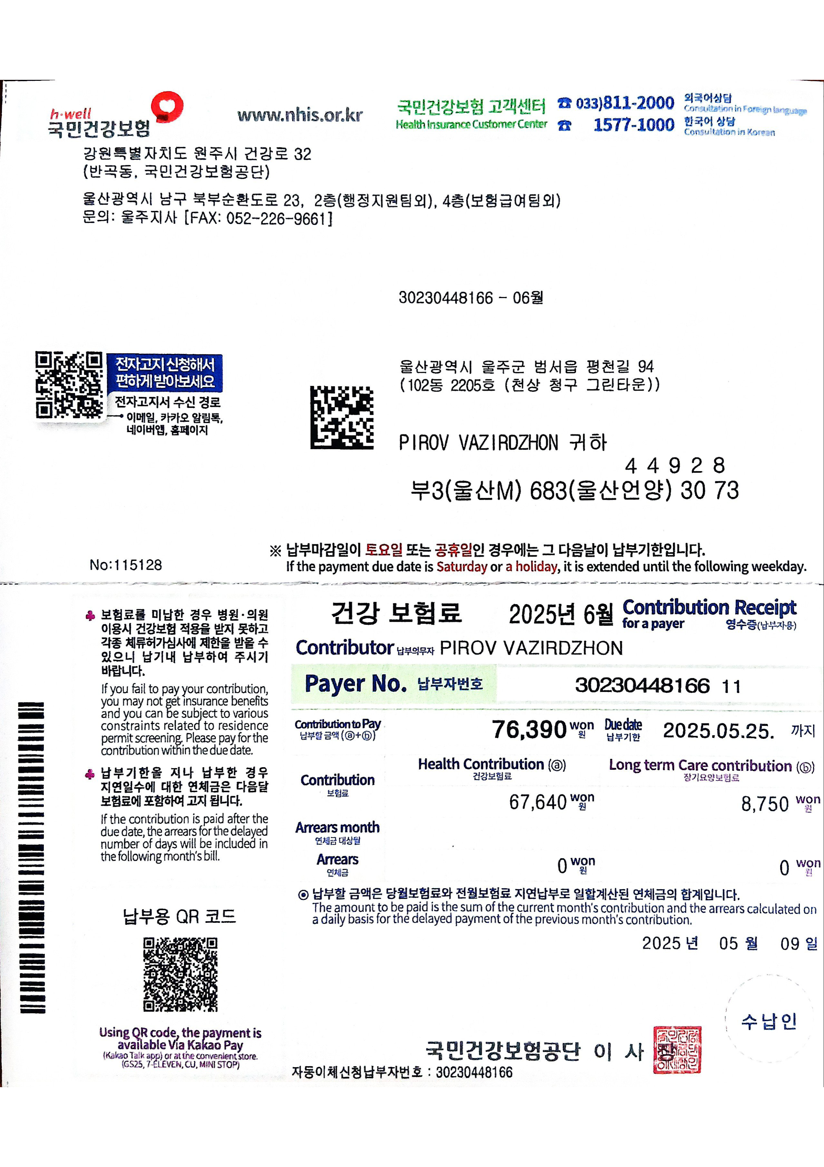


ZIZPIROV VAZIRDZHON
Enter a note (up to 20 characters) #
Transaction date an 2025.05.24 15:30
d time
Ae | SAlOlAl
Transaction classific
ation
Transaction amount
76,390KRW
Transfer amount 76,390KRW
Fees OKRW
Balance after transa
ction
Show recipient's ban PIROV VAZIRDZHON
kbook
71Z2IPIROV VAZIRDZHON
Show my bankbook

