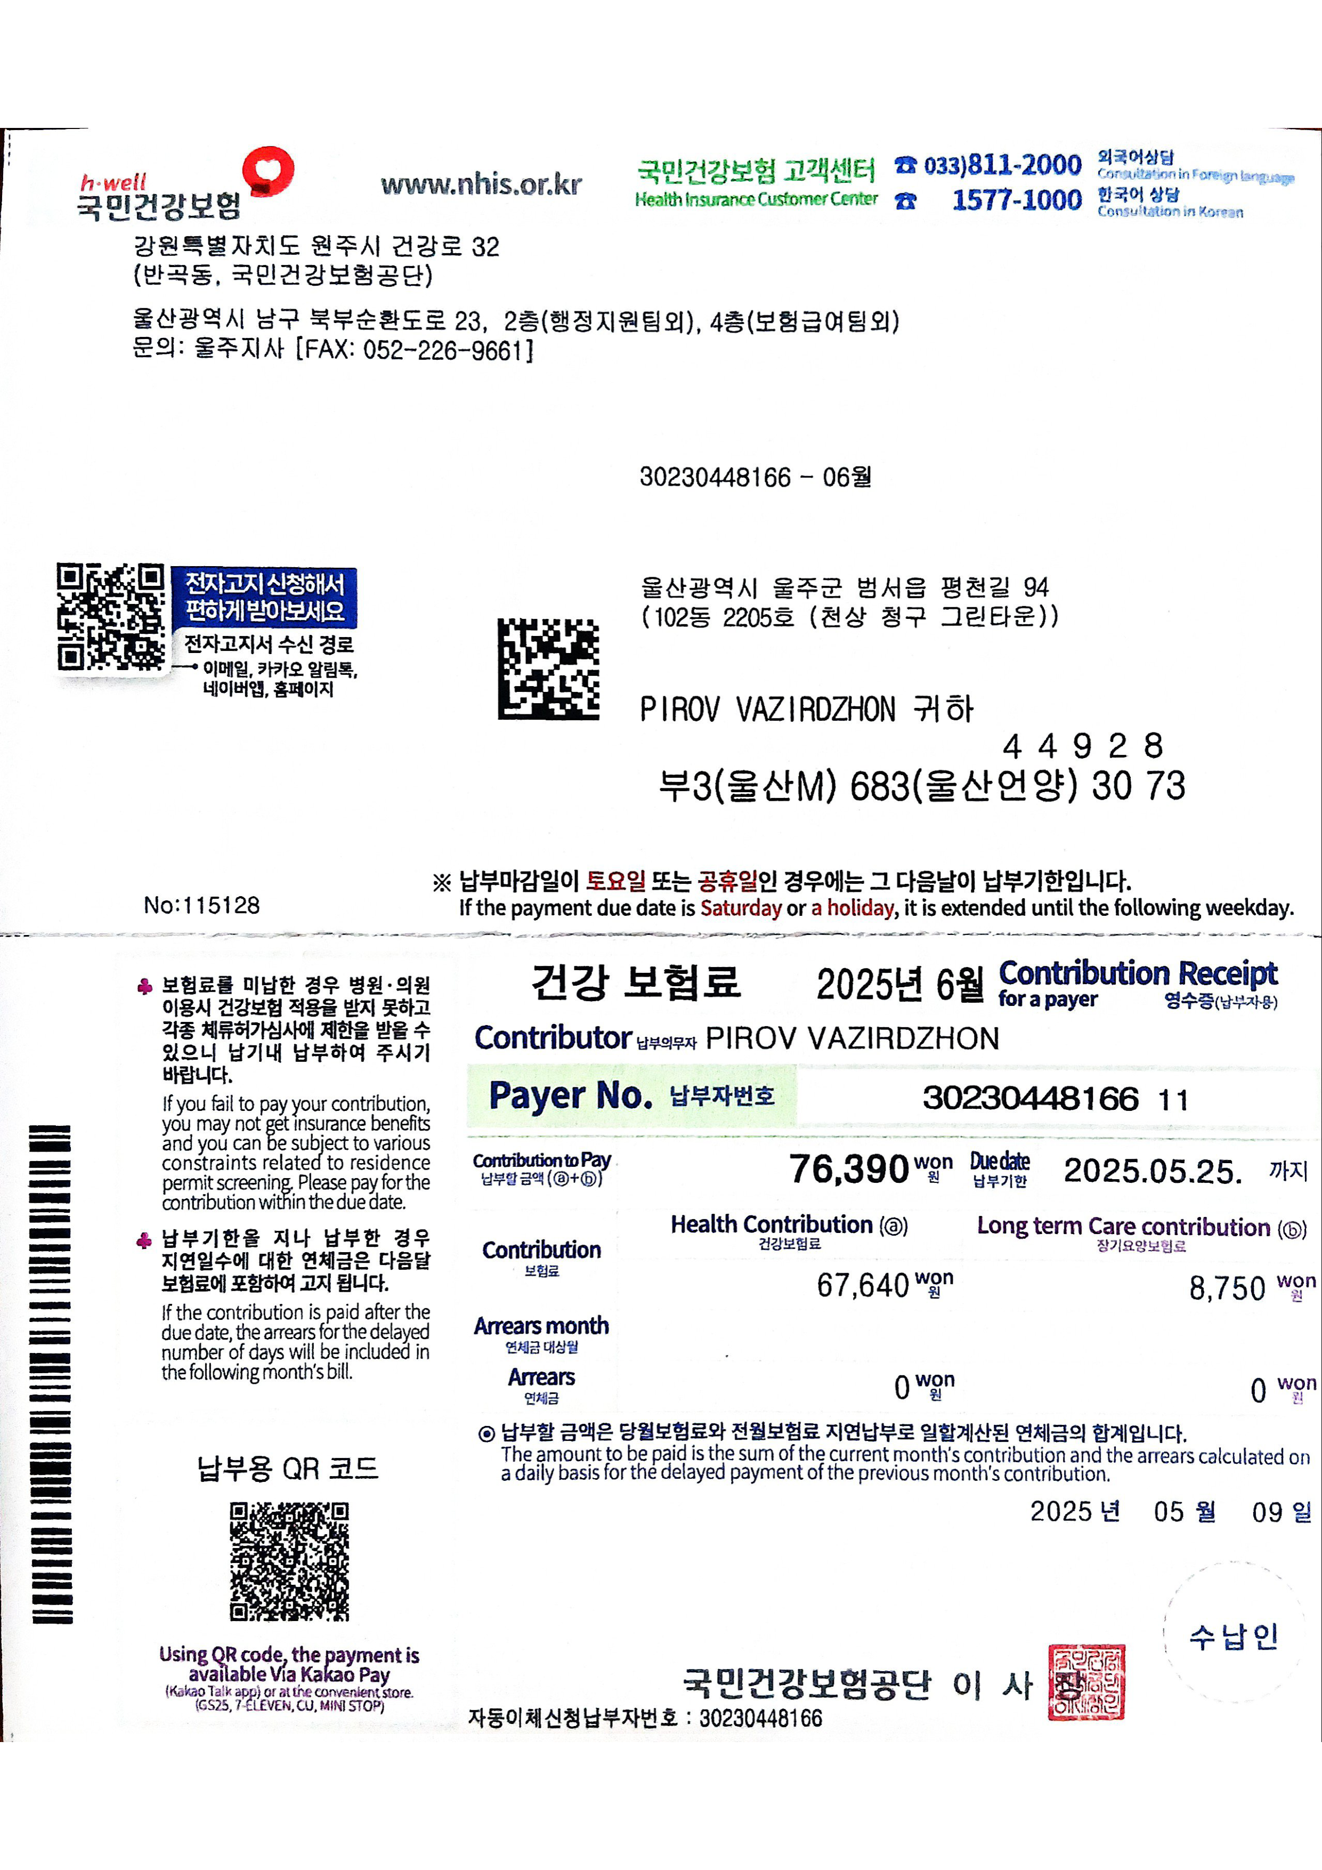


ZIZPIROV VAZIRDZHON
Enter a note (up to 20 characters) #
Transaction date an 2025.05.24 15:30
d time
Transaction classific 지급 | 즉 시 이체
ation
Transaction amount 76,390KRW
Transfer amount 76,390KRW
Fees OKRW
Balance after transa
ction
Show recipient's ban PIROV VAZIRDZHON
kbook
71Z2IPIROV VAZIRDZHON
Show my bankbook

