Introduction to MarkDoc (heading 1)

Using Markdown (heading 2)
Writing with markdown syntax allows you to add text and graphs to smcl logfile and export it to a editable document format. I will demonstrate the process by using the Auto.dta dataset.

Get started with MarkDoc (heading 3)
I will open the dataset, list a few observations, and export a graph. Then I will export the logfile to Microsoft Office docx format.

Even smaller bolding
italics
one underscore is probably also italics.
. sysuse auto, clear

. histogram price
(bin=8, start=3291, width=1576.875)

. graph export graph.png, width(400) replace
(file graph.png written in PNG format)

You use two stars to include only output, and three stars to include only the command. So two stars plus "quietly" gets you nothing. You can also add numbers inline, but it's not quite as smooth as in R Markdown.
Because you put it on the next command line to say the mean of Price variable is 6165.26 and SD is 2949.50

Adding a graph or image in the report

Adding a graph using Markdown
In order to add a graph using Markdown, I export the graph in PNG format. You can explain the graph in the "brackets" and define the file path in parentheses
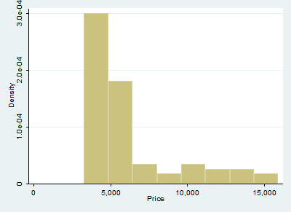
You can also export to a ton of different file types. (Thanks, pandoc!) So that's actuall y kind of cool.
Let's try and add math at the bottom.

