# Introduction to MarkDoc (heading 1)

## Using Markdown (heading 2)

Writing with **markdown** syntax allows you to add text and graphs to *smcl* logfile and export it to a editable document format. I will demonstrate the process by using the **Auto.dta** dataset.

### Get started with MarkDoc (heading 3)

I will open the dataset, list a few observations, and export a graph. Then I will export the logfile to Microsoft Office docx format.

#### Even smaller bolding

*italics*

*one underscore* is probably *also* italics.

. sysuse auto, clear  
   
 . histogram price  
 (bin=8, start=3291, width=1576.875)  
   
   
 . graph export graph.png, width(400) replace  
 (note: file graph.png not found)  
 (file graph.png written in PNG format)

You use two stars to include only output, and three stars to include only the command. So two stars plus “quietly” gets you nothing. You can also add numbers inline, but it’s not quite as smooth as in R Markdown.

TRY TO GET 1:both results & code

. summ price  
   
 Variable | Obs Mean Std. Dev. Min Max  
 -------------+--------------------------------------------------------  
 price | 74 6165.257 2949.496 3291 15906

2: results only

Variable | Obs Mean Std. Dev. Min Max  
 -------------+--------------------------------------------------------  
 price | 74 6165.257 2949.496 3291 15906

3: code only

. summ price

4: neither

The mean of Price variable is 6165.26 and SD is 2949.50

# Adding a graph or image in the report

## Adding a graph using Markdown

In order to add a graph using Markdown, I export the graph in PNG format. You can explain the graph in the “brackets” and define the file path in parentheses

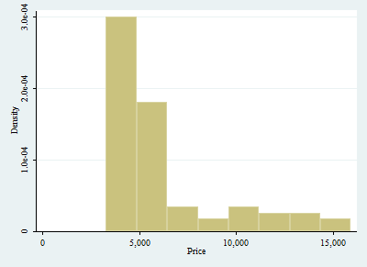[h]

You can also export to a ton of different file types. (Thanks, pandoc!) So that’s actuall y kind of cool.

Let’s try and add math at the bottom. $y_{i}=α+β_{1}*X_{i}$