GITNOS API LOAD TESTING USING LOCUST:
LOCUST:
Locust is an open source load testing tool which can be used to swarm the system with millions of simultaneous users and can be easily imported in python.
GOAL:
To load the Gitnos API till failure.
- Initial number of users and the users added simultaneously to push the API till failure.
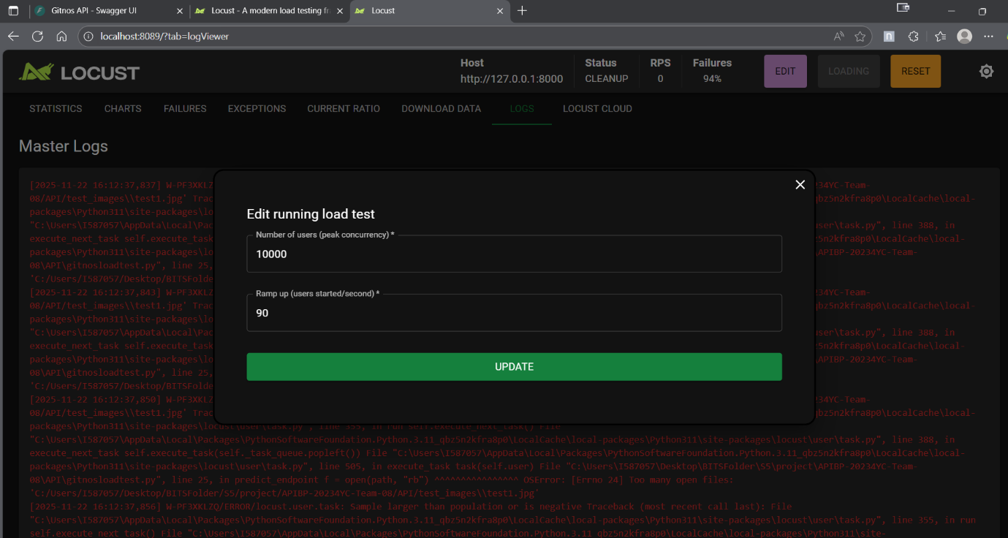
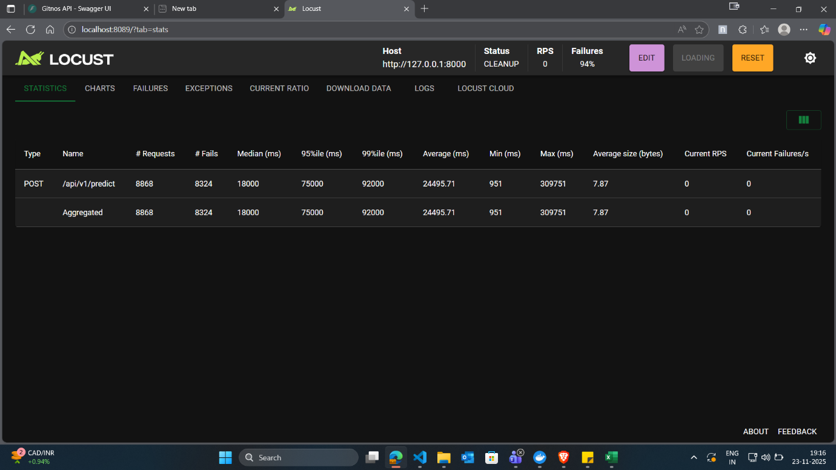
- Statistics of the failure:
- Failure Reason:

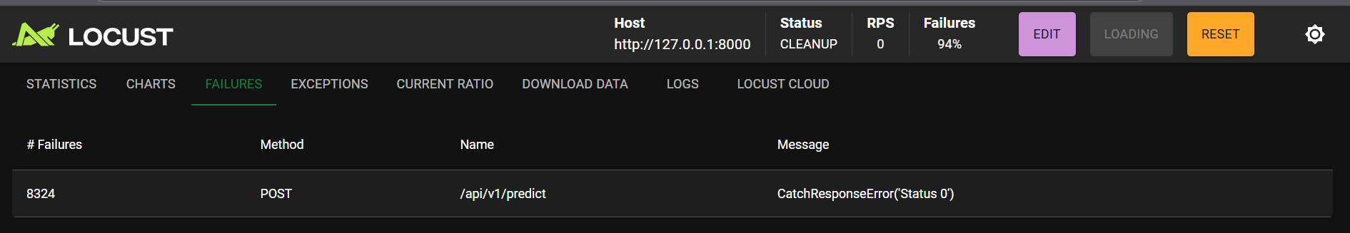

Since the http response code is ‘0’, and since http does not have a 0 response code as standard, this implies that the connection failed before the response was received.

- Logs of the load testing

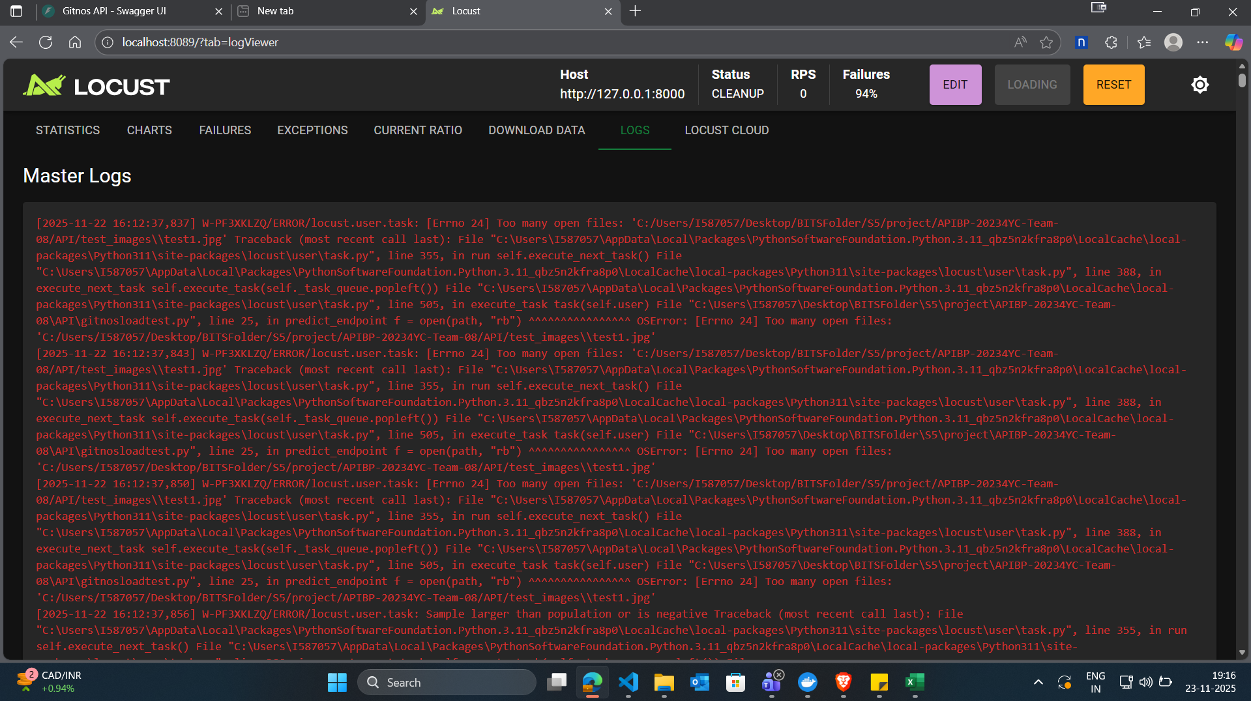

- Statistics of RPS and Response time:
