

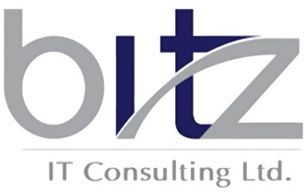
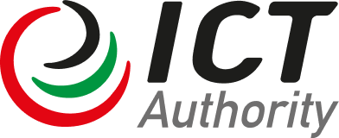
The ICT Authority is a State Corporation under the State Corporations Act 446

www.icta.go.ke

© ICTA 2025 – All Rights Reserved
Date: December 15, 2025

REPORT PREPARED BY:
DRAFT PRELIMINARY Report

Assessment Study for E-Service Delivery, Manual Records, and Governance Requirements

Table of Contents
1. EXECUTIVE SUMMAdRY 1

- EXECUTIVE SUMMAdRY

