ICT AUTHORITY – Service Delivery

Cover Page
- Ministry/Department/Agency (MDA): Ministry of Information, Communications and the Digital Economy
- Department: ICT Authority (ICTA)
- Process Name: Government ICT Project Implementation and Digital Infrastructure Management
- Document Version: 2.1
- Date: 2026-03-04
- Classification: Official

Executive Summary
The ICT Authority (ICTA) is the principal implementing agency responsible for coordinating, implementing, and standardizing ICT initiatives across the Government of Kenya.
Operating under the State Department for ICT and the Digital Economy, ICTA ensures that government ICT investments align with the Government Enterprise Architecture (GEA), national digital standards, and cybersecurity frameworks.
ICTA provides centralized capabilities including: - ICT project oversight and technical approvals - Government digital infrastructure implementation - Interoperability and shared platforms - Government cloud and data center management - Digital standards and architecture enforcement
Currently, ICT projects are often implemented at the MDA level with varying degrees of coordination, resulting in fragmented systems and duplication of infrastructure.
The future state introduces a platform-based government architecture where ICTA operates shared national digital infrastructure including: - Government Cloud - KeSEL / X-Road Interoperability Layer - National PKI - Digital identity integrations - Shared digital services platforms
This transition enables whole-of-government interoperability, improved security, and efficient digital service delivery.

1. AS-IS Process Flowchart (BPMN 2.0)
Current State visualization of ICT project approval and implementation.
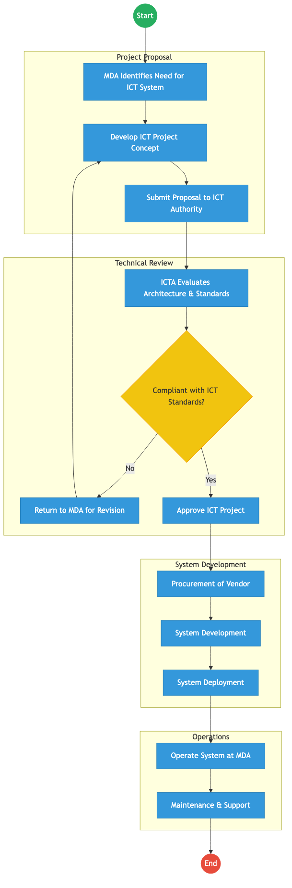
AS_IS Diagram

Process Overview

Process Name
Government ICT Project Governance and Implementation

Service Category
- G2G (Government to Government)

Scope
- In Scope: Review and approval of government ICT projects; Enforcement of Government Enterprise Architecture (GEA); Implementation of national digital infrastructure; ICT standards development and compliance; Coordination of ICT programs across MDAs.
- Out of Scope: Sector-specific service delivery systems operated by MDAs.

Triggers
- A ministry, department, or agency proposes a new ICT system or digital platform.

End States
- Successful: ICT system approved and deployed; System complies with national ICT standards; Government digital infrastructure expanded.

Policy Context
- ICT Authority Act (2013); Kenya Digital Economy Blueprint; Government Enterprise Architecture (GEA) Framework; Data Protection Act (2019); National Cybersecurity Strategy.

Detailed Process (AS-IS)
Step | Role | Action | Tool/System | Notes
1 | MDA | Identifies need for ICT system | Internal
2 | MDA | Develops project concept and submits to ICT Authority | Project Proposal
3 | ICT Authority | Reviews architecture and compliance with standards | GEA Framework
4 | ICT Authority | Approves or rejects project | ICTA Governance
5 | MDA / Vendor | Procures vendor and develops system | Vendor Systems
6 | MDA | Deploys and operates system | Local Infrastructure

Pain Points & Opportunities

Pain Points
- Fragmented Digital Systems: Multiple government systems operate independently without integration.
- Duplicated Infrastructure: Different agencies procure similar ICT infrastructure.
- Limited Interoperability: Data exchange between MDAs is often manual or through batch exports.
- Procurement Complexity: Long procurement cycles slow the deployment of digital services.

Opportunities
- Shared Government Platforms: Centralized infrastructure including government cloud and national interoperability platforms.
- Secure Interoperability: Adoption of KeSEL / X-Road for secure data exchange.
- Digital Trust Infrastructure: Integration with National PKI and digital identity frameworks.
- Platform-Based Service Delivery: Reusable government services such as payments, notifications, identity verification, and registries.

2. TO-BE Process Flowchart (BPMN 2.0)
Future State visualization (Shared Digital Infrastructure & Platform Government).
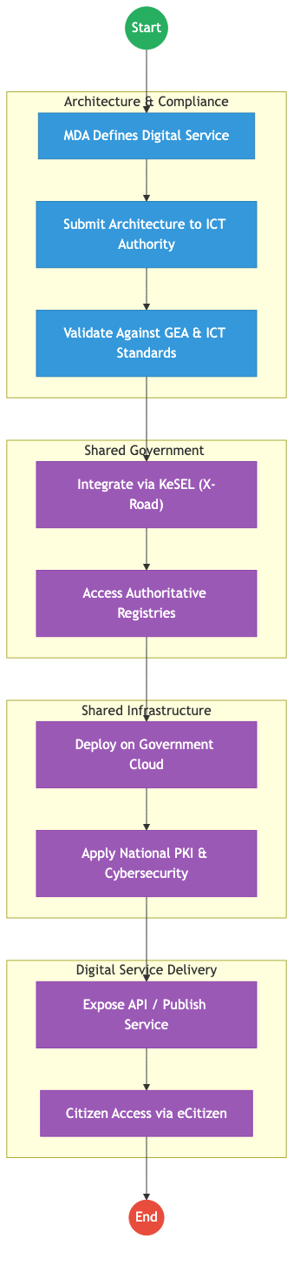
TO_BE Diagram

Future State Process (TO-BE)

Narrative
TO-BE Process: Platform-Based Government ICT Implementation
ICT Authority transitions from merely reviewing ICT projects to operating shared digital government platforms.
Design Principles: - Architecture First: All ICT initiatives must align with Government Enterprise Architecture (GEA) before implementation. - Shared Platforms: Instead of each agency building separate systems, MDAs use shared government platforms and APIs. - Interoperability by Default: Systems exchange data through KeSEL (X-Road) ensuring standardized integration. - Cloud-First Government: All government digital services are deployed on Government Cloud Infrastructure. - Secure Digital Trust: Systems utilize National PKI, identity verification services, and cybersecurity frameworks.

Optimized Steps (Digital)
Step | Actor | Action | System
1 | MDA | Designs digital service aligned with GEA | Architecture Portal
2 | ICT Authority | Reviews architecture and integration | GEA Compliance System
3 | System | Integrates with national registries via interoperability layer | KeSEL Bridge
4 | Government Cloud | Hosts digital service platform | National Data Center
5 | Citizen/Business | Accesses service through digital government portals | eCitizen Platform

References
- ICT Authority Act (2013)
- Kenya Digital Economy Blueprint
- Government Enterprise Architecture Framework
- Data Protection Act (2019)
- National Cybersecurity Strategy

ICT AND DIGITAL ECONOMY – Service Delivery

Cover Page
- Ministry/Department/Agency (MDA): Ministry of Information, Communications and the Digital Economy
- Department: State Department for ICT and the Digital Economy
- Process Name: Digital Government Infrastructure and ICT Policy Coordination
- Document Version: 2.1
- Date: 2026-03-04
- Classification: Official

Executive Summary
The State Department for ICT and the Digital Economy is the national policy authority responsible for the development, coordination, and governance of Kenya’s digital transformation agenda.
It provides strategic leadership for the development of digital public infrastructure, ICT policy frameworks, digital economy growth, and government technology standards.
The department coordinates multiple agencies including the ICT Authority, Communications Authority of Kenya, and Konza Technopolis Development Authority to ensure that government services are delivered through secure, interoperable, and citizen-centric digital platforms.
Under the Kenya Digital Economy Blueprint, the department is responsible for enabling digital government services, national connectivity infrastructure, innovation ecosystems, digital skills development, and cybersecurity frameworks.
The transition to a Digital Shared Services Architecture Platform (DSAP) and whole-of-government interoperability platforms (such as KeSEL / X-Road) will allow ministries, departments, and agencies (MDAs) to exchange data securely and provide seamless digital services to citizens and businesses.

1. AS-IS Process Flowchart (BPMN 2.0)
Current State visualization of ICT governance and digital service implementation.
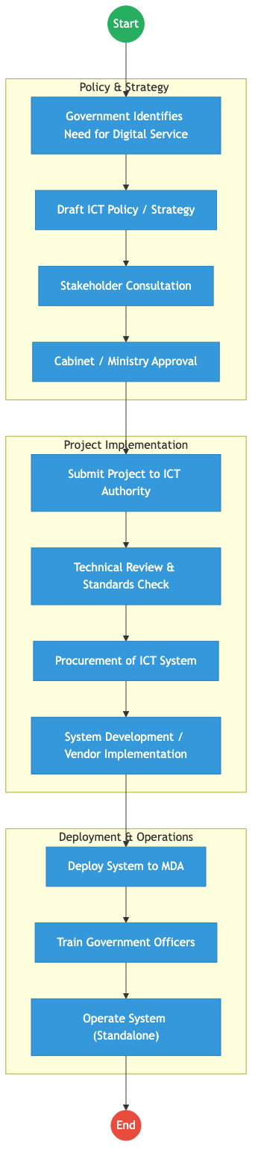
AS_IS Diagram

Process Overview

Process Name
Digital Government Policy Coordination and ICT Infrastructure Enablement

Service Category
- G2G (Government to Government)
- G2C (Government to Citizen – indirect through digital platforms)

Scope
- In Scope: National ICT policy development; Digital government architecture and standards; Coordination of ICT projects across MDAs; Development of digital public infrastructure; Cybersecurity governance and digital trust frameworks.
- Out of Scope: Sector-specific service delivery (handled by respective MDAs).

Triggers
- Government need for digital transformation or ICT-enabled service delivery.

End States
- Successful: ICT policy approved; Digital platform or infrastructure deployed; Government service digitized and operational.

Policy Context
- Constitution of Kenya (2010); Kenya Digital Economy Blueprint; Data Protection Act (2019); National ICT Policy; Kenya National Cybersecurity Strategy.

Detailed Process (AS-IS)
Step | Role | Action | Tool/System | Notes
1 | MDA | Identifies need for digital service or ICT project | Internal
2 | State Department ICT | Develops ICT policy, strategy, or framework | Policy Documents
3 | ICT Authority | Reviews proposed ICT project for standards compliance | GEA / ICT Standards
4 | MDA / Vendor | Procures and develops ICT system | Vendor Systems
5 | MDA | Deploys and operates ICT system | Standalone Systems

Pain Points & Opportunities

Pain Points
- Fragmented Systems: Many MDAs develop standalone systems that do not integrate with other government platforms.
- Duplication of Infrastructure: Multiple agencies build similar systems without shared platforms.
- Limited Interoperability: Data exchange between MDAs is often manual or ad-hoc.
- Inconsistent Standards: Some ICT implementations bypass government enterprise architecture frameworks.

Opportunities
- Whole-of-Government Interoperability: Adoption of KeSEL / X-Road architecture for secure data exchange.
- Shared Digital Infrastructure: Government cloud, national data centers, and shared digital platforms.
- Digital Identity Integration: Use of Maisha Namba / National Digital ID across government services.
- Digital Trust Frameworks: Use of National PKI and verifiable credentials for digital services.

2. TO-BE Process Flowchart (BPMN 2.0)
Future State visualization (Kenya DSAP Architecture – Whole of Government Digital Platform).
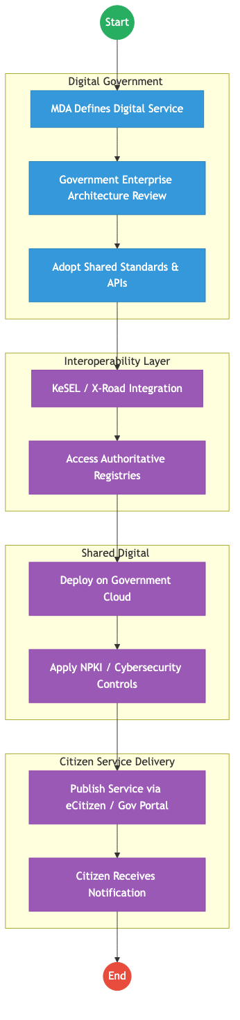
TO_BE Diagram

Future State Process (TO-BE)

Narrative
TO-BE Process: Integrated Digital Government Service Delivery
The State Department for ICT and the Digital Economy will transition government ICT implementation to a platform-based digital government architecture.
Design Principles: - Whole-of-Government Architecture: All ICT projects must comply with Government Enterprise Architecture (GEA) standards before implementation. - Shared Infrastructure: Digital services are deployed on government cloud and shared platforms, reducing duplication across MDAs. - Secure Data Exchange: Government systems exchange data through KeSEL / X-Road, ensuring interoperability between authoritative registries. - Digital Trust: All transactions use National PKI, digital signatures, and secure identity verification. - Citizen-Centric Service Delivery: Services are published through eCitizen or government digital portals, enabling citizens to access services digitally without visiting physical offices.

Optimized Steps (Digital)
Step | Actor | Action | System
1 | MDA | Designs digital service aligned with GEA | Digital Architecture Framework
2 | ICT Authority | Validates architecture and integration requirements | GEA Compliance Portal
3 | System | Integrates with authoritative registries via X-Road | KeSEL Bridge
4 | Government Cloud | Hosts the digital service platform | Gov Cloud Infrastructure
5 | Citizen | Accesses service digitally via portal or mobile device | eCitizen Platform

References
- Kenya Digital Economy Blueprint
- National ICT Policy
- Data Protection Act (2019)
- Government Enterprise Architecture (GEA) Framework
- ICT Authority Standards and Guidelines

