ICT AND DIGITAL ECONOMY – Service Delivery

Cover Page
- Ministry/Department/Agency (MDA): Ministry of Information, Communications and the Digital Economy
- Department: State Department for ICT and the Digital Economy
- Process Name: Digital Government Infrastructure and ICT Policy Coordination
- Document Version: 2.1
- Date: 2026-03-04
- Classification: Official

Executive Summary
The State Department for ICT and the Digital Economy is the national policy authority responsible for the development, coordination, and governance of Kenya’s digital transformation agenda.
It provides strategic leadership for the development of digital public infrastructure, ICT policy frameworks, digital economy growth, and government technology standards.
The department coordinates multiple agencies including the ICT Authority, Communications Authority of Kenya, and Konza Technopolis Development Authority to ensure that government services are delivered through secure, interoperable, and citizen-centric digital platforms.
Under the Kenya Digital Economy Blueprint, the department is responsible for enabling digital government services, national connectivity infrastructure, innovation ecosystems, digital skills development, and cybersecurity frameworks.
The transition to a Digital Shared Services Architecture Platform (DSAP) and whole-of-government interoperability platforms (such as KeSEL / X-Road) will allow ministries, departments, and agencies (MDAs) to exchange data securely and provide seamless digital services to citizens and businesses.

1. AS-IS Process Flowchart (BPMN 2.0)
Current State visualization of ICT governance and digital service implementation.
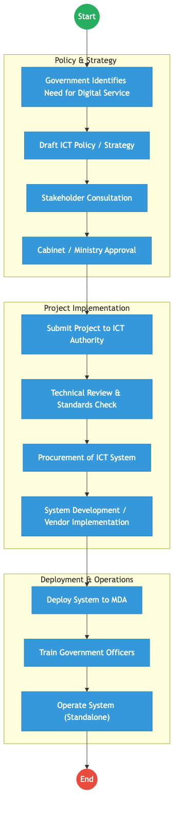
AS_IS Diagram

Process Overview

Process Name
Digital Government Policy Coordination and ICT Infrastructure Enablement

Service Category
- G2G (Government to Government)
- G2C (Government to Citizen – indirect through digital platforms)

Scope
- In Scope: National ICT policy development; Digital government architecture and standards; Coordination of ICT projects across MDAs; Development of digital public infrastructure; Cybersecurity governance and digital trust frameworks.
- Out of Scope: Sector-specific service delivery (handled by respective MDAs).

Triggers
- Government need for digital transformation or ICT-enabled service delivery.

End States
- Successful: ICT policy approved; Digital platform or infrastructure deployed; Government service digitized and operational.

Policy Context
- Constitution of Kenya (2010); Kenya Digital Economy Blueprint; Data Protection Act (2019); National ICT Policy; Kenya National Cybersecurity Strategy.

Detailed Process (AS-IS)
Step | Role | Action | Tool/System | Notes
1 | MDA | Identifies need for digital service or ICT project | Internal
2 | State Department ICT | Develops ICT policy, strategy, or framework | Policy Documents
3 | ICT Authority | Reviews proposed ICT project for standards compliance | GEA / ICT Standards
4 | MDA / Vendor | Procures and develops ICT system | Vendor Systems
5 | MDA | Deploys and operates ICT system | Standalone Systems

Pain Points & Opportunities

Pain Points
- Fragmented Systems: Many MDAs develop standalone systems that do not integrate with other government platforms.
- Duplication of Infrastructure: Multiple agencies build similar systems without shared platforms.
- Limited Interoperability: Data exchange between MDAs is often manual or ad-hoc.
- Inconsistent Standards: Some ICT implementations bypass government enterprise architecture frameworks.

Opportunities
- Whole-of-Government Interoperability: Adoption of KeSEL / X-Road architecture for secure data exchange.
- Shared Digital Infrastructure: Government cloud, national data centers, and shared digital platforms.
- Digital Identity Integration: Use of Maisha Namba / National Digital ID across government services.
- Digital Trust Frameworks: Use of National PKI and verifiable credentials for digital services.

2. TO-BE Process Flowchart (BPMN 2.0)
Future State visualization (Kenya DSAP Architecture – Whole of Government Digital Platform).
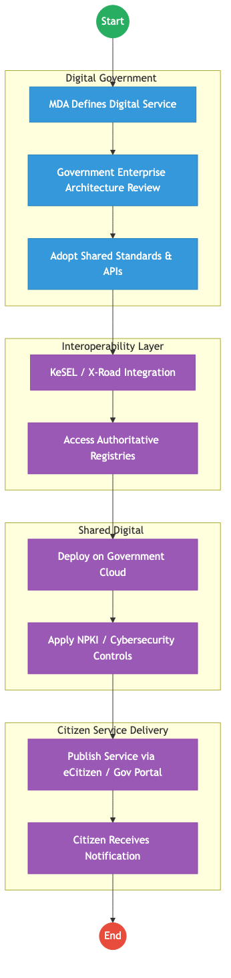
TO_BE Diagram

Future State Process (TO-BE)

Narrative
TO-BE Process: Integrated Digital Government Service Delivery
The State Department for ICT and the Digital Economy will transition government ICT implementation to a platform-based digital government architecture.
Design Principles: - Whole-of-Government Architecture: All ICT projects must comply with Government Enterprise Architecture (GEA) standards before implementation. - Shared Infrastructure: Digital services are deployed on government cloud and shared platforms, reducing duplication across MDAs. - Secure Data Exchange: Government systems exchange data through KeSEL / X-Road, ensuring interoperability between authoritative registries. - Digital Trust: All transactions use National PKI, digital signatures, and secure identity verification. - Citizen-Centric Service Delivery: Services are published through eCitizen or government digital portals, enabling citizens to access services digitally without visiting physical offices.

Optimized Steps (Digital)
Step | Actor | Action | System
1 | MDA | Designs digital service aligned with GEA | Digital Architecture Framework
2 | ICT Authority | Validates architecture and integration requirements | GEA Compliance Portal
3 | System | Integrates with authoritative registries via X-Road | KeSEL Bridge
4 | Government Cloud | Hosts the digital service platform | Gov Cloud Infrastructure
5 | Citizen | Accesses service digitally via portal or mobile device | eCitizen Platform

References
- Kenya Digital Economy Blueprint
- National ICT Policy
- Data Protection Act (2019)
- Government Enterprise Architecture (GEA) Framework
- ICT Authority Standards and Guidelines

