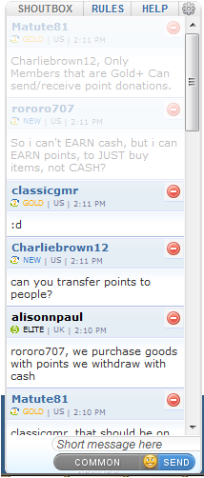

Home

Forum

News

IRC

USER CP

LOGIN/REGISTER

SEARCH





© BIZKIT551



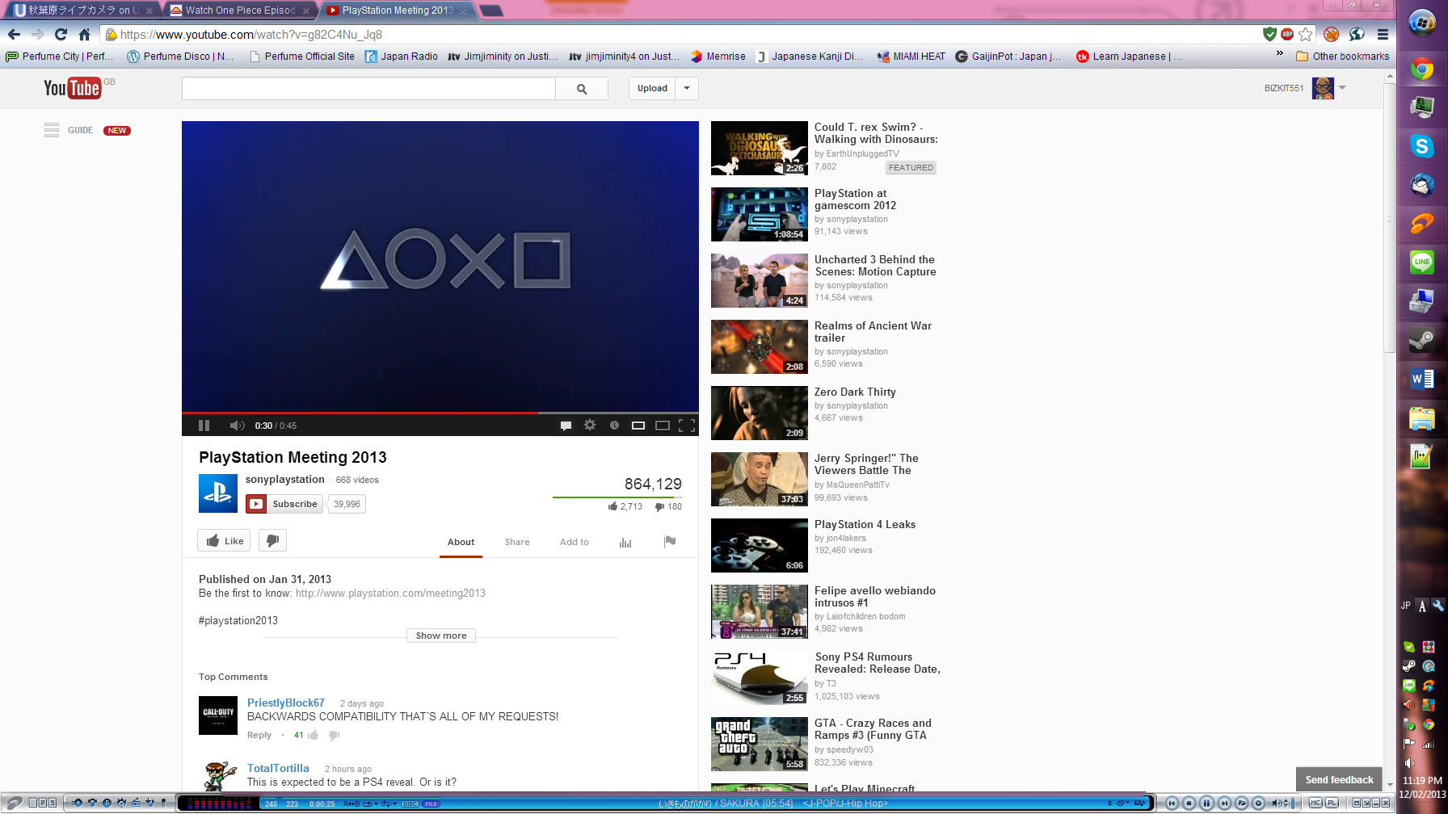

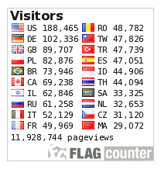

CLOSE

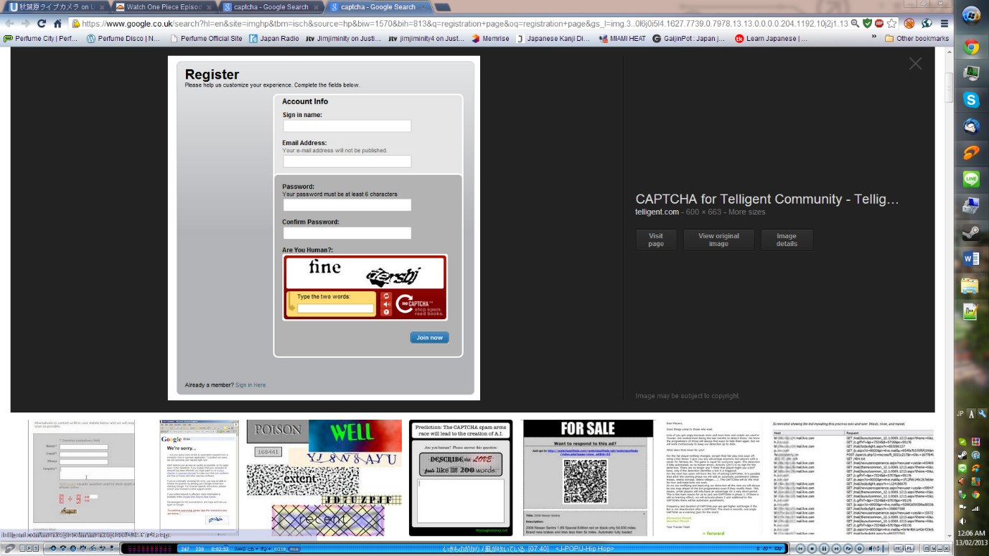

REGISTER

COUNTRY:

EMAIL:

RE-TYPE PASSWORD:

PASSWORD:

USERNAME:

Home

Forum

News

IRC

USER CP

LOGIN/REGISTER

LOGIN

PASSWORD:

USERNAME:

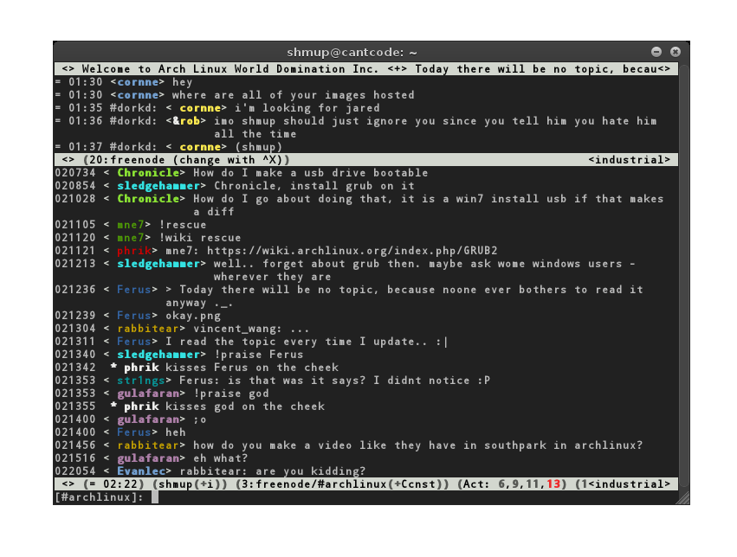

Home

Forum

News

IRC

USER CP

LOGIN/REGISTER