Exercise 3: 1) docker run -d dockersamples/static-site

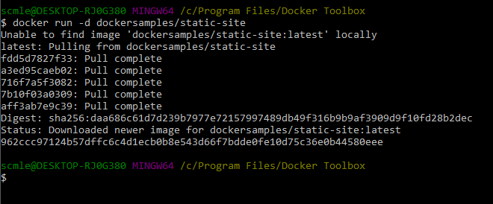

Exercise 3: 2) access container ID, docker ps

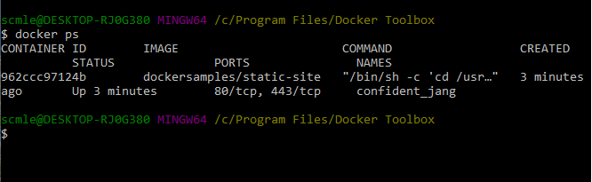

Exercise 3: 3) Stop and remove dockersamples (ID 962ccc97124b)

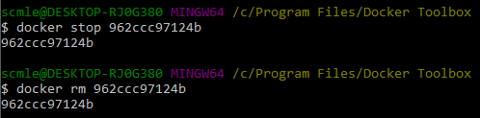

Execise 3: 4) re-run and add command to publish the ports

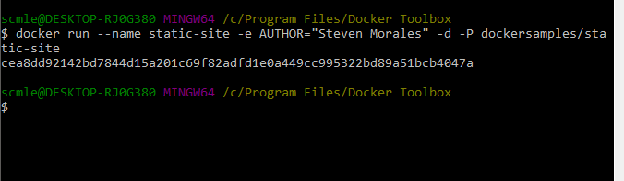

Exercise 3: 5) view the published ports for static-site

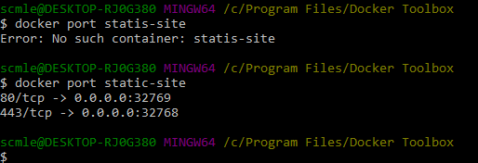

Exercise 3: 6) docker- machine IP address call

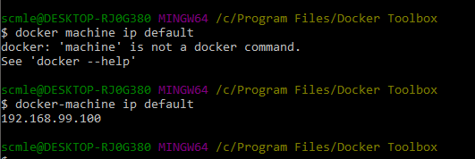

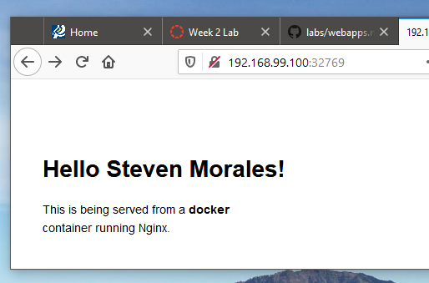 YYAYY!!

Excerise 3: 7) Custom port mapping on second server

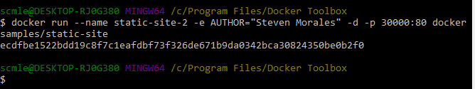

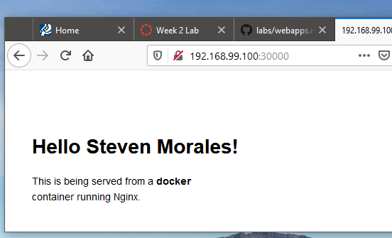 YYAYY!

Exercise 3: 8) Ending the container process static-site

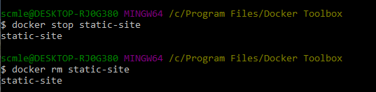

Exercise 3: 9) Ending process Static-site-2 with force-stop removal

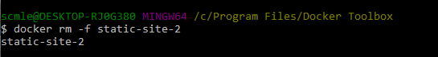

Excersice 3: 10) Check to make sure the container are gone

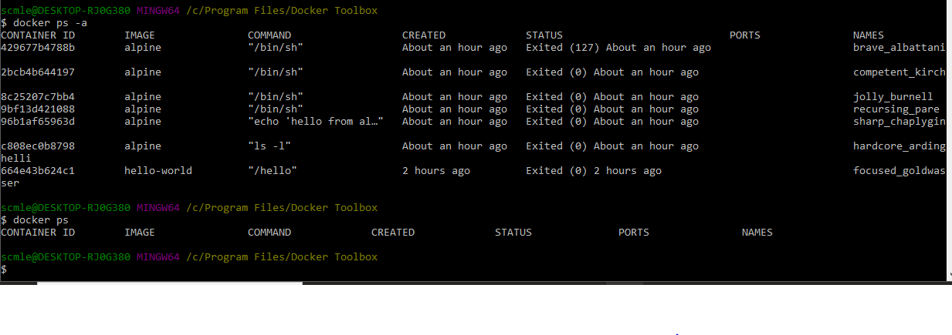

\*\*\*\*\*\* Exercise 3: Docker Images \*\*\*\*\*\*\*\*\*\*\*\*\*

Exercise 3: 11) docker images cmd

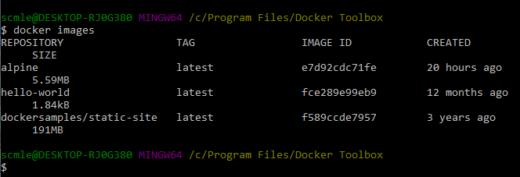

Exercise 3: 12) pull Ubuntu:12.04

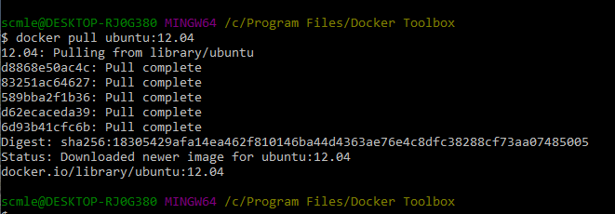

Exercise 3: 13) pull ubuntu[:latest]

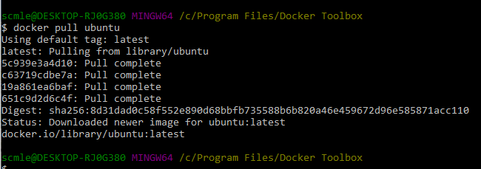

Exercise 3: 14) Docker search without parameter

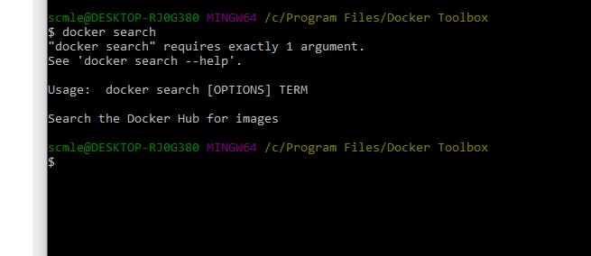

Exercise 3: 15) docker build -t shortrib/myfirstapp .

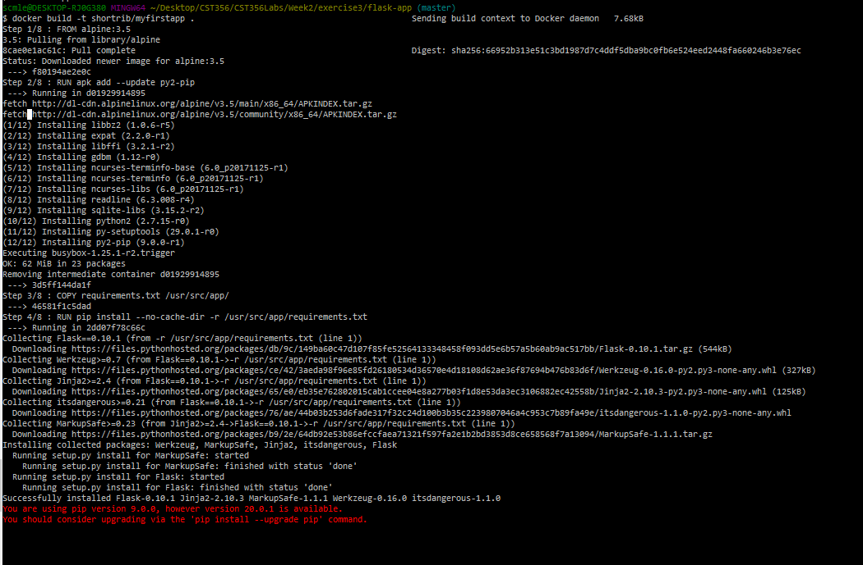

Exercise 3: 16) docker run -p 8888:5000 --name myfirstapp shortrib/myfirstapp

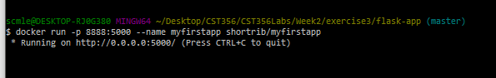

Exercise 3: 17 ) ( went through all the cat gifs :P )

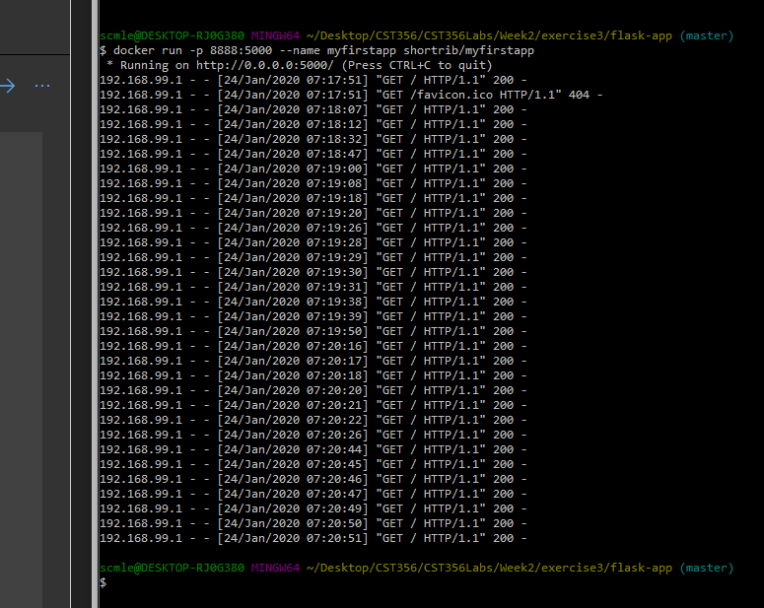

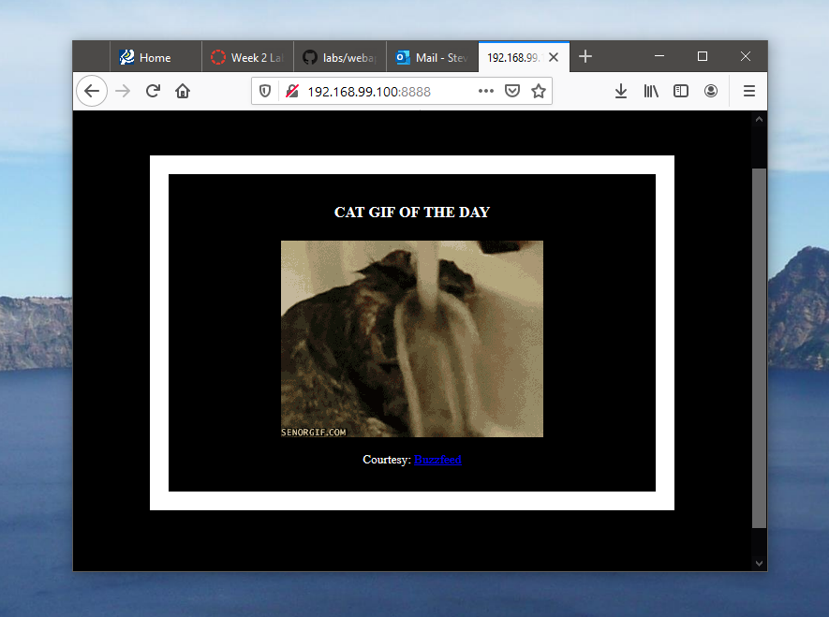

Exercise 3: 18) Docker login

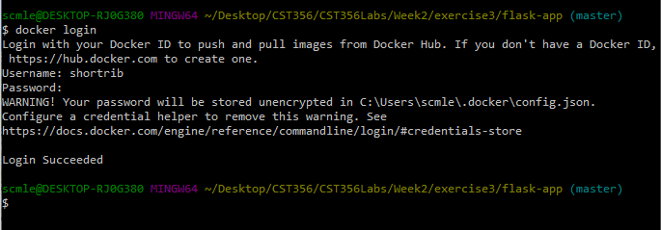

Exercise 3: 19) Image push to docker cloud

