UNIVERSITY OF INFORMATION AND TECHNOLOGY

VNU-HCM

## Department: Information System

Technical Report:

Project:

simple games

INSTRUCTOR: Trần minh triết

course: object oriented programming for windows

15520270-nguyễn trọng huấn

([15520270@gm.uit.edu.vn](mailto:15520270@gm.uit.edu.vn) -01666937492)

15520079-Phan huy Cường

([15520079@gm.uit.edu.vn](mailto:15520079@gm.uit.edu.vn) -0978738325)

Table of contents

List of figures Page

Introduction 2  
I.System Analysis and Design 3

1.1 UML Class diagram for game Caro 3

1.2 UML Class diagram for game FlappyBird 4

1.3 UML Class diagram for game HuntingSnake 5

1.4 UML Class diagram for game PingPong 6

II.Graphics User Interface(GUI) 6

1. MainForm 6

2. GameCaroForm 7

3. GameFlappyBirdForm 8

4. GameHuntingSnakeForm 9

5. GamePingPongForm 9

Introduction:

**1/Overview:**

- This app have 4 simple games: Caro, Flappy Bird, Hunting Snake and PingPong game

- Game caro have 3 classes:

+ class CaroChess.

+ class ChessBoard.

+ class ChessPieces.

- Game flappy bird have 5 classes:

+ class Bird.

+ class Game.

+ class GameObject.

+ class Pipe.

+ class ScrollBackgroud.

- Game Hunting Snake have 2 classes:

+ class Food.

+ class Snake.

- Game PingPong have 4 classes

+ class CBong

+ class CNguoiChoi1,class CNguoiChoi2

+ class CSanDau

**2/Function:**

+ class CaroChess: control the game, this class have a lot of function : playchess, start game : vs com , vs player, undo, redo , check winner, create

AI to play with player…

+ class ChessBoard : create chess board.

+ class ChessPieces: create chess pices

+ class Bird : create bird , check die().

+ class Game: control the game: update, count, check collision, add Pipe into form,draw bird , background into form

+ class GameObject.

+ class Pipe: create pipe

+ class ScrollBackgroud:create background

+ class Food:create food.

+ class Snake:create and update snake.

+ class CSanDau: create draw game PingPong

I.System Analysis and Design:

**1.1.UML Class diagram for game Caro:**

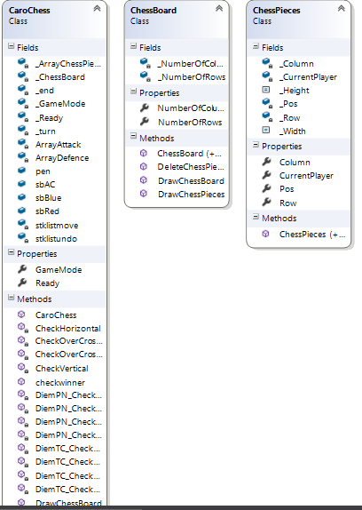

**1.2.UML Class diagram for game FlappyBird:**

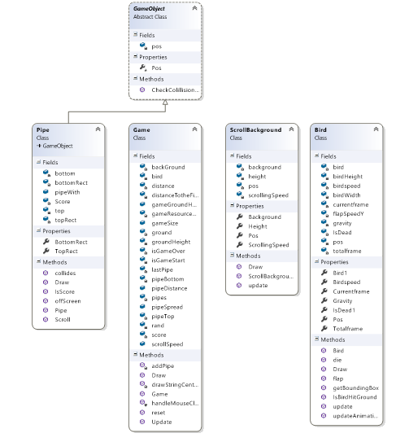

**1.3.UML Class diagram for game Hunting Snake:**

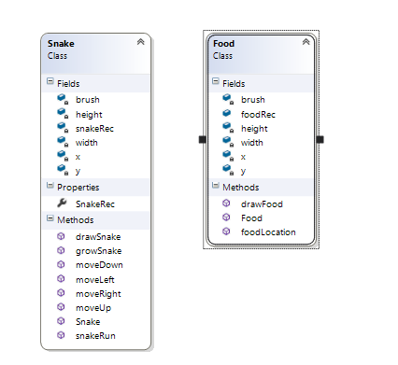

**1.4.UML Class diagram for game Ping Pong:**

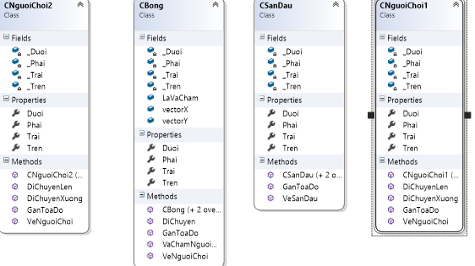

II.Graphics User Interface(GUI):

**1.MainForm:**

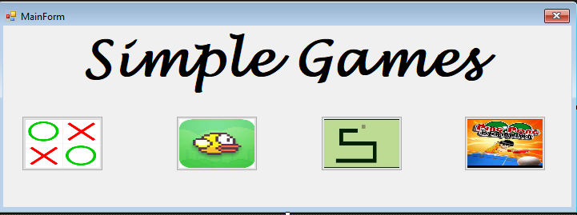

**2.GameCaroForm:**

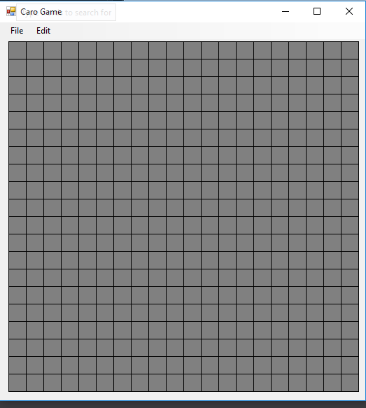

**3.GameFlappyBirdForm:**

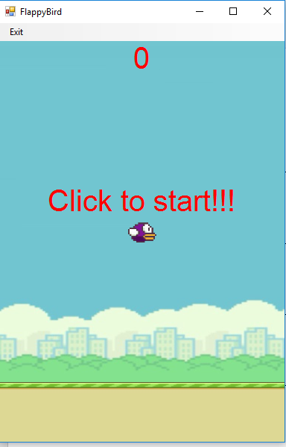

**4.GameHuntingSnake form:**

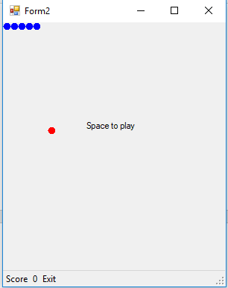

**5. GamePingPongForm:**

