SAP Scripting Studio
Overview and Quick User Guide
SAP Scripting Studio is a desktop application for recording and replaying actions in SAP GUI. It combines step capture, access to saved scripts, and the ability to run them individually or in groups in one interface. It is useful for repetitive tasks that follow the same steps in SAP.
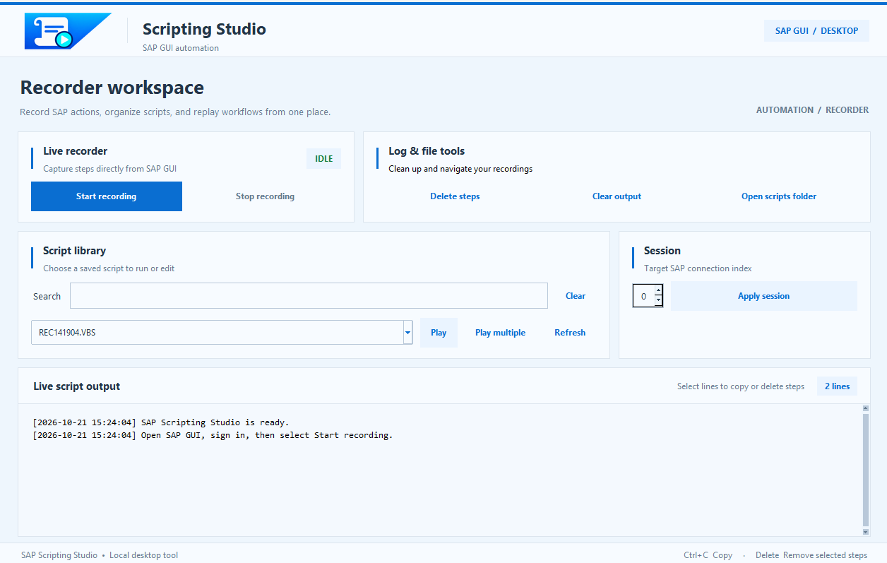
Figure 1. Main window with recording, script library, and log.

Recording and Reviewing Steps
- Live recorder. Start recording begins recording actions in SAP GUI, and Stop recording ends it. The steps are saved to a VBScript (.vbs) file.
- Live script output. Displays the captured lines and application messages. Lines can be selected and copied using Ctrl+C.
- Log & file tools. Delete steps removes selected steps from the current recording; changes are written to the file when recording stops. Clear output clears the display, and Open scripts folder opens the scripts folder.

Finding and Reusing Scripts
Script library provides access to the scripts in the SAP GUI folder. The Search field filters names as you type, without regard to uppercase or lowercase letters. Clear removes the filter, and Refresh updates the file list.
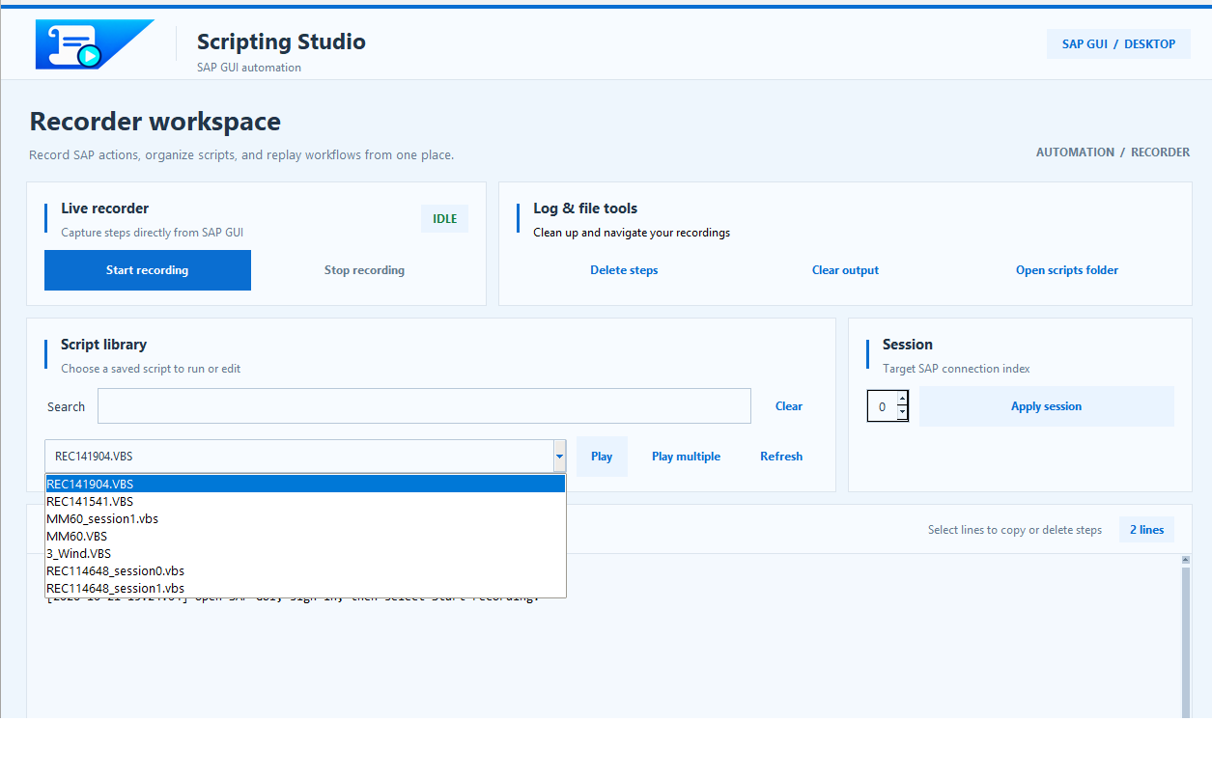
Figure 2. Selecting a saved script from the library.
- Play. Runs the selected script to replay the recorded operations.
- Session and Apply session. Allow you to select a session index from 0 to 5 and create a copy of the script for that session, with the suffix _sessionN.vbs. The script must contain a session-selection instruction that the application recognizes.

Quick Start
- Open SAP GUI and sign in to the desired system.
- Click Start recording and perform the process steps in SAP.
- Review the displayed steps and, if necessary, remove unwanted lines before stopping the recording.
- Click Stop recording, then select the script from the library.
- Check the session and the initial screen in SAP, then click Play.

Running Multiple Scripts
Play multiple opens a window for preparing an execution queue. Find the scripts under Available scripts, select them, and use Add to place them in the Playback queue. Remove takes scripts out of the queue, and Play collection starts execution.
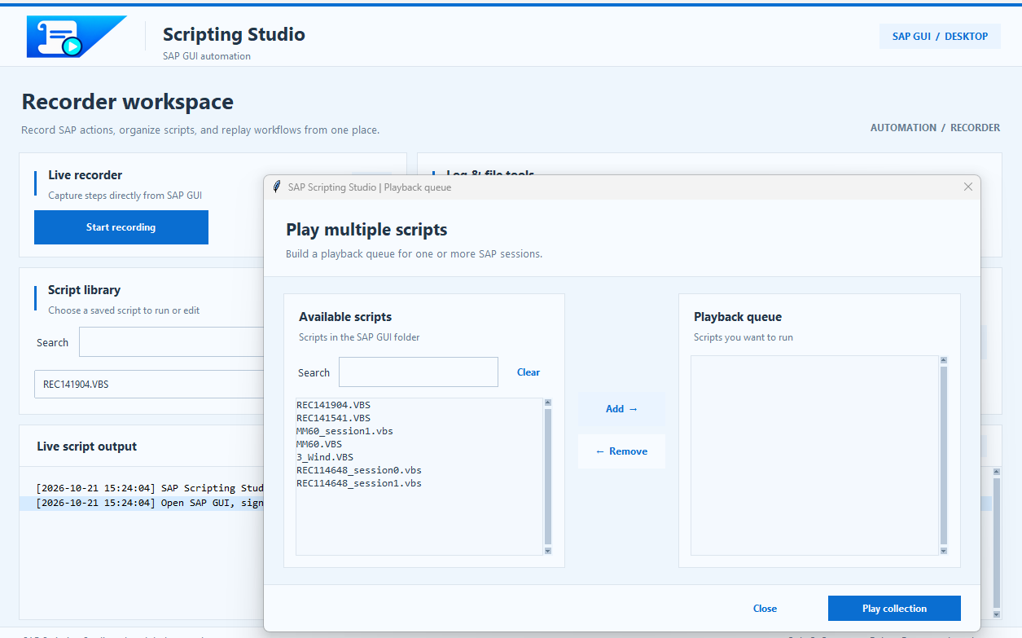
Figure 3. Preparing a collection of scripts for execution.
Scripts assigned to the same session run one after another, in queue order. Groups assigned to different sessions can run in parallel. Those sessions must be available in SAP GUI.

Benefits for Daily Work
- Less repetitive work. Reusing scripts can reduce the time spent on the same sequences of operations.
- More consistent execution. Replaying recorded steps can reduce omissions and manually introduced variations.
- Organization and visibility. Search, the library, and the log make it easier to find scripts and track activity.
- Managing multiple operations. The execution queue and session assignment make it easier to launch several scripts from the same interface.

Requirements for Use
The application requires Windows, SAP GUI, and SAP GUI Scripting to be enabled. Results depend on the script, the data used, and the state of the SAP session; checking a script before reusing it is recommended. Time savings depend on the process and are not automatically measured by the application.

