**Part II. Final Project Topic**

1. Map Topic: My map will explore the story of the August 2016 Louisiana flooding.
2. Objective: to offer an understanding of the events related to the severe flooding phenomena and will make use of time series data. User needs: to understand the unprecedented floods.
3. Data source: precipitation data, river & stream gauge data from government agencies. Possibly elevation data. Possibly population and housing data (helps understand the long term effects within the community long after the water subsides).

**Final Project Topic Description**:

**Title**: South Louisiana Floods

**Subtitle**: *Everyone has a bayou in their backyard, whether they know it or not.*

**Topic/objectives**: This map intends to illustrate the story of the unprecedented flooding of August 2016. It will cover much of southern Louisiana, a region where an understanding of micro-topography and watersheds are critical. Everyone has a bayou in their backyard whether they realize it or not. This project plans to aggregate and integrate time series data sources from precipitation, river and stream gauges, elevation and topography. This helps display events telling the story. In addition, I will search for methods to provide insight into long-term effects on the population such as housing shortage after the water has receded.

**Audience**: Anyone interested in a quantitative geospatial visual chronicling the story of the flooding, particularly those without an understanding of the regional terrain and weather. This user is a novice or average public persona interested in and caring about those affected by the floods. The user will interact with the map to see the time series data presented visually.

**Data Sources:**

* [http://waterdata.usgs.gov/la/nwis/rt](http://www.google.com/url?q=http%3A%2F%2Fwaterdata.usgs.gov%2Fla%2Fnwis%2Frt&sa=D&sntz=1&usg=AFQjCNG5lZoRDnQTVQ9HFVxvRXNuixugaA)

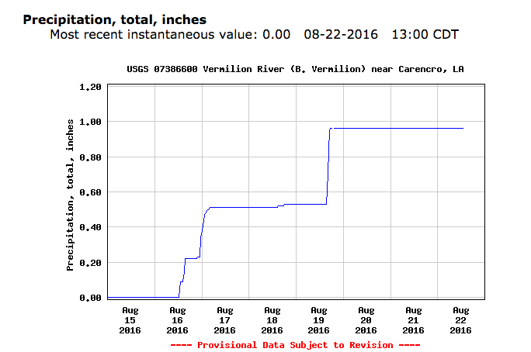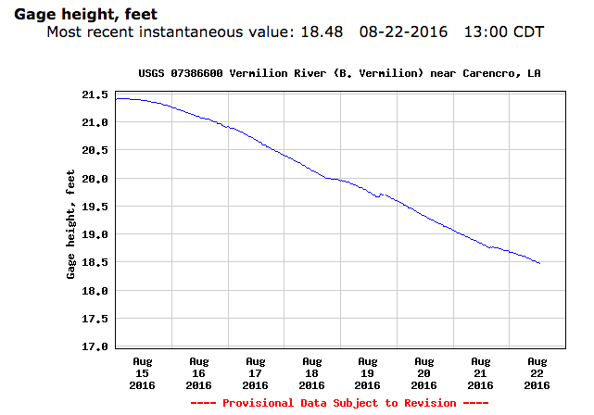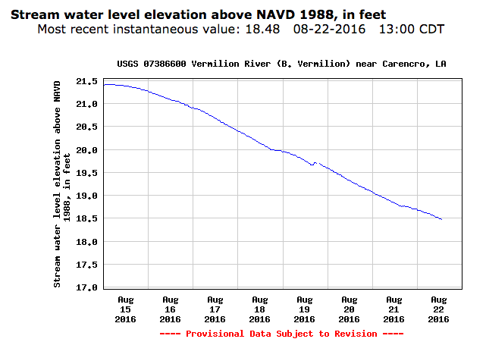

For Lafayette Parish, 08-15-16 through 08-22-16.

* [http://water.weather.gov/precip/download.php](http://www.google.com/url?q=http%3A%2F%2Fwater.weather.gov%2Fprecip%2Fdownload.php&sa=D&sntz=1&usg=AFQjCNEFa6IGFFsb44s2h-bbrCklsw96jA)

**Part III. Technology Stack**

I plan to use a technology stack including QGIS. Data can be downloaded in csv, or GeoJASON data formats. JS libraries & plugins are undetermined; but CartoDB.js, is one likely. CartoDB will be used at least initially as the database host. HTML, CSS, will be utilized in building the document, and GitHub for initial web hosting. I would like to learn the ins and outs of moving it to a cloud service such as AWS or similar.

Having considered the topic and available data a little further, I think the events would be best shown by having river and stream gauge sites represented by some form of point /dot. This would be true for the Weather station / precipitation gauges. The flooding should be represented by polygons that will be regenerated for each time interval (if series extents are available.)

Content / Requirements:

* River & Stream gauge data
* Precipitation Gauge data (wx stations)
* Flooding extent polygons (hopefully a time series)
* Base Map / layers

The user will approach the map with an initial view of “Normal.” They will then be able to read a description of the area and events that occurred; also of what the map intends to illustrate. The time series data will likely have a slider interface for the user to progress through the sequence of events. Clicking or rolling over the gauge points will also trigger pop-ups stating gauge reading.

Vary Simple Mockup:

