**Part II. Final Project Topic**

1. Map Topic: My map will explore the story of the August 2016 Louisiana flooding.
2. Objective: to offer an understanding of the events that caused the severe flooding phenomena and will make use of time series data. User needs: to understand the unprecedented floods.
3. Data source: precipitation data, river & stream gauge data from government agencies. Possibly elevation data. Possibly population and housing data (helps understand the long term effects within the community long after the water subsides).

**Final Project Topic Description**:

**Title**: South Louisiana Floods

**Subtitle**: *Everyone has a bayou in their backyard, whether they know it or not.*

**Topic/objectives**: This map intends to illustrate the story of the unprecedented flooding of August 2016. It will cover much of southern Louisiana, a region where an understanding of micro-topography and watersheds are critical. Everyone has a bayou in their backyard whether they realize it or not. This project plans to aggregate and integrate time series data sources from precipitation, river and stream gauges, elevation and topography. This helps display events telling the story. In addition, I will search for methods to provide insight into long-term effects on the population such as housing shortage after the water has receded.

**Audience**: Anyone interested in a quantitative geospatial visual chronicling the story of the flooding, particularly those without an understanding of the regional terrain and weather. This user is a novice or average public persona interested in and caring about those affected by the floods. The user will interact with the map to see the time series data presented visually.

**Data Sources:**

* [http://waterdata.usgs.gov/la/nwis/rt](http://www.google.com/url?q=http%3A%2F%2Fwaterdata.usgs.gov%2Fla%2Fnwis%2Frt&sa=D&sntz=1&usg=AFQjCNG5lZoRDnQTVQ9HFVxvRXNuixugaA)

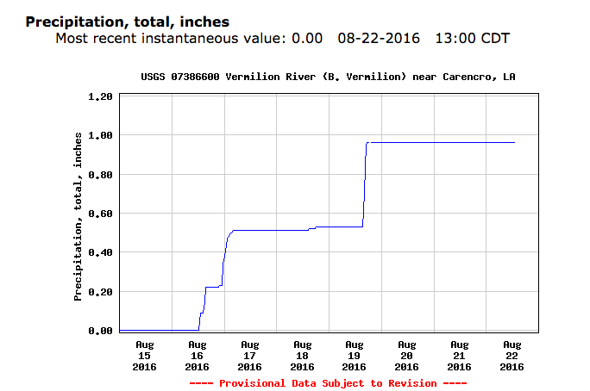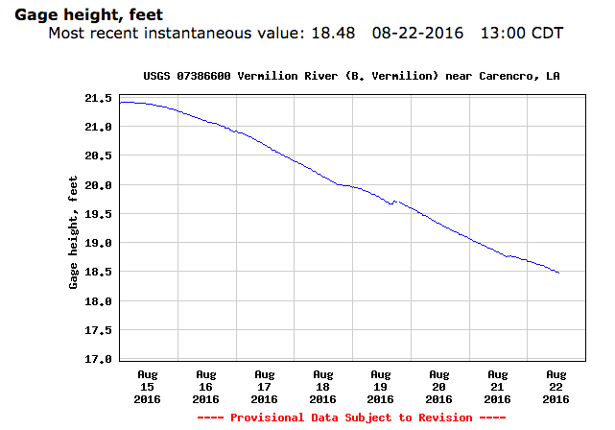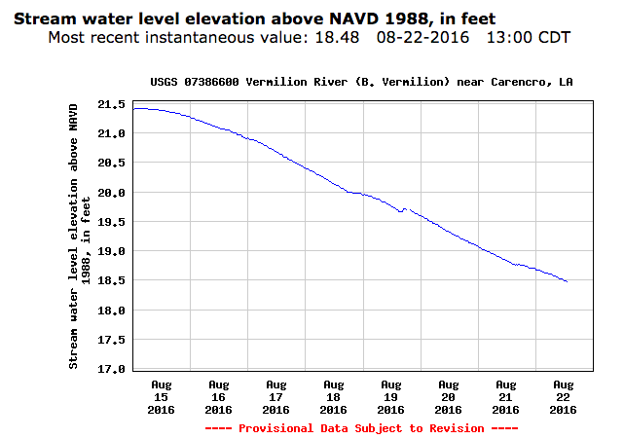

For Lafayette Parish, 08-15-16 through 08-22-16.

* [http://water.weather.gov/precip/download.php](http://www.google.com/url?q=http%3A%2F%2Fwater.weather.gov%2Fprecip%2Fdownload.php&sa=D&sntz=1&usg=AFQjCNEFa6IGFFsb44s2h-bbrCklsw96jA)

**Part III. Technology Stack**

I plan to use a technology stack including QGIS. Data can be downloaded in csv, or GeoJASON data formats. JS libraries & plugins are undetermined; but CartoDB.js, is one likely. CartoDB will be used at least initially as the database host. HTML, CSS, will be utilized in building the document, and GitHub for initial web hosting. I would like to learn the ins and outs of moving it to a cloud service such as AWS or similar.