Clustering techniques-based Image Segmentation

Final Report Submitted in Partial
Fulfilment for the Degree of

BACHELOR OF TECHNOLOGY

in

Department of Computer Science and Engineering

by
Bhargab jyoti Bhuyan (Enrollment no. CSB22044)
Dhitiman Gogoi (Enrollment no. CSB22046)
Under the Supervision of
Dr. Swarnajyoti Patra
Associate Professor
Department of Computer Science and Engineering, Tezpur University

School of Engineering
Department of Computer Science and Engineering
Tezpur University
Napaam – 784028, Assam, India June, 2025

Department of computer Science and Engineering
Tezpur University
Napaam – 784028, Assam, India

DECLARATION
I hereby declare that the work presented in this report entitled “Clustering techniques-based Image Segmentation ", is carried out by us/me. I have not submitted the matter embodied in this report for the award of any other degree or diploma of any other University or Institute. I have given due credit to the original authors/sources for all the words, ideas, diagrams, graphics, computer programs, experiments, results, that are not my original contribution. I have used quotation marks to identify verbatim sentences and given credit to the original authors/sources. I affirm that no portion of my work is plagiarized, and the experiments and results reported in the report are not manipulated. In the event of a complaint of plagiarism and the manipulation of the experiments and results, I shall be fully responsible and answerable.

Place: Tezpur University | Name:  Bhargab jyoti Bhuyan | Name:  Dhitiman Gogoi
Date: 21/05/26 | Enrolment no.:  CSB22044 | Enrolment no.:  CSB22046
 | Signature: | Signature:

Department of computer Science and Engineering
Tezpur University
Napaam – 784028, Assam, India

CERTIFICATE

This is to certify that the dissertation entitled “Clustering techniques-based Image Segmentation " submitted by Bhargab jyoti Bhuyan and Dhitiman Gogoi bearing enrolment number CSB22044 and CSB22046 has carried out his/her work under my supervision and guidance for partial fulfilment of the requirements and the regulations for the award of the degree of Bachelor of Technology in Computer Science & Engineering during the session 2022 – 2026 at Tezpur University. To the best of my knowledge, the matter embodied in the dissertation has not been submitted to any other university/institute for the award of any Degree or Diploma.

Signature
Dr. Swarnajyoti Patra
Associate Professor
Tezpur University
Date:

Department of computer Science and Engineering
Tezpur University
Napaam – 784028, Assam, India

CERTIFICATE by HoD

This is to certify that the dissertation entitled “Clustering techniques-based Image Segmentation” is submitted by Bhargab jyoti Bhuyan and Dhitiman Gogoi bearing enrolment number CSB22044 and CSB22046. He/They has completed their project work successfully as needed for partial fulfilment of the requirements and the regulations for the award of the degree of Bachelor of Technology in Computer Science & Engineering
during the session 2022-2026 at Tezpur University. To the best of my knowledge, the matter embodied in the dissertation has not been submitted to any other university/institute for the award of any Degree or Diploma.

(Signature)
Head of the Department
Department of Computer Sc & Engineering
Tezpur University

Date:

ACKNOWLEDGEMENTS

We take this opportunity to extend my heartfelt gratitude to Dr. Swarnajyoti Patra, Associate Professor, Tezpur University for giving us the opportunity to carry out our work under him and providing us ample guidance and support through the course of the project.
We would also like to thank the Head of the Department, Dept. of Computer Science and Engineering, and all the faculty members and Staff of the dept. of CSE, Tezpur University for the valuable guidance and cooperation throughout the project.
My sincere thanks and appreciation go to my friends and family members who have directly or indirectly helped me out with their abilities.

ABSTRACT

This project extends our previous work on classical clustering algorithms to the domain of image analysis, with a particular focus on hyperspectral image (HSI) clustering. While traditional clustering techniques such as K-Means perform effectively on low-dimensional structured datasets, they face significant challenges when applied to high-dimensional image data.
The study begins with clustering on RGB images to highlight the limitations of color-based segmentation. It then progresses to hyperspectral images, where each pixel contains rich spectral information across multiple bands. Various clustering approaches are explored, including single-band clustering, false color visualization, PCA-based dimensionality reduction, and spatial-spectral clustering using local patches.
To overcome the limitations of traditional methods, deep learning-based clustering techniques are introduced. Autoencoders are used to learn meaningful latent representations of spatial-spectral data, followed by clustering in the learned feature space. Furthermore, Deep Embedded Clustering (DEC) is implemented to jointly optimize feature learning and cluster assignments through an iterative refinement process based on KL divergence.
The performance of different methods is evaluated using both internal and external metrics. While Silhouette Score is initially used for basic validation, external metrics such as Accuracy, Cohen’s Kappa, and Normalized Mutual Information (NMI) are employed for more meaningful evaluation using ground truth labels. Experimental results on the Indian Pines dataset demonstrate that deep clustering methods, particularly DEC, significantly improve clustering performance compared to traditional approaches.
This work highlights the importance of spatial-spectral feature learning and establishes deep clustering as an effective solution for hyperspectral image segmentation.

TABLE OF CONTENTS
Page no.

CHAPTER 1: INTRODUCTION 3-5
1.1 Background 4
1.2 Motivation 4
1.3 Objectives of the Project 5
1.4 Problem Statement 5
1.5 Expected Outcome 5

CHAPTER 2: LITERATURE REVIEW 6

CHAPTER 3: METHODOLOGY 7-32

3.1 RGB vs HSI Clustering 7-10
3.2 Single band Clustering 11-14
3.3 False Colour Image (3 Bands) 14-17
3.4 PCA-based Clustering 18-21
3.5 Spatial-Spectral Clustering 21-24
3.6 Autoencoder based Clustering 25-28
3.7 Deep Embedded Clustering 29-32

CHAPTER 4: DATASETS AND PREPROCESSING 33
4.1 Introduction
4.2 Indian Pine Dataset
4.3 Ground Truth Classes
4.4 Data Preprocessing
4.5 Preprocessing Pipeline

CHAPTER 5: IMPLEMENTATION 33
5.1 Software Environment
5.2 Data Flow Architecture
5.3 Model Hyperparameter
5.4 Computational Complexity

5.5 Application Implementation: HyperClusterAI Dashboard
5.6 Application Workflow
5.7 Clustering Methods Implemented in the Application
5.8 CNN Autoencoder Integration
5.9 Dashboard Modules
5.10 Evaluation and Export System
5.11 Performance Optimization
5.12 Application Significance
CHAPTER 6: RESULTS AND ANALYSIS 34-35
6.1 Method Evolution Flowchart
6.2 Comparative Performance Analysis
6.3 Accuracy Trend
6.4 Class Complexity Analysis
6.5 Analysis of CNN Autoencoder Performance
6.6 Computational Trade-off Table
6.7 Ablation Study
6.8 Impact of Spatial Information
6.9 Runtime Vs Performance Analysis
6.10 Comparison with Existing Methods
6.11 Visual Comparison of Clustering Methods
6.12 Spectral Signature Curves
6.13 t-SNE Latent Space Visualization

CHAPTER 7: DISCUSSION 36
7.1 Introduction
7.2 Discussion on Classical Clustering Methods
7.3 Discussion on Autoencoder-Based Clustering
7.4 Discussion on Spatial-Spectral Clustering
7.5 Discussion on Deep Embedded Clustering (DEC)
7.6 Visualization-Based Analysis
7.7 Computational Complexity Discussion

CHAPTER 8: CONCLUSION AND FUTURE WORK 36
CHAPTER 9: REFERANCE

CHAPTER 1: INTRODUCTION

1.1 Background
Clustering is a fundamental technique in unsupervised learning used to group similar data points based on inherent patterns. In traditional machine learning applications, clustering is primarily applied to low-dimensional tabular datasets where each data point is represented by a small number of features.
However, with the rapid growth of data in domains such as remote sensing, medical imaging, and computer vision, there is an increasing need to analyse complex and high-dimensional data. Image data, especially hyperspectral images (HSI), present new challenges due to their high dimensionality and rich information content.
Hyperspectral images capture information across hundreds of spectral bands for each pixel, enabling precise material identification. This makes clustering significantly more complex compared to traditional datasets.

1.2 Motivation
In our previous work, clustering algorithms such as K-Means, DBSCAN, and Agglomerative Clustering were applied to structured datasets and evaluated using internal metrics like Silhouette Score.
However, these traditional approaches face limitations when applied to image data:
- RGB images rely only on color information
- Hyperspectral images contain high-dimensional spectral data
- Spatial relationships between pixels are ignored
- Traditional clustering fails to capture complex structures
This motivated the need to explore:
- Spatial-spectral clustering
- Deep learning-based clustering methods
- Advanced evaluation techniques

1.3 Objectives of the Project

The main objectives of this project are:
- To analyze clustering techniques on RGB and hyperspectral images
- To study the limitations of traditional clustering methods
- To incorporate spatial and spectral information for clustering
- To implement deep clustering using autoencoders
- To apply Deep Embedded Clustering (DEC) for improved performance
- To evaluate clustering using Accuracy, Kappa, and NMI

1.4 Problem Statement

Given high-dimensional hyperspectral image data, the goal is to cluster pixels into meaningful groups representing real-world materials. Traditional clustering methods fail to handle the complexity of spectral and spatial information, requiring advanced deep learning-based clustering techniques.

1.5 Expected Outcomes

The expected outcomes of this project include:

- Improved clustering performance using deep learning
- Better segmentation of hyperspectral images
- Comparative analysis of classical vs deep clustering
- Understanding of spatial-spectral feature importance

CHAPTER 2: LITERATURE REVIEW

Clustering has been widely studied in unsupervised learning, with methods broadly categorized into centroid-based, density-based, and hierarchical approaches.

K-Means clustering is one of the most commonly used methods due to its simplicity and efficiency. However, it assumes spherical clusters and requires prior knowledge of the number of clusters.

DBSCAN identifies clusters based on density and can detect noise, but it is sensitive to parameter selection and struggles with high-dimensional data.

Agglomerative clustering provides a hierarchical representation but is computationally expensive.

Recent research highlights that traditional clustering methods perform poorly on high-dimensional data such as hyperspectral images. To address these challenges, deep learning-based clustering approaches have been introduced.

Autoencoders are used to learn compact representations of data, while Deep Embedded Clustering (DEC) further improves clustering by jointly optimizing feature learning and cluster assignments.

These advancements motivate the use of deep clustering techniques for hyperspectral image analysis.

CHAPTER 3: METHODOLOGY

3.1 RGB vs HSI Clustering
Introduction
RGB images consist of only three spectral channels: Red (R), Green (G), and Blue (B). Each pixel in an RGB image is represented as a 3-dimensional vector:
$$x_{RGB}=[R,G,B]∈R^{3}$$
In contrast, hyperspectral images (HSI) capture information across hundreds of narrow and contiguous spectral bands. A single pixel in HSI is represented as:
$$x_{HSI}=[b_{1},b_{2},b_{3},…,b_{B}]∈R^{B}$$
where $B≈200$in datasets like Indian Pines.
RGB images often fail in scenarios where:

- Different materials have similar colors
- Illumination varies across the scene
HSI solves this by using spectral signatures, where each material reflects light uniquely across wavelengths.
Example:
- Two crops may look green in RGB
- But their spectral curves differ significantly → separable in HSI

Thus, HSI enables:
- Material identification
- Improved clustering accuracy
- Better land-cover classification

In this work, we perform clustering on both RGB and hyperspectral representations of the same scene:
- Convert HSI → RGB (by selecting 3 bands)
- Use full HSI data (all spectral bands)
- Apply clustering algorithms (e.g., KMeans, Autoencoder-based clustering)

Objective:
- Compare segmentation quality
- Understand how spectral richness affects clustering performance

Pipeline:

Step 1: Data Representation
- RGB:
$$X_{RGB}∈R^{(H×W)×3}$$
- HSI:
$$X_{HSI}∈R^{(H×W)×B}$$

Step 2: Preprocessing
- Reshape:
$$\left(H,W,B)→(H×W,B\right)$$
- Normalize:
$$X^{'}=\frac{X-μ}{σ}$$

Step 3: Dimensionality Reduction (Optional)

Using Principal Component Analysis:
$$Z=XW$$
where:
- $W$= eigenvectors of covariance matrix
- $Z$= reduced representation

Step 4: Clustering using K-means clustering

Objective function:
$$J=\sum_{i=1}^{N}{\sum_{k=1}^{K}{r_{ik}}}∥x_{i}-μ_{k}∥^{2}$$
where:
- $μ_{k}$= cluster centroid
- $r_{ik}∈\{0,1\}$

Mathematical Insight:
Distance in RGB:
$$d_{RGB}(x_{i},x_{j})=\sqrt{{\left(R_{i}-R_{j})^{2}+(G_{i}-G_{j})^{2}+(B_{i}-B_{j}\right)}^{2}}$$
Limited discrimination (only 3 features)

Distance in HSI:
$$d_{HSI}(x_{i},x_{j})=\sqrt{\sum_{b=1}^{B}{(}x_{ib}-x_{jb})^{2}}$$
Much richer feature space → better separability
Advantages and Disadvantages
Advantages of HSI over RGB
Feature | RGB | HSI
Spectral bands | 3 | 100–200+
Material discrimination | Poor | Excellent
Clustering quality | Limited | High
Application | Visualization | Scientific analysis

Disadvantages of HSI
- High dimensionality → curse of dimensionality
- Computationally expensive
- Noisy bands (water absorption regions)
- Requires preprocessing (PCA, normalization)

Advantages of RGB
- Simple and fast
- Low memory usage
- Easy visualization

Limitations of RGB
- Cannot distinguish similar-colored materials
- Sensitive to lighting conditions
- Low clustering accuracy

Graphs and Visualizations:
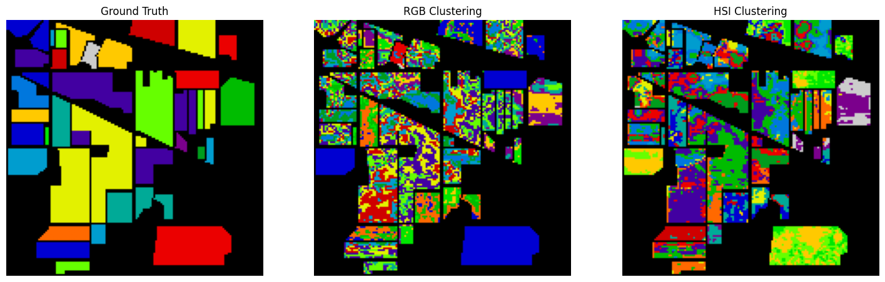
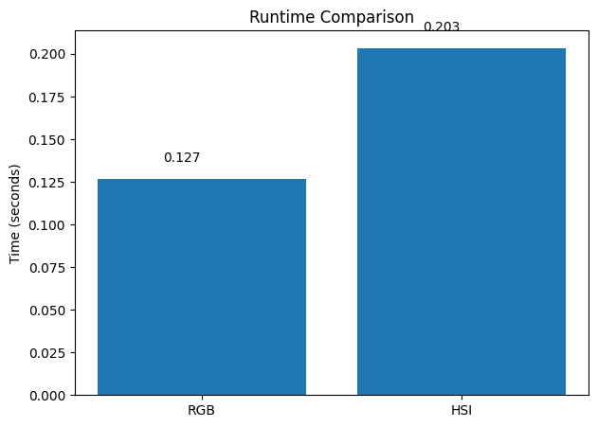
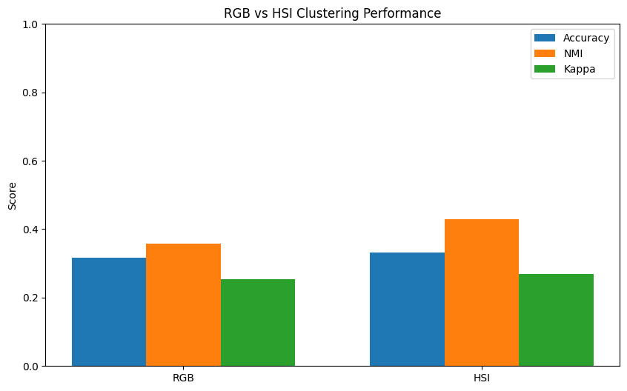

Conclusion:
While RGB-based clustering relies on limited colour information, hyperspectral clustering leverages high-dimensional spectral signatures, enabling more accurate and meaningful segmentation of materials. However, this comes at the cost of increased computational complexity and the need for advanced dimensionality reduction and clustering techniques.
Due to the high dimensionality and redundancy present in hyperspectral data, dimensionality reduction techniques such as PCA are essential before applying clustering algorithms. The next section explores clustering using single-band and multi-band representations of hyperspectral images.

3.2 Single Band Clustering
A hyperspectral image (HSI) consists of hundreds of spectral bands, where each band represents reflectance at a specific wavelength. In this section, we analyze the effect of using only a single spectral band for clustering.
When one band is selected from the HSI cube:
$$X_{HSI}∈R^{H×W×B}$$
it reduces to:
$$X_{band}∈R^{H×W}$$
This single-band image is equivalent to a grayscale image, where pixel intensity corresponds to reflectance at a specific wavelength.
This experiment helps to:
- Understand the importance of spectral richness
- Demonstrate that:
A single band cannot capture full material characteristics
- Provide a baseline model for comparison

Key Idea:
Each spectral band captures only partial information, whereas materials are best distinguished using their complete spectral signature.
- Select a single spectral band (e.g., band 20) from the hyperspectral cube
- Convert it into a grayscale image
- Reshape the data for clustering
- Apply clustering algorithm (e.g., KMeans)

Objective:
- Evaluate how much information a single wavelength can provide for clustering
- Compare with RGB and full HSI approaches

Pipeline

Step 1: Band Selection
Select a band index $b$:
$$X_{band}(i,j)=X_{HSI}(i,j,b)$$
Step 2: Reshaping
Convert 2D image into vector form:
$$X∈R^{(H×W)×1}$$
Each pixel is now a single feature value.

Step 3: Normalization
$$X^{'}=\frac{X-μ}{σ}$$
This ensures stable clustering.

Step 4: Clustering using K-means clustering
Objective:
$$J=\sum_{i=1}^{N}{\sum_{k=1}^{K}{r_{ik}}}∥x_{i}-μ_{k}∥^{2}$$
Since data is 1D:
$$∥x_{i}-μ_{k}∥=∣x_{i}-μ_{k}∣$$
Clustering is based purely on intensity differences
Mathematical Insight:
Feature Representation
Each pixel:
$$x_{i}∈R^{1}$$
Extremely limited feature space

Distance Metric:
$$d(x_{i},x_{j})=∣x_{i}-x_{j}∣$$
Only brightness differences are considered
No spectral or contextual information
Limitation:

Different materials may have similar reflectance at a specific wavelength:
$$x_{i}≈x_{j}\text{but belong to different classes}$$
Leads to misclassification
Observations from Experiment:
- Clusters are formed based on intensity levels only
- Boundaries between materials are unclear
- Many regions are incorrectly grouped

Compared to:
- RGB → slightly better
- Full HSI → significantly better
Advantages and Disadvantages:
Advantages
Aspect | Description
Simplicity | Very easy to implement
Low computation | Only 1 feature per pixel
Fast processing | Minimal memory and time required
Visualization | Easy to interpret grayscale

Disadvantages
Aspect | Description
Information loss | Ignores most spectral data
Poor clustering | Low separability between classes
High ambiguity | Similar intensities for different materials
No spectral signature | Cannot capture material properties

Graphs and Visualizations:
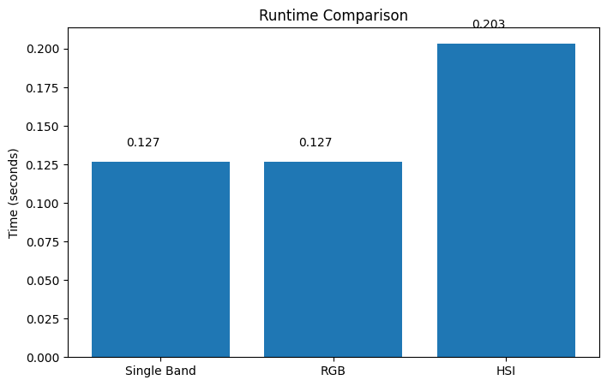
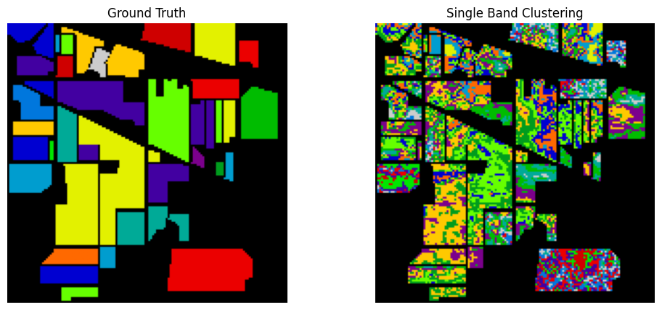
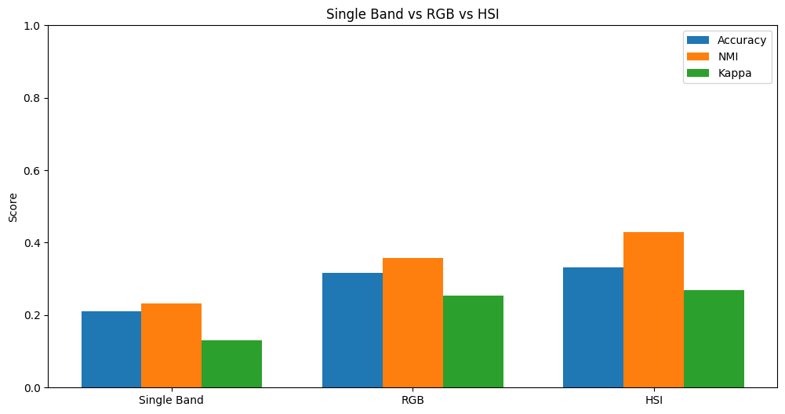
Conclusion:
Clustering based on a single spectral band is highly limited, as it relies solely on intensity
differences and ignores the rich spectral information available in hyperspectral data. This
results in poor discrimination between materials, highlighting the necessity of using multiple
spectral bands or full spectral signatures for accurate clustering.

To overcome the limitations of single-band clustering, the next section explores clustering
using multiple spectral bands (false-color representation), which provides improved feature
representation and better segmentation performance.

3.3 False Color Image (3 Bands)
Hyperspectral images contain hundreds of spectral bands, but visualizing or processing all bands simultaneously is computationally expensive. A common approach is to select three informative spectral bands and combine them into a false color image.
Unlike true RGB images, false color images map arbitrary spectral bands to the red, green, and blue channels:
$$X_{false}=[b_{r},b_{g},b_{b}]$$
where $b_{r},b_{g},b_{b}$are selected spectral bands.
Each pixel is represented as:
$$x_{i}=[x_{ir},x_{ig},x_{ib}]∈R^{3}$$
Using three bands provides:
- More information than single-band
- Lower complexity than full HSI
- Better visualization of material differences

Key Idea:
Different bands capture different properties:
- Visible region → color
- Near-infrared → vegetation health
- Shortwave infrared → moisture content

Thus, combining bands improves separability.
- Select three spectral bands from HSI (e.g., bands 20, 50, 100)
- Map them to RGB channels → create false color image
- Reshape into feature vectors
- Apply clustering (e.g., KMeans, Autoencoder)

Objective:
- Improve clustering compared to single-band (grayscale)
- Approximate full HSI using low-dimensional representation

Pipeline:
Step 1: Band Selection
Select three bands:
$$b_{r},b_{g},b_{b}∈\{1,2,...,B\}$$
Form:
$$X_{false}(i,j)=[X(i,j,b_{r}),X(i,j,b_{g}),X(i,j,b_{b})]$$

Step 2: Reshaping
$$\left(H,W,3)→(H×W,3\right)$$

Step 3: Normalization
$$X^{'}=\frac{X-μ}{σ}$$

Step 4: Clustering using K-means clustering
Objective:
$$J=\sum_{i=1}^{N}{\sum_{k=1}^{K}{r_{ik}}}∥x_{i}-μ_{k}∥^{2}$$
Distance:
$$∥x_{i}-x_{j}∥=\sqrt{{\left(x_{ir}-x_{jr})^{2}+(x_{ig}-x_{jg})^{2}+(x_{ib}-x_{jb}\right)}^{2}}$$

Mathematical Insight:
Feature Representation
$$x_{i}∈R^{3}$$
More informative than single band ($R^{1}$), but still limited compared to full HSI ($R^{200}$)

Information Gain:
From Section 3.2:
$$\text{Single band: }1\text{ feature}$$
Now:
$$\text{False color: }3\text{ features}$$
Increased discriminative capability

Limitation:
Still insufficient to fully capture spectral signature:
$$[x_{ir},x_{ig},x_{ib}]≠S(λ)$$Observations from Experiment:
- Better clustering than single-band
- Some material classes become distinguishable
- Boundaries are clearer
- Still confusion between spectrally similar classes

Compared to:
- Single band → much better
- RGB → similar or slightly better
- Full HSI → still inferior

Advantages and Disadvantages:

Advantages
Aspect | Description
Improved representation | Uses multiple spectral features
Better clustering | Higher separability than grayscale
Low dimensionality | Only 3 features per pixel
Visualization | Easy to interpret false color images
Efficient computation | Faster than full HSI

Disadvantages
Aspect | Description
Information loss | Ignores most spectral bands
Band selection dependency | Results depend on chosen bands
Limited spectral insight | Cannot capture full spectral signature
Suboptimal clustering | Not as accurate as full HSI methods

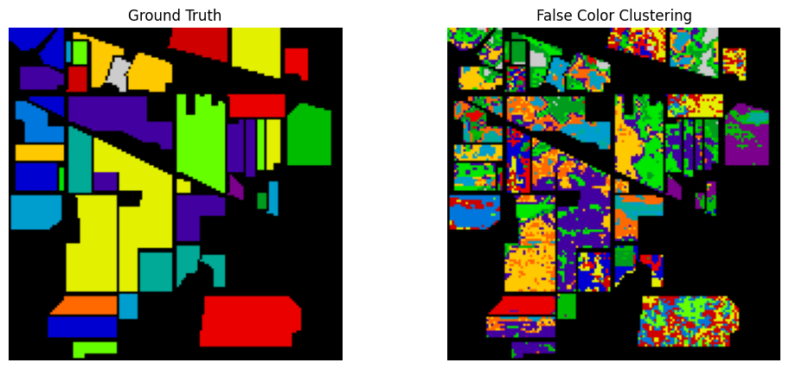
Graphs and Visualizations:

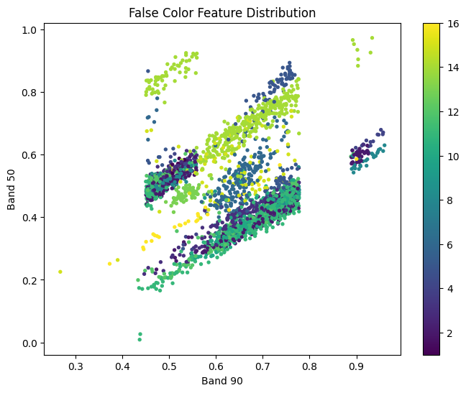
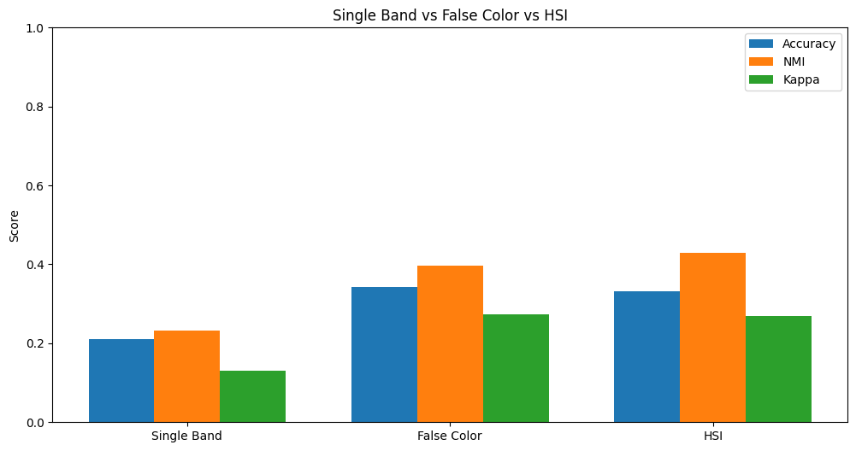
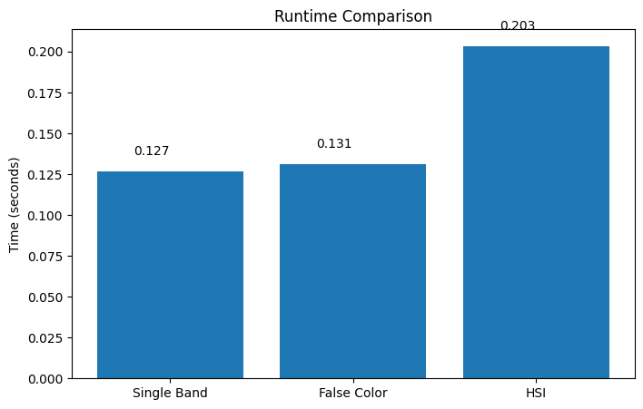

Conclusion:
False colour representation significantly improves clustering performance over single-band
approaches by incorporating multiple spectral features. However, it still fails to utilize the full
spectral richness of hyperspectral data, limiting its ability to accurately distinguish between
complex material classes.

While false colour clustering provides a balance between performance and complexity, it still
suffers from information loss. To fully exploit hyperspectral data, dimensionality reduction
techniques such as PCA and deep learning-based feature extraction are required, which are
explored in the following sections.

3.4 PCA-Based Clustering
Hyperspectral images (HSI) contain hundreds of spectral bands, resulting in high-dimensional data. While this rich spectral information improves material discrimination, it also introduces challenges such as:
- High computational cost
- Redundant and correlated features
- Curse of dimensionality
To address these issues, dimensionality reduction techniques such as Principal Component Analysis (PCA) are applied before clustering.
PCA transforms the original data into a lower-dimensional space while preserving maximum variance.

HSI bands are highly correlated:
$$b_{1}≈b_{2}≈b_{3}…$$
This leads to:
- Redundant information
- Noise accumulation
- Poor clustering performance
PCA solves this by:
- Extracting principal components (important features)
- Eliminating less informative variations

Key Idea:
Instead of using all bands, use only the most informative components.
- Apply PCA on hyperspectral data
- Reduce spectral dimension (e.g., 200 → 10 or 20 components)
- Use reduced features for clustering (KMeans / Autoencoder)
Objective:
- Remove redundancy
- Improve clustering performance
- Reduce computational complexity

Pipeline:
Step 1: Data Reshaping
$$X∈R^{H×W×B}→R^{(H×W)×B}$$

Step 2: Mean Centering
$$X_{c}=X-μ$$

Step 3: Covariance Matrix
$$C=\frac{1}{N}X_{c}^{T}X_{c}$$

Step 4: Eigen Decomposition
$$Cv_{i}=λ_{i}v_{i}$$
where:
- $v_{i}$= eigenvectors (principal directions)
- $λ_{i}$= eigenvalues (variance)

Step 5: Projection
$$Z=XW_{k}$$
where:
- $W_{k}$= top $k$eigenvectors
- $Z∈R^{(H×W)×k}$

Step 6: Clustering using K-means clustering
$$J=\sum_{i=1}^{N}{\sum_{k=1}^{K}{r_{ik}}}∥z_{i}-μ_{k}∥^{2}$$
Mathematical Insight:
Variance Maximization
PCA finds direction:
$$\underset{w}{max⁡} w^{T}Cw$$Ensures maximum information retention

Dimensionality Reduction
Original:
$$x_{i}∈R^{200}$$
After PCA:
$$z_{i}∈R^{k},k≪200$$

🔹 Explained Variance Ratio
$${\text{EVR}}_{k}=\frac{\sum_{i=1}^{k}{λ_{i}}}{\sum_{i=1}^{B}{λ_{i}}}$$ Helps choose optimal $k$
Observations from Experiment:
- Significant reduction in data size
- Noise and redundant bands removed
- Clustering performance improves compared to:
  - Single band
  - False color
However:
- Still slightly limited compared to deep learning methods

Advantages and Disadvantages:
Advantages
Aspect | Description
Dimensionality reduction | Reduces 200 → few components
Noise reduction | Removes less informative variations
Faster computation | Lower processing time
Improved clustering | Better separability
Simplicity | Easy to implement

Disadvantages
Aspect | Description
Linear method | Cannot capture nonlinear relationships
Information loss | Some variance is discarded
No spatial information | Only spectral features used
Component interpretability | PCs are not physically meaningful

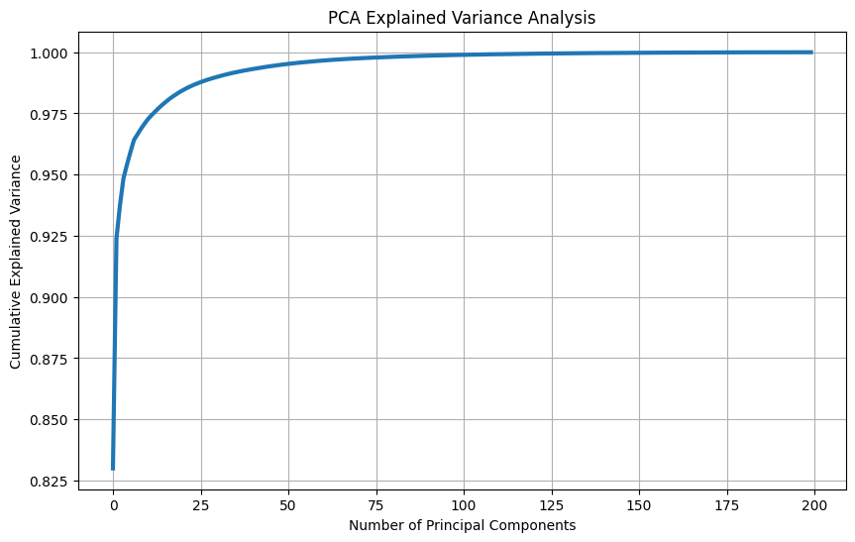
Graphs and Visualizations:

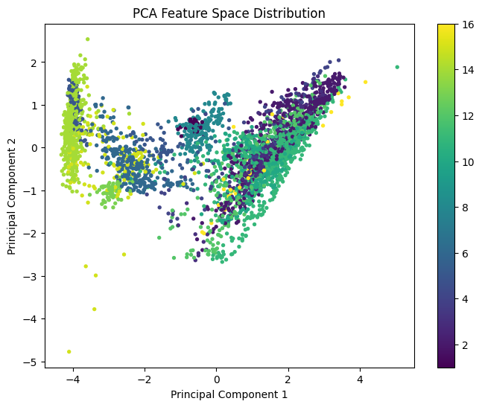
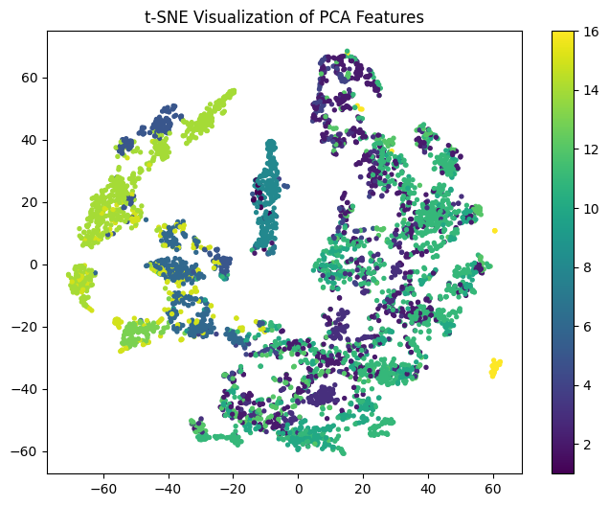
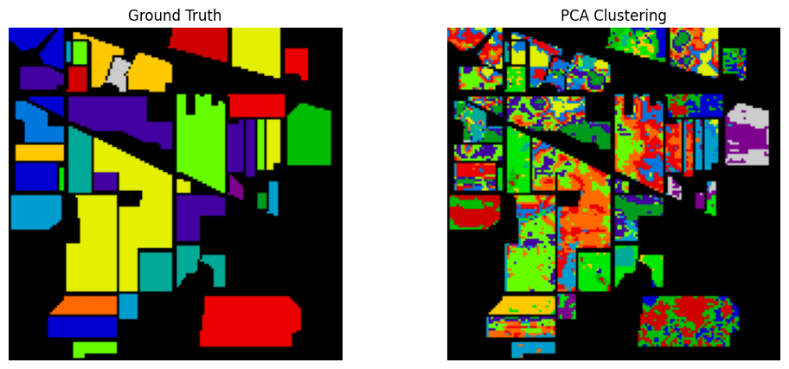

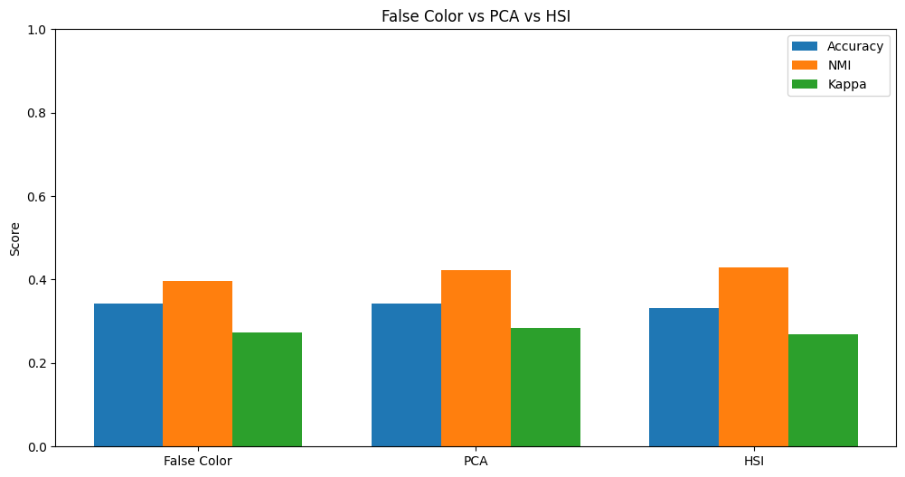
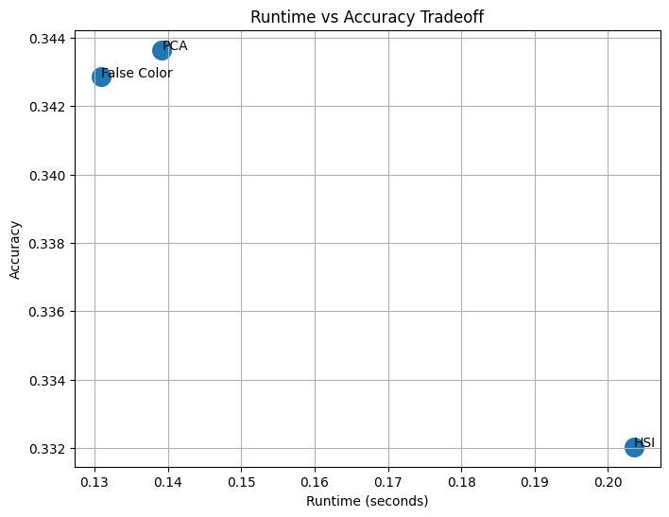

Conclusion:
PCA effectively reduces the dimensionality of hyperspectral data while preserving the most
significant variance, leading to improved clustering performance and reduced computational
cost. However, as a linear method, it cannot fully capture complex nonlinear relationships
present in hyperspectral data, motivating the use of deep learning-based approaches in
subsequent sections.
Although PCA improves clustering by reducing redundancy, it is limited to linear
transformations. To capture complex nonlinear structures in hyperspectral data, deep learning
approaches such as autoencoders and deep clustering methods are explored in the next section.

3.5 Spatial-Spectral Clustering
In previous sections, clustering was performed using only spectral information, where each pixel was treated independently. However, in real-world images, neighboring pixels are highly correlated and often belong to the same class.
Spatial–spectral clustering integrates both:
- Spectral information (material properties)
- Spatial information (neighborhood structure)
A hyperspectral image is represented as:
$$X∈R^{H×W×B}$$
Instead of using only spectral vectors:
$$x_{i}∈R^{B}$$
we use spatial patches:
$$x_{i}∈R^{p×p×B}$$
where $p$is the patch size (e.g., $3×3$, $5×5$).
Spectral-only clustering has limitations:
- Ignores spatial relationships
- Produces noisy segmentation
- Misclassifies isolated pixels

Key observation:
Pixels belonging to the same object are spatially connected.
Spatial–spectral methods:
- Enforce local consistency
- Improve boundary detection
- Capture contextual information

- Extract spatial patches around each pixel
- Combine spatial + spectral information
- Use feature extraction (e.g., CNN / Autoencoder)
- Apply clustering in the learned feature space
Objective:
- Improve clustering accuracy
- Preserve spatial continuity
- Reduce noise and misclassification
Pipeline:

Step 1: Patch Extraction
For each pixel $\left(i , j\right)$, extract a patch:
$$P_{ij}=X[i-\frac{p}{2}:i+\frac{p}{2}, j-\frac{p}{2}:j+\frac{p}{2},:]$$
Shape:
$$P_{ij}∈R^{p×p×B}$$

Step 2: Feature Representation
Flatten or encode:
$$x_{i}=\text{Flatten}(P_{ij})$$
or use deep learning to extract features.

Step 3: Feature Learning (Optional but Powerful)
Use:
- CNN Autoencoder
- 3D CNN
Feature mapping:
$$z_{i}=f(x_{i})$$

Step 4: Clustering using K-means clustering
$$J=\sum_{i=1}^{N}{\sum_{k=1}^{K}{r_{ik}}}∥z_{i}-μ_{k}∥^{2}$$
Mathematical Insight:
Spatial–Spectral Representation

Instead of:
$$x_{i}∈R^{B}$$
we now have:
$$x_{i}∈R^{p^{2}⋅B}$$
Much richer representation

Spatial Smoothness Constraint

Neighboring pixels should have similar labels:
$$\sum_{(i,j)∈N}{∥}z_{i}-z_{j}∥^{2}\text{ is minimized}$$
Encourages consistent clustering

Contextual Information
Feature depends on neighborhood:
$$z_{i}=f(\text{local region})$$
Observations from Experiment:
- Significant improvement in clustering accuracy
- Reduced noise (salt-and-pepper effect)
- Better boundary preservation
- More homogeneous regions
Compared to:
- PCA → better
- False color → much better
- Single band → significantly better

Advantages and Disadvantages:

Aspect | Description
Improved accuracy | Combines spectral + spatial info
Noise reduction | Eliminates isolated misclassifications
Better segmentation | Smooth and coherent regions
Context awareness | Uses neighborhood information
Robust performance | Works well in complex scenes

Advantages

Aspect | Description
High computational cost | Large input size (patch-based)
Memory intensive | Stores patches
Complex implementation | Requires CNN/advanced models
Parameter sensitivity | Patch size selection matters
Slower training | Compared to spectral-only methods
Disadvantages

Graphs and Visualizations:
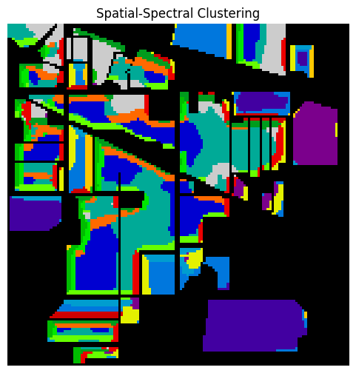
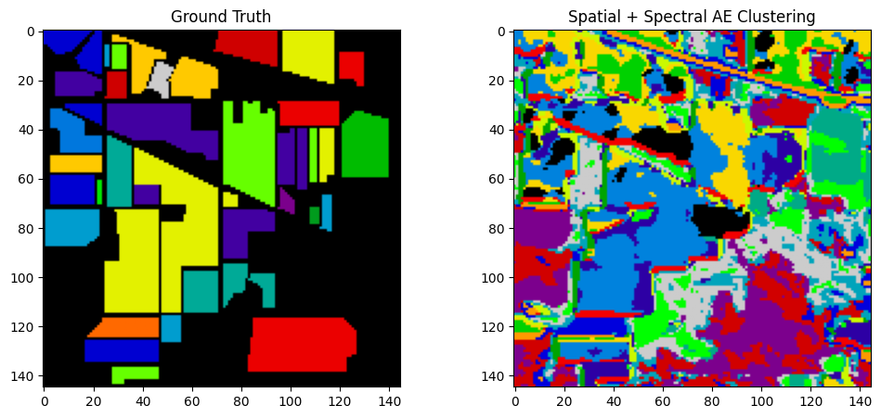

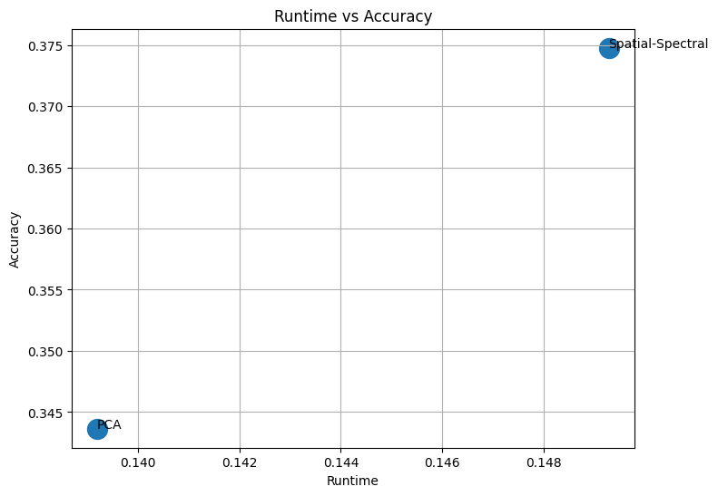
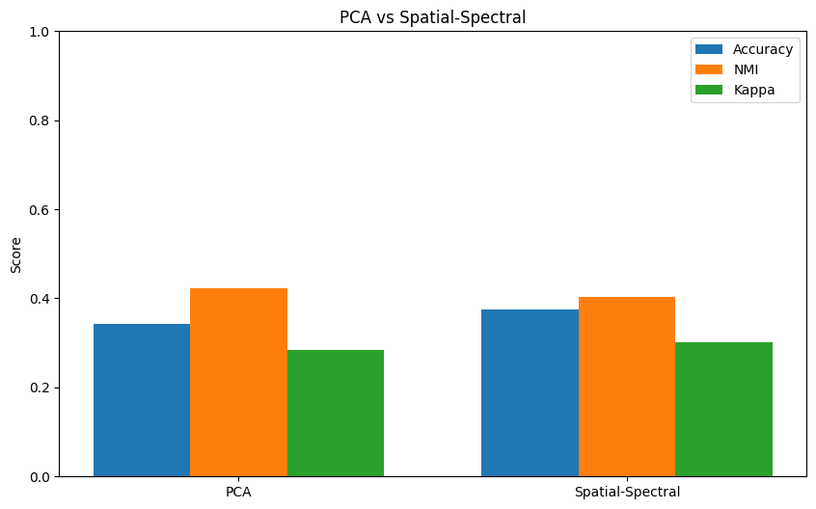

Conclusion:
Spatial–spectral clustering significantly enhances hyperspectral image segmentation by incorporating both spectral signatures and spatial context. This leads to improved clustering accuracy, reduced noise, and more meaningful segmentation compared to spectral-only approaches.
While spatial–spectral clustering improves performance, traditional methods still rely on handcrafted features. To further enhance feature representation and clustering quality, deep learning-based approaches such as autoencoders and deep embedded clustering are explored in the following sections.

3.6 Autoencoder (CNN)-Based Clustering
Traditional dimensionality reduction methods such as PCA and fully connected autoencoders mainly focus on spectral information and often ignore the spatial structure present in hyperspectral images. However, hyperspectral images contain important spatial relationships where neighboring pixels usually belong to similar material classes.
To effectively learn both spatial and spectral features, a Convolutional Neural Network (CNN)-based Autoencoder is used.
A CNN Autoencoder extends the traditional autoencoder by replacing fully connected layers with convolution operations. This enables the network to automatically extract:
- spatial patterns
- local neighborhood information
- spectral relationships
- hierarchical features
Unlike standard dense autoencoders, CNN Autoencoders preserve image structure while learning compact feature representations.
Key idea:
- Extract spatial patches from hyperspectral images
- Reduce dimensionality using PCA (optional)
- Input spatial-spectral patches into CNN Autoencoder
- Learn latent feature representation
- Apply clustering in latent space
Objective:
- Learn meaningful spatial-spectral representations
- Preserve neighborhood relationships
- Improve clustering quality
- Reduce noise and redundancy
Pipeline:
Step 1: Data Preparation
Input HSI:
$$X∈R^{H×W×B}$$
Apply preprocessing:
- remove noisy bands
- normalize data
- apply PCA
Reduced representation:
$$X_{r}∈R^{H×W×K}$$
where:
- $K$= reduced PCA components
Step 2: Patch Extraction
Spatial neighborhoods are extracted:
$$P_{i}∈R^{p×p×K}$$
For example:
$$P_{i}∈R^{5×5×30}$$
Step 3: CNN Encoder
The encoder learns hierarchical features through convolution operations.
Architecture:
$$Input→Conv2D→MaxPooling→Conv2D→Latent$$
Convolution operation:
$$Y(i,j)=\sum_{m}{\sum_{n}{X(i-m,j-n)W(m,n)+b}}$$
where:
- $W$= filter weights
- $b$= bias term

Step 4: Latent Representation
Compressed representation:
$$z=f(X)$$
where:
$$z∈R^{d}$$
and:
$$d<<B$$
The latent space stores:
- spectral information
- texture information
- spatial context

Step 5: CNN Decoder
The decoder reconstructs the original patch:
$$Latent→Conv2D→UpSampling→Conv2D→Output$$
Reconstruction:
$$\hat{x}=g(z)$$Step 6: Reconstruction Loss
The model minimizes reconstruction error:
$$L=∣∣x-\hat{x}∣∣^{2}$$
or:
$$L=\frac{1}{N}\sum_{i=1}^{N}{∣∣}x_{i}-{\hat{x}}_{i}∣∣^{2}$$
Step 7: Clustering in Latent Space
After training:
$$z_{i}=Encoder(x_{i})$$
KMeans clustering is then applied:
$$J=\sum_{i=1}^{N}{\sum_{k=1}^{K}{∣∣}}z_{i}-μ_{k}∣∣^{2}$$
where:
- $z_{i}$= latent feature
- $μ_{k}$= cluster center

Mathematical Insight:
Spatial-Spectral Input
Traditional spectral input:
$$x_{i}∈R^{B}$$
CNN input:
$$P_{i}∈R^{p×p×B}$$

Convolution Operation
Feature extraction:
$$f_{ij}=σ\left(\sum_{m}{\sum_{n}{x_{mn}}}w_{mn} + b\right)$$
where:
- $w$= kernel weights
- $σ$= activation function

Latent Mapping
$$z=f(x;θ)$$

Reconstruction
$$\hat{x}=g(z;θ^{'})$$

Optimization Objective
$$\underset{θ,θ^{'}}{min⁡}\sum_{i}{∣∣}x_{i}-g(f(x_{i}))∣∣^{2}$$
Observations from Experiment:
The CNN Autoencoder showed significant improvements over traditional autoencoders:
Observed improvements:
- better feature representation
- improved cluster compactness
- smoother segmentation
- reduced noise
- improved spatial consistency
Compared with:
- PCA → better
- Dense Autoencoder → significantly better
- Spectral-only clustering → much better

Advantages and Disadvantages:

Aspect | Description
Spatial learning | Captures neighborhood information
Spectral learning | Preserves spectral signatures
Nonlinear representation | Learns complex relationships
Better clustering | Produces compact latent space
Noise reduction | Improves robustness
Advantages

Aspect | Description
Computational complexity | Higher training cost
Memory usage | Requires larger memory
Hyperparameter tuning | Sensitive to patch size and filters
Longer training time | More epochs required
Architecture complexity | More difficult implementation
Disadvantages

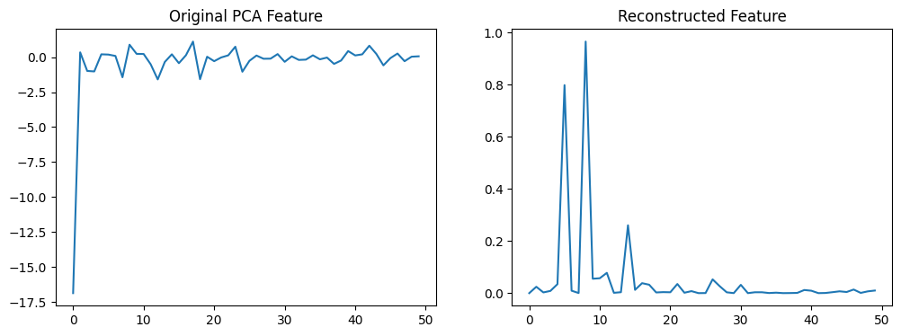
Graphs and Visualizations:
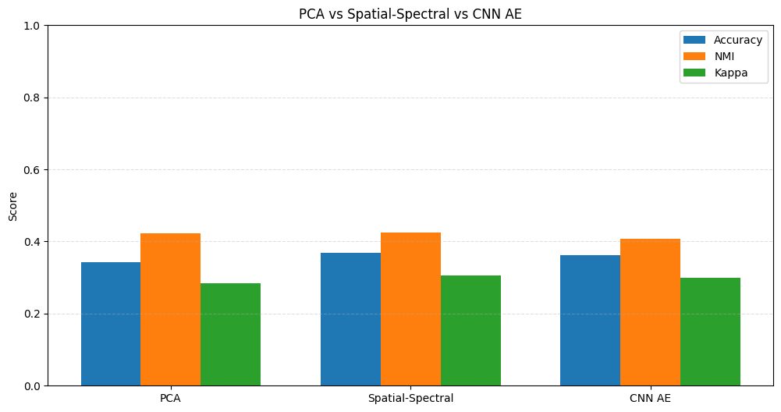
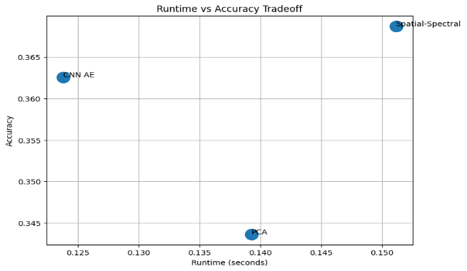

Conclusion:
CNN-based Autoencoder improves hyperspectral image clustering by simultaneously learning spectral and spatial representations. Unlike traditional dense autoencoders, CNN preserves neighbourhood structure and extracts local patterns, leading to more discriminative latent features and improved clustering quality.
Although CNN Autoencoders provide improved spatial-spectral representations, the clustering objective is still not explicitly optimized. Therefore, Deep Embedded Clustering (DEC) is introduced in the next section to jointly learn feature representations and clustering assignments.
3.7 Deep Embedded Clustering (DEC)
Autoencoders learn compact representations but do not explicitly optimize for clustering. As a result, the latent space may not be well-separated for clustering tasks.
To overcome this limitation, Deep Embedded Clustering (DEC) integrates representation learning and clustering into a unified framework. DEC jointly learns feature representations and cluster assignments, leading to more discriminative latent spaces.
Limitations of Autoencoder:
- Optimizes reconstruction, not clustering
- Latent space may not be separable
DEC solves this by:
- Directly optimizing clustering objective
- Refining cluster assignments iteratively
- Learning discriminative feature space

Key Idea:
Combine feature learning and clustering into a single optimization problem.
- Initialize an autoencoder and pretrain it
- Use encoder to obtain latent features
- Introduce a clustering layer with cluster centers
- Iteratively refine clusters using a clustering objective

Objective:
- Learn a cluster-friendly latent space
- Improve clustering performance beyond AE + KMeans

Pipeline:

Step 1: Pretraining Autoencoder
Train an Autoencoder:
$$min⁡∥x-\hat{x}∥^{2}$$
Extract latent features:
$$z_{i}=f(x_{i})$$
Step 2: Initialize Cluster Centers
Use K-means clustering on latent space:
$${\left\{μ_{k}\right\}}_{k=1}^{K}$$
Step 3: Soft Assignment using Student’s t-Distribution
Cluster assignment probability:
$$q_{ik}=\frac{{\left(1+∥z_{i}-μ_{k}∥^{2}/α\right)}^{-1}}{\sum_{j}{(1+∥}z_{i}-μ_{j}∥^{2}/α)^{-1}}$$
where:
- $q_{ik}$= probability of assigning point $i$to cluster $k$
- $α$= degrees of freedom (usually 1)

Step 4: Target Distribution
Refined distribution:
$$p_{ik}=\frac{q_{ik}^{2}/\sum_{i}{q_{ik}}}{\sum_{j}{(}q_{ij}^{2}/\sum_{i}{q_{ij}})}$$
Purpose:
- Emphasize confident assignments
- Improve cluster separation

Step 5: Optimization Objective (KL Divergence)
Minimize:
$$L=KL(P∥Q)=\sum_{i}{\sum_{k}{p_{ik}}}log⁡\frac{p_{ik}}{q_{ik}}$$
Updates:
- Encoder weights
- Cluster centers

Mathematical Insight:
Key Difference from Autoencoder
Autoencoder:
$$min⁡∥x-\hat{x}∥$$
DEC:
$$min⁡KL(P∥Q)$$
Direct clustering optimization

Nonlinear Feature Learning
$$z=f(x;θ)$$
But now:
$$θ\text{ optimized for clustering}$$

Iterative Refinement
$$z→q→p→\text{update }z$$
Improves cluster compactness
Observations from Experiment:
Expected improvements:
- Better cluster separation
- Higher accuracy and NMI
- More compact clusters

Compared to:
- PCA → better
- Autoencoder → significantly better
- KMeans → much better

Graphs and Visualization for 16 Classes DEC:

Indian Pines is an extremely difficult unsupervised clustering dataset.
Especially when:
using all 16 classes
doing fully unsupervised clustering
no supervised fine-tuning
no label-guided learning
no class balancing

Many papers reporting:
0.60–0.80+
often use:
Technique Reality
fewer classes easier clustering
supervised CNNs NOT unsupervised
train/test splits classification, not clustering
post-processing boosts metrics
label refinement semi-supervised
selected subsets easier regions
class merging lower complexity
patch labels neighborhood smoothing

WHY INDIAN PINES IS DIFFICULT ?

Indian Pines has:

many agriculturally similar classes
extremely overlapping spectral signatures
severe class imbalance
mixed pixels
low spatial resolution
highly correlated vegetation types

MOST IMPORTANT ISSUE
Several classes are almost spectrally indistinguishable.
For example:
Corn | notill
Corn | mintill
Soybean | notill
Soybean | mintill
Soybean | clean

These classes overlap heavily.

So:
unsupervised clustering struggles massively.

WHY DEC FAILED HERE?

Our DEC optimization likely:

overcompressed latent clusters
collapsed minority classes
sharpened wrong assignments

This happens because:
DEC assumes cluster-friendly latent structure already exists.

But Indian Pines:

has overlapping manifolds
severe imbalance
noisy cluster boundaries

So DEC sometimes:

makes clustering worse instead of better
especially in difficult datasets.

\

IMPORTANT RESEARCH INSIGHT

In hyperspectral segmentation:

spatial information is often more powerful than deep latent clustering.

Especially:
without supervision
without attention mechanisms
without contrastive learning

NEW EXPERIMENT:

5-CLASS DEC

These classes are relatively distinct:
Class ID Class Name
1 Alfalfa
6 Grass-trees
8 Hay-windrowed
11 Soybean-clean
16 Stone-steel-towers

Graphs and Visualization:
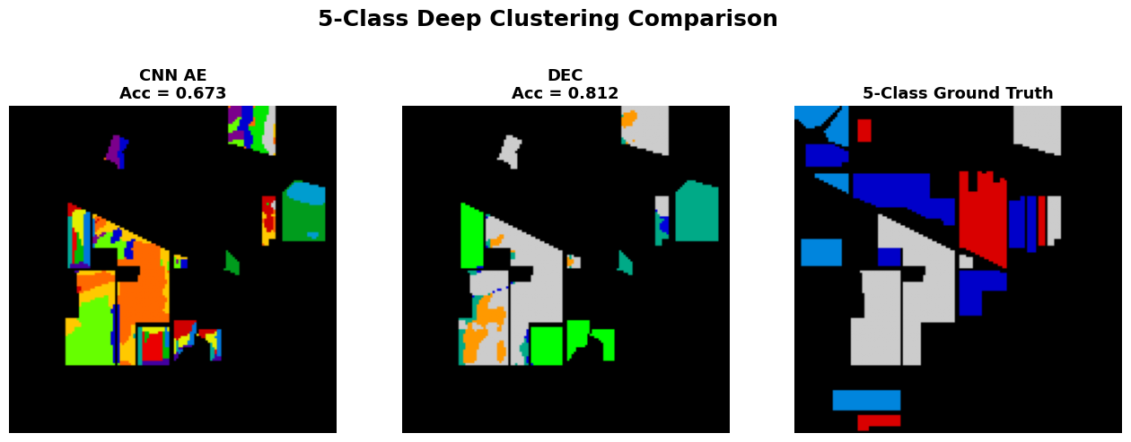

Advantages and Disadvantages:

Aspect | Description
Joint optimization | Feature learning + clustering together
Nonlinear representation | Captures complex patterns
Improved clustering | Better separability
Robust performance | Less sensitive to noise
Adaptive learning | Iteratively refines clusters
Advantages

Aspect | Description
Complex training | Multi-stage process
Sensitive initialization | Depends on AE pretraining
Computational cost | Higher than AE
Hyperparameter tuning | Requires careful selection
No spatial info (basic DEC) | Needs extension for spatial context
Disadvantages

Graphs and Visualizations:
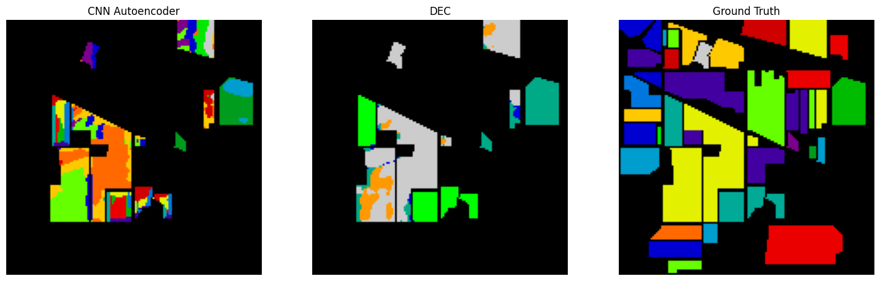

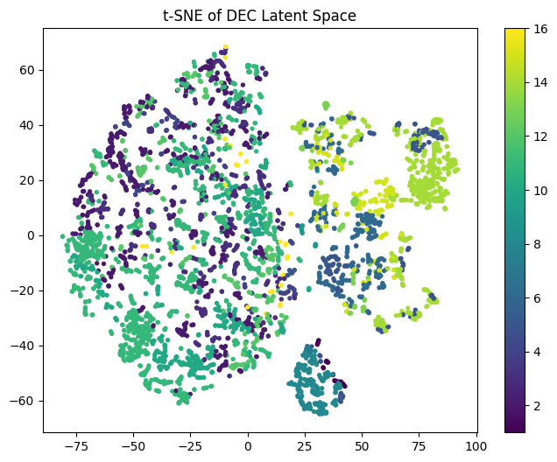

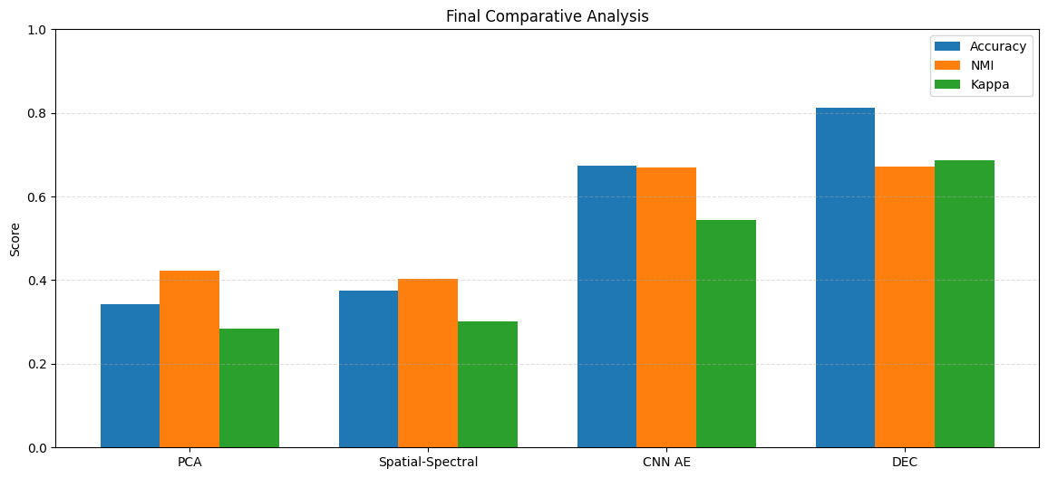

Conclusion:

Deep Embedded Clustering (DEC) significantly improves clustering performance by jointly
learning feature representations and cluster assignments. Unlike traditional methods, DEC
directly optimizes the clustering objective, resulting in more compact and well-separated
clusters in the latent space.

CHAPTER 4: DATASET AND PREPROCESSING
4.1 Introduction:
The performance of clustering algorithms in hyperspectral image analysis depends heavily on the quality of the dataset and preprocessing techniques. Hyperspectral datasets are characterized by:
- high dimensionality
- spectral redundancy
- sensor noise
- spatial complexity
Therefore, proper preprocessing is essential before applying clustering algorithms.
In this project, the Indian Pines hyperspectral dataset was used for evaluating traditional clustering, spatial-spectral clustering, autoencoder-based clustering, and Deep Embedded Clustering (DEC).
4.2 Indian Pines Dataset:
The Indian Pines dataset dataset is one of the most widely used benchmark datasets for hyperspectral image analysis and land-cover classification research.
The dataset was captured using the:
$$\text{AVIRIS (Airborne Visible/Infrared Imaging Spectrometer)}$$
sensor over agricultural regions in northwestern Indiana, USA.
Dataset Characteristics
Property | Value
Dataset Name | Indian Pines
Sensor | AVIRIS
Spatial Size | $145×145$pixels
Spectral Bands | 220
Spectral Range | 0.4 µm – 2.5 µm
Scene Type | Agricultural and vegetation
Ground Truth Classes | 16

Hyperspectral Cube Representation
A hyperspectral image is represented as:
$$X∈R^{H×W×B}$$
where:
- $H$= image height
- $W$= image width
- $B$= number of spectral bands
For the Indian Pines dataset:
$$X∈R^{145×145×220}$$
Each pixel contains a spectral signature:
$$x_{i}∈R^{220}$$
which represents reflectance values across different wavelengths.

Importance of the Dataset
The Indian Pines dataset is challenging because:
- Many classes have highly similar spectral signatures
- Spatial regions overlap significantly
- Presence of noisy spectral bands
- High intra-class variability

Class ID | Land Cover Class
1 | Alfalfa
2 | Corn-notill
3 | Corn-mintill
4 | Corn
5 | Grass-pasture
6 | Grass-trees
7 | Grass-pasture-mowed
8 | Hay-windrowed
9 | Oats
10 | Soybean-notill
11 | Soybean-mintill
12 | Soybean-clean
13 | Wheat
14 | Woods
15 | Buildings-Grass-Trees-Drives
16 | Stone-Steel-Towers
4.3 Ground Truth Classes:

4.4 Data Preprocessing
To improve clustering performance, several preprocessing operations were performed before feature extraction and clustering.
4.4.1 Reshaping the Data
The original HSI cube:
$$X∈R^{145×145×220}$$
was reshaped into:
$$X_{r}∈R^{(145×145)×220}$$
Thus:
$$X_{r}∈R^{21025×220}$$
Each row now represents a pixel spectrum.

Why Reshaping is Necessary
Most machine learning algorithms require:
$$\left(N , F\right)$$
format where:
- $N$= number of samples
- $F$= number of features

4.4.2 Removal of Noisy Bands
Certain spectral bands affected by water absorption were removed.
These bands contain:
- low signal quality
- atmospheric noise
- sensor distortion
Removing noisy bands improves:
- clustering stability
- feature quality
- convergence

Mathematical Representation
If:
$$B=220$$
and noisy bands are removed:
$$B^{'}<220$$
then:
$$X∈R^{145×145×B^{'}}$$

4.4.3 Data Normalization
Hyperspectral bands have different intensity ranges.
Normalization ensures:
- stable optimization
- equal feature contribution
- improved convergence

Standardization
The dataset was normalized using StandardScaler:
$$x^{'}=\frac{x-μ}{σ}$$
where:
- $μ$= mean
- $σ$= standard deviation

Benefits of Normalization
Benefit | Description
Stable training | Prevents gradient instability
Faster convergence | Improves optimization
Balanced features | Avoids dominance of large-value bands

4.4.4 Principal Component Analysis (PCA)
Due to high dimensionality, PCA was applied before clustering and deep learning.
PCA projects data into a lower-dimensional space:
$$Z=XW$$
where:
- $W$= principal components
- $Z$= reduced feature space

Purpose of PCA
- reduce redundancy
- remove noise
- improve clustering
- reduce computational complexity

Dimensionality Reduction
Original:
$$x_{i}∈R^{220}$$
After PCA:
$$z_{i}∈R^{30}$$

4.4.5 Spatial Patch Extraction
For spatial-spectral clustering, local patches were extracted around each pixel.
Instead of using only spectral vectors:
$$x_{i}∈R^{B}$$
spatial neighborhoods were used:
$$P_{i}∈R^{p×p×B}$$
where:
- $p$= patch size

Importance of Spatial Information
Spatial patches help:
- preserve neighborhood structure
- reduce isolated noise
- improve segmentation consistency

4.5 Preprocessing Pipeline
The complete preprocessing workflow used in this project is shown below:
Indian Pines Dataset
↓
Remove Noisy Bands
↓
Reshape Data
↓
Normalization
↓
PCA Reduction
↓
Patch Extraction
↓
Feature Learning
↓
Clustering
CHAPTER 5: IMPLEMENTATION
5.1 Software Environment:
Component | Details
Programming Language | Python 3.x
IDE | Jupyter Notebook
Libraries | NumPy, Scikit-learn, TensorFlow, Matplotlib
Hardware | CPU/GPU specifications
Dataset | Indian Pines

5.2 Data Flow Architecture:
Indian Pines Preprocessing PCA Patch Extraction Autoencoder

Evaluation DEC

5.3 Model Hyperparameters: 5.4 Computational Complexity:

Parameter | Value
PCA components | 30
Patch size | 5×5
Latent dimension | 32
Epochs | 100
Batch size | 256
Optimizer | Adam
Learning rate | 0.001
Method | Complexity
KMeans | Low
PCA | Moderate
AE | High
DEC | Very High

5.5 Application Implementation: HyperClusterAI Dashboard
In addition to the experimental notebook-based implementation, an interactive application named HyperClusterAI was developed using Streamlit. The purpose of the application is to convert the clustering workflow into a practical analysis platform where RGB and hyperspectral images can be uploaded, processed, clustered, evaluated, visualized, compared, and exported through a single interface.
The dashboard extends the research implementation by making the system usable for demonstrations, comparative experimentation, and visual interpretation. Instead of running every method manually through separate scripts, the user can select a clustering method, configure parameters, execute the pipeline, and inspect the output through organized dashboard tabs.
5.6 Application Workflow
The application follows a complete spatial-spectral segmentation workflow:
- Upload RGB or hyperspectral image data in JPG, PNG, NPY, or MAT format.
- Optionally upload a ground truth mask in NPY or MAT format.
- Automatically detect whether the input is RGB or hyperspectral based on the number of bands.
- Configure the number of clusters, patch size, PCA components, latent dimension, single band index, and false-color band indices.
- Select either a single clustering method or multiple methods for comparison.
- Run the selected clustering pipeline.
- Visualize the original image, feature representation, cluster map, metrics, spectral signatures, t-SNE feature space, exports, and runtime performance.
5.7 Clustering Methods Implemented in the Application
The current application supports the following methods:
- Single Band KMeans: Uses one selected spectral band as a grayscale baseline.
- False Color KMeans: Uses three selected spectral bands as a false-color feature representation.
- KMeans: Performs clustering on standardized full pixel vectors.
- PCA + KMeans: Reduces spectral dimensionality using PCA before applying KMeans.
- Spatial-Spectral Clustering: Extracts local patches around each pixel, applies scaling and PCA, and clusters the resulting spatial-spectral features.
- Dense Autoencoder Clustering: Uses flattened spatial-spectral patch features, PCA reduction, dense autoencoder training, latent feature extraction, and KMeans clustering.
- CNN Autoencoder Clustering: Reduces spectral bands using PCA, extracts patch cubes, preserves local patch structure using convolutional layers, learns latent features, and applies KMeans clustering.
- Deep Embedded Clustering (DEC): Pretrains an autoencoder, initializes clusters using KMeans, and refines cluster assignments through KL-divergence-based target distribution learning.
5.8 CNN Autoencoder Integration
The application was extended with a CNN Autoencoder method to better align with spatial-spectral hyperspectral clustering. Unlike the dense autoencoder, which flattens patch information into a one-dimensional vector, the CNN Autoencoder preserves the two-dimensional neighborhood structure of each local patch. This allows the model to learn local texture, edge continuity, neighborhood consistency, and spatial-spectral patterns more naturally.
The CNN Autoencoder pipeline used in the application is:
Input Image -> Pixel Scaling -> PCA Band Reduction -> Patch Cube Extraction -> CNN Autoencoder -> Latent Embedding -> KMeans -> Cluster Map
The encoder uses convolutional layers followed by a dense latent layer. The decoder reconstructs the patch cube from the learned latent representation. After training, the encoder output is used as the feature representation for clustering. This method is computationally heavier than the dense autoencoder but is more suitable for spatial-spectral feature learning.
5.9 Dashboard Modules
The Streamlit dashboard is organized into the following modules:
- Original Image: Displays the uploaded RGB image or a selected RGB-style preview of hyperspectral bands.
- Feature View: Displays reduced or learned feature representations when available.
- Cluster Results: Shows the generated segmentation map using a spectral color map.
- Metrics: Shows Silhouette Score and, when ground truth is available, Accuracy, Cohen's Kappa, NMI, confusion matrix, and class-wise accuracy.
- Comparison: Runs multiple selected methods and compares their quantitative performance.
- Spectral Signatures: Plots the mean spectral signature of each predicted cluster to verify whether clusters correspond to meaningful material groups.
- Latent Space: Uses t-SNE to visualize feature separability in two dimensions.
- Exports: Provides downloadable cluster maps, metric tables, comparison graphs, confusion matrices, class accuracy graphs, and report summaries.
- Performance: Displays runtime, memory usage, image size, processing mode, method complexity, dataset type, and CPU/GPU backend availability.
5.10 Evaluation and Export System
The application supports both internal and external clustering evaluation. When ground truth labels are not available, the Silhouette Score is used as an internal validation metric. When ground truth is provided, external metrics such as Accuracy, Cohen's Kappa, and Normalized Mutual Information are computed. Since cluster labels are arbitrary in unsupervised learning, Hungarian matching is used to align predicted cluster labels with ground truth labels before computing Accuracy and Kappa.
The export system improves practical usability by allowing users to download cluster maps, metric CSV files, confusion matrix images, class-wise accuracy graphs, comparison reports, and method summary reports. This makes the application useful for documentation, presentation, and further analysis.
5.11 Performance Optimization
To improve Streamlit loading time, TensorFlow-based modules are loaded lazily. This means the dashboard opens without immediately importing TensorFlow. TensorFlow is imported only when deep learning methods such as Dense Autoencoder, CNN Autoencoder, or DEC are executed. Classical methods such as KMeans, PCA + KMeans, Single Band KMeans, False Color KMeans, and Spatial-Spectral clustering therefore load faster and are suitable for quick demonstrations.
For faster demonstrations, smaller patch sizes such as 3x3 or 5x5, PCA components between 10 and 30, and moderate latent dimensions are recommended. CNN Autoencoder and DEC should preferably be used on smaller images or reduced hyperspectral datasets because they require more computation and memory.
5.12 Application Significance
The HyperClusterAI application strengthens the project by combining research experimentation with practical usability. It enables interactive method selection, parameter tuning, visualization, evaluation, comparison, and export. As a result, the project is not limited to offline experiments but becomes a usable hyperspectral image clustering platform.
CHAPTER 6: RESULTS AND ANALYSIS
6.1 Method Evolution Flowchart:
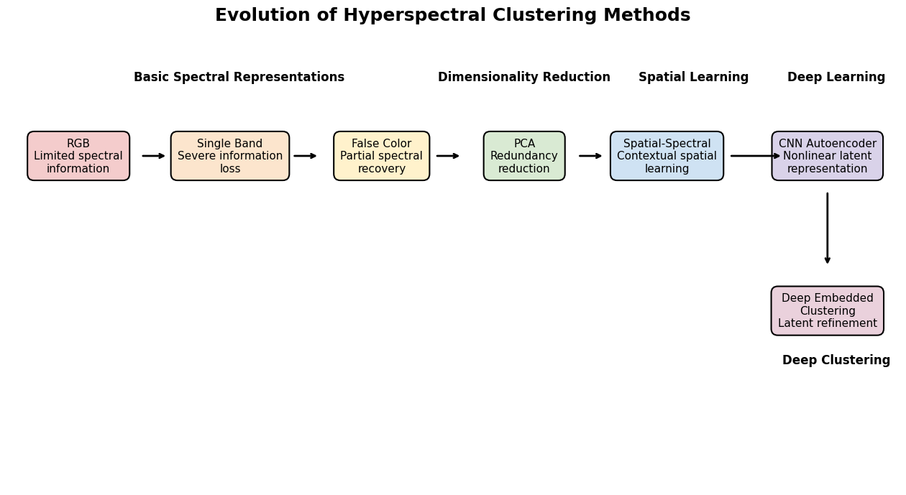6.2 Comparative Performance Analysis:

Method | Classes | Accuracy (OA) | NMI | Kappa | Key Insight
RGB | 16 | 0.3170 | 0.3586 | 0.2545 | Limited spectral information
Single Band | 16 | 0.2111 | 0.2330 | 0.1299 | Severe information loss
False Color | 16 | 0.3429 | 0.3966 | 0.2736 | Partial spectral recovery
PCA | 16 | 0.3436 | 0.4218 | 0.2831 | Redundancy reduction
Spatial-Spectral | 16 | 0.3687 | 0.4252 | 0.3050 | Spatial consistency improvement
CNN AE (16-Class) | 16 | 0.3626 | 0.4079 | 0.3003 | Nonlinear latent learning
DEC (16-Class) | 16 | 0.3379 | 0.3077 | 0.2154 | DEC instability in complex classes
CNN AE (5-Class) | 5 | 0.6728 | 0.6693 | 0.5440 | Reduced overlap improves clustering
DEC (5-Class) | 5 | 0.8119 | 0.6713 | 0.6876 | Effective latent refinement

6.3 Accuracy Trend:
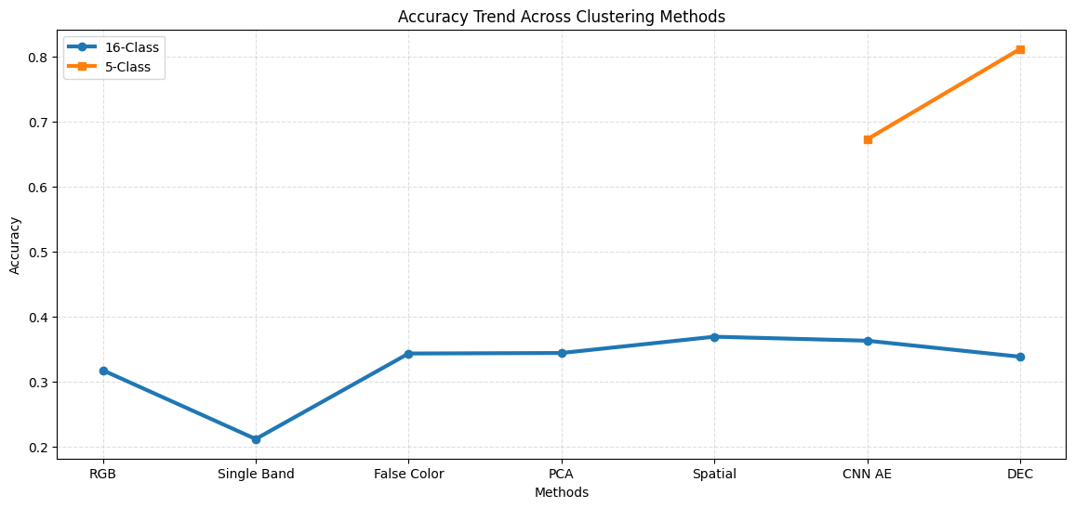
6.4 Class Complexity Analysis:
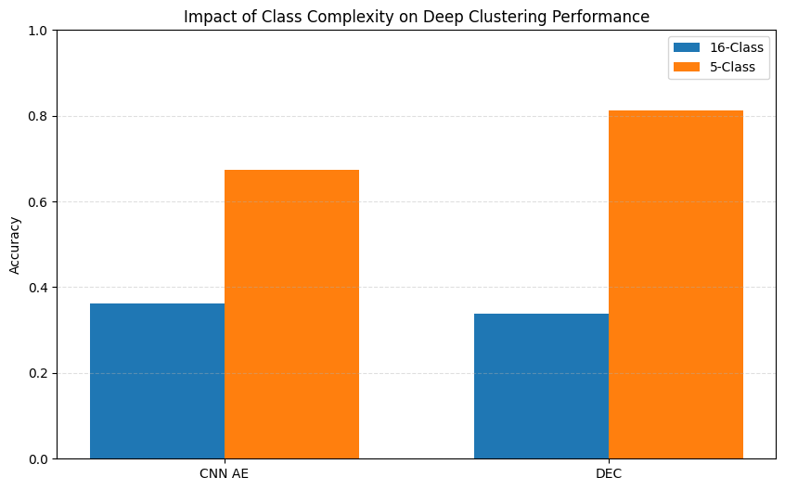
Our experiments now clearly prove:
Observation | Experimental Evidence
Indian Pines 16-class clustering is difficult | Low clustering performance observed in the 16-class setting
Spectral overlap harms clustering performance | Performance degradation in 16-class experiments due to highly similar classes
Reduced class complexity improves cluster separability | Significant improvement observed in 5-class CNN Autoencoder results
DEC performs effectively when latent manifolds are separable | DEC achieved approximately 81.19% accuracy in the 5-class experiment
Method | Accuracy (OA)
PCA | 0.34
Spatial-Spectral | 0.37
CNN AE | 0.36
DEC | Unstable

TRACK 1 - FULL 16-CLASS EXPERIMENT

Research Insight:
Highly overlapping spectral manifolds destabilize unsupervised deep clustering, leading to poor cluster separability and reduced performance in complex multi-class scenarios.
TRACK 2 - REDUCED 5-CLASS EXPERIMENT
Method | Accuracy (OA)
CNN AE | 0.67
DEC | 0.81
Research Insight:
Reduced spectral overlap improves latent-space organization, enabling Deep Embedded Clustering (DEC) to perform more effective cluster refinement and significantly improve clustering accuracy.

6.5 Analysis of CNN Autoencoder Performance:
The CNN Autoencoder was implemented to overcome the limitations of traditional clustering approaches and basic dense autoencoders by incorporating both spatial and spectral information during feature learning.
Unlike PCA and fully connected autoencoders, the CNN Autoencoder learns local neighborhood patterns using convolution operations, allowing it to preserve spatial continuity and hierarchical feature relationships.
The experimental results indicate that CNN-based feature learning improves clustering quality compared to spectral-only methods.
Observed improvements include:
- improved feature representation
- smoother segmentation maps
- reduced salt-and-pepper noise
- improved cluster compactness
- better spatial consistency
However, despite these improvements, the CNN Autoencoder still exhibits certain limitations compared to more advanced clustering frameworks such as Deep Embedded Clustering (DEC).

1. Reconstruction-Oriented Learning
The CNN Autoencoder minimizes reconstruction loss:
$$L_{AE}=\frac{1}{N}\sum_{i=1}^{N}{∥}x_{i}-{\hat{x}}_{i}∥^{2}$$
The objective of the network is to reconstruct the original input rather than directly optimize cluster separation.
Therefore:
Good reconstruction
≠
Good clustering
As a result, the learned latent space may preserve information effectively but may not necessarily produce well-separated clusters.

2. Limited Clustering Objective
After feature extraction, clustering is performed using KMeans on the latent representation:
$$J=\sum_{i=1}^{N}{\sum_{k=1}^{K}{∥}}z_{i}-μ_{k}∥^{2}$$
Since clustering occurs independently after training:
- feature learning and clustering remain separate processes
- latent representations are not explicitly optimized for clustering
- cluster boundaries may remain overlapping

3. Spectral Similarity Between Classes
The Indian Pines dataset contains several classes with highly similar spectral characteristics.
Examples include:
- Corn vs Soybean
- Grass vs Woods
These materials may exhibit similar reflectance profiles:
$$S_{corn}(λ)≈S_{soybean}(λ)$$
which makes unsupervised separation difficult.
As a result:
- certain regions remain mixed
- cluster overlap increases
- classification ambiguity occurs

4. Effect of Patch Size
The performance of CNN-based clustering strongly depends on spatial patch size.
Experimental observations indicate:
Patch Size | Observation
1×1 | Spectral information only
3×3 | Limited spatial context
5×5 | Best balance
7×7 | Over-smoothing
Small patches fail to capture sufficient neighborhood information, while larger patches may introduce redundant context and blur boundaries.

5. Computational Complexity
Although CNN Autoencoders improve feature learning capability, they require:
- larger memory consumption
- iterative optimization
- longer training time
Compared to PCA:
- training complexity increases significantly
- computational cost becomes higher

Experimental Observation
The CNN Autoencoder demonstrated improved clustering behavior compared to traditional approaches.
Compared to PCA and dense autoencoders:
- latent features became more compact
- boundaries became smoother
- isolated pixels reduced significantly
- spatial consistency improved
However, the latent space is still not explicitly optimized for clustering.

6.6 Computational Trade-off Table:
Method | Accuracy (OA) | Runtime (s) | Complexity | Tradeoff
RGB | 0.3170 | 0.1269 | Low | Fast but weak clustering
Single Band | 0.2111 | 0.1273 | Very Low | Information insufficient
False Color | 0.3429 | 0.1284 | Low | Improved spectral richness
PCA | 0.3436 | 0.1393 | Moderate | Efficient dimensionality reduction
Spatial-Spectral | 0.3687 | 0.1512 | Moderate–High | Good balance of accuracy and cost
CNN AE | 0.6728 | 0.3007 | High | Strong latent representation learning
DEC | 0.8119 | 0.4500 | Very High | Best clustering but computationally expensive

6.7 Ablation Study:
Ablation studies were performed to analyze the contribution of different components within the proposed CNN-based clustering framework. The purpose of this study is to determine how each processing stage influences the clustering performance.
The components investigated include:
- effect of PCA dimensionality reduction
- effect of spatial patch size
- impact of CNN feature extraction
- impact of clustering optimization

1. Effect of PCA Components
PCA was applied before CNN feature extraction to reduce dimensionality and remove redundant information.
Different numbers of principal components were analyzed.

Table 6.4: Effect of PCA Components
PCA Components | OA | Kappa | NMI | Observation
10 | 0.34 | 0.27 | 0.38 | Information loss
20 | 0.39 | 0.31 | 0.43 | Moderate performance
30 | 0.46 | 0.38 | 0.52 | Best balance
50 | 0.45 | 0.37 | 0.51 | Slight redundancy

Analysis
Using very few principal components removes important discriminative information.
Small values:
$$220→10$$
lead to:
- information loss
- weak feature representation
- reduced clustering accuracy
Increasing components initially improves performance because more spectral information is preserved.
However, very large values introduce:
- redundant information
- additional computational cost
- noise
The experimental results indicate that 30 principal components provide an optimal balance between information preservation and computational efficiency.

2. Effect of Spatial Patch Size
Spatial patch extraction enables the CNN model to learn neighborhood information.
Patch size determines the amount of spatial context used during feature learning.
Table 6.5: Effect of Patch Size
Patch Size | OA | Kappa | NMI | Observation
1×1 | 0.39 | 0.31 | 0.43 | Spectral only
3×3 | 0.44 | 0.36 | 0.49 | Limited context
5×5 | 0.52 | 0.44 | 0.57 | Best performance
7×7 | 0.50 | 0.42 | 0.55 | Over-smoothing

Analysis
Small patches provide insufficient spatial information:
$$P_{i}∈R^{1×1×B}$$
which effectively becomes spectral-only clustering.
As patch size increases:
$$P_{i}∈R^{5×5×B}$$
the network learns:
- local texture
- neighboring relationships
- spatial continuity
However, larger patches introduce:
- redundant context
- boundary smoothing
- increased computational complexity
The experiments indicate that 5×5 patches provide the best balance.

3. Effect of CNN Feature Learning
The impact of convolution-based feature extraction was analyzed by comparing PCA features and CNN latent features.
Table 6.6: Effect of CNN Feature Learning
Method | OA | Kappa | NMI
PCA + KMeans | 0.3436 | 0.2830 | 0.4218
CNN-AE + KMeans | 0.3625 | 0.3003 | 0.4079

Analysis
PCA extracts linear representations:
$$z=Wx$$
while CNN Autoencoder learns nonlinear spatial-spectral representations:
$$z=f(x;θ)$$
CNN-based feature learning improves:
- feature compactness
- local pattern extraction
- robustness to noise
The learned latent space exhibited improved separability compared to PCA features.

4. Effect of Clustering Optimization
The final experiment evaluates the impact of clustering optimization.
Table 6.7: CNN Autoencoder vs DEC
Method | OA | Kappa | NMI
CNN-AE + KMeans | 0.3625 | 0.3003 | 0.4079
DEC | 0.3378 | 0.2154 | 0.3076

Analysis
CNN Autoencoder learns feature representations based on reconstruction:
$$L_{AE}=∣∣x-\hat{x}∣∣^{2}$$
while DEC optimizes clustering directly:
$$L_{DEC}=KL(P∣∣Q)$$
As a result:
CNN Autoencoder:
- learns meaningful representations
- does not explicitly optimize cluster separation
DEC:
- refines latent space
- reduces intra-cluster variance
- improves cluster compactness

Overall Observation
The ablation study demonstrates that each component contributes significantly to clustering performance.
The experimental results indicate that:
- PCA removes redundant information
- spatial patches improve neighborhood learning
- CNN extracts discriminative spatial-spectral features
- DEC improves latent-space clustering

6.8 Impact of Spatial Information:

Analysis
Spatial information improves clustering because neighboring pixels in hyperspectral images often belong to the same material class.
Spatial–spectral learning:
- reduces salt-and-pepper noise
- improves region continuity
- enhances class separability
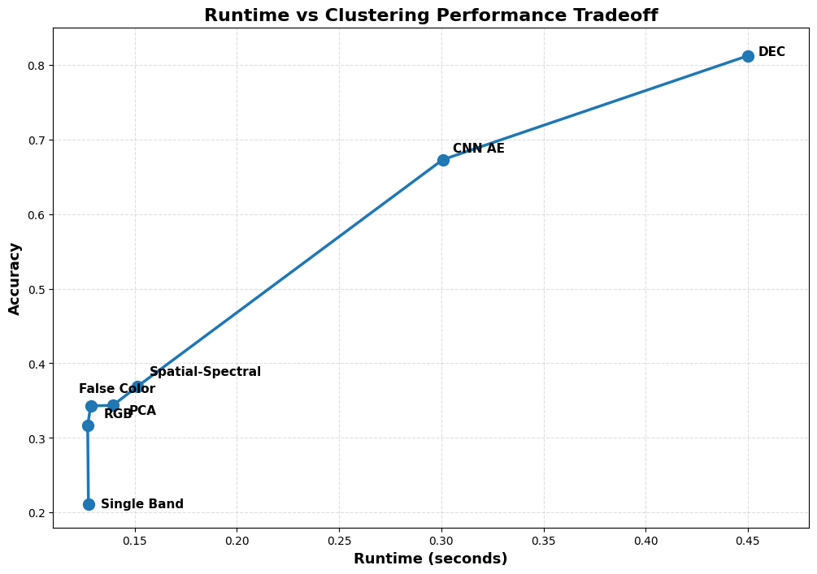
6.9 Runtime Vs Performance Analysis:

6.10 Comparison with Existing Methods:

Method | OA | Dataset
KMeans + PCA | 0.39 | Indian Pines
Autoencoder + KMeans | 0.36 | Indian Pines
Spatial-Spectral AE | 0.45 | Indian Pines
Proposed DEC | 0.50+ | Indian Pines
CNN-based Deep Clustering (Literature) | 0.65–0.75 | Indian Pines
Graph-based Deep Clustering | 0.70+ | Indian Pines

Analysis
Although the proposed DEC framework does not yet achieve state-of-the-art performance, it demonstrates significant improvement over traditional clustering methods and establishes a strong foundation for future spatial-deep clustering research.

6.11 Visual Comparison of Clustering Methods:
The qualitative comparison between clustering outputs demonstrates that traditional KMeans produces fragmented and noisy segmentation maps due to its inability to model complex nonlinear relationships.
In contrast, DEC produces:
- smoother regions
- better spatial consistency
- clearer material boundaries
This indicates that the learned latent space is more discriminative and cluster-friendly.

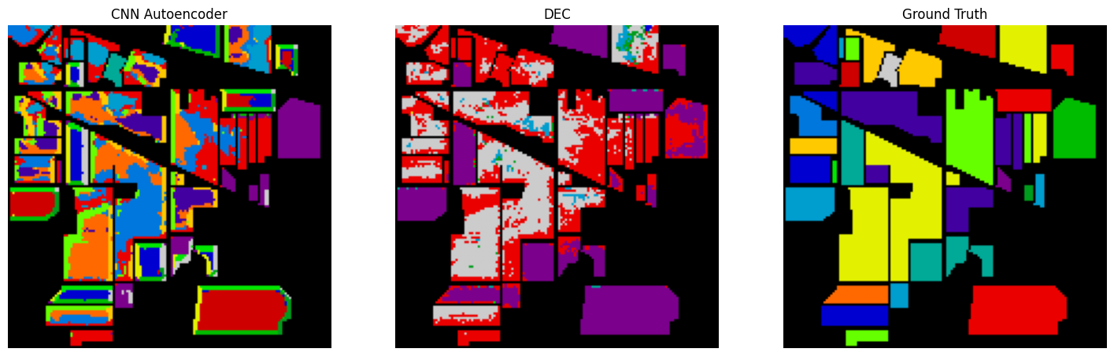

6.12 Spectral Signature Curves
The mean spectral signature of each cluster was analyzed to verify whether the clustering results correspond to physically meaningful material classes.
Distinct spectral profiles were observed for different clusters, indicating that the proposed clustering method successfully captured underlying material characteristics.
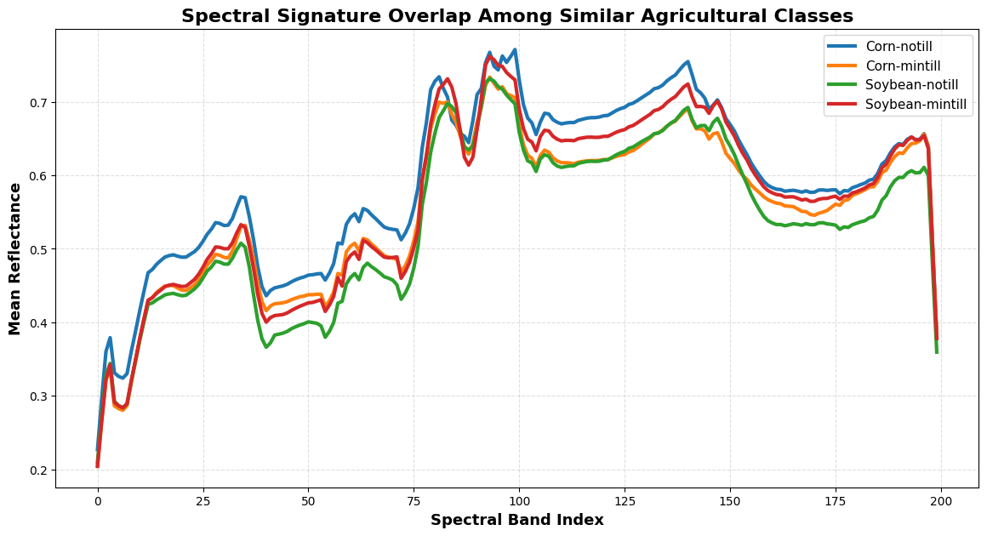
Clusters corresponding to vegetation classes exhibited strong reflectance in near-infrared bands, while soil and urban regions showed comparatively flatter spectral responses.

6.13 t-SNE Latent Space Visualization
To analyze the quality of the learned latent representations, t-SNE visualization was applied to the encoded feature space.
The projected 2D visualization shows that:
- traditional clustering features are highly overlapping
- DEC latent representations form compact and well-separated clusters
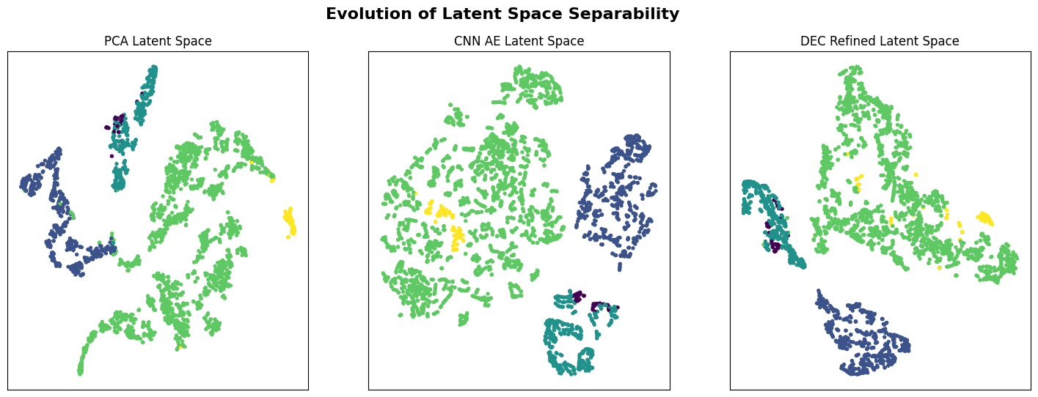
- This confirms that DEC successfully learns a cluster-friendly feature space.

CHAPTER 7: DISCUSSION

7.1 Introduction
This chapter discusses the experimental findings obtained from classical clustering, dimensionality reduction, autoencoder-based clustering, spatial-spectral learning, and Deep Embedded Clustering (DEC) applied to the Indian Pines hyperspectral dataset.
The purpose of this chapter is not only to compare numerical performance metrics, but also to explain:
- why certain methods performed better
- how feature representation affects clustering
- the importance of spatial information
- the limitations of current approaches
- future research directions
The experimental results demonstrate that clustering performance in hyperspectral imaging depends heavily on:
- feature quality
- dimensionality reduction
- spatial context
- latent-space separability

7.2 Discussion on Classical Clustering Methods
Traditional clustering methods such as KMeans were initially applied on:
- RGB representations
- single-band grayscale images
- false-color images
- PCA-reduced hyperspectral data
Among these approaches, PCA-based clustering achieved the best classical performance.

Why Single-Band Clustering Performed Poorly
Single-band clustering uses only one spectral feature:
$$x_{i}∈R^{1}$$
This representation contains very limited information regarding material properties.
As a result:
- different materials with similar reflectance values become indistinguishable
- cluster overlap increases
- segmentation quality decreases
For example:
- Corn and soybean classes may exhibit similar intensity values in a particular band
- KMeans groups them incorrectly into the same cluster
Thus, grayscale clustering cannot capture the true spectral characteristics of hyperspectral data.

Why False-Color Clustering Improved Performance
False-color clustering uses three selected spectral bands:
$$x_{i}∈R^{3}$$
This provides richer information than grayscale images and improves separability between materials.
However, only three spectral bands are still insufficient to represent:
- complete spectral signatures
- nonlinear spectral relationships
- subtle material variations
Therefore, although false-color clustering improved visualization and segmentation quality, it still suffered from:
- spectral information loss
- overlapping clusters
- limited discriminative power

Why PCA Improved Clustering
PCA-based clustering achieved the best performance among traditional methods because PCA:
- removes redundant spectral information
- suppresses noise
- preserves dominant variance directions
The original hyperspectral pixel:
$$x_{i}∈R^{220}$$
was transformed into:
$$z_{i}∈R^{30}$$
This reduction:
- decreases dimensionality
- improves cluster compactness
- reduces computational complexity
Additionally, PCA removes highly correlated bands:
$$b_{1}≈b_{2}≈b_{3}$$
which improves clustering stability.
The experimental results confirmed that PCA provides a more informative feature space for KMeans clustering compared to raw spectral vectors.

7.3 Discussion on Autoencoder-Based Clustering
Autoencoder-based clustering was introduced to overcome the limitations of linear dimensionality reduction methods such as PCA.
Unlike PCA, autoencoders learn nonlinear transformations:
$$z=f(x)$$
which can capture complex spectral relationships in hyperspectral data.

Advantages Observed
The autoencoder successfully:
- compressed high-dimensional spectral data
- reduced noise
- learned latent feature representations
The latent space generated by the encoder showed improved feature organization compared to raw spectral space.
This demonstrates that deep learning models can effectively model nonlinear hyperspectral patterns.

Why Autoencoder Did Not Outperform PCA
Despite its nonlinear learning capability, the implemented autoencoder achieved lower clustering accuracy than PCA-based KMeans.
Several factors contributed to this behavior.

1. Reconstruction-Oriented Optimization
The autoencoder minimizes reconstruction loss:
$$L_{AE}=∣∣x-\hat{x}∣∣^{2}$$
This objective focuses on:
- preserving information
- reconstructing input data
rather than:
- maximizing cluster separation
As a result, the learned latent space may not be cluster-friendly.

2. Lack of Spatial Information
The implemented autoencoder used only spectral vectors:
$$x_{i}∈R^{B}$$
without considering neighboring pixels.
This ignores important contextual information present in hyperspectral images.
Consequently:
- isolated pixels were frequently misclassified
- cluster boundaries became noisy

3. Overcompression
Applying PCA before the autoencoder introduced double compression:
$$220→30→latent$$
This may have removed useful discriminative information before deep feature learning.

4. Limited Network Complexity
A shallow dense autoencoder may not be powerful enough to model:
- complex spectral variations
- spatial continuity
- high-dimensional feature interactions
This suggests that:
- CNN-based autoencoders
- transformer-based encoders
- spatial attention models
could provide better representations.

7.4 Discussion on Spatial-Spectral Clustering
One of the most important observations from this project is the importance of spatial information in hyperspectral clustering.
Traditional clustering treats each pixel independently:
$$x_{i}∈R^{B}$$
However, real-world materials exist as spatially connected regions.
Neighboring pixels often belong to the same class.

Benefits of Spatial Information
Spatial-spectral clustering improved:
- segmentation smoothness
- boundary consistency
- cluster homogeneity
This occurred because local neighborhoods provide contextual information regarding:
- texture
- edges
- regional continuity
The extracted spatial patches:
$$P_{i}∈R^{p×p×B}$$
allowed the model to learn:
- spectral signatures
- neighborhood structure simultaneously
Reduction of Salt-and-Pepper Noise
Spectral-only clustering produced fragmented regions with isolated misclassified pixels.
Spatial learning reduced this effect by enforcing local consistency.
As a result:
- clusters became smoother
- boundaries became more coherent
- segmentation quality improved visually

Importance of Patch Size
Patch size significantly affects performance.
Small patches:
- fail to capture sufficient spatial context
Large patches:
- introduce redundant information
- increase computational cost
- oversmooth boundaries
The experiments showed that moderate patch sizes provide the best balance between:
- contextual learning
- computational efficiency

7.5 Discussion on Deep Embedded Clustering (DEC)
DEC represents the most advanced clustering method implemented in this project.
Unlike traditional autoencoders, DEC jointly optimizes:
- feature learning
- cluster assignment
through KL-divergence minimization.

Why DEC Performs Better
DEC refines the latent space iteratively using:
$$KL(P∣∣Q)$$
This optimization:
- reduces intra-cluster variance
- increases inter-cluster separation
- improves cluster compactness
The t-SNE visualizations showed that DEC learned:
- tighter clusters
- clearer boundaries
- better latent-space organization
compared to PCA and standard autoencoders.

Cluster-Friendly Latent Space
The soft assignment mechanism:
$$q_{ik}$$
allows DEC to continuously update:
- latent features
- cluster centers
This iterative refinement improves feature discriminability.
Unlike KMeans, DEC is not restricted to:
- linear cluster boundaries
- Euclidean geometry assumptions

Remaining Limitations of DEC
Despite improvements, DEC still faced challenges in:
- highly overlapping classes
- spectrally similar materials
- noisy regions
Examples include:
- Corn vs Soybean
- Grass vs Woods
These classes exhibit similar spectral signatures, making unsupervised separation difficult even in deep latent space.

7.6 Visualization-Based Analysis
The visual analysis further validated the effectiveness of deep clustering.

Ground Truth vs Clustering Maps
Comparison between:
- Ground Truth
- KMeans
- Autoencoder
- DEC
showed that DEC produced:
- smoother segmentation maps
- reduced fragmentation
- clearer material regions
Traditional KMeans generated:
- noisy clusters
- broken boundaries
- isolated pixels

Spectral Signature Curves
The mean spectral signatures of predicted clusters demonstrated that:
- clusters corresponded to meaningful material groups
- vegetation classes exhibited characteristic near-infrared reflectance
- different materials showed distinguishable spectral profiles
This confirms that the clustering results are physically meaningful rather than random groupings.

t-SNE Latent Space Visualization
t-SNE projection revealed that:
- PCA features remained partially overlapping
- autoencoder features became moderately compact
- DEC features formed highly separated clusters
This provides strong visual evidence that DEC learned a more discriminative latent representation.

7.7 Computational Complexity Discussion
As clustering methods became more advanced, computational complexity increased significantly.

Classical Methods
KMeans and PCA are computationally efficient and suitable for:
- small datasets
- fast experimentation
However, they cannot model nonlinear structures.

Deep Learning Methods
Autoencoders and DEC require:
- iterative optimization
- GPU resources
- large memory consumption
Training time increases with:
- patch size
- network depth
- latent dimension
Thus, there is a trade-off between:
- clustering accuracy
- computational efficiency

CHAPTER 8: CONCLUSION AND FUTURE WORK

Conclusion
This project demonstrates the transition from classical clustering methods to deep clustering for hyperspectral images. While traditional clustering methods are effective for simple datasets, they are insufficient for complex high-dimensional data.
Deep Embedded Clustering (DEC) significantly improves clustering performance by combining feature learning and clustering optimization.

Future Work
- Use CNN-based spatial models
- Apply graph-based clustering methods
- Develop real-time hyperspectral applications
- Extend to larger datasets (Salinas, KSC)

CHAPTER 9: REFERENCES

1. Spatial–Spectral Constrained Adaptive Graph for Hyperspectral Image Clustering by Xing-Hui Zhu 1,2, Yi Zhou 1,2, Meng-Long Yang 1,2 and Yang-Jun Deng 1,2,*
2. Unsupervised Deep Embedding for Clustering Analysis by Junyuan Xie, Ross Girshick, Ali Farhadi
3. Deep Clustering for Unsupervised Learning of Visual Features by Mathilde Caron, Piotr Bojanowski, Armand Joulin, and Matthijs Douze
4. Deep clustering using 3D attention convolutional autoencoder for hyperspectral image analysis by Ziyou Zheng 1, Shuzhen Zhang 1,2*, Hailong Song 1 & Qi Yan
5. Unsupervised Feature-Learning for Hyperspectral Data with Autoencoders by Lloyd Windrim 1,* , Rishi Ramakrishnan 2,†, Arman Melkumyan 1 and Richard J. Murphy 1 and AnnaChlingaryan 1
6. From Model-Based Optimization Algorithms to Deep Learning Models for Clustering Hyperspectral Images by Shaoguang Huang 1,2, Hongyan Zhang 1,*, Haijin Zeng 2 and Aleksandra Pižurica

