PSYCH 308B - DA6 - 2024

A local school district realized that none of their elementary teachers taught science (true story). In an attempt to remedy the situation, they developed a professional development course designed to teach their teachers science and how to teach science to their classes. This district sent their teachers to this course in cohorts. In order to determine if the PD course was working they had the first cohort of teachers complete a survey which asked them to rate, among other things, how comfortable they were teaching science to their elementary school class on a scale of 1 to 7. This survey was administered just before the PD course began, during the course, and one month after the course was completed. A CGU student begged them to get a comparison group and so, the same survey was administered to the second cohort of teachers at the same time as it was administered to the first cohort of teachers. This second cohort still has not received the PD course.

#Pre-work  
#Set up your libraries  
library(psych)

library(ez)  
library(car)

library(reshape)  
library(jmv)  
library(ggplot2)

library(heplots) # <- this library is needed for Box's test

library(tidyr) # <- this one is needed for pivot-wider code

library(pastecs)

#Pre-work  
#Set up your data  
science <- read.csv("308B.Data.DA6.csv")  
science$Subject <- as.factor(science$Subject)  
science$time <- factor(science$time, levels = c("pre", "during", "post"))  
  
#convert data from long to wide so you have it ready for the ANOVA code  
science.wide <- pivot_wider(science, names_from = time, values_from = value)

#creating a bar graph   
barscience <- ggplot(science, aes(time, value, fill = condition)) #order of the variables matters here!! If it's backwards, the bars are gonna go sideways  
  
barscience + stat_summary(fun.y = mean, geom = "bar", position = "dodge") + stat_summary(fun.data = mean_cl_normal, geom = "errorbar", position = position_dodge(width = 0.90), width = 0.2) + labs(x = "time", y = "Comfort Level", fill = "condition") + ggtitle('Effect of Professional Development on Comfort Level with Teaching Over Time') + scale_fill_manual("condition", values = c("aquamarine3", "orange2"))

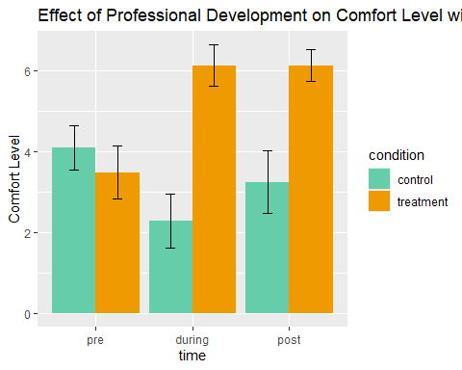

#create a line graph  
linescience <- ggplot(science, aes(time, value, colour = condition))

linescience + stat_summary(fun.y = mean, geom = "point") + stat_summary(fun.y = mean, geom = "line", aes(group = condition)) + stat_summary(fun.data = mean_cl_boot, geom = "errorbar", width = 0.2) + labs(x = "time", y = "Comfort Level", colour = "condition") + ggtitle('Effect of Professional Development on Comfort Level with Teaching Over Time') + scale_color_manual("condition", values = c("aquamarine3", "orange2"))

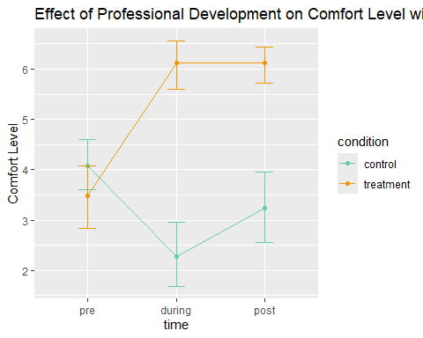

#This code specifies your model...  
modeltc<-aov(value~as.factor(condition)*as.factor(time),data=science)  
  
#....and this one returns all of the means (cell, marginal, and grand) for the model you specified   
model.tables(modeltc, type="means")

Tables of means  
Grand mean  
   
4.22   
  
 as.factor(condition)   
as.factor(condition)  
 control treatment   
 3.20 5.24   
  
 as.factor(time)   
as.factor(time)  
 pre during post   
 3.78 4.20 4.68   
  
 as.factor(condition):as.factor(time)   
 as.factor(time)  
as.factor(condition) pre during post  
 control 4.08 2.28 3.24  
 treatment 3.48 6.12 6.12

**Check Assumptions**

#Histograms: You already specified your model above, so in the code below we're just plotting the residuals (how much the model over or underestimates someones feedback score.You only need to check this one histogram!  
restc<-modeltc$residuals  
hist(restc, main="Histogram of residuals",xlab="Residuals")

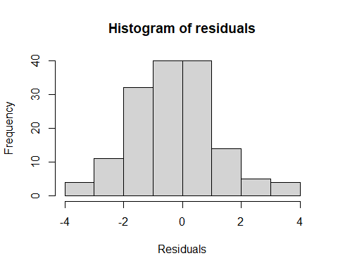

#confirm skew and kurtosis  
by(science$value, list(science$time, science$condition), basic = FALSE, norm = TRUE, stat.desc)

: pre  
: control  
 median mean SE.mean CI.mean.0.95 var std.dev   
 4.0000000 4.0800000 0.2640707 0.5450151 1.7433333 1.3203535   
 coef.var skewness skew.2SE kurtosis kurt.2SE normtest.W   
 0.3236161 0.1728305 0.1863669 -0.1412354 -0.0783144 0.9230784   
 normtest.p   
 0.0602361   
------------------------------------------------------------

: during  
: control  
 median mean SE.mean CI.mean.0.95 var   
 2.0000000000 2.2800000000 0.3241398875 0.6689918476 2.6266666667   
 std.dev coef.var skewness skew.2SE kurtosis   
 1.6206994375 0.7108330866 1.0288620478 1.1094443150 -0.1675416321   
 kurt.2SE normtest.W normtest.p   
-0.0929010838 0.7852087638 0.0001301105   
------------------------------------------------------------   
: post  
: control  
 median mean SE.mean CI.mean.0.95 var std.dev   
 3.00000000 3.24000000 0.37094474 0.76559231 3.44000000 1.85472370   
 coef.var skewness skew.2SE kurtosis kurt.2SE normtest.W   
 0.57244559 0.52794926 0.56929916 -0.85511909 -0.47415970 0.90891373   
 normtest.p   
 0.02882748   
------------------------------------------------------------   
: pre  
: treatment  
 median mean SE.mean CI.mean.0.95 var std.dev   
 4.00000000 3.48000000 0.31685959 0.65396605 2.51000000 1.58429795   
 coef.var skewness skew.2SE kurtosis kurt.2SE normtest.W   
 0.45525803 -0.29684142 -0.32009056 -1.08220766 -0.60007930 0.90412488   
 normtest.p   
 0.02258554   
------------------------------------------------------------   
: during  
: treatment  
 median mean SE.mean CI.mean.0.95 var   
 7.000000e+00 6.120000e+00 2.471167e-01 5.100238e-01 1.526667e+00   
 std.dev coef.var skewness skew.2SE kurtosis   
 1.235584e+00 2.018927e-01 -1.362090e+00 -1.468772e+00 7.870201e-01   
 kurt.2SE normtest.W normtest.p   
 4.363991e-01 7.269201e-01 1.715429e-05   
------------------------------------------------------------   
: post  
: treatment  
 median mean SE.mean CI.mean.0.95 var   
 6.0000000000 6.1200000000 0.1942506971 0.4009137344 0.9433333333   
 std.dev coef.var skewness skew.2SE kurtosis   
 0.9712534856 0.1587015499 -1.2745294451 -1.3743528106 1.8119708424   
 kurt.2SE normtest.W normtest.p   
 1.0047297081 0.7881593646 0.0001452044

#Box's Test  
#This code run Box's test to check homogeneity of the co-variance matrices. Box's M follows the chi square distribution, so we report is as x2(df) = X.XX, p = .XXX. Note that it uses the wide data  
BoxTestScience<-boxM(science.wide[,4:6],science.wide$condition) #use the wide format data for Box's test  
BoxTestScience$cov

$control  
 pre during post  
pre 1.7433333 -0.10666667 -1.31166667  
during -0.1066667 2.62666667 -0.02833333  
post -1.3116667 -0.02833333 3.44000000  
  
$treatment  
 pre during post  
pre 2.5100000 -0.81000000 -0.39333333  
during -0.8100000 1.52666667 0.06833333  
post -0.3933333 0.06833333 0.94333333

BoxTestScience

Box's M-test for Homogeneity of Covariance Matrices  
  
data: science.wide[, 4:6]  
Chi-Sq (approx.) = 14.491, df = 6, p-value = 0.02461

#Mixed Factorial ANOVA  
#Questions 2-3: Main Effect for Time, Main Effect for Condition, and Interaction   
model.rm <- anovaRM(data = science.wide,   
 rm = list(list(label = 'Time',  
 levels = c('pre', 'during', 'post'))),   
 rmCells = list(list(measure = 'pre', cell = 'pre'),  
 list(measure = 'during', cell = 'during'),  
 list(measure = 'post', cell = 'post')),  
 rmTerms = list('Time'),  
 bs = 'condition',  
 bsTerms = list('condition'),  
 effectSize = c('partEta'),  
 leveneTest = TRUE,  
 spherTests = TRUE,  
 spherCorr = c('none','GG'),  
 postHoc = list('Time', 'condition'),  
 postHocCorr = list('holm', 'tukey'),  
 emMeans = ~ Time + condition + Time:condition,  
 emmTables = T)  
model.rm

Between Subjects Effects   
 ───────────────────────────────────────────────────────────────────────────────────────────   
 Sum of Squares df Mean Square F p η²-p   
 ───────────────────────────────────────────────────────────────────────────────────────────   
 condition 156.06000 1 156.060000 122.7745 < .0000001 0.7189276   
 Residual 61.01333 48 1.271111   
 ───────────────────────────────────────────────────────────────────────────────────────────   
 Note. Type 3 Sums of Squares  
  
  
 ASSUMPTIONS  
  
 Tests of Sphericity   
 ─────────────────────────────────────────────────────────────────────────────   
 Mauchly's W p Greenhouse-Geisser ε Huynh-Feldt ε   
 ─────────────────────────────────────────────────────────────────────────────   
 Time 0.9590914 0.3747229 0.9606992 0.9999058   
 ─────────────────────────────────────────────────────────────────────────────   
  
  
 Homogeneity of Variances Test (Levene's)   
 ──────────────────────────────────────────────────   
 F df1 df2 p   
 ──────────────────────────────────────────────────   
 pre 1.674873 1 48 0.2017993   
 during 2.764349 1 48 0.1029033   
 post 10.746707 1 48 0.0019470   
 ──────────────────────────────────────────────────   
  
  
   
  
  
  
  
POST HOC TESTS  
  
 Post Hoc Comparisons - Time   
 ───────────────────────────────────────────────────────────────────────────────────────────────────────────   
 Time Time Mean Difference SE df t p-tukey p-holm   
 ───────────────────────────────────────────────────────────────────────────────────────────────────────────  
 pre - during -0.4200000 0.3200000 48.00000 -1.312500 0.3952720 0.2106991   
 - post -0.9000000 0.3470831 48.00000 -2.593039 0.0330659 0.0377185   
 during - post -0.4800000 0.2908035 48.00000 -1.650599 0.2347467 0.2106991   
 ───────────────────────────────────────────────────────────────────────────────────────────────────────────  
  
  
 Post Hoc Comparisons - condition   
 ───────────────────────────────────────────────────────────────────────────────────────────────────────────  
condition condition Mean Difference SE df t p-tukey p-holm   
 ───────────────────────────────────────────────────────────────────────────────────────────────────────────   
control - treatment -2.040000 0.1841095 48.00000 -11.08036 < .0000001 < .0000001   
 ───────────────────────────────────────────────────────────────────────────────────────────────────────────  
 ESTIMATED MARGINAL MEANS  
 TIME  
  
 Estimated Marginal Means - Time   
 ───────────────────────────────────────────────────────────   
 Time Mean SE Lower Upper   
 ───────────────────────────────────────────────────────────   
 pre 3.780000 0.2062361 3.365335 4.194665   
 during 4.200000 0.2037973 3.790238 4.609762   
 post 4.680000 0.2093641 4.259045 5.100955   
 ───────────────────────────────────────────────────────────   
  
  
 CONDITION  
  
 Estimated Marginal Means - condition   
 ──────────────────────────────────────────────────────────────   
 condition Mean SE Lower Upper   
 ──────────────────────────────────────────────────────────────   
 control 3.200000 0.1301851 2.938245 3.461755   
 treatment 5.240000 0.1301851 4.978245 5.501755   
 ──────────────────────────────────────────────────────────────   
  
  
 TIME:CONDITION  
  
 Estimated Marginal Means - Time:condition   
 ────────────────────────────────────────────────────────────────────────   
 condition Time Mean SE Lower Upper   
 ────────────────────────────────────────────────────────────────────────   
 control pre 4.080000 0.2916619 3.493574 4.666426   
 during 2.280000 0.2882129 1.700509 2.859491   
 post 3.240000 0.2960856 2.644680 3.835320   
 treatment pre 3.480000 0.2916619 2.893574 4.066426   
 during 6.120000 0.2882129 5.540509 6.699491   
 post 6.120000 0.2960856 5.524680 6.715320   
 ────────────────────────────────────────────────────────────────────────

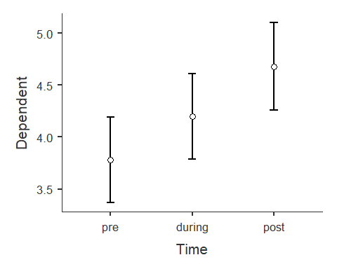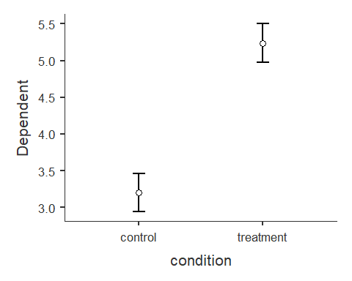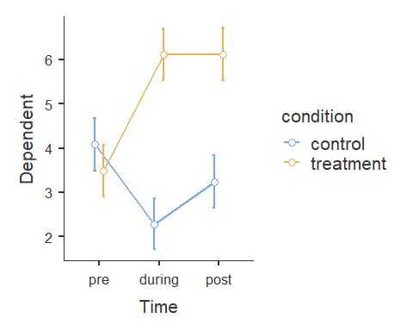

#Simple Effects Option 1  
#Question 4: Assumptions for simple effect analyses  
#Normal distribution, but to do this, you can first create a subset for each time point  
Pre <- subset(science, science$time == "pre")  
During <- subset(science, science$time == "during")  
Post <- subset(science, science$time == "post")  
  
# Then run descriptives of each time point by condition  
descriptives(Pre, vars = c('value'), splitBy = c('condition'), skew = TRUE, kurt = TRUE, hist = TRUE)

DESCRIPTIVES  
  
 Descriptives   
 ──────────────────────────────────────────────────   
 condition value   
 ──────────────────────────────────────────────────   
 N control 25   
 treatment 25   
 Missing control 0   
 treatment 0   
 Mean control 4.080000   
 treatment 3.480000   
 Median control 4   
 treatment 4   
 Standard deviation control 1.320353   
 treatment 1.584298   
 Minimum control 1   
 treatment 1   
 Maximum control 7   
 treatment 6   
 Skewness control 0.1956867   
 treatment -0.3360976   
 Std. error skewness control 0.4636835   
 treatment 0.4636835   
 Kurtosis control 0.4103199   
 treatment -0.8488039   
 Std. error kurtosis control 0.9017205   
 treatment 0.9017205   
 ──────────────────────────────────────────────────

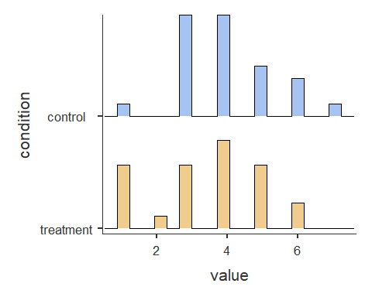

descriptives(During, vars = c('value'), splitBy = c('condition'), skew = TRUE, kurt = TRUE, hist = TRUE)

DESCRIPTIVES  
  
 Descriptives   
 ─────────────────────────────────────────────────   
 condition value   
 ─────────────────────────────────────────────────   
 N control 25   
 treatment 25   
 Missing control 0   
 treatment 0   
 Mean control 2.280000   
 treatment 6.120000   
 Median control 2   
 treatment 7   
 Standard deviation control 1.620699   
 treatment 1.235584   
 Minimum control 1   
 treatment 3   
 Maximum control 6   
 treatment 7   
 Skewness control 1.164925   
 treatment -1.542222   
 Std. error skewness control 0.4636835   
 treatment 0.4636835   
 Kurtosis control 0.3751193   
 treatment 1.652427   
 Std. error kurtosis control 0.9017205   
 treatment 0.9017205   
 ─────────────────────────────────────────────────

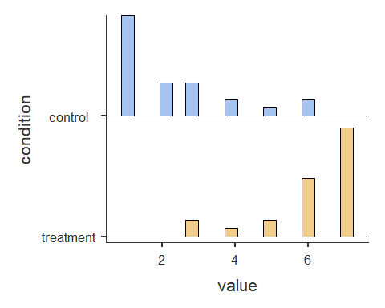

descriptives(Post, vars = c('value'), splitBy = c('condition'), skew = TRUE, kurt = TRUE, hist = TRUE)

DESCRIPTIVES  
  
 Descriptives   
 ──────────────────────────────────────────────────   
 condition value   
 ──────────────────────────────────────────────────   
 N control 25   
 treatment 25   
 Missing control 0   
 treatment 0   
 Mean control 3.240000   
 treatment 6.120000   
 Median control 3   
 treatment 6   
 Standard deviation control 1.854724   
 treatment 0.9712535   
 Minimum control 1   
 treatment 3   
 Maximum control 7   
 treatment 7   
 Skewness control 0.5977686   
 treatment -1.443081   
 Std. error skewness control 0.4636835   
 treatment 0.4636835   
 Kurtosis control -0.5449346   
 treatment 3.023923   
 Std. error kurtosis control 0.9017205   
 treatment 0.9017205   
 ──────────────────────────────────────────────────

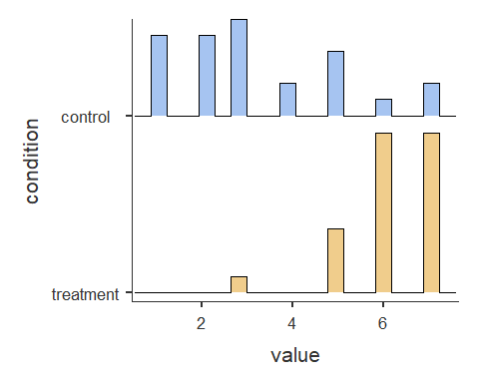

#Simple Effects Option 1  
# Question 5: Simple Effects Analyses  
# Note: notice that a Welch's correction was added to the code for the third t-test since levene's was significant for those two groups (i.e., treatment and control for the "Post" time point)  
ttestIS(data=Pre, vars = 'value', group = 'condition', eqv = T, effectSize = T, desc = TRUE)

INDEPENDENT SAMPLES T-TEST  
  
 Independent Samples T-Test   
 ──────────────────────────────────────────────────────────────────────────────────────────   
 Statistic df p Effect Size   
 ──────────────────────────────────────────────────────────────────────────────────────────   
 value Student's t 1.454643 48.00000 0.1522766 Cohen's d 0.4114353   
 ──────────────────────────────────────────────────────────────────────────────────────────   
 Note. Hₐ μ <sub>control</sub> ≠ μ <sub>treatment</sub>  
  
  
 ASSUMPTIONS  
  
 Homogeneity of Variances Test (Levene's)   
 ───────────────────────────────────────────────   
 F df df2 p   
 ───────────────────────────────────────────────   
 value 1.674873 1 48 0.2017993   
 ───────────────────────────────────────────────   
 Note. A low p-value suggests a violation  
 of the assumption of equal variances  
  
  
 Group Descriptives   
 ─────────────────────────────────────────────────────────────────────────────   
 Group N Mean Median SD SE   
 ─────────────────────────────────────────────────────────────────────────────   
 value control 25 4.080000 4.000000 1.320353 0.2640707   
 treatment 25 3.480000 4.000000 1.584298 0.3168596   
 ─────────────────────────────────────────────────────────────────────────────

ttestIS(data=During, vars = 'value', group = 'condition', eqv = T, effectSize = T, desc = TRUE)

INDEPENDENT SAMPLES T-TEST  
  
 Independent Samples T-Test   
 ───────────────────────────────────────────────────────────────────────────────────────────   
 Statistic df p Effect Size   
 ───────────────────────────────────────────────────────────────────────────────────────────   
 value Student's t -9.421126 48.00000 < .0000001 Cohen's d -2.664697   
 ───────────────────────────────────────────────────────────────────────────────────────────   
 Note. Hₐ μ <sub>control</sub> ≠ μ <sub>treatment</sub>  
  
  
 ASSUMPTIONS  
  
 Homogeneity of Variances Test (Levene's)   
 ───────────────────────────────────────────────   
 F df df2 p   
 ───────────────────────────────────────────────   
 value 2.764349 1 48 0.1029033   
 ───────────────────────────────────────────────   
 Note. A low p-value suggests a violation  
 of the assumption of equal variances  
  
  
 Group Descriptives   
 ─────────────────────────────────────────────────────────────────────────────   
 Group N Mean Median SD SE   
 ─────────────────────────────────────────────────────────────────────────────   
 value control 25 2.280000 2.000000 1.620699 0.3241399   
 treatment 25 6.120000 7.000000 1.235584 0.2471167   
 ─────────────────────────────────────────────────────────────────────────────

ttestIS(data=Post, vars = 'value', group = 'condition', welchs = T, eqv = T, effectSize = T, desc = TRUE)

INDEPENDENT SAMPLES T-TEST  
  
 Independent Samples T-Test   
 ───────────────────────────────────────────────────────────────────────────────────────────   
 Statistic df p Effect Size   
 ───────────────────────────────────────────────────────────────────────────────────────────   
 value Student's t -6.877969 48.00000 < .0000001 Cohen's d -1.945384   
 Welch's t -6.877969 36.24219 < .0000001 Cohen's d -1.945384   
 ───────────────────────────────────────────────────────────────────────────────────────────   
 Note. Hₐ μ <sub>control</sub> ≠ μ <sub>treatment</sub>  
  
  
 ASSUMPTIONS  
  
 Homogeneity of Variances Test (Levene's)   
 ───────────────────────────────────────────────   
 F df df2 p   
 ───────────────────────────────────────────────   
 value 10.74671 1 48 0.0019470   
 ───────────────────────────────────────────────   
 Note. A low p-value suggests a violation  
 of the assumption of equal variances  
  
  
 Group Descriptives   
 ──────────────────────────────────────────────────────────────────────────────   
 Group N Mean Median SD SE   
 ──────────────────────────────────────────────────────────────────────────────   
 value control 25 3.240000 3.000000 1.854724 0.3709447   
 treatment 25 6.120000 6.000000 0.9712535 0.1942507   
 ──────────────────────────────────────────────────────────────────────────────

#Simple Effects Option 2  
#Question 4: Assumptions for simple effect analyses (subset by condition)  
#Normal distribution, but to do this, you can first create a subset for each time point  
Treatment <- subset(science.wide, science.wide$condition == "treatment")  
Control <- subset(science.wide, science.wide$condition == "control")  
  
# Then run descriptives of each time point by condition  
describe.by(Treatment)

Warning: describe.by is deprecated. Please use the describeBy function

Warning in describeBy(x = x, group = group, mat = mat, type = type, ...): no  
grouping variable requested

vars n mean sd median trimmed mad min max range skew kurtosis  
Subject* 2 25 13.00 7.36 13 13.00 8.90 1 25 24 0.00 -1.34  
condition* 3 25 1.00 0.00 1 1.00 0.00 1 1 0 NaN NaN  
pre 4 25 3.48 1.58 4 3.48 1.48 1 6 5 -0.30 -1.08  
during 5 25 6.12 1.24 7 6.33 0.00 3 7 4 -1.36 0.79  
post 6 25 6.12 0.97 6 6.24 1.48 3 7 4 -1.27 1.81  
 se  
Subject* 1.47  
condition* 0.00  
pre 0.32  
during 0.25  
post 0.19

describe.by(Control)

Warning: describe.by is deprecated. Please use the describeBy function  
  
Warning: no grouping variable requested

vars n mean sd median trimmed mad min max range skew kurtosis  
Subject* 2 25 38.00 7.36 38 38.00 8.90 26 50 24 0.00 -1.34  
condition* 3 25 1.00 0.00 1 1.00 0.00 1 1 0 NaN NaN  
pre 4 25 4.08 1.32 4 4.05 1.48 1 7 6 0.17 -0.14  
during 5 25 2.28 1.62 2 2.05 1.48 1 6 5 1.03 -0.17  
post 6 25 3.24 1.85 3 3.10 1.48 1 7 6 0.53 -0.86  
 se  
Subject* 1.47  
condition* 0.00  
pre 0.26  
during 0.32  
post 0.37

#Simple Effects Option 2  
# Question 5: Simple Effects Analyses - Subset by condition, Treatment  
  
modeltreat <- anovaRM(data = Treatment,   
 rm = list(list(label = 'Time',  
 levels = c('pre', 'during', 'post'))),   
 rmCells = list(list(measure = 'pre', cell = 'pre'),  
 list(measure = 'during', cell = 'during'),  
 list(measure = 'post', cell = 'post')),  
 rmTerms = list('Time'),  
 effectSize = c('partEta', 'eta'),  
 spherTests = TRUE,   
 spherCorr = c('none','GG'),  
 postHoc = list('Time'),  
 postHocCorr = 'holm',  
 emMeans = ~ Time,  
 emmTables = T)  
modeltreat

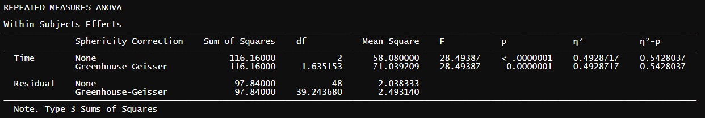

Between Subjects Effects   
 ───────────────────────────────────────────────────────────────────────────────────────────────   
 Sum of Squares df Mean Square F p η² η²-p   
 ───────────────────────────────────────────────────────────────────────────────────────────────   
 Residual 21.68000 24 0.9033333   
 ───────────────────────────────────────────────────────────────────────────────────────────────   
 Note. Type 3 Sums of Squares  
  
  
 ASSUMPTIONS  
  
 Tests of Sphericity   
 ─────────────────────────────────────────────────────────────────────────────   
 Mauchly's W p Greenhouse-Geisser ε Huynh-Feldt ε   
 ─────────────────────────────────────────────────────────────────────────────   
 Time 0.7768731 0.0548310 0.8175767 0.8691952   
 ─────────────────────────────────────────────────────────────────────────────   
  
  
 POST HOC TESTS  
  
 Post Hoc Comparisons - Time   
 ───────────────────────────────────────────────────────────────────────────────────────────────   
 Time Time Mean Difference SE df t p-holm   
 ───────────────────────────────────────────────────────────────────────────────────────────────   
 pre - during -2.640000 0.4756750 24.00000 -5.550008 0.0000208   
 - post -2.640000 0.4118252 24.00000 -6.410487 0.0000038   
 during - post 0.000000 0.3055050 24.00000 0.000000 1.0000000   
 ───────────────────────────────────────────────────────────────────────────────────────────────   
  
  
 ESTIMATED MARGINAL MEANS  
  
 TIME  
  
 Estimated Marginal Means - Time   
 ───────────────────────────────────────────────────────────   
 Time Mean SE Lower Upper   
 ───────────────────────────────────────────────────────────   
 pre 3.480000 0.3168596 2.826034 4.133966   
 during 6.120000 0.2471167 5.609976 6.630024   
 post 6.120000 0.1942507 5.719086 6.520914   
 ───────────────────────────────────────────────────────────

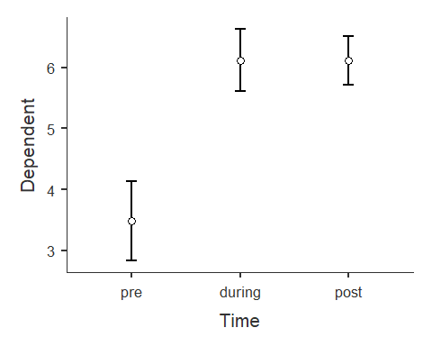

#Simple Effects Option 2  
# Question 5: Simple Effects Analyses - Subset by condition, Control  
  
modelcont <- anovaRM(data = Control,   
 rm = list(list(label = 'Time',  
 levels = c('pre', 'during', 'post'))),   
 rmCells = list(list(measure = 'pre', cell = 'pre'),  
 list(measure = 'during', cell = 'during'),  
 list(measure = 'post', cell = 'post')),  
 rmTerms = list('Time'),  
 effectSize = c('partEta', 'eta'),  
 spherTests = TRUE,   
 spherCorr = c('none','GG'),  
 postHoc = list('Time'),  
 postHocCorr = 'holm',  
 emMeans = ~ Time,  
 emmTables = T)  
modelcont

Between Subjects Effects   
 ───────────────────────────────────────────────────────────────────────────────────────────────   
 Sum of Squares df Mean Square F p η² η²-p   
 ───────────────────────────────────────────────────────────────────────────────────────────────   
 Residual 39.33333 24 1.638889   
 ───────────────────────────────────────────────────────────────────────────────────────────────   
 Note. Type 3 Sums of Squares  
  
  
 ASSUMPTIONS  
  
 Tests of Sphericity   
 ─────────────────────────────────────────────────────────────────────────────   
 Mauchly's W p Greenhouse-Geisser ε Huynh-Feldt ε   
 ─────────────────────────────────────────────────────────────────────────────   
 Time 0.9089985 0.3337923 0.9165890 0.9886273   
 ─────────────────────────────────────────────────────────────────────────────   
  
  
 POST HOC TESTS  
  
 Post Hoc Comparisons - Time   
 ───────────────────────────────────────────────────────────────────────────────────────────────   
 Time Time Mean Difference SE df t p-holm   
 ───────────────────────────────────────────────────────────────────────────────────────────────   
 pre - during 1.8000000 0.4281744 24.00000 4.203894 0.0009431   
 - post 0.8400000 0.5588083 24.00000 1.503199 0.1458335   
 during - post -0.9600000 0.4949074 24.00000 -1.939757 0.1284987   
 ───────────────────────────────────────────────────────────────────────────────────────────────   
  
  
 ESTIMATED MARGINAL MEANS  
  
 TIME  
  
 Estimated Marginal Means - Time   
 ───────────────────────────────────────────────────────────   
 Time Mean SE Lower Upper   
 ───────────────────────────────────────────────────────────   
 pre 4.080000 0.2640707 3.534985 4.625015   
 during 2.280000 0.3241399 1.611008 2.948992   
 post 3.240000 0.3709447 2.474408 4.005592   
 ───────────────────────────────────────────────────────────

