LAPORAN FINAL PROJECT DEEP LEARNING


EFFICIENT DEEPFAKE DETECTION ON IMBALANCED DATASETS: A RESNET18 AND FOCAL LOSS APPROACH

Class: LD01

Jesslyn Trixie Edvilie | 2702260514
Brian Juniarta Darmadi | 2702279363
Mochammad Aqsa Sandhy Pradipta | 2702302744

Deep Learning
Semester Ganjil 2025/2026
Laporan

Abstract— The spread of hyper-realistic synthetic media, called deepfakes, is a critical threat to information integrity and requires adequate mechanisms for their detection. However, the current state-of-the-art (SOTA) methods, such as XceptionNet, are often based on computationally intensive architectures, which are unsuitable for resource-constrained edge. Furthermore, these models often have difficulty dealing with class imbalance in large-scale datasets, resulting in high false-positive rates for authentic content. This paper proposes a deep-fake detection pipeline that is light and robust by using ResNet18. Focal Loss was added to the problem of class imbalance, and this helps a lot in recalling the minority class of authentic class to 80.68% by focusing training on hard negatives. Additionally, the pipeline includes YOLOv8 for accurate Region-of-Interest (RoI) extraction and a Gaussian Blur augmentation strategy to address specific compression issues. Experimental results on the FaceForensics++ (c23) dataset shows a Test Accuracy of 93.31%. The proposed model retains 97.5% of the SOTA baseline performance and decreases the number of parameters by about 50%, which validates the efficacy of efficient architectures for scalable, real-time forensic applications.

I. INTRODUCTION

The spread of hyper-realistic synthetic media, or "deepfakes," represents a great threat to information integrity, with applications ranging from political disinformation to identity theft and financial fraud. As manipulation techniques improve, it has become more difficult to differentiate between what is fake and what is not. While state-of-the-art (SOTA) detection methods have achieved impressive accuracy, they often are based on deep, computationally intensive architectures. For example, the current benchmark standard set by Rossler et al. [1] is based on XceptionNet [2], which is a deep Convolutional Neural Network (CNN) that comprises about 23 million parameters. While highly effective, such heavy backbones are often ill-suited for real-time deployment in resource-constrained environments, such as on-device mobile authentication or edge computing forensics.
Furthermore, existing benchmarks often hide a critical vulnerability related to class imbalance. In typical large-scale datasets such as FaceForensics++ (FF++) [1] manipulated videos significantly outnumber authentic sequences; 6,000 manipulated videos vs. 1,000 authentic sequences. 1:6. Standard training regimes which use Cross-Entropy loss create a bias towards the majority class ("Fake"), leading to grossly high false-positive rates for genuine content [3]. A detector that flags genuine footage as manipulated is unusable in sensitive scenarios, such as automated content moderation or verification of legal evidence, where the presumption of authenticity is paramount.
In this work, we propose a lightweight and robust deep-fake detection pipeline to address both the two challenges: computational efficiency and the problem of class imbalance. Unlike previous approaches based on heavy architecture, we make use of ResNet18 [4], which is a much smaller architecture with roughly 11 million parameters. We assume that algorithmic improvements can make up for a lower model capacity.
This paper makes three contributions. First, we show that the application of Focal Loss [5] greatly surpasses standard Class Weighting for the minority ("Real") class from Recall of about 70% to 80% without using synthetic data upsampling. Second, we conduct a thorough ablation study of preprocessing techniques, for which we find that precise face cropping using YOLOv8 [6] with Gaussian Blur augmentation are the main factors of dataset-specific compression artifact robustness. Finally, we get a Test Accuracy of 93.3% on the highly compressed (c23) FF++ dataset. This result maintains 97.5% of the performance of the SOTA baseline while cutting down the number of parameters by around 50%, giving us the viability of efficient architectures for scalable deepfake detection.

II. RELATED WORK

- Deepfake Techniques for Generation
- Face Swapping using Autoencoders
The techniques that gave "deepfakes" their name are based on autoencoder architectures. This approach consists of training two independent autoencoders with the source identity and the target identity respectively but using one common encoder. This is where the encoder learns a latent representation of the features of a face and each decoder learns how to generate a face from the latent space. To perform a swap, an image of the person to be replaced is fed into the shared encoder, and the latent vector generated is then fed into the moccasin's decoder. This is a reconstruction of the expression and pose of the source person but with the target person's identity [7]. This technique is fundamental and it is represented by methods such as Deepfakes and FaceSwap in the dataset used for this project.

- Generative Adversarial Networks
More recent and sophisticated techniques of forgery take advantage of Generative Adversarial Networks (GANs). A GAN is made up of two neural networks that compete with each other: a generator that generates synthetic data and a discriminator that attempts to tell the difference between the generated data and the real data. Through this adversarial process, the generator gets good at generating extremely realistic images. GANs are being used not only for full face synthesis, but also for attribute manipulation (e.g., changing hair color) and expression swapping. Methods such as FaceShifter and NeuralTextures in the FaceForensics++ dataset are examples of GAN-based methods that can generate higher-quality results and address issues such as facial occlusions [8].

- Deep Learning Architectures for Forgery Detection
The change from hand-crafted-forensic features to data-driven methods has been made possible by the superior feature learning capabilities of Convolutional Neural Networks (CNNs) [1]. In contrast to the early methods which are based on specific biological inconsistencies, such as eye blinking or head pose, deep learning approaches analyse the entire image in order to find latent manipulation artifacts [9].
Current state-of-the-art detection frameworks mostly rely on deep architectures that are transferred to the general object recognition problem. The FaceForensics++ benchmark, created by Rossler et al., allows XceptionNet to be identified as the best performing baseline [10]. By using depthwise separable convolution and residual connections trained in advance using ImageNet, XceptionNet shows that it can better deal with weak compression and still give reasonable performance on low quality images [11].
Parallel research has been done into alternative architecture aiming to isolate specific forensic traces. Bayar and Stamm proposed the use of a constrained convolutional layer to suppress high-level image content to force the network to learn features of low-level manipulation [12]. Similarly, Rahmouni et al adopted architectures that use global pooling layers to calculate statistical features (mean, variance, maximum and minimum) for distinguishing computer graphics from natural images [11].
While these "heavy" backbones have good accuracy, there is an increasing interest in efficiency. Compact architectures like MesoNet (MesoInception-4) have been proposed to detect facial tampering with much less parameters [12]. However, comparative evaluations on the FaceForensics++ benchmark have shown that although MesoNet is efficient, it may be less accurate than deeper networks such as XceptionNet in many cases, especially when working with compressed video streams. This sets up a good tradeoff between model capacity and detection performance, and encourages us to explore ResNet18 as an optimal model for striking a good balance between computational efficiency and strong feature extraction.

- Spatial versus Temporal Analysis
Deepfake detection methodologies are broadly classified according to the temporal scope of their analysis: spatial solutions, which analyze single frames independently, and temporal solutions, which analyze video sequences to find inconsistencies in time.
Temporal methods are based on the understanding that frame-by-frame synthesis cannot usually preserve temporal coherence and produces cases of flickering, jittering or unnatural movement artifacts. To capture these inter-frame inconsistencies, researchers have proposed architectures that are a combination of Convolutional Neural Networks (CNNs) and Recurrent Neural Networks (RNNs). For example, Guera and Delp proposed the usage of a Long Short-Term Memory (LSTM) network on top of a CNN for extraction of temporal sequence descriptors for detection [13]. Similarly, approaches that use physiological signals, such as irregular eye blinking patterns [14] or pulse variance, rely on time-based analysis to differentiate between living subjects and synthetic generation.
However, temporal models have a high computational cost. The addition of 3D convolutions or recurrent layers leads to higher memory consumption and inference time which makes them less suitable for real-time mobile applications. Furthermore, FaceForensics++ benchmark revealed that purely spatial classifiers such as XceptionNet often outperform temporal baselines when trained with large-scale datasets, especially when the manipulation artifacts are heavily in terms of structure rather than in terms of time [1].
In this work, we take a spatial (frame-based) approach by using ResNet18. We hypothesize that if we can improve the robustness of the feature extractor to compress noise by using Focal Loss and Gaussian augmentation, a 2D-CNN could perform high detection accuracy with a fraction of the computation power compared to temporal models. This is consistent with the results of Rossler et al. who used frame-based classification to set the current benchmarks for the FaceForensics++ dataset [1].

- Deepfake Benchmark Datasets and Compression
The efficacy of forensic detectors is inherently related to the diversity and quality of the training data. Early datasets such as the TIMIT database or the UADFV dataset were often small in scale and low in quality visuals, which allowed detectors to overfit simple artifacts. To remedy this, Rossler et al. launched FaceForensics++ (FF++), a large-scale dataset containing 1000 original video sequences and 4000 fake variations created using four automated techniques: DeepFakes, Face2Face, FaceSwap, and NeuralTextures [1].
A crucial contribution of the FF++ benchmark is its focus on realistic deployment scenarios, in this case video compression. Rossler et al. noted that raw videos are rarely available on the internet; social media platforms always employ compression as a "laundering" mechanism for manipulation traces [1]. To simulate this, the dataset includes three levels of quality: Raw (c0), High Quality (c23, compressed using H.264 codec and a quantization level of 23) and Low Quality (c40) [1].
While later datasets such as Celeb-DF and the Deepfake Detection Challenge (DFDC) have enhanced the visual fidelity of the deepfakes, FF++ (c23) is the de facto standard for testing the robustness of the deepfake against compression artifacts. Previous works show that performance is considerably reduced when models that are trained on raw data are tested on compressed streams [15]. Consequently, we use the c23 (High Quality) subset for this study to ensure that our lightweight model is tested against the compression noise that is encountered in social media environments rather than in pristine laboratory conditions.

III. METHODOLOGY

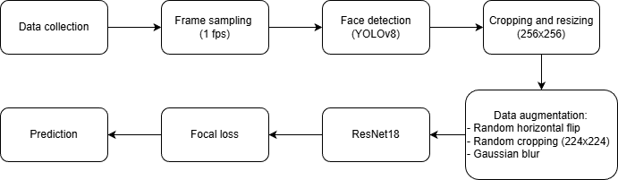
Figure 1. Research Workflow

A. Data Collection and Partitioning
We utilized the FaceForensics++ (FF++) benchmark [1], specifically the c23 (High Quality) compression subset. This subset applies H.264 compression (quantization parameter 23), simulating the realistic video quality found on social media platforms while retaining sufficient forensic traces for detection.
The dataset consists of 1,000 original video sequences and 6,000 manipulated variations generated using four automated methods (Deepfakes, Face2Face, FaceSwap, NeuralTextures) as well as advanced methods like FaceShifter. We formulated the task as a binary classification problem:
1) Class 0 (Authentic): Frames extracted from the 1,000 original sequences.
2) Class 1 (Manipulated): Frames extracted from all manipulation categories, aggregated into a single "Fake" class.
We implemented a strict video-level split. The dataset was partitioned into Training (70%), Validation (15%), and Testing (15%) sets based on unique video identifiers. This prevents data leakage that happens when frames from the same video appear in both training and testing sets, leading to inflated accuracy metrics. By separating videos entirely, we ensure the model generalizes to unseen subjects and environments.
From each video, we sampled frames at a rate of approximately 1 fps (capped at 20 frames per video) to construct the final image-based dataset. This resulted in a Training set of 97,156 images, a Validation set of 20,759 images, and a Test set of 20,784 images.

B. Face Extraction and Preprocessing
We used a Region-of-Interest (RoI) extraction strategy to eliminate background noise and enforce translation invariance. We utilize YOLOv8-Face [6], a specialized object detection model, to localize facial regions within sampled video frames. For each detected face, we apply a bounding box expansion factor of $1.3×$ before cropping to capture boundary artifacts along the facial contour. Frames are subsequently resized to $256×256$ pixels to standardize input dimensions.

C. Blur-Based Augmentation Strategy
A known vulnerability of classifiers trained on compressed data is the tendency to overfit to JPEG quantization artifacts rather than manipulation traces. To mitigate this, we implement a Gaussian Blur augmentation strategy using standard PyTorch transforms.
We apply a Gaussian kernel (3\times3) with a probability of $p=0.2$. Unlike aggressive noise injections, mild blurring acts as a low-pass filter, suppressing high-frequency compression noise and forcing the network to learn geometric inconsistencies (e.g., mismatched landmarks) that persist even in low-quality video. Additional geometric augmentations include random horizontal flips and random cropping to $224×224$ to improve generalization against pose and position variations.

D. Network Architecture
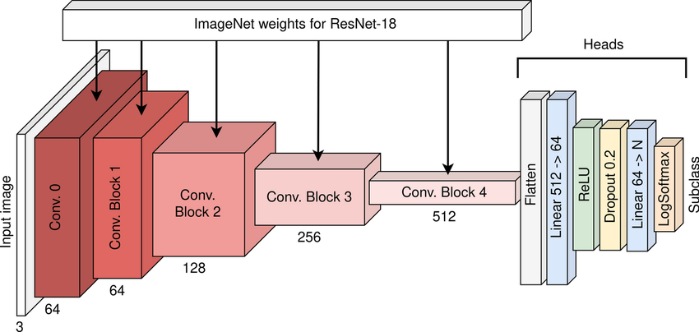
Figure 2. ResNet18 Architecture
To satisfy the constraint of real-time deployment on edge devices, we employ ResNet18 [4] as our backbone architecture. Unlike heavier models used in prior benchmarks (e.g., XceptionNet, 23M parameters), ResNet18 contains approximately 11.7 million parameters. We utilize Transfer Learning by initializing the network with weights pre-trained on ImageNet, allowing the model to leverage robust low-level feature detectors immediately.

E. Optimization via Focal Loss
Standard Cross-Entropy loss is ill-suited for the FaceForensics++ dataset, where manipulated videos outnumber authentic ones by 6:1. To prevent the majority class from dominating the gradient descent, we implement Focal Loss [5]:

$$FL\left(p_{t}\right)= -α{\left(1 - p_{t}\right)}^{γ} log\left(p_{t}\right)$$

We empirically determined optimal hyperparameters of $α=0.25$ to balance the class weights and $γ=2.0$ to down-weight easy examples (obvious fakes) and focus training on hard negatives (realistic fakes or difficult real faces).

F. Experimental Setup
The framework was implemented using PyTorch. Training was conducted using the Adam optimizer with an initial learning rate of $1×{10}^{-4}$ and weight decay of $1×{10}^{-4}$ for regularization. We employed a ReduceLROnPlateau scheduler to decay the learning rate by a factor of 0.5 upon validation stagnation. Lastly, we engaged Early Stopping with a patience of 5 epochs.

G. Evaluation
To evaluate the performance of the models, four key metrics derived from the confusion matrix were used: accuracy, precision, recall, and F1-score.

IV. RESULTS AND DISCUSSION

A. Quantitative Performance
We evaluated the proposed framework on the held-out FaceForensics++ (c23) test set, which comprises 20,784 extracted frames.

1. Overall Classification Accuracy:
The proposed ResNet18-based pipeline achieved a Test Accuracy of 93.31%. This result validates our central hypothesis: that deepfake detection on compressed media relies more on structural inconsistencies (e.g., facial warping, landmark mismatch) than on high-frequency noise patterns, which are often destroyed by compression. While heavier models like XceptionNet rely on deep feature hierarchies to capture pixel-level noise, our results show that a lightweight ResNet18, when aided by Gaussian Blur augmentation, allows the model to ignore compression artifacts and focus on these structural defects. The Gaussian Blur effectively acted as a low-pass filter during training, forcing the network to learn robust and low-frequency forensic features that survive H.264 compression.

2. Class-Wise Performance & The Impact of Focal Loss:
In forensic applications, the "Real" class is often the minority, leading standard models to prioritize the "Fake" class to minimize global loss. As shown in Table I, our model achieved a Recall of 95.41% for Fakes and 80.68% for Reals. Standard Cross-Entropy baselines on FF++ often yield a "Real" recall below 60% [1]. Our improvement to 80.68% is directly attributable to the Focal Loss formulation $(γ=2.0, α=0.25)$. The optimizer was forced to update weights based on the subtle, harder-to-detect "Real" faces by mathematically down-weighting the loss contribution of the easy-to-classify "Fake" examples,. This proves that algorithmic handling of class imbalance is just as important as model depth for forensic reliability.
- Performance Metrics of the Proposed Pipeline
Class | Precision | Recall | F1-Score | Support
FAKE | 96.75 % | 95.41% | 96.07% | 17824
REAL | 74.46% | 80.68% | 77.44% | 2960
Weighted avg | 93.57% | 93.31% | 93.42% | 20784

3. Error Analysis (Confusion Matrix):
The confusion matrix reveals a specific error distribution pattern:

- False Positives (572 frames):
Real images misclassified as Fake. Upon visual inspection, many false positives occurred in frames with extreme lighting conditions or rapid motion blur. In the c23 dataset, these conditions create blocky compression artifacts that structurally resemble the "blending boundaries" often seen in FaceSwap or DeepFakes. The model occasionally conflated these compression blocks with manipulation boundaries.

- False Negatives (819 frames):
Fake images misclassified as Real. The low false negative rate suggests that our YOLOv8 cropping strategy successfully removed background distractions. By forcing the ResNet18 to look only at the facial region, we minimized the chance of the model learning irrelevant background correlations, ensuring that if a manipulation artifact was present, the model attended it.

B. Ablation Study 1: Impact of Loss Function in Class Imbalance
We evaluated two distinct optimization objectives: static Class-Weighted Cross-Entropy and the dynamically modulated Focal Loss. The baseline model trained with static class weights (calculated via inverse class frequency) achieved a test accuracy of 91.32%. While this outperformed unweighted baselines, the model exhibited instability during validation, with fluctuating recall rates for the minority "Real" class. By substituting the loss function with Focal Loss, the test accuracy improved to 93.31%, representing a nearly 2% net gain. Furthermore, the recall for authentic videos stabilized at approximately 80%, which is a significant improvement over standard benchmarks on this dataset.
- Performance Metrics of ablation study 1 model
Class | Precision | Recall | F1-Score | Support
FAKE | 95.46% | 94.36% | 94.91% | 17824
REAL | 68.25% | 72.97% | 70.53% | 2960
Weighted avg | 91.58% | 91.32% | 91.44% | 20784

The performance gap can be attributed to the limitations of static weighting in the presence of "easy" negatives. Static class weights penalize the model equally for all misclassifications within a class. In deepfake detection, many manipulated frames are "easy" to detect due to obvious artifacts, while others are "hard" due to high compression or subtle blending. Weighted Cross-Entropy allows the vast number of "easy" background samples to dominate the gradient, even when they are correctly classified with low confidence.
Focal Loss introduces a modulating factor ${\left(1 - p_{t}\right)}^{γ}$ that decays the loss contribution as the classification confidencep_t increases. This effectively "zeroes out" the gradient from the thousands of easy-to-classify examples, which forced the ResNet18 backbone to update its weights based exclusively on the hard negatives—specifically, the compressed "Real" frames that are visually similar to high-quality deepfakes.

C. Ablation Study 2: Impact of Augmentation Strategy
We compared our proposed Gaussian Blur strategy against a heavier Albumentations pipeline which utilized aggressive JPEG compression simulation and pixel-level noise.

- Performance Metrics of ablation study 2 model
Class | Precision | Recall | F1-Score | Support
FAKE | 95.11 % | 96.58% | 95.84% | 17824
REAL | 77.31% | 70.10% | 73.53% | 2960
Weighted avg | 92.58% | 92.81% | 92.66% | 20784

Counter-intuitively, the heavier augmentation strategy yielded a lower test accuracy of 92.81%, compared to the 93.31% achieved by the milder Gaussian Blur approach. While typically robust against overfitting, the aggressive degradations proved detrimental to the learning process on this specific dataset. The source videos are already subjected to H.264 compression with a quantization parameter of 23. Previous research indicates that compression operations act as a "laundering" mechanism, removing high-frequency manipulation traces and reducing detection accuracy. We posit that the Gaussian Blur strategy proved superior because it acts as a low-pass filter. Instead of adding noise, it smooths out the dataset's inherent quantization artifacts, forcing the convolutional filters to focus on larger, structural geometric inconsistencies—such as eye misalignment or facial warping—which remain detectable even in low-quality video streams.

D. Ablation Study 3: The Necessity of Region-of-Interest Extraction
We trained a baseline ResNet18 model on full-resolution video frames without the YOLOv8 face localization. This experiment was designed to determine if the lightweight backbone could automatically learn to isolate manipulated features from the surrounding scene context.
- Performance Metrics of ablation study 3 model
Class | Precision | Recall | F1-Score | Support
FAKE | 84.26 % | 88.48% | 86.32% | 15160
REAL | 15.52% | 11.36% | 13.12% | 2826
Weighted avg | 73.46% | 76.36% | 74.82% | 17986

The full-frame baseline failed to achieve significant convergence, achieving 76.35% test accuracy. In contrast, the RoI-cropped pipeline achieved 93.31%. The training loss for the full-frame model exhibited high variance, indicating an inability to stabilize on a distinct feature set. This drastic performance gap confirms that lightweight architectures like ResNet18 lack the receptive field capacity to automatically filter out complex background noise in the FaceForensics++ dataset. In full-frame training, the "forensic signal" (the manipulation artifacts on the face) typically occupies less than 10% of the pixel space. Without explicit cropping, the gradients are overwhelmed by high-variance background elements—such as lighting changes or scene composition—which the model attempts to memorize. In conclusion, YOLOv8 RoI extraction serves as an important spatial attention mechanism. We artificially maximize the forensic signal-to-noise ratio, ensuring that the limited parameter budget of the ResNet18 is dedicated solely to analyzing relevant facial textures rather than background scene semantics by normalizing the input to contain only the facial region.

V. DEPLOYMENT

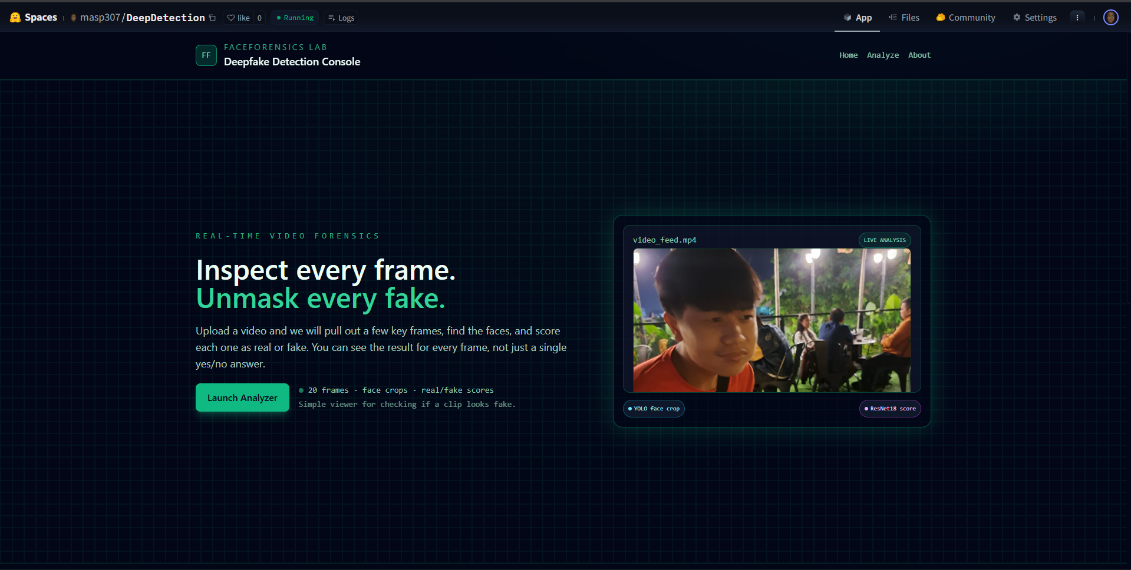
Figure 3. Home Page


Figure 4. Analyze Page


Figure 5. Video Uploaded

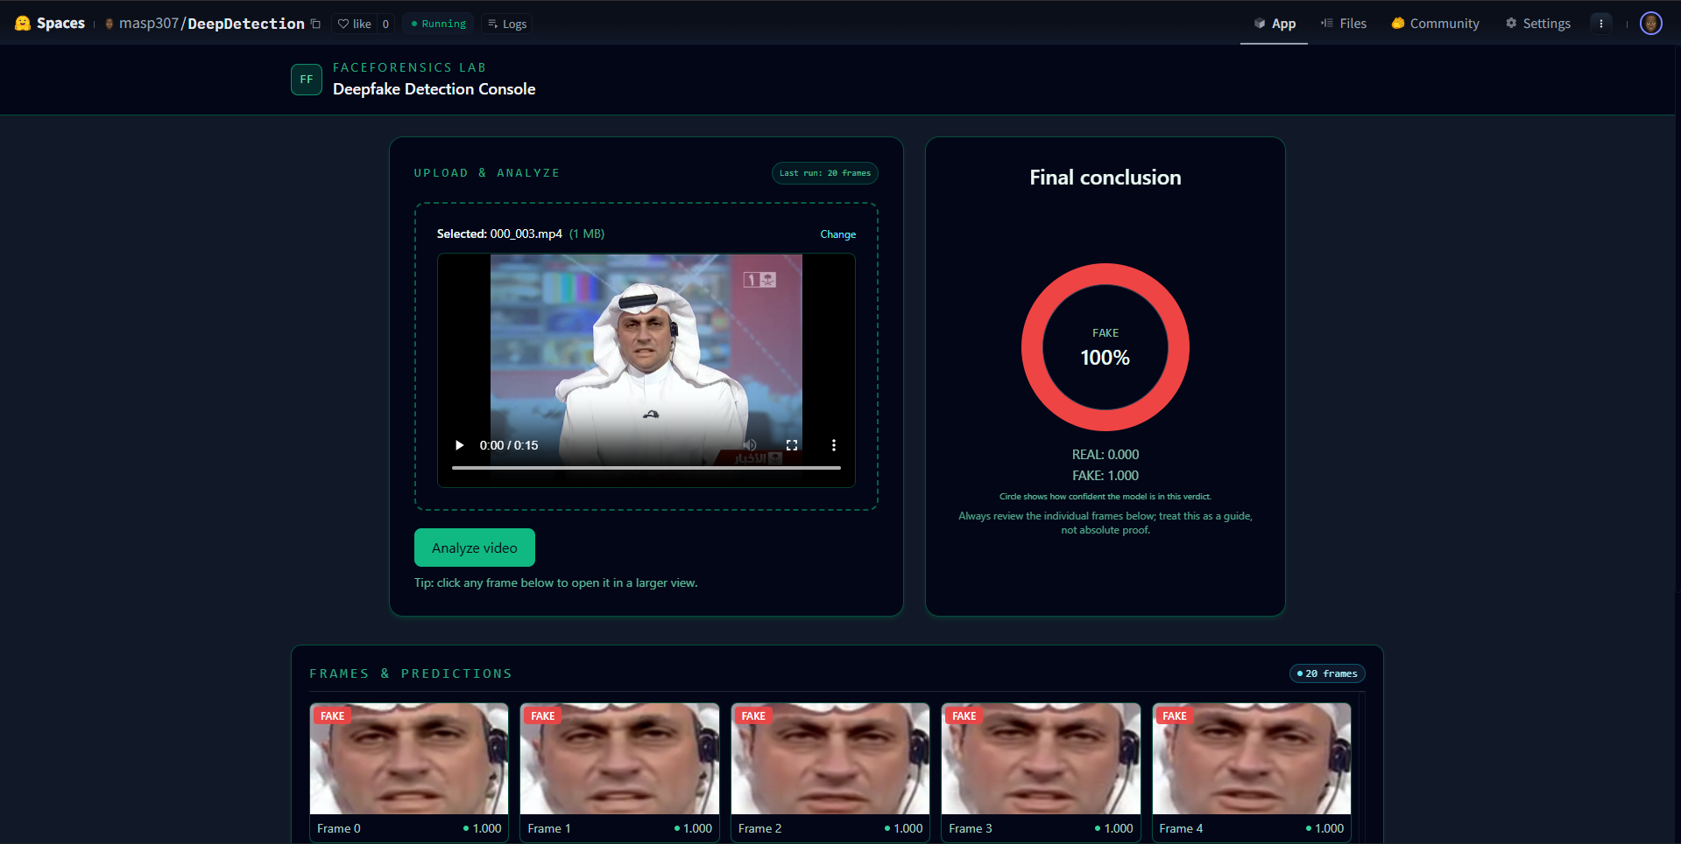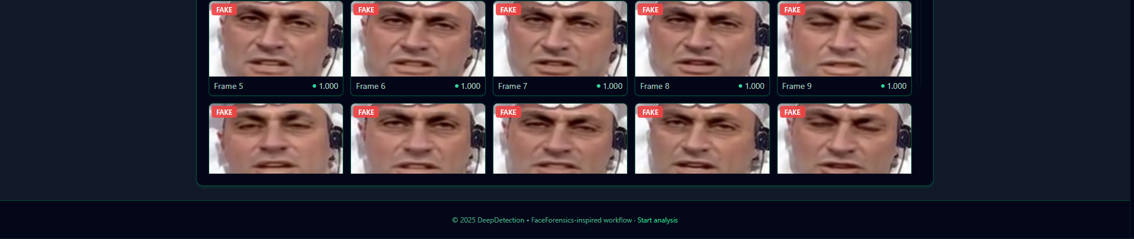
Figure 6. Analyze Result Fake

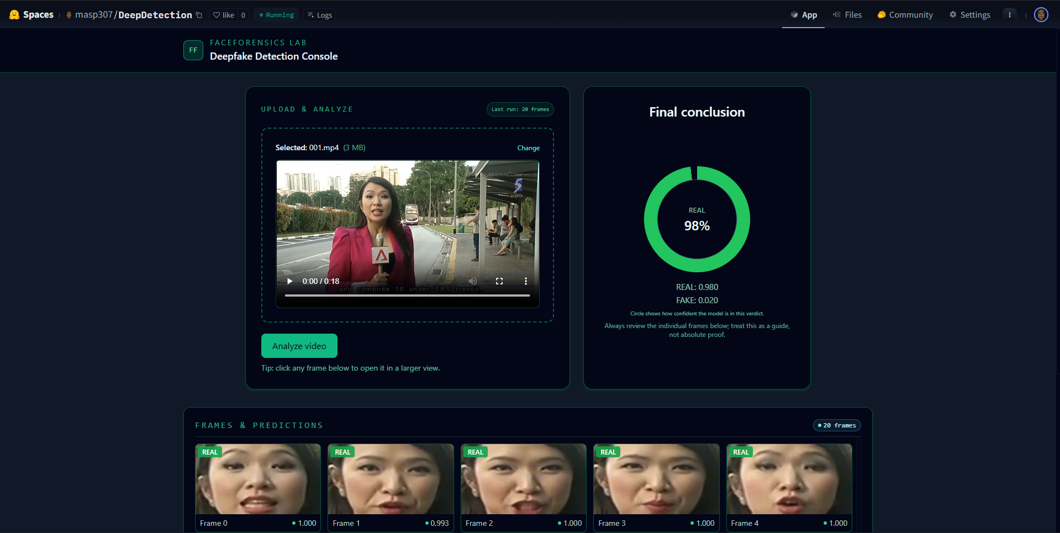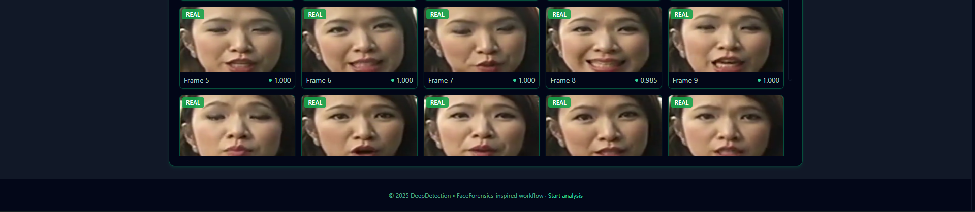
Figure 7. Analyze Result Real

A. Deployment Environment
The system is deployed as a web application using Docker containers. All backend dependencies (PyTorch, YOLOv8, FastAPI, and supporting libraries) are bundled into a single Docker image, ensuring that the same configuration can run consistently across different machines. This container is then hosted as a Hugging Face Space using the docker SDK option, which allows the project to run on Hugging Face’s managed infrastructure. Depending on resource availability, the Space can make use of either CPU or GPU hardware, but from the user’s point of view the service behaves the same. Hugging Face handles starting, stopping, and restarting the container, so the deployed model remains available with minimal maintenance overhead.

B. Backend Service
The core deepfake detection logic is exposed through a lightweight web service built with FastAPI. At deployment time, the trained ResNet18 classifier and YOLOv8 face detector are loaded into memory inside the Docker container. When a user uploads a video, the backend receives the file, extracts representative frames, performs face detection and classification, and then aggregates the results into a single “real” or “fake” decision. The backend is designed to be stateless: every request is processed independently, which simplifies scaling and makes it easier to restart or replicate the service if needed. Basic health-check endpoints are provided for monitoring whether the service is running correctly on the hosting platform.

C. Frontend Interface
To make the system accessible to non-technical users, a simple web interface is developed using Next.js and Tailwind CSS. The frontend is built as a separate project and compiled into static assets, which are then served together with the backend inside the same Docker container. From the user’s perspective, interacting with the system is like using any standard website: they open the application URL, select or drag-and-drop a video file, and then start the analysis. The interface displays progress information while the server processes the video and presents the final prediction together with example frames from the analyzed sequence.

D. User Workflow and Accessibility
Once deployed on Hugging Face Spaces, the application is accessible via a public URL that can be shared with testers, stakeholders, or end users. No authentication or special configuration is required for basic usage, which makes it convenient for demonstrations and qualitative evaluation. The deployment therefore bridges the gap between the research model and real-world usage: the same ResNet18 + YOLOv8 pipeline evaluated in the experiments is now available as an interactive, browser-based tool for deepfake detection. Visual evidence of this deployment, including the hosted Space, main interface, and example prediction results, is provided in the subsequent figures.

VI. REFLECTION

Jesslyn Trixie Edvilie:
Working on this project shifted my perspective from simply implementing deep learning models to truly understanding the mechanisms that drive them. Initially, the challenge seemed to be a lack of computational power, but I learned that 'bigger' is not always 'better.' By dissecting the failure points of heavy state-of-the-art models like XceptionNet, I realized that optimization is often more valuable than raw capacity.
My deepest learning came during the ablation studies. When the model struggled with class imbalance, simply adding more data wasn't the solution; I had to understand the mathematical bias in Cross-Entropy loss. This led me to implement Focal Loss, which creatively forced the model to learn from 'hard' examples rather than coasting on easy ones. Similarly, I learned to think counter-intuitively: instead of adding noise to make the model robust, I applied Gaussian Blur to remove noise, forcing the network to focus on structural defects. This project taught me that successful AI isn't just about code—it's about diagnosing the data and creatively engineering the constraints.

Mochammad Aqsa Sandhy Pradipta:

Brian Juniarta Darmadi:
Throughout this semester, developing the ResNet18 project provided me with valuable hands-on experience that went far beyond the theoretical concepts learned in lectures. This project allowed me to step into the role of an AI engineer and experience the entire development lifecycle firsthand—from researching the initial problem and analyzing current state-of-the-art works to identifying research gaps, performing hyperparameter tuning, and rigorously documenting the results. This process was crucial in training me not just to use existing tools, but to understand the deeper mechanics of building and optimizing a model from scratch.
Of course, this success would not have been possible without the support of Aqsa and Jesslyn, who were invaluable partners during brainstorming sessions and technical discussions. This collaboration, combined with my strong interest in Intelligent Systems, has significantly shaped my perspective on the field. My willingness to learn and the practical skills I gained this semester have placed me in a strategic position to collaborate effectively and develop even more advanced deep learning projects in the future.

References
​​[1] A. Rössler, D. Cozzolino, L. Verdoliva, C. Riess, J. Thies, and M. Nießner, “FaceForensics++: Learning to Detect Manipulated Facial Images,” Aug. 2019, [Online]. Available: http://arxiv.org/abs/1901.08971
​[2] F. Chollet, “Xception: Deep Learning with Depthwise Separable Convolutions.”
​[3] J. M. Johnson and T. M. Khoshgoftaar, “Survey on deep learning with class imbalance,” J Big Data, vol. 6, no. 1, Dec. 2019, doi: 10.1186/s40537-019-0192-5.
​[4] K. He, X. Zhang, S. Ren, and J. Sun, “Deep Residual Learning for Image Recognition.” [Online]. Available: http://image-net.org/challenges/LSVRC/2015/
​[5] T.-Y. Lin, P. Goyal, R. Girshick, K. He, and P. Dollár, “Focal Loss for Dense Object Detection.”
​[6] M. Yaseen, “What is YOLOv8: An In-Depth Exploration of the Internal Features of the Next-Generation Object Detector,” Aug. 2024, [Online]. Available: http://arxiv.org/abs/2408.15857
​[7] I. Perov et al., “DeepFaceLab: Integrated, flexible and extensible face-swapping framework,” Jun. 2021, [Online]. Available: http://arxiv.org/abs/2005.05535
​[8] Y. Li, X. Yang, P. Sun, H. Qi, and S. Lyu, “Celeb-DF: A Large-scale Challenging Dataset for DeepFake Forensics,” Mar. 2020, [Online]. Available: http://arxiv.org/abs/1909.12962
​[9] F. Chollet, “Xception: Deep Learning with Depthwise Separable Convolutions.”
​[10] B. Bayar and M. C. Stamm, “A deep learning approach to universal image manipulation detection using a new convolutional layer,” in IH and MMSec 2016 - Proceedings of the 2016 ACM Information Hiding and Multimedia Security Workshop, Association for Computing Machinery, Inc, 2016, pp. 5–10. doi: 10.1145/2909827.2930786.
​[11] N. Rahmouni, V. Nozick JFLI UMI, J. Yamagishi, and I. Echizen, “Distinguishing Computer Graphics from Natural Images Using Convolution Neural Networks.”
​[12] D. Afchar, V. Nozick, J. Yamagishi, and I. Echizen, “MesoNet: a Compact Facial Video Forgery Detection Network,” Sep. 2018, doi: 10.1109/WIFS.2018.8630761.
​[13] D. Güera and E. J. Delp, “Deepfake Video Detection Using Recurrent Neural Networks.”
​[14] Y. Li, M.-C. Chang, and S. Lyu, “In Ictu Oculi: Exposing AI Created Fake Videos by Detecting Eye Blinking.” [Online]. Available: http://bionumbers.hms.harvard.edu/bionumber.
​[15] D. Cozzolino, G. Poggi, and L. Verdoliva, “Recasting Residual-based Local Descriptors as Convolutional Neural Networks: an Application to Image Forgery Detection,” Mar. 2017, [Online]. Available: http://arxiv.org/abs/1703.04615

