**jQuery UI 기본 설정**

**https://jqueryui.com https://jeasyui.com https://getbootstrap.com https://bootswatch.com**

jQueryui.com에서 다운로드 jquery-ui-1.13.1.custom.zip

**ex01.html**

<!DOCTYPE html>

<html>

<head>

<meta charset="UTF-8">

<meta name="viewport" content="width=device-width, initial-scale=1">

<title>jQuery UI Datepicker - Default functionality</title>

<link rel="stylesheet" href="//code.jquery.com/ui/1.12.1/themes/base/jquery-ui.css">

<script src="https://code.jquery.com/jquery-1.12.4.js"></script>

<script src="https://code.jquery.com/ui/1.12.1/jquery-ui.js"></script>

<script>

$( function() {

$( "#datepicker" ).datepicker({

dateFormat : 'yy-mm-dd',

monthNames : ['1월','2월','3월','4월','5월','6월','7월','8월','9월','10월','11월','12월'],

showMonthAfterYear : true,

yearSuffix : '년', // "2020년 3월"

showOtherMonths : true,

dayNamesMin:['일','월','화','수','목','금','토']

});

} );

</script>

</head>

<body>

<p>생년월일 <input type="text" name="birth" id="datepicker"></p>

</body>

</html>

**ex01-1.html**

<!DOCTYPE html>

<html>

<head>

<meta charset="UTF-8">

<title>Insert title here</title>

<link rel="stylesheet" href="//code.jquery.com/ui/1.12.1/themes/base/jquery-ui.css">

<script src="https://code.jquery.com/jquery-1.12.4.js"></script>

<script src="https://code.jquery.com/ui/1.12.1/jquery-ui.js"></script>

<script>

$( function() {

$( "#datepicker" ).datepicker({

dateFormat: 'yy-mm-dd',

changeMonth: true, // 월을 바꿀수 있는 셀렉트 박스를 표시한다.

monthNamesShort: ['1월', '2월', '3월', '4월', '5월', '6월', '7월', '8월', '9월', '10월', '11월', '12월'],

showMonthAfterYear: true,

yearSuffix: '년',

showOtherMonths: true,

dayNamesMin: ['일', '월', '화', '수', '목', '금', '토'],

changeYear: true,

minDate: '-100y', // 현재날짜로부터 100년이전까지 년을 표시한다.

minDate: 0, // 지나간 날은 선택이 안 됨

yearRange: 'c-100:c+10', // 년도 선택 셀렉트박스를 현재 년도에서 이전, 이후로 얼마의 범위를 표시할것인가.

});

} );

</script>

</head>

<body>

<p>생년월일 <input type="text" name="birth" id="datepicker"></p>

</body>

</html>

**ex02.html**

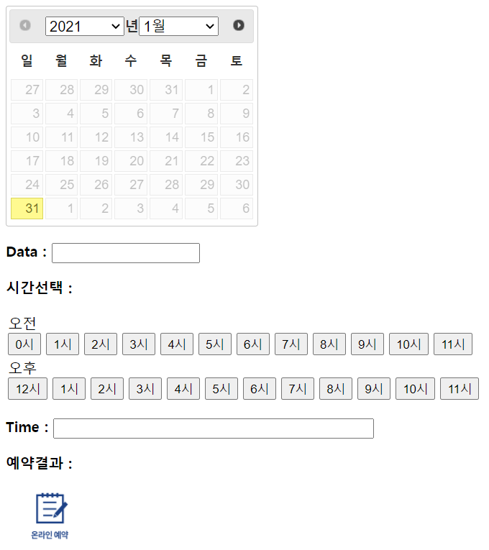

<!DOCTYPE html>

<html>

<head>

<meta charset="UTF-8">

<meta name="viewport" content="width=device-width, initial-scale=1">

<title>jQuery UI Datepicker - Default functionality</title>

<link rel="stylesheet" href="//code.jquery.com/ui/1.12.1/themes/base/jquery-ui.css">

<script src="https://code.jquery.com/jquery-1.12.4.js"></script>

<script src="https://code.jquery.com/ui/1.12.1/jquery-ui.js"></script>

<script>

$(function () {

$("#datepicker").datepicker({

dateFormat: 'yy-mm-dd',

changeMonth: true, // 월을 바꿀수 있는 셀렉트 박스를 표시한다.

monthNamesShort: ['1월', '2월', '3월', '4월', '5월', '6월', '7월', '8월', '9월', '10월', '11월', '12월'],

showMonthAfterYear: true,

yearSuffix: '년',

showOtherMonths: true,

minDate: 0, // 지나간 날은 선택이 안 됨

dayNamesMin: ['일', '월', '화', '수', '목', '금', '토'],

changeYear: true,

onSelect: function (dateText, inst) {

$('.reservedDate').val(dateText);

$('.result').html(dateText + '일 시간:');

for (var i = 0; i <= 23; i++) {

$('#' + i).attr('disabled', false);

$('#' + i).css('color', '#000000');

}//for - 날짜가 바뀌면 시간을 다시 셋팅

$('.reservedTime').val('');

// 오늘을 선택하면 지금 이 시점 이후에만 예약 가능

var today = new Date();

var year = today.getFullYear();

var month = String(today.getMonth() + 1);

if(month.length == 1){

month = '0' + month;

}// if - 1월이라 month 변수가 1이면 01로

var day = String(today.getDate());

if (day.length == 1) {

day = '0' + day;

}//if - 일 한자리면 두자리로

if (dateText == (year + '-' + month + '-' + day)) {

alert('오늘 ' + dateText + '은 ' + today.getHours() + '이후만 예약 가능해요');

for (var i = 0; i <= today.getHours(); i++) {

$('#' + i).attr('disabled', 'disabled');

//$('#' + i).attr('disabled', true);

$('#' + i).css('color', '#cccccc');

}//for

} //if

}//콜백함수

}); // datepicker함수(매개변수 안에 객체 넣음)

});// $()함수

$(document).ready(function () {

$('#am input').click(function () {

$('.reservedTime').val($('.reservedTime').val() + 'am ' + $(this).attr('class') + '시. ');

$('.result').append('am ' + $(this).attr('class') + '시. ');

$(this).css('color', '#FF0000');

$(this).attr('disabled', 'disabled');

});

$('#pm input').click(function () {

$('.reservedTime').val($('.reservedTime').val() + 'pm ' + $(this).attr('class') + '시. ');

$('.result').append('pm ' + $(this).attr('class') + '시. ');

$(this).css('color', '#FF0000');

$(this).attr('disabled', 'disabled');

});

});

</script>

<style>

input[type=submit] { background-image: url('reservation.png');

background-size:100%;

width:100px; height:70px;

background-color:white;

border:0; outline:0;

}

</style>

</head>

<body>

<div id="datepicker"></div>

<form>

<p><b>Data :</b> <input type="text" name="reservedDate" class="reservedDate" /></p>

<p class="tSelect">

<b>시간선택 :</b>

<table>

<tr>

<td id="am">

<sapn style="display:block;">오전</sapn>

<input type="button" id="0" class="0" value="0시" />

<input type="button" id="1" class="1" value="1시" />

<input type="button" id="2" class="2" value="2시" />

<input type="button" id="3" class="3" value="3시" />

<input type="button" id="4" class="4" value="4시" />

<input type="button" id="5" class="5" value="5시" />

<input type="button" id="6" class="6" value="6시" />

<input type="button" id="7" class="7" value="7시" />

<input type="button" id="8" class="8" value="8시" />

<input type="button" id="9" class="9" value="9시" />

<input type="button" id="10" class="10" value="10시" />

<input type="button" id="11" class="11" value="11시" />

</td>

</tr>

<tr>

<td id="pm">

<sapn style="display:block;">오후</sapn>

<input type="button" id="12" class="12" value="12시" />

<input type="button" id="13" class="1" value="1시" />

<input type="button" id="14" class="2" value="2시" />

<input type="button" id="15" class="3" value="3시" />

<input type="button" id="16" class="4" value="4시" />

<input type="button" id="17" class="5" value="5시" />

<input type="button" id="18" class="6" value="6시" />

<input type="button" id="19" class="7" value="7시" />

<input type="button" id="20" class="8" value="8시" />

<input type="button" id="21" class="9" value="9시" />

<input type="button" id="22" class="10" value="10시" />

<input type="button" id="23" class="11" value="11시" />

</td>

</tr>

</table>

</p>

<p><b>Time :</b> <input type="text" name="reservedTime" class="reservedTime" size="50" /></p>

<p><b>예약결과 :</b> <span class="result"></span></p>

<p><input type="submit" value=""/></p>

</form>

</body>

</html>