Examining Urbanization in Santa Cruz, Bolivia 1988-2015

# Objective

In this project, I sought to determine the spatial extent of urbanization that has occurred in the region surrounding Santa Cruz de la Sierra, Bolivia using remote sensing techniques, primarily Supervised Classification. A recent report I prepared on this issue for a Development Economics course sparked my interest in studying this area.

# Background

Bolivia has demonstrated extreme urbanization over the past century. For most of its history, Bolivia was a very rural agriculture-oriented nation, with only tin and silver mining representing its major industrial operations. In the post-colonial 20th century, the nation began to rapidly urbanize. According to UNICEF, “At the beginning of the 20th century the urban population was below 20 per cent. Between 1976 and 1992 Bolivian cities registered an average growth rate of 4 per cent (Resources).” The urban population now represents 68% of Bolivia- a 70% increase in the urban population ratio from 1900.

As Urbanization Trends in Bolivia states, “the incentives for migrants are clear: higher incomes and access to basic services... migrants have substantially improved their income levels (Trohanis et al, 2015, pg. 2).” The Todaro model shows us that as rural Bolivians see higher incomes in urban areas, they will raise their calculations of their expected earnings in urban areas. Once these expected earnings calculations exceed expected earnings in the rural areas, rural Bolivians choose to migrate to the cities (Todaro).

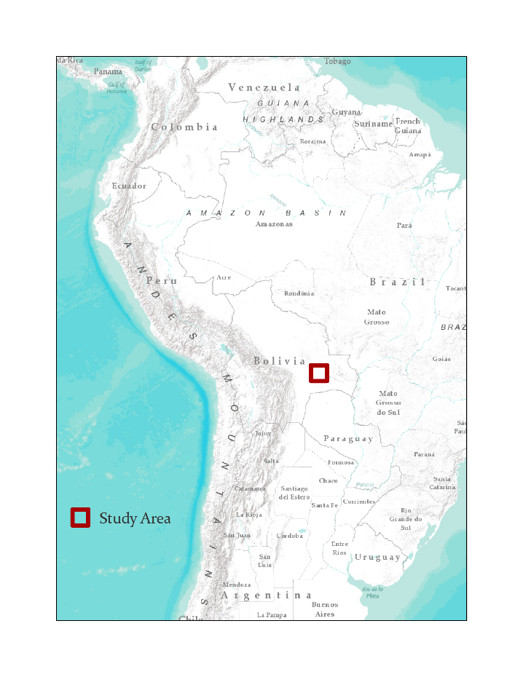

Figure : Location of Study Area

# Methods

I first acquired the relevant data, which consisted of two Satellite images of Santa Cruz- one a 1988 Landsat 5 image, and a 2015 Landsat 8 image.

I began my analysis with the 1988 image. Using ENVI, the data was projected into South American Datum Universal Transverse Mercator Zone 20 South. Next, I created a Region of Interest and subsetted my data into the desired study area extent. I then performed a radiometric correction on the data, followed by an atmospheric correction.

I then began classifying the image. In order to produce the most accurate possible results, I chose to run a trained classification. I created 5 land use classes: Water, Farmland, Other Vegetation, Urban, and Dirt. Training sites were developed for each class, and then the classification program was run, creating my 1988 classified raster. These exact steps were repeated with the 2015 image.

The classified rasters were then imported into ArcMap. In ArcMap, cartographic elements and symbolism were added, and the areas of each land use category were calculated.

# Results

The analysis revealed enormous increases in Santa Cruz urbanization over the past 27 years. Results are shown below:

Table : Land Use change 1988-2007





# 

Figure : Santa Cruz de la Sierra, 1988

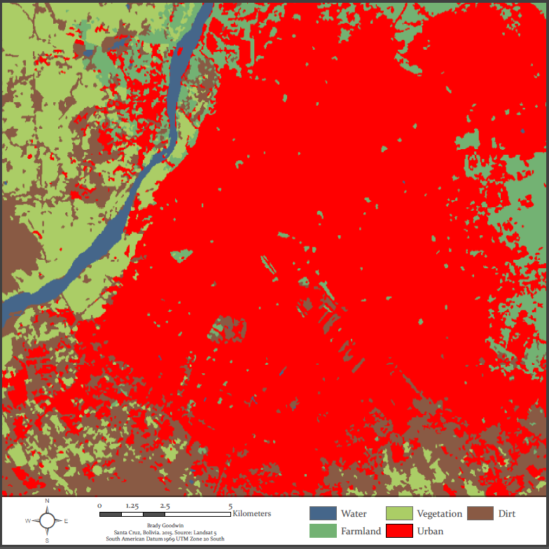

Figure : SANTA CRUZ DE LA SIERRA, 1988

# Conclusion

As expected, the increase in urban area around Santa Cruz de la Sierra was enormous. Urban land use increased by 167% in the 27 year gap examined by this report. The results are even more drastic than I expected. I am satisfied with these results.

I made one large mistake during my analysis that I did not notice until I was finished and examining the area around Santa Cruz on google maps. A large sugar cane farm was classified as Urban in both my 1988 and 2015 images. This is because it has an appearance that wasn’t typical of farmland, especially in the lower resolution 1988 image. Fortunately, the sugar cane farm was present and identified mistakenly in both images. Thus, while it was an error, it was less extreme in its distortion of the data than it would be if it had been classified incorrectly in one but not the other. This sugar cane farm is the rectangular section of red resting diagonally within the square identifier around it in the image below.

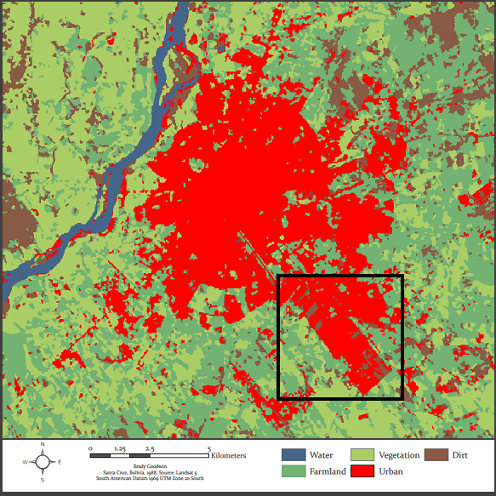

Figure : Location of Erroneous Classification

# References

Resources Bolivia. (n.d.). Retrieved October 11, 2015, from

http://www.unicef.org/bolivia/resources_2333.htm

Todaro, M. (2015). Economic development (Twelfth ed.). Trans-Atlantic Publications.

Trohanis, Z., Zangerling, B., & Sanchez, J. (2015, May 1). Urbanization Trends in Bolivia : Opportunities and Challenges. Retrieved November 1, 2015.

*Thank you to Humboldt State for computer and software access and Professor Hanna for instructional assistance.*