**Identification of Potential Sites for New Bus Stops in the City of Los Angeles, California**

*Brady Goodwin, Christina Perez*

*Spring 2015*

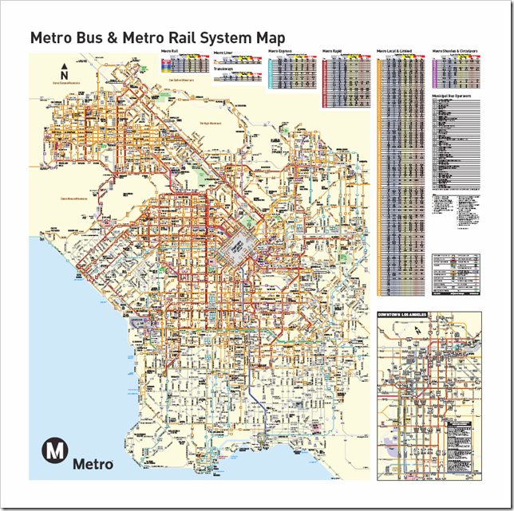

**Project Report**

*Abstract:*

Analysis of potential sites for new bus stops in the Los Angeles city area. Potential bus stop areas were analyzed based on people per area, income levels, proximity to existing bus routes, bus stops and bike paths.

*Introduction:*

The city of Los Angeles in southern California has a significant ongoing investment in increasing accessibility and development in transit systems in order to implement reductions in energy use and environmental impacts of urbanized living and transportation (Nahlik, 2014). Residences that are located near a transit zone on average own drive 1300 miles less than those who are not (De Vos, 2014) . Planning and developing new transit route stops and based on population density and need would greatly benefit the city of Los Angeles in lowering its high traffic densities and meeting the cities ongoing goals of reducing energy use and improving environmental conditions. For our project we plan on designating new transit stop areas in the city of Los Angeles where they would be most impactful in alleviating traffic density and the most helpful for those who are heavily reliant on transit systems. The new bus stop areas will be located solely in the city of Los Angeles near currently existing bus transit lines and in areas where new transit lines and stops would be beneficial.

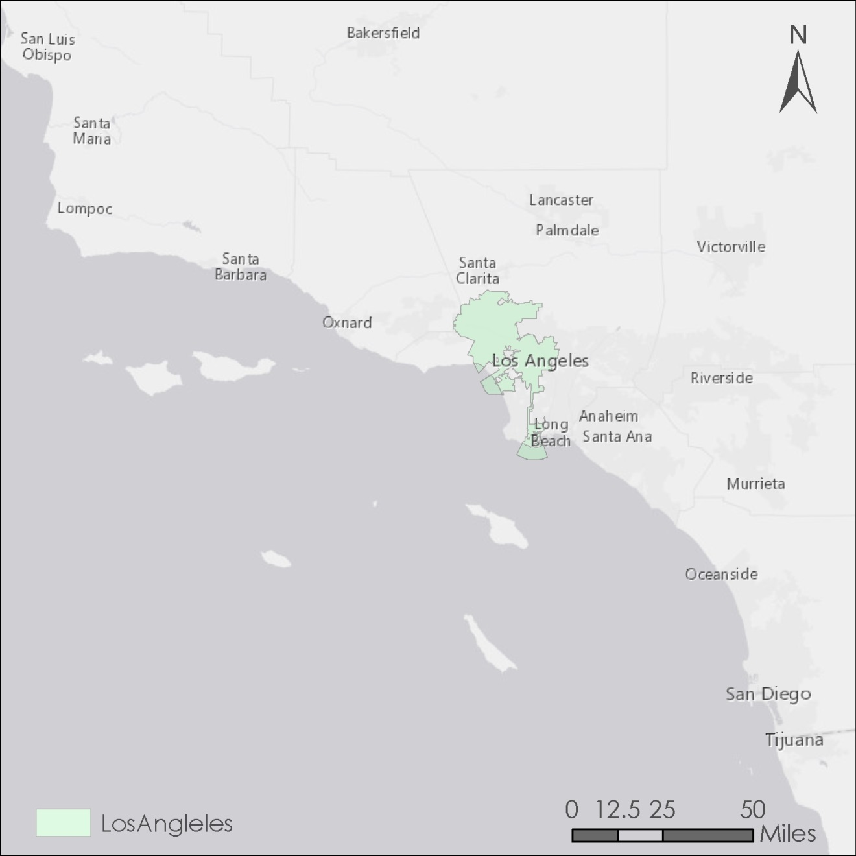

*Fig. 1) Locator Map of Los Angeles city in Southern California.*

*Objectives:*

Our project seeks to determine the optimal location for the placement of a new bus stop along pre-existing bus lines within the city limits of Los Angeles. This bus stop will focus on serving the needs of Los Angeles’ residents who are among the city’s least wealthy and most dependent on public transportation. In order to determine the location, we will be utilizing ArcMap to spatially examine Los Angeles to find the stretch of roadway that best meets the following criteria:

* Current service by an L.A. Metro bus route.
* Distance from bus stops already in operation.
* Within a census tract block that demonstrates both a high level of poverty and a high reliance on public transportation.
* Within proximity of bike paths to promote bike-and-bus intracity transportation.
* Within proximity of points of interest such as service providers, churches, parks, and other important community assets.

Using these criteria, we will identify a selection of suitable sites. From this selection, we will propose the ideal location for the new bus stop. Furthermore, we will also develop three additional proposal locations, which will serve as alternate options should the first choice prove unsuitable due to adverse on-the-ground circumstances.

*Description of GIS Data Sources:*

Most of the data used for this project was sourced from Metro Developer, the official blog of L.A. Metro. Metro Developer provided vector line shapefiles of L.A. bus routes and bike paths, in addition to vector point shapefiles of current bus stop locations.

The Los Angeles County GIS Data Portal provided data on points of interest within Los Angeles, in addition to a polygon containing the city of L.A.’s administrative boundaries. 2010 Census tract data was sourced from the National Historic Geographic Information Society.

|  |  |  |  |
| --- | --- | --- | --- |
| **GIS Data Sources** | | | |
| **Data** | **File Format** | **Data Source** | **Description** |
| EGIS_LMS_DATA | Vector point Shapefile | [Los Angeles County GIS Data Portal](http://egis3.lacounty.gov/dataportal/2014/07/07/locationspoints-of-interest-lms-data/) | Points of interest for the county of Los Angeles |
| LinesServingStops1214 | Vector point Shapefile | [Metro Developer](http://developer.metro.net/introduction/gis-data/download-gis-data/) | Bus stop Locations for the county of Los Angeles |
| 2012_Bikeways | KMZ file | [Metro Developer](http://developer.metro.net/introduction/bikeways-data/download-bikeways-data/) | Designated bike paths in the county of Los Angeles |
| ComCir1214 | Vector Line Shapefile | [Metro Developer](http://developer.metro.net/introduction/gis-data/download-gis-data/) | Bus route transits in the county of Los Angeles |
| LimExp1214 | Vector Line Shapefile | [Metro Developer](http://developer.metro.net/introduction/gis-data/download-gis-data/) | Bus route transits in the county of Los Angeles |
| LocalCDB1214 | Vector Line Shapefile | [Metro Developer](http://developer.metro.net/introduction/gis-data/download-gis-data/) | Bus route transits in the county of Los Angeles |
| LocalNonCBD1214 | Vector Line Shapefile | [Metro Developer](http://developer.metro.net/introduction/gis-data/download-gis-data/) | Bus route transits in the county of Los Angeles |
| RapidBRT2014 | Vector Line Shapefile | [Metro Developer](http://developer.metro.net/introduction/gis-data/download-gis-data/) | Bus route transits in the county of Los Angeles |
| CensusData | Excel Table | National Historic Geographic Society | Attribute table containing tract-level data on poverty and bus ridership |

*Table 1) GIS Data and Sources*

*Methods:*

We began this project by downloading all our necessary data and organizing files for our workspace. Since we used data coming in from various sources we batch projected them into ArcMap using NAD 1983 State Plane California V FIPS 0405 (Feet) projection to ensure uniformity. Many of our data sets contained and displayed data that was outside of our project range so in order to narrow and focus it to the Los Angeles city area we selected by attribute the area that covered the city of Los Angles from our Los Angeles County shapefile and used the resulting output shapefile as a base to clip the rest of our following data. We began narrowing the ideal positions for new bus stop areas by creating a 100 meter buffer around the existing bus stops in the L.A. city area. From there we erased the bus route polylines that were within the buffer are of the bus stops. Our next step was to find areas that were within at least 300 meters of existing bike paths. To do this we used the select by location tool in ArcMap and found bus route areas that were within 300 meters of existing Bike paths. The resulting output were areas that were within 300 meters of existing bike paths, 300 meters away of existing bus stops and were located near on existing bus route. Our final step was to select by attribute the bust route areas in our census tract that were at least 100 people who are both under the poverty line and take public transportation to work and intersect this with the resulting bus route area.

*Results*

Our analysis yielded twenty-one potential sites for a new bus stop. Two are located within the Van Nuys neighborhood in North Los Angeles along the Orange Line Busway. All other potential sites are located within two clusters in close proximity to each other- one just west of Downtown Los Angeles, and one just south of the University of Southern California. These two clusters are displayed in Fig 2.

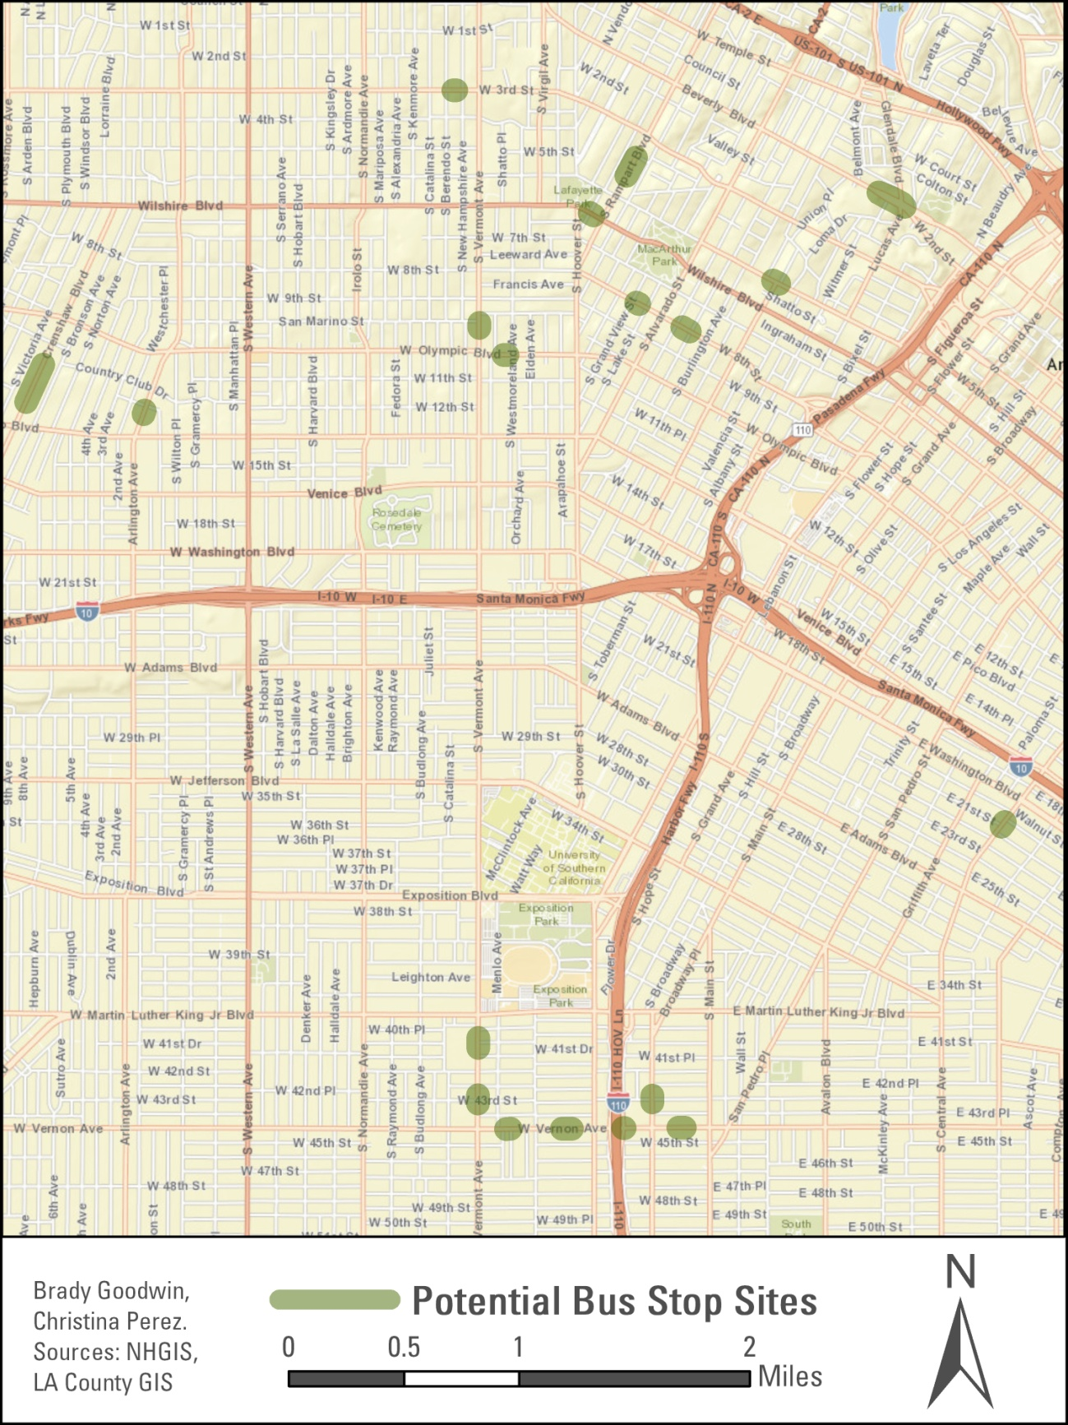

*Fig. 2) Potential sites for new bus stops within the city of Los Angeles*

*Conclusion*

Los Angeles city has some of the highest mean distances in feet between bus stop areas (*fta.dot.gov*) .The city also has some of the highest traffic volumes in California, considering these two factors and the fact that many people below the poverty line are dependent upon public transportation it is essential to designate new bus stops areas with these things in mind in order to battle traffic congestion and to aid those who are most dependent on public transportation. To help resolve these issues our analysis has worked in these factors as well as ease of access by designating areas close in proximity to established bike path areas. We limited our analyses to currently established bus route and stop areas within the city of Los Angeles and did not analyze for proposed sites. Other factors that would be good to analyze but were not included in our report might be residential area locations and areas near newly proposed bus routes.

*References:*

De Vas, Jonas, Veronique Van Acker, and Frank Witlox. "The Influence OfattitudesonTransit-OrientedDevelopment: An Explorativeanalysis." Transport Policy (2014): 326-29. ScienceDirect. Web. 8 Apr. 2015.

Nahlik, Matthew J., and Chester V. Mikhail. "Transient- Oriented Smart Growth Can Reduce Life- Cycle Environmental Impacts and Household Costs in Los Angeles." Transport Policy (2014): 21-30. ScienceDirect. Web. 07 Apr. 2105.

http://www.fta.dot.gov/12351_4361.html