Burned Area Analysis for Restoration of the Mad River Complex Fire in Trinity County, CA and Humboldt County, CA.

Brady Goodwin, Daniel Kidwell, and Perry Scott

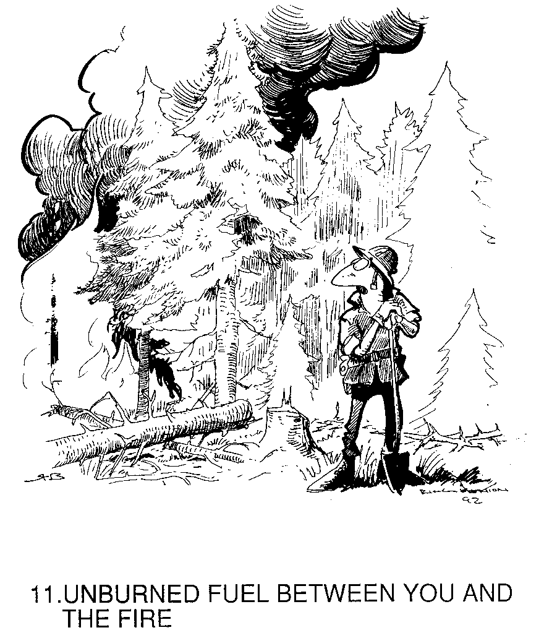

**Abstract**

Due to prolonged drought, climate change, and fire suppression strategies, fires throughout the Western United states have increased drastically in frequency and severity. In the summer of 2015, the Mad River Complex Fire burned 37642 acres near Ruth Lake. Our study sought to determine locations within this complex that showed greatest potential for slope movement with potential to deposit sediment into sensitive Trinity/ Humboldt watersheds. To do so, we identified locations within the complex that are of steep slope, were severely burned, and are in close proximity to water features. Lesser weight values were given to other important but less critical factors such as spotted owl habitat, proximity to roads, and sensitive soil types.

Based on these factors, we were able to isolate an area of 663 acres of high restoration priority and 40 acres of very high restoration priority, together representing a total of approximately 2% of the study area. This offers a feasible spatial starting point for mitigation efforts in the region.

**Table of Contents**

Contents

I. List of Tables and Figures. 3

II. Introduction. 4

III. Methods. 6

IV. Results. 6

V. Conclusion. 10

VI. Acknowledgments. 10

VII. Literature Cited. 11

List of Tables and Figures

**Figures**

Figure 1. Locator Map of Mad River Complex Fire Location

Figure 2. Mad River Complex Post-Fire Restoration Priority Overview Map

Figure 3. Lassic Fire Restoration Priority Map

Figure 4. Gobbler Fire Restoration Priority Map

Figure 5. Picket Fire Restoration Priority Map

**Tables**

Table 1. Restoration Priority and Acres in Each Category

**Introduction**

As California's drought continues for its fourth year, we have seen an increase in historic wildfires. The drought has decreased live and dead fuel moisture content and contributed to greater tree mortality making a larger percentage of fuels available for burning. Since the advent of militarized fire suppression in the 1940s the majority of California's forests have become extremely overgrown as a result of the disruption of natural disturbance regimes. This has resulted in large amounts of fuel loading. Warmer weather and crowding has also led to large bark beetle outbreaks causing even greater mortality and fuel loading (Brotons et al., 2013).

These historically extreme fuel loading conditions combined with, low fuel moisture content, low relative humidities, and higher temperatures have resulted in explosive wildfires over the last couple of years. Fires have become larger and more intense burning longer and starting in months that would not have been considered part of the normal fire season in past years. These new megafires often result in increased amounts of degradation and mortality outside the scope of historic fire regimes (Mantgem et al., 2013).

Megafires burning at extremely high intensities often cause high percentages of surface and canopy fuel mortality. This mortality causes extreme decreases in ground cover and root mass leading to decreased water infiltration. Also during fires, once fuel particles reach a high enough temperature, natural waxes and tannins in the fuel become volatilized and end up bonding with the upper layer of soil. This causes the soil to become hydrophobic or water resistant further decreasing infiltration rates and causing large amounts of runoff. This increased mortality combined with the volatilization of natural waxes and tannins in plant material during intense wildfires, leaves sloped areas open for major erosion during precipitation events (Inbar et al., 2014).

Large amounts of erosion after these fires can then lead to a multitude of water quality issues caused by sedimentation. Increased soil heating caused by greater fuel bed depths can lead to mycorrhizal death and soil nutrient volatilization. This causes problems for regeneration of burned sites due to the lack of soil nutrients and mycorrhizal associations. Additionally, fuel bed consumption and soil heating can destroy the seed bed, restricting sources of regeneration (Inbar et al., 2014 and Collins & Roller, 2013).

As fires get larger this can pose a problem since the majority of wind dispersed conifer seeds can only travel up to six times the trees height. With current fires growing larger than 100,000 acres, colonization can take years in the interior if the only remaining seed sources are outside of the fire's perimeter (Greene et al., 2006). This also leaves the burned area open for colonization by hardy non-native pioneer species such as Cheatgrass (*Bromus tectorum*) or Scotch broom (*Cytisus scoparius*) leading to possible changes in ecosystem type and composition (Welch et al., 2014).

The resulting likelihood of long term environmental degradation combined with the difficulties of natural regeneration after megafires has resulted in a new industry specializing in post-fire ecological rehabilitation. Most of these rehabilitation groups such as the Forest Service’s Burned Area Emergency Response Team focus on planting and other erosion mitigation measures such as culvert installation and straw dispersal in areas with fragile soils, high erosion potential, and critical stream channels in an effort to protect downstream users, provide additional seed sources, and prevent the loss of remaining topsoil (USDA Forest Service BAER, 2015, and Robichaud, 2009).

Our group sought to increase the efficiency and of these rehabilitation projects by creating a restoration project priority map. Specifically, we examined the Mad River Complex, a local fire that burned 37,462 acres near Highway 36 around the Ruth Lake and Mad River communities. Major fires within the complex consisted of the Picket, Lassic, and Gobbler fires. The fire started on July 30th and wasn't considered contained until September 3rd. The fire burned with extreme conditions characteristic of recent drought fueled burns. We attempted to create a map analyzing areas of priority for restoration within the burn, using an analysis that accounts for burn severity found using the Normalized Burn Ratio, steep slopes (over 40%), critical habitat data, stream and road proximity, and soil type.

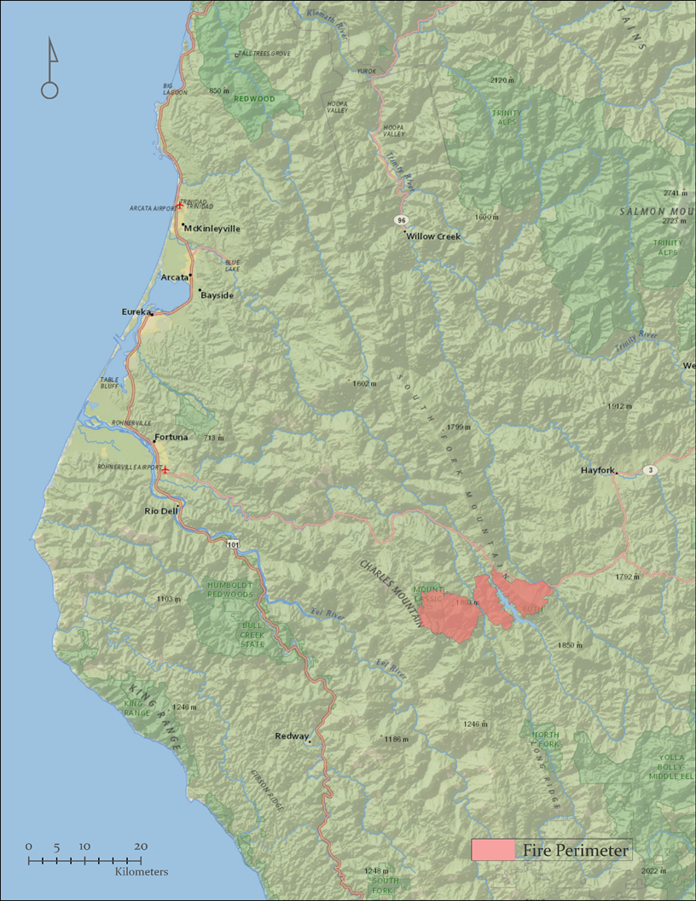

**Figure 1: Geographic extent of Mad River Fire Complex**

**Methods**

The spatial reference for all data was set to WGS 1984, and all layers were clipped to the study area. Soil maps were created by adding the soil layer shapefile, and the mapunit text file to the map. The mapunit text file was then joined to soil layer shapefile. Symbology was then set to categories with unique values, and the mapunit field was input as the value field.

We then created differenced Normalized Burn Ratio (dNBR) of the fire area. The resulting raster was classified based on burn severity. Euclidean Distance layers were created for the roads and rivers layer. In order to isolate only the most vulnerable soil types, a soil raster was reclassified the soil values to 2 for Xerofluvents-Riverwash, and 1 for all other soil classes. The DNBR, distance from a road, and distance from a river were reclassified with values of 1-10, with greater values having larger burn severity values or closer proximity to a road or river. The slope layer was reclassified, slopes of 1-40% were broken into 4 categories and assigned values of 1-4. Slopes greater than 40% were assigned a value of 10. In order to isolate for critical species, a raster was created giving all areas with spotted owl habitat value of 2 and all other areas a value of 1.

Next, we created a total cost surface raster using the raster calculator to multiply the reclassified DNBR, distance from river, distance from road, critical habitat, slope, and soils rasters together. We additionally weighted the layer values when we created the total cost surface by multiplying the DNBR by 2, the distance from river by 1.5, the distance from road by .5, the critical habitat by .5, the slope by 2, and the soils by 1.

*("dnbrrec" * 2) * ("sloprec" * 2) * ("riverrec" * 1.5) * ("owlfinalrec" * .5) * ("roadrec" * .5) * ("soilrec" * 1)*

Wherein “dnbrrec” corresponds to the dNBR raster, “sloprec” with slope raster, “riverrec” with river proximity raster, “owlfinalrec” with critical habitat raster, “roadrec” with road proximity raster, and “soilrec” with soil type raster.

We used classified symbology using Natural Breaks with 5 classes to display our results.

**Results**

Our final raster identified 40 acres of very high restoration need, 663 acres of high restoration priority, and 2780 acres in medium need of restoration. Conversely, 11458 and 18125 acres are of low and very low restoration priority, respectively. These results provide a viable starting point for planning post-fire restoration and mitigation activities in the region.

*See table 1 and fig.1.*

Table 1: Land area in acres divided

by restoration priority categories

|  |  |
| --- | --- |
| **PRIORITY** | **(ACRES)** |
| Very Low | 18125 |
| Low | 11458 |
| Medium | 2780 |
| High | 663 |
| Very High | 40 |

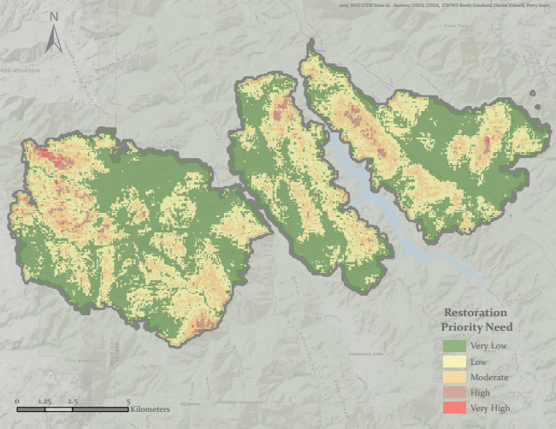

**Figure 2: Overview of Mad River Complex**

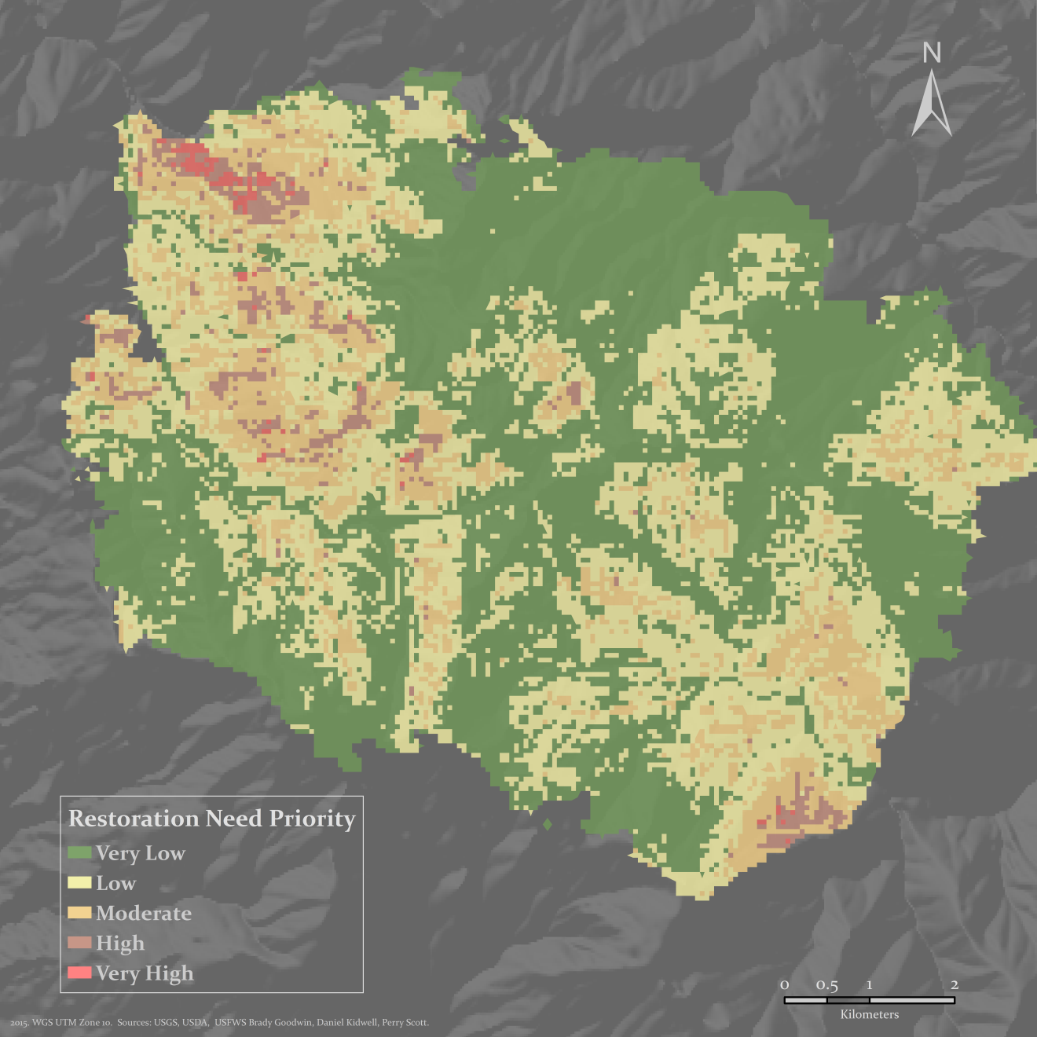

**Figure 3: Lassic Fire**

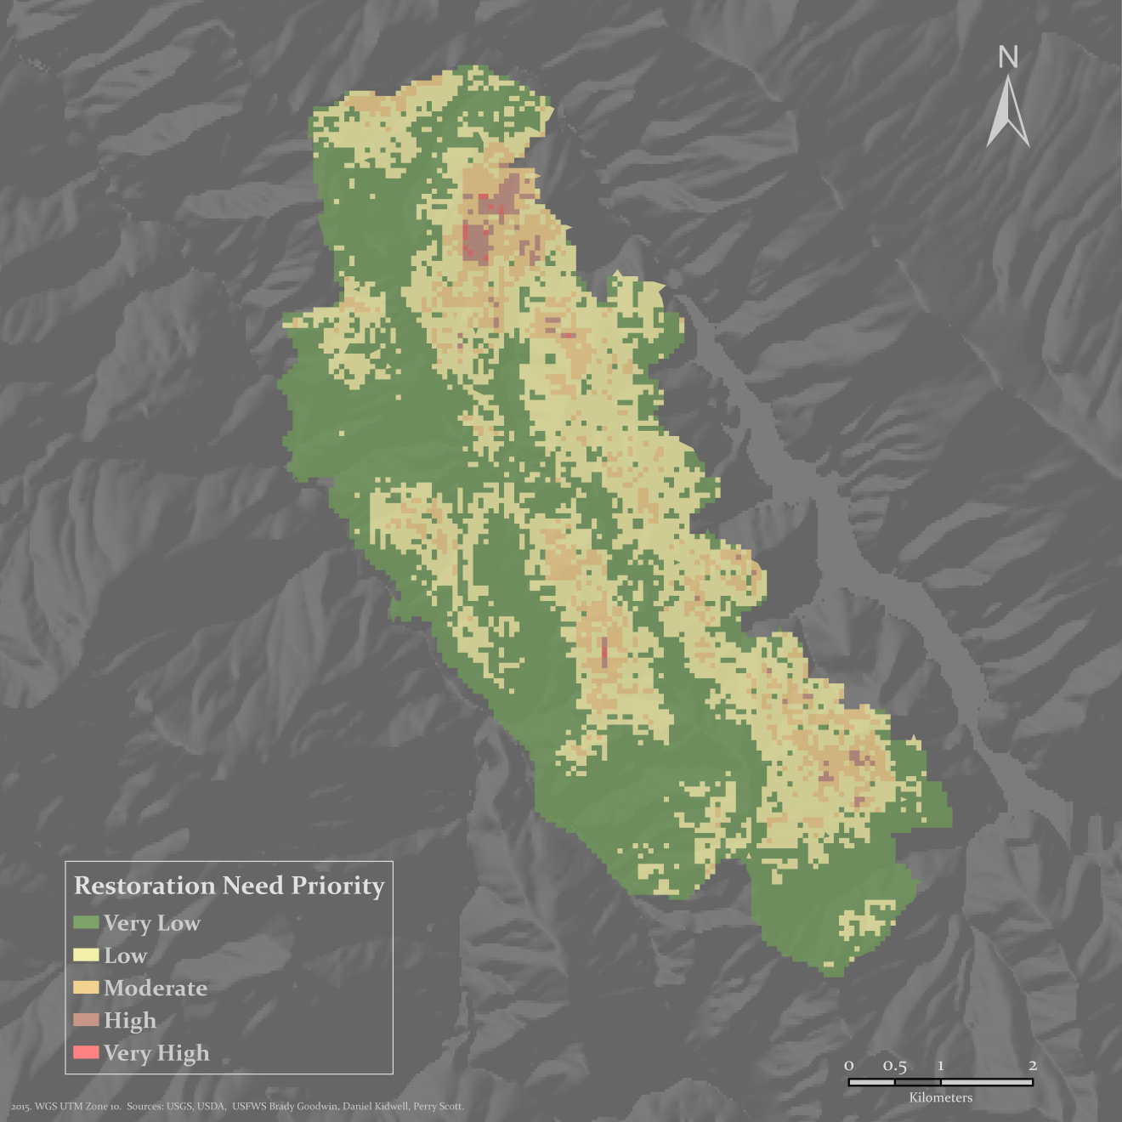

**Figure 4: Gobbler Fire**

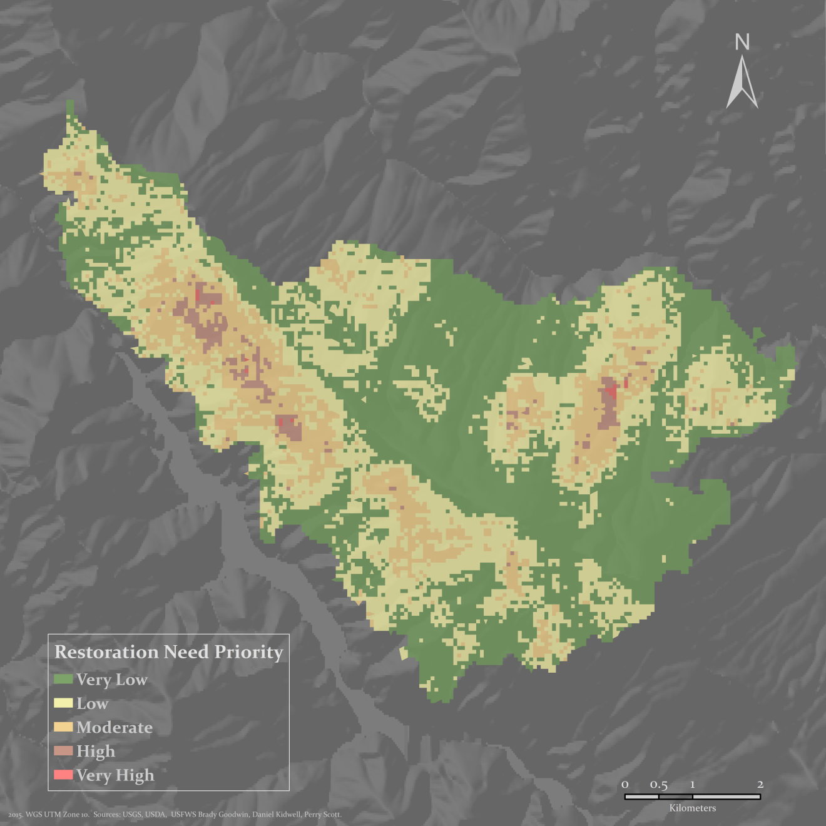

**Figure 5: Picket Fire**

**Conclusion**

Our analysis successfully identified regions within the Mad River Fire Complex of high restoration need. Further study would be needed to assign cost to accessing and mitigating these regions.

We would recommend planting native tree seedlings in the very high and, if financially viable, high priority areas. As the trees grow and mature they will provide a source of natural regeneration for the rest of the burned area. Since the high priority areas are spaced somewhat centrally, this should increase the rate of regeneration and natural encroachment in the burned area. We would also recommend using erosion mitigation methods such as straw and seeding on slopes in areas of moderate priority or greater.

**Acknowledgments**

We would like to thank Professor Nicolas Malloy, the USGS for Landsat, DEMs & river data, the Fish & Wildlife Service for endangered habitat data, the USGS Geosciences and Environmental Change Science Center for the fire perimeter data, the GeoCommunity for road data, and the USDA Natural Resource Conservation Services for soil data. Additionally, we’d like to thank HSU for computer and software access (ENVI and Arcmap).

**Literature Cited**

Brotons, L., Aquilue, N. , Caceres, M. , Fortin, M. , & Fall, A. (2013). How fire history, fire suppression practices and climate change affect wildfire regimes in Mediterranean landscapes. e62392. PLoS ONE, 8(5).

Collins, B., & Roller, G. (2013). Early forest dynamics in stand-replacing fire patches in the northern Sierra Nevada, California, USA. *Landscape Ecology*, *28*(9), 1801.

Greene, D., Gauthier, S., Noel, J. , Rousseau, M. , & Bergeron, Y. (2006). A field experiment to determine the effect of post-fire salvage on seedbeds and tree regeneration. Frontiers in Ecology and the Environment, 4(2), 69-74.

Inbar, A., Lado, M., Sternberg, M., Tenau, H., & Ben-Hur, M. (2014). Forest fire effects on soil chemical and physicochemical properties, infiltration, runoff, and erosion in a semiarid Mediterranean region. Geoderma, 221-222, 131-138.

Mantgem, P., Nesmith, J., Keifer, M., Knapp, E., Flint, A., et al. (2013). Climatic stress increases forest fire severity across the western United States. Ecology Letters, 16(9), 1151-1156.

Robichaud, P. (2009). Bare soil: Changes in mitigating post-fire erosion mitigation. Fourth International Fire Ecology and Management Congress: Fire as a Global Process.

Watershed - WFW - Watershed, Fish, Wildlife, Air & Rare Plants - USDA Forest Service. (n.d.). Retrieved October 2, 2015.

Welch, K. , Safford, H. , & Young, T. (2014). Post-fire conifer regeneration in california's diverse forests. *99th Annual Meeting of the Ecological Society of America (ESA 2014)*.