Activity # 1 – Flowcharts & Pseudocodes

# Flowcharts

## Definition

A flowchart is a diagram that depicts a process, system or computer algorithm. They are widely used in multiple fields to document, study, plan, improve and communicate often complex processes in clear, easy-to-understand diagrams. Flowcharts, sometimes spelled as flow charts, use rectangles, ovals, diamonds and potentially numerous other shapes to define the type of step, along with connecting arrows to define flow and sequence. They can range from simple, hand-drawn charts to comprehensive computer-drawn diagrams depicting multiple steps and routes. If we consider all the various forms of flowcharts, they are one of the most common diagrams on the planet, used by both technical and non-technical people in numerous fields. Flowcharts are sometimes called by more specialized names such as Process Flowchart, Process Map, Functional Flowchart, Business Process Mapping, Business Process Modeling and Notation (BPMN), or Process Flow Diagram (PFD). They are related to other popular diagrams, such as Data Flow Diagrams (DFDs) and Unified Modeling Language (UML) Activity Diagrams.

## Importance

Flowchart in Various Fields

Beyond computer programming, flowcharts have many uses in many diverse fields.

In any field:

* Document and analyze a process.
* Standardize a process for efficiency and quality.
* Communicate a process for training or understanding by other parts of the organization.
* Identify bottlenecks, redundancies and unnecessary steps in a process and improve it.

Education:

* Plan coursework and academic requirements.
* Create a lesson plan or oral presentation.
* Organize a group or individual project.
* Show a legal or civil process, like voter registration.
* Plan and structure creative writing, like lyrics or poetry.
* Demonstrate character development for literature and film.
* Represent the flow of algorithms or logic puzzles.
* Understand a scientific process, like the Krebs cycle.
* Chart an anatomical process, such as digestion.
* Map out symptoms and treatment for diseases/disorders.
* Communicate hypotheses and theories, like Maslow’s hierarchy of needs.

Sales and marketing:

* Plot out the flow of a survey.
* Chart a sales process.
* Plan research strategies.
* Show registration flows.
* Disseminate communication policies, like an emergency PR plan.

Business:

* Understand order and procurement processes.
* Represent an employee’s tasks or daily routine.
* Understand the paths that users take on a website or in a store.
* Develop a business plan or product realization plan.
* Document a process in preparation for an audit, including for regulatory compliance, such as under the Sarbanes-Oxley Act.
* Document a process in preparation for a sale or consolidation.

Manufacturing:

* Denote the physical or chemical makeup of a product.
* Illustrate the manufacturing process from beginning to end.
* Discover and solve inefficiencies in a manufacturing or procurement process.

Engineering:

* Represent process flows or system flows.
* Design and update chemical and plant processes.
* Assess the life cycle of a structure.
* Chart a reverse-engineering flow.
* Demonstrate the design and prototype phase of a new structure or product.

# Types of flowcharts

Different authors describe various types of flowcharts in different terms. These people include published experts such as Alan B. Sterneckert, Andrew Veronis, Marilyn Bohl and Mark A. Fryman.

Sterneckert, in his 2003 book Critical Incident Management, listed four popular flowchart types, framed around the concept of flow controls rather than the flow itself:

* **Document Flowcharts:**These “have the purpose of showing existing controls over document-flow through the components of a system. … The chart is read from left to right and documents the flow of documents through the various business units.”
* **Data Flowcharts:**These show “the controls governing data flows in a system. … Data flowcharts are used primarily to show the channels that data is transmitted through the system rather than how controls flow.”
* **System Flowcharts:** These “show the flow of data to and through the major components of a system such as data entry, programs, storage media, processors, and communication networks.”
* **Program Flowcharts:** These show “the controls placed internally to a program within a system.

Veronis, in his 1978 book Microprocessors: Design and Applications, outlined three flowchart types based on scope and level of detail:

* **System Flowchart:**Identifies the devices to be used.
* **General Flowchart:** Overview.
* **Detailed Flowchart:** Increased detail.

Bohl, in her 1978 book A Guide for Programmers, listed only two:

* **System Flowchart.**
* **Program Flowchart.**

But Fryman, in his 2001 book Quality and Process Improvement, differentiated the types in multiple ways from more of a business perspective than a computer perspective:

* **Decision Flowchart.**
* **Logic Flowchart.**
* **Systems Flowchart.**
* **Product Flowchart.**
* **Process Flowchart.**

Additional flowchart types defined by others include:

* **Swimlane Diagram, a.k.a Swimlane Flowchart:** To delineate who does what in cross-team processes.
* **Workflow Flowchart:**To document workflows, often involving tasks, documents and information in offices.
* **Event-Driven Process Chain (EPC) Flowchart:**To document or plan a business process.
* **Specification and Description Language (SDL) Flowchart:** To brainstorm computer algorithms using three basic components: system definition, block and process.

## How to plan and draw a basic flowchart

* **Define your purpose and scope.** What do you hope to accomplish? Are you studying the right things with appropriate start and end points to accomplish that purpose? Be detailed enough in your research but simple enough in your charting to communicate with your intended audience.
* **Identify the tasks in chronological order.**This might involve talking to participants, observing a process and/or reviewing any existing documentation. You might write out the steps in note form, or begin a rough chart.
* **Organize them by type and corresponding shape,**such as process, decision, data, inputs or outputs.
* **Draw your chart,** either sketching by hand or using a program such as Lucidchart.
* **Confirm your flowchart,** walking through the steps with people who participate in the process. Observe the process to make sure you haven’t missed anything important to your purpose.

## Symbols

Common flowchart symbols

These flowchart shapes and symbols are some of the most common types you'll find in most flowchart diagrams.

| Flowchart Symbol | Name | Description |
| --- | --- | --- |
| Process Flowchart Symbol | Process symbol | Also known as an “Action Symbol,” this shape represents a process, action, or function. It’s the most widely-used symbol in flowcharting. |
| Start/End Flowchart Symbol | Start/End symbol | Also known as the “Terminator Symbol,” this symbol represents the start points, end points, and potential outcomes of a path. Often contains “Start” or “End” within the shape. |
| Document Flowchart Symbol | Document symbol | Represents the input or output of a document, specifically. Examples of and input are receiving a report, email, or order. Examples of an output using a document symbol include generating a presentation, memo, or letter. |
| Decision Flowchart Symbol | Decision symbol | Indicates a question to be answered — usually yes/no or true/false. The flowchart path may then split off into different branches depending on the answer or consequences thereafter. |
| Connector Flowchart Symbol | Connector symbol | Usually used within more complex charts, this symbol connects separate elements across one page. |
| Off-page Connector Flowchart Symbol | Off-Page Connector/Link symbol | Frequently used within complex charts, this symbol connects separate elements across multiple pages with the page number usually placed on or within the shape for easy reference. |
| Input/Output Flowchart Symbol | Input/Output symbol | Also referred to as the “Data Symbol,” this shape represents data that is available for input or output as well as representing resources used or generated. While the paper tape symbol also represents input/output, it is outdated and no longer in common use for flowchart diagramming. |
| Comment Flowchart Symbol | Comment/Note symbol | Placed along with context, this symbol adds needed explanation or comments within the specified range. It may be connected by a dashed line to the relevant section of the flowchart as well |
| Database Symbol | Database symbol | Represents data housed on a storage service that will likely allow for searching and filtering by users. |
| Paper Tape Symbol | Paper tape symbol | An outdated symbol rarely ever used in modern practices or process flows, but this shape could be used if you’re mapping out processes or input methods on much older computers and CNC machines. |
| Summing junction symbol | Summing junction symbol | Sums the input of several converging paths. |
| predefined process symbol | Predefined process symbol | Indicates a complicated process or operation that is well-known or defined elsewhere. |
| internal storage symbol | Internal storage symbol | Commonly used to map out software designs, this shape indicates data that is stored within internal memory. |
| manual input symbol | Manual input symbol | Represents the manual input of data into a field or step in a process, usually through a keyboard or device. Example scenario includes the step in a login process where a user is prompted to enter data manually. |
| manual operation symbol | Manual operation symbol | Indicates a step that must be done manually, not automatically. |
| merge symbol | Merge symbol | Combines multiple paths to become one. |
| multiple documents symbol | Multiple documents symbol | Represents multiple documents or reports. |
| preparation symbol | Preparation symbol | Differentiates between steps that prepare for work and steps that actually do work. It helps introduce the setup to another step within the same process. |
| stored data symbol | Stored data symbol | Also known as “Data Storage” symbol, this shape represents where data gets stored within a process. |
| delay symbol | Delay symbol | Represents a segment of delay in a process. It can be helpful to indicate the exact length of delay within the shape. |
| or symbol | Or symbol | Just as described, this shape indicates that the process flow continues two paths or more. |
| display symbol | Display symbol | This shape is useful to indicate where information will get displayed within a process flow. |
| hard disk symbol | Hard disk symbol | Indicates where data is stored within a hard drive, also known as direct access storage. |

## Examples

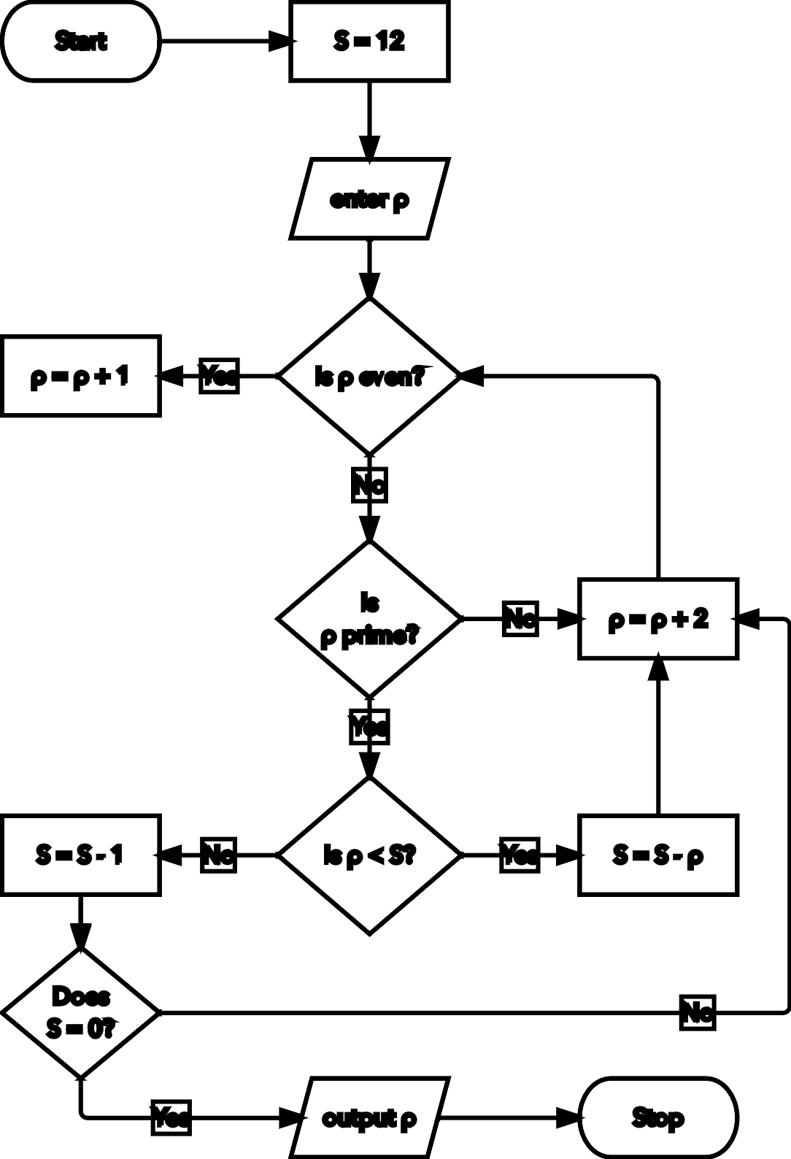 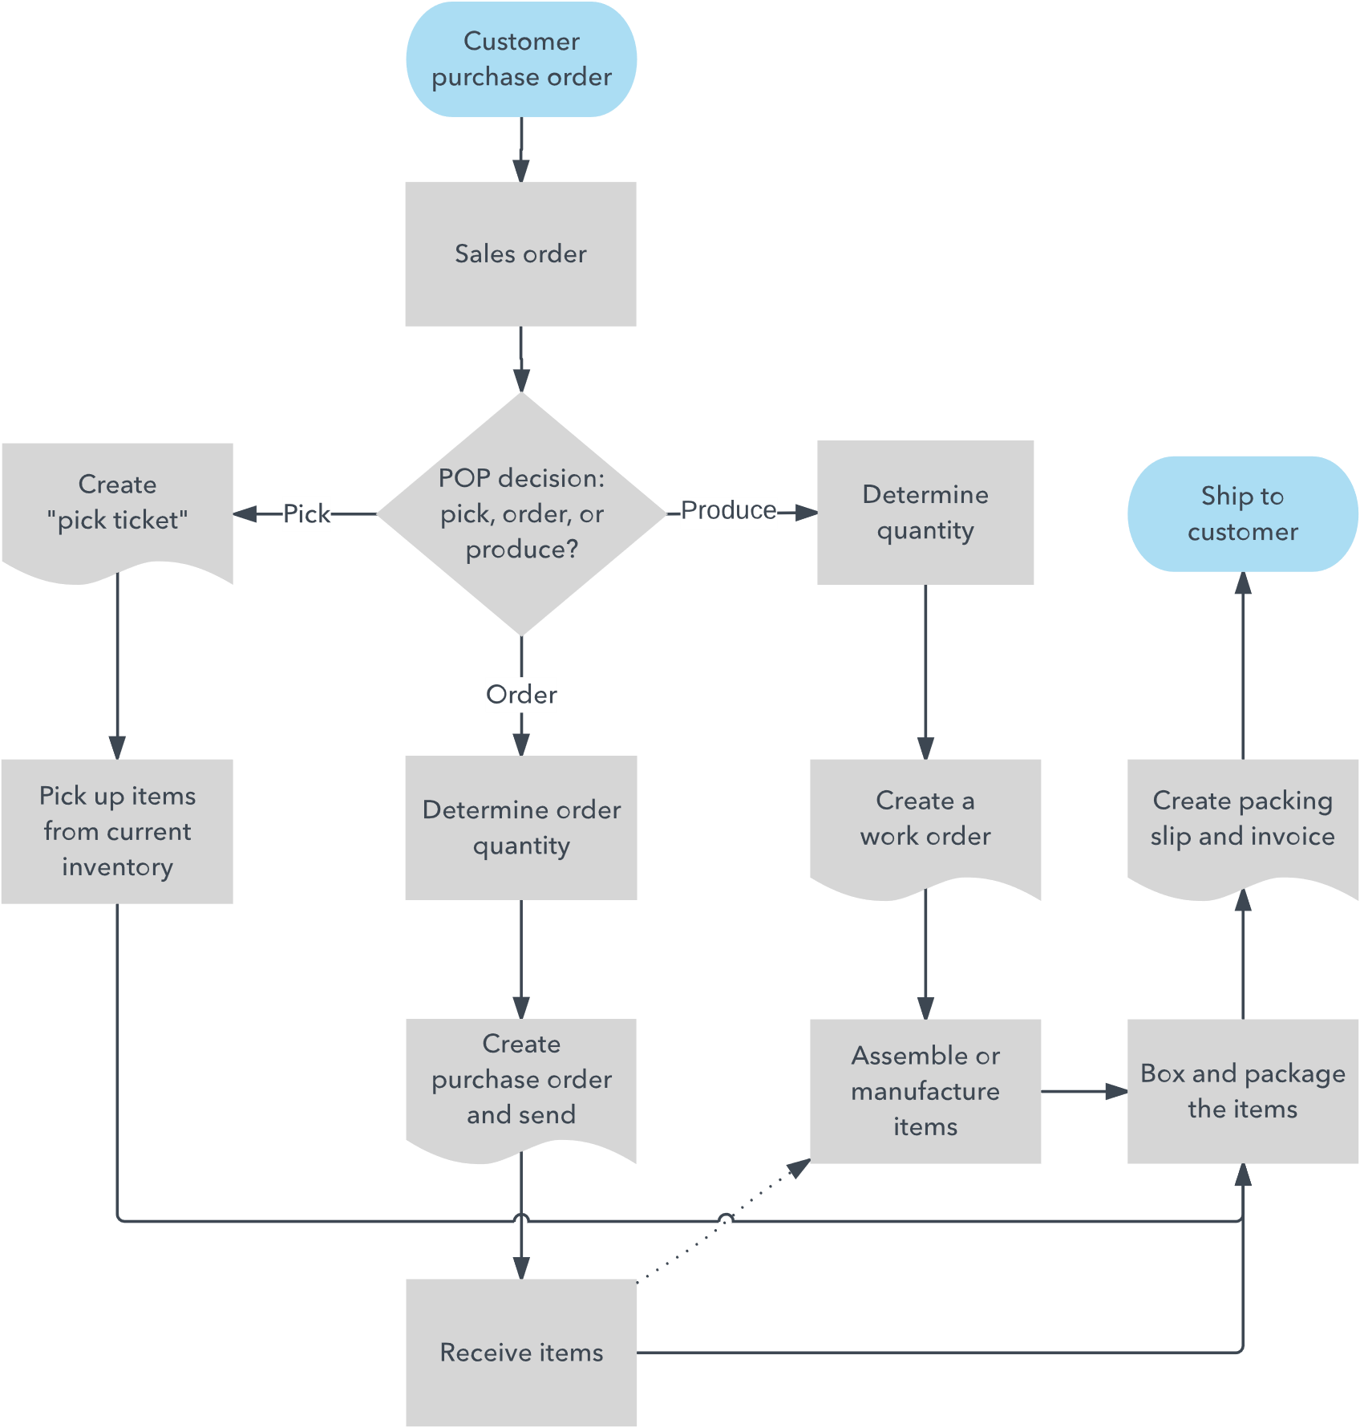

# Pseudocodes

## Definition

Pseudocode is an informal way of programming description that does not require any strict programming language syntax or underlying technology considerations. It is used for creating an outline or a rough draft of a program. Pseudocode summarizes a program’s flow, but excludes underlying details. System designers write pseudocode to ensure that programmers understand a software project's requirements and align code accordingly.

## Importance

Pseudo coding is the process of using comments in your code in order to keep track of what is actually going on. One might say that pseudocode is a bit ‘extra’, but it has its purpose. Pseudo coding allows not only the person writing the code, but also the reader, to understand what’s happening inside of the code. Everyone have their own coding style, and some are harder to read than others. Although we strive to have clean code where each line is self-explanatory, sometimes that does not happen — this is where pseudocode shine!

## How to plan and draw a basic flowchart

1. Arrange the sequence of tasks and write the pseudocode accordingly.
2. Start with the statement of a pseudo code which establishes the main goal or the aim.
3. The way the if-else, for, while loops are indented in a program, indent the statements likewise, as it helps to comprehend the decision control and execution mechanism. They also improve the readability to a great extent.
4. Use appropriate naming conventions. The human tendency follows the approach to follow what we see. If a programmer goes through a pseudo code, his approach will be the same as per it, so the naming must be simple and distinct.
5. Use appropriate sentence casings, such as CamelCase for methods, upper case for constants and lower case for variables.
6. Elaborate everything which is going to happen in the actual code. Don’t make the pseudo code abstract.
7. Use standard programming structures such as ‘if-then’, ‘for’, ‘while’, ‘cases’ the way we use it in programming.
8. Check whether all the sections of a pseudo code is complete, finite and clear to understand and comprehend.
9. Don’t write the pseudo code in a complete programmatic manner. It is necessary to be simple to understand even for a layman or client, hence don’t incorporate too many technical terms.

## Examples

Let’s have a look at this code

// This program calculates the Lowest Common multiple

// for excessively long input values

import java.util.*;

public class LowestCommonMultiple {

    private static long

    lcmNaive(long numberOne, long numberTwo)

    {

        long lowestCommonMultiple;

        lowestCommonMultiple

            = (numberOne * numberTwo)

              / greatestCommonDivisor(numberOne,

                                      numberTwo);

        return lowestCommonMultiple;

    }

    private static long

    greatestCommonDivisor(long numberOne, long numberTwo)

    {

        if (numberTwo == 0)

            return numberOne;

        return greatestCommonDivisor(numberTwo,

                                     numberOne % numberTwo);

    }

    public static void main(String args[])

    {

        Scanner scanner = new Scanner(System.in);

        System.out.println("Enter the inputs");

        long numberOne = scanner.nextInt();

        long numberTwo = scanner.nextInt();

        System.out.println(lcmNaive(numberOne, numberTwo));

    }

}

## References

How to write a Pseudo Code? (2018, December 18). Retrieved from https://www.geeksforgeeks.org/how-to-write-a-pseudo-code/

Jackson, D. (2017, September 28). Pseudocode and its importance. Retrieved from https://medium.com/@andremj013090/pseudocode-and-its-importance-5f71e38a0d95

Lucidchart. (n.d.). Flowchart Symbols and Notation. Retrieved from https://www.lucidchart.com/pages/flowchart-symbols-meaning-explained