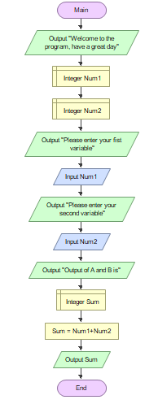

**Steps & Procedures:**

1. Start the flowchart
2. Write output
3. Declare Num1
4. Declare Num2
5. Write output
6. Input the value of Num1
7. Input the value of Num2
8. Write output
9. Declare Sum
10. Process formula of sum
11. Write output Sum
12. End the flowchart

Flowcharting Symbols:

Start/End Flowchart SymbolStart/End Symbol

Input/Output Flowchart Symbol Input/output Symbol

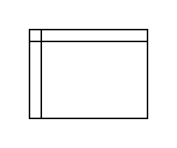Declaration Symbol

Process Flowchart Symbol Process Symbol

Explanation:

Once the flow chart started, you need to values to add it to a sum. Num1 and Num2 is declared and inputted to represent these two numbers. Then you need to declare the sum before processing it into a formula which is Num1 + Num2 in these scenario. The result of this formula will show the sum of the two inputted number before ending this flow chart.

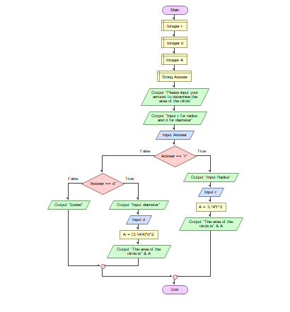

Steps & Procedures:

1. Start Flow Chart

2. Declare Integer r

3. Declare Integer D

4. Declare String Answer

5. Input Answer

6. Decide if the Answer is equal to r

If True (if answer is r)

7. Input r

8. Process the formula of A

9. Output A

10. End the Flow Chart

If False (if answer is not r)

7. Decide if the Answer is equal to d

If True (if answer is d)

8. Input r

9. Process the formula of A

10. Output A

11. End the Flow Chart

If False (if answer is not d)

8. End the Flow Chart

Flowcharting Symbols:

Start/End Flowchart SymbolStart/End Symbol

Input/Output Flowchart Symbol Input/output Symbol

Declaration Symbol

Process Flowchart Symbol Process Symbol

Decision Symbol

Explanation:

In finding the area of the circle, you need to know if the values you have is either a radius or a diameter. In this flowchart we declared r, d, and A representing radius, diameter, and Area. We also declare a string answer. After declaring these three variables we input them into the flow chart. Then we need to find if the number is radius or a diameter. If neither we end the flowchart. Once answered we need to input the values then process them into their respective formula. The result will be the output A or area will show before ending the flowchart