**Bioinformatics**

UCSF –

Requirements: <https://bioinformatics.ucsf.edu/admissions>

App: <https://gradapplication.ucsf.edu/Applicant/Default.aspx>

UN bwiley4@jh.edu

## in password

EMBL-EBI –

Requirements: <https://www.ebi.ac.uk/research/eipp/how-to-apply>

App: <https://erecruit.embl.de/phd-app/#!>

username: [bwiley4@jh.edu](mailto:bwiley4@jh.edu)

password: MjMHBsRg

Harvard –

Require: <https://gsas.harvard.edu/admissions/apply>

App: <https://apply.gsas.harvard.edu/apply/>

UN bwiley4@jh.edu

** in password

**Computational Medicinal Chemistry**

Stevens Institute of Technology – Non-Thesis Option

Require: Master of Science - Computational and Medicinal Chemistry for Drug Discovery

Must mail Transcripts

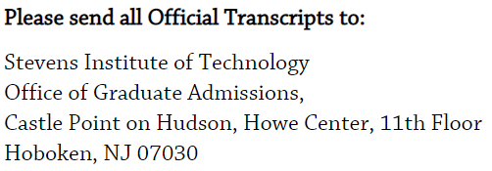

CH 664 Computer Methods in Chemistry

CH 760 Chemoinformatics

App: <https://gradadmissions.stevens.edu/apply/ins>

UN bwiley4@jh.edu

** in password

University of Illinois Chicago (Pharmaceutical Sciences)

Require: <https://pharmacy.uic.edu/programs/graduate-programs/phd-programs/phd-in-pharmaceutical-sciences/psci-admissions-requirements/>

App: <https://admissions.uic.edu/graduate-professional/apply>

UN bwiley4@jh.edu

** in password

University of Michigan

Require: <https://pharmacy.umich.edu/prospective-students/admissions/graduate-program-admissions>

App: <https://www.applyweb.com/cgi-bin/app?s=umgrad>

UN bwiley4@jh.edu

** in password

<https://pharmacy.umich.edu/people/neamati>