Bioinformatics: Tool for Genome Analysis
Final Portfolio

Brian Wiley
Johns Hopkins University
MS Bioinformatics

Table of Contents

1. Purpose 3

2. Tools Used 3

2.1. General Annotations Tools 3

2.2. Prokaryotic Annotation Tools 3

2.3. Eukaryotic Annotation Tools 3

2.4. Other Core Annotation Tools 3

2.5. Protein Bioinformatics Tools (Might remove this) 4

2.5.1. Alignment Tools 4

2.5.2. Profiles and Motifs 4

2.5.3. Visualization 4

2.5.4. Secondary Structure and SASA Prediction 4

2.5.5. PDB/Structure Validation 4

2.5.6. Comparative Modeling and Fold Recognition 4

2.6. Databases 4

2.7. Genome Browsers 4

2.8. File Types 5

3. Software 5

4. Case Studies 8

4.1. Week 1 - Gene annotation and structure 8

4.2. Week 2 - Prokaryotic genes and gene prediction 8

4.3. Week 3 - Eukaryotic genes and gene prediction 11

4.4. Week 4 - Ensembl and Biomart 14

4.5. Week 5 - Genome browsers and analysis platforms 17

4.6. Week 6 - Single nucleotide and copy number variations 23

4.7. Week 7 - Single nucleotide and copy number variations 29

5. SNP Project 34

6. Issues 34

7. “Be a Teacher. Please, please, please be a teacher... Even if you’re not a teacher, be a teacher” (Tim Minchin) 37

8. Future Opportunity & Outlook 45

Purpose

Purpose text good old purpose

Tools Used
This section briefly lists tools used, their purpose, and how the tool is used.
Blah blah blah

General Annotations Tools
tbl2asn
Genbank
Sequin

Prokaryotic Annotation Tools
Glimmer3
ORF Finder
FGENESB
BPROM
Prodigal

Eukaryotic Annotation Tools
Augustus
Genscan
FGENESH
HMMGene
Splign

Other Core Annotation Tools
samtools
bcftools
IGV

Protein Bioinformatics Tools (Might remove this)
All the tools from Protein Bioinformatics

Alignment Tools
ClustalO, MAFFT, T-Coffee, Muscle, Kalign, PROBCONS

Profiles and Motifs
PROSITE, ProtScale Regular Expressions

Visualization
Chimera, Pymol

Secondary Structure and SASA Prediction
PredictProtein including PHDsec, PHDacc, PHDhtm by Rost Lab.

PDB/Structure Validation
PROCHECK, Bio3D (R), WHATCHECK

Comparative Modeling and Fold Recognition
FFAS, Fugue, I-Tasser, Modeller, SWISS-MODEL, Phyre2

Databases
Nuccore/Nucleotide
Pubmed
Protein
UniProt
PDBsum
Interpro
Pfam
PATRIC
Ensembl
UCSC Table Browser
dbSNP
ClinVar

Genome Browsers
NCBI Variation Viewer
NCBI Genome Data Viewer
Ensemble
UCSC

File Types
Bed
GFF/GFF3
GTF
Wig/Wiggle
Sam/Bam
Genbank
Sequin
ASN.1
Fasta/Fastq
PDB file (.pdb)
VCF/BCF

Software
Python
Example Scripts and Descriptions

R
Example Scripts and Descriptions

Perl
Example Scripts and Descriptions

Case Studies

Week 1 - Gene annotation and structure
Genbank, Accessing Genbank files with Bio::DB::EUtilities in perl in datbase class.
In the first week of class we reviewed general annotation. A major topic was reading Genbank files. Interesting I started very early on week 3 in my Biological databases courses which had a module on E-utilities and accessing information from NCBI progromatically. I discovered a package for accessing Genbank file in perl.
I wrote a perl script in my database class, eUtils_genbank.pl to access Genbank files searching nucleotide/nuccore database and return exons of search hits or protein database and return CDSs of search hits. Usage is below:
Usage:
eUtils_genbank.pl -q [query] -e [e-mail] [OPTIONS...]
Options:
--max-return=<number>
How many max database entries to return
-t, --taxid=<number>
Option filter by tax id
-r, --refseq
Option to filter by only RefSeq entries
-d, --db=<String>
Database option. Default is 'nucleotide'. Only allows for
'nucleotide', 'nuccore', or 'protein'. I figured a way to get NG and
NC reference number from 'gene' database but it requires parsing the
Entrez gene file for the genomic accessions. It's a pain.

Week 2 - Prokaryotic genes and gene prediction

Using tools in the Glimmer package, genome for Halanaerobium praevalens and contig for strain of Halanaerobium predict coding sequences for the contig. Compare this to FGENESB.
# obtain open reading frames from complete genome in hprev_genome.fasta
# using entropy threshold of t=1.15
long-orfs -n -t 1.15 hprev_genome.fasta Hpraevalens.longorfs
# extract sequences for training using -t for no stop codon
extract -t hprev_genome.fasta Hpraevalens.longorfs > Hpraevalens.train
# create interpolated context model from train set
build-icm -r Hpraevalens.icm < Hpraevalens.train
# run glimmer3 to predict CDS’s
# maxoverlap=50, min_gene_length=110, threshold_score >= 30
glimmer3 -o50 -g110 -t30 halan.fasta Hpraevalens.icm halan
# extract sequences from halan.predict using -t for no stop codon
extract -t halan.fasta halan.predict > halan.glimmer
Results:
>Halanaerobium sp. MDAL1, whole genome shotgun sequence
orf00001 171 350 +3 11.68
orf00003 343 1626 +1 8.96
orf00004 1629 4733 +3 6.58
orf00005 5786 4971 -3 8.13

From Softberry homepage run FGENESB with full genome and contig to predict CDS sequences
Selecting BACTERIAL generic as closest organism returns following results:
Output:
Number of transcription units - 2, operons - 1
N Tu/Op Conserved S Start End Score
pairs(N/Pv)
1 1 Op 1 . + CDS 3 - 350 298
2 1 Op 2 . + CDS 343 - 1626 1063
3 1 Op 3 . + CDS 1629 - 4733 1901
4 2 Tu 1 . - CDS 4971 - 5786 654

Install and use Prodigal for bacterial gene prediction to compare with Glimmer and FGENESB

Steps:q
1) Download binary with:
wget https://github.com/hyattpd/Prodigal/releases/download/v2.6.3/prodigal.linux
2) Change name to prodigal and move to desired directory
3) Alternatively download source code and make with:
wget https://github.com/hyattpd/Prodigal/archive/v2.6.3.tar.gz
tar -xvzf v2.6.3.tar.gz
cd Prodigal-2.6.3
make install INSTALLDIR=/home/coyote/tools
4) Run prodigal in training mode with:
prodigal -i hprev_genome.fasta -t hprev_genome.train
5) Use training to predict CDS sequences
prodigal -i halan.fasta -t hprev_genome.train -a halan_protein.faa

Results for Prodigal are same as with FGENESB:

FEATURES Location/Qualifiers
CDS <3..350

CDS 343..1626

CDS 1629..4733

CDS complement(4971..5786)

Use PATRIC to find information on bacterial genomes as well as transcriptomic experiments
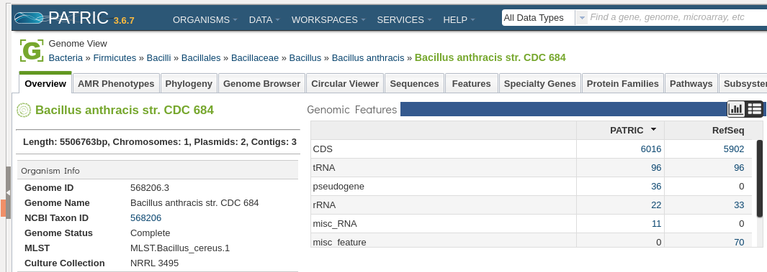

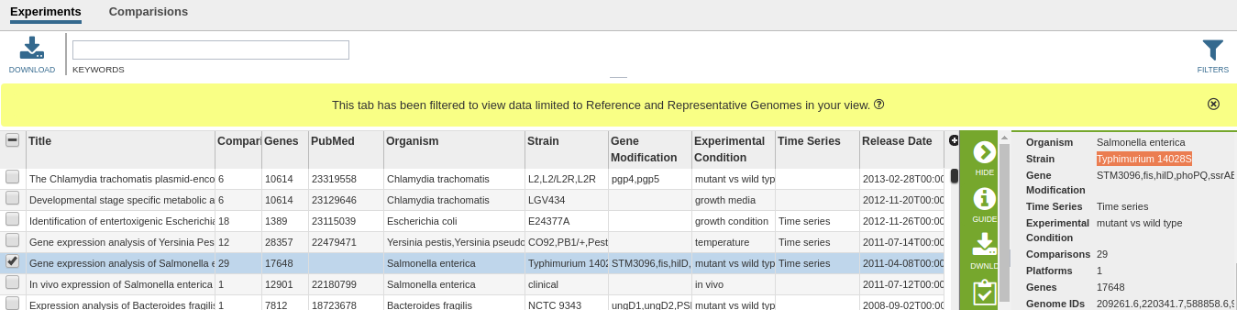

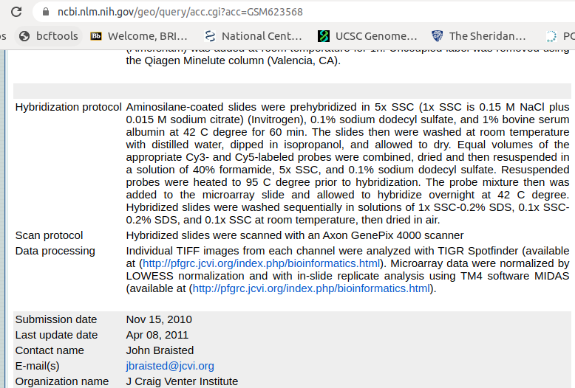

Week 3 - Eukaryotic genes and gene prediction

Add tracks to Variation Viewer: Added .bed file for CpG island and H3K27ac narrowPeaks wiggle file to NCBI Variation Viewer.
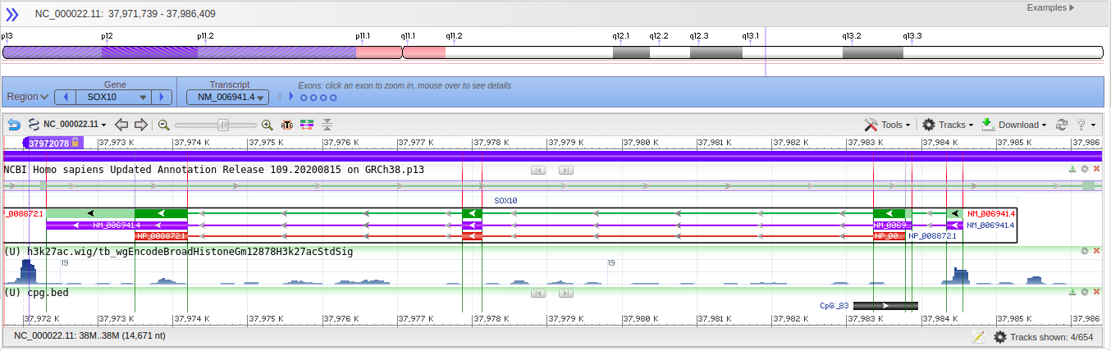
Align mRNA to genomic DNA in Splign. Then annotated with tbl2asn and Sequin to generate Genbank file. Steps below:
Step 1: Splign with cDNA input from silkworm mRNA fasta file and Genomic input from silkworm genomic input file for the gene FK506-binding protein (LOC733041)

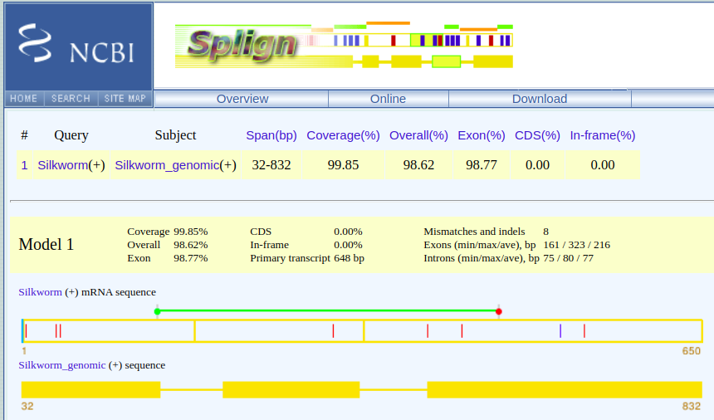

Step 2: install tbl2asn from ftp here. Using the guide by NCBI for tbl2asn to create Feature table.

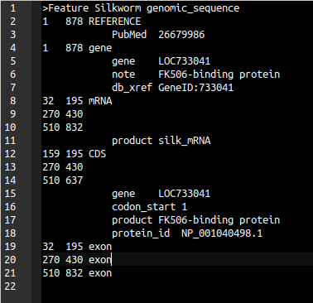

Step 3: Run tbl2asn with three required input files (silkworm genomic DNA, feature table, and submit file from NCBI) and update in Sequin before exporting genbank file (silkworm.gb)
tbl2asn -p silkworm_tbl2asn

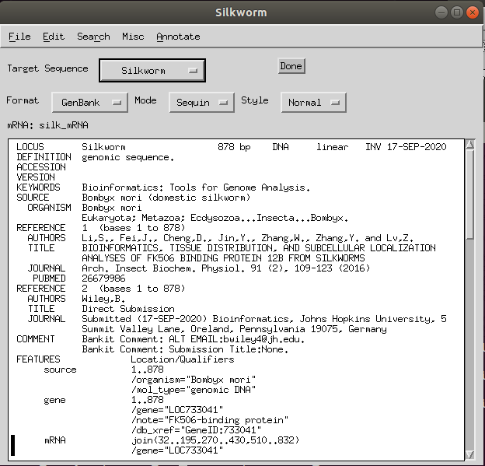

Downloaded and install Augusts to run gene prediction analysis on genomic DNA from chicken from command line.
Steps:
1) Clone package from github with:
git clone https://github.com/Gaius-Augustus/Augustus.git
2) Install samtools, bcftools, and htslib to build Augustus with bam2wig
3) Run gene prediction with:
augustus --species=chicken chicken_gene.txt > chicken.out.gff
3) Obtain the proteins, coding exons, and coding sequence (mRNA) using getAnnoFasta.pl script:
getAnnoFasta.pl chicken.out.gff --seqfile=chicken_gene.txt
Exon sequences:
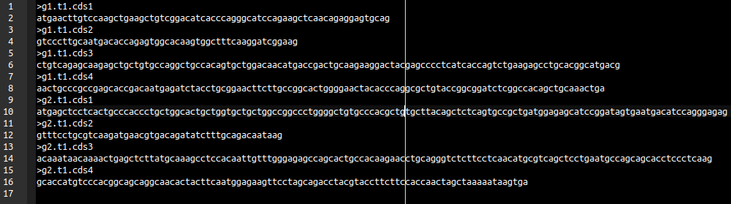

Week 4 - Ensembl and Biomart

Use BioMart interface on Ensembl website since “biomaRt” R package was working on updates.
This analysis was performed in Week 5 as when querying UCSC Table Browser when for the “Genes and Gene Predictions” group. Most tracks and tables, particularly GENCODE tracks, have a name column for “Name of gene” but list transcript IDs. The question asked how many Ensembl genes are listed in a particular region and the return from UCSC listed all the transcripts and so, after discussing with professors, to obtain the Ensembl genes we input the transcript IDs to BioMart interface and then we can export to R to count unique gene IDs in the gene ID column.

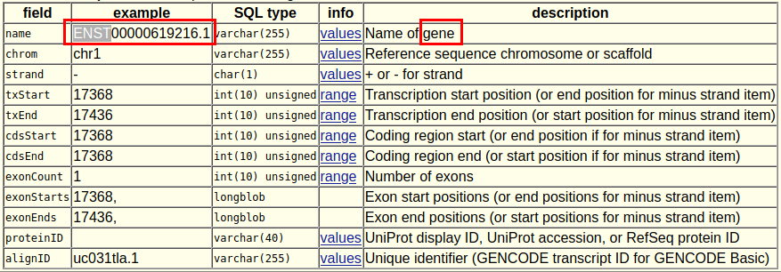

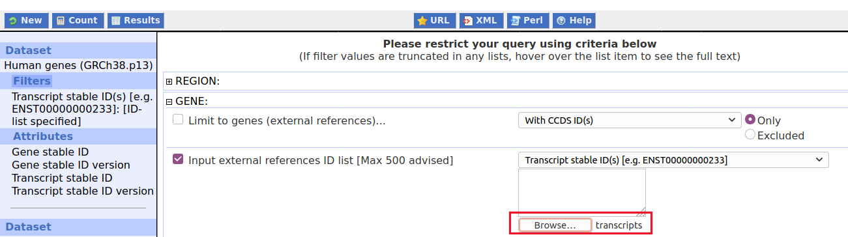
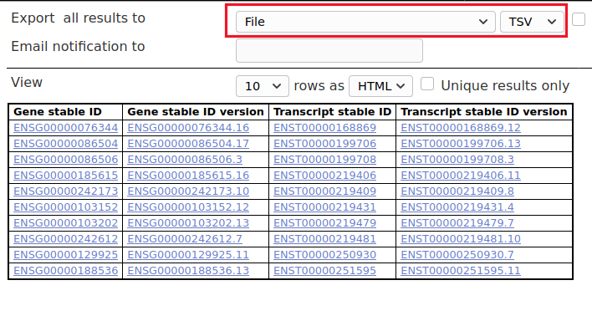

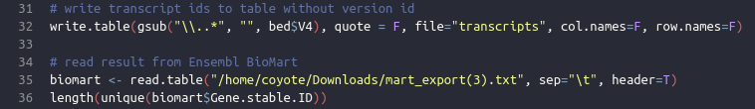
Use ‘biomaRt’ and ‘GenomicRanges’ bioconductor packages to obtain genes overlapping region
Part 3 - biomaRt
1. What Ensembl genes are in a 100,000 base pair region of chromosome 20 from 5.0 to 5.3 Mb? What chromosome band are they on, what strand, and what type of genes are they?
Hint: Attributes are: hgnc_symbol, band, strand, gene_biotype
2. Are there OMIM genes in this same region? Use "hgnc_symbol","band","strand","gene_biotype","mim_morbid_accession","mim_morbid_description" for the Attributes.

I used ‘biomaRt’ package in R to send request to database to answer this question. The R script, titled part3_2.R is available on github. We discussed this problem on Slack and Discussion board as a class and there was some good conversation. We did come to agreement on interpreting the question to only include ranges that had with less than 100 kb which I performed with BiocGenerics::width() function and as long as any base of the region overlapped the 300 kb range we would include it. For this I also used the GenomicRanges Bioconductor package in R and use of the findOverlaps() function.

Use ‘biomaRt’ and ‘GenomicRanges’ Bioconductor packages to obtain mouse genes with RefSeq peptides and write GRanges to BED file using ‘rtracklayer’ package.
Use the web-based BioMart in Ensembl to create a dataset and save it as a TSV, CSV, or XLS file. Use the following parameters to make the dataset:
Dataset:
Ensembl Genes 93 (or the latest version)
Mouse genes (GRCm38.p6) (or the latest version)
Filters:
Chromosome 11
Band E2 only
Transcript count >=7
Limit to genes with RefSeq protein (peptide) IDs only
Attributes:
Default attributes
Add “RefSeq Protein (peptide) ID”

I performed the search with ‘biomaRt’ in R, put information into GRanges object, sorted by start position and wrote to BED6 file using ‘rtracklayer’. Script is named week4_problem4_updated.R and is available on github along with the bed file week4_problem4.bed with RefSeq accession ID for the peptide entry.

Week 5 - Genome browsers and analysis platforms
Create and document a workflow for students to follow for comparative genomics analysis using Galaxy, UCSC Genome Browser, and IGV. Posted to discussion forums for students to follow.
I decided to apply all that I learned in reading and in my own experience with all three tools, UCSC, Galaxy, & IGV that includes some extra nice stuff.

An interesting function in the UCSC Table browser is the “describe table” schema. For part 4 in peer collab clicking this for the Mouse Chain table shows the fields of the data in the table and gives a description. The name of the Primary Table: chainMm10 is what shows in Galaxy.
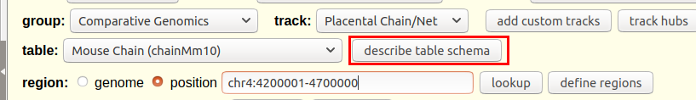
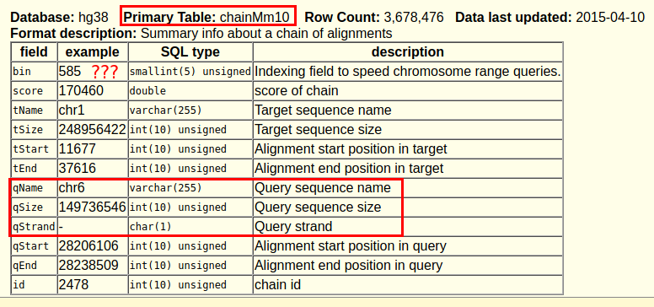

You may be asking yourself what is this “bin” field? It doesn’t seem important! Oh but wait...it is EXTREMELY important. The developers of the UCSC Table Browser, including a name you will see on about every single UCSC paper, James Kent, came up with a clever, “mystic” as they describe it, way to index the HUGE amount of data that can be queried and retrieved from extremely large tables and created a binning algorithm for faster data retrieval. You don’t need to worry about it from the user interface but if you are accessing information programatically, such as overnight batch retrieval, according to this “famous” Biostars post, Heng Li (the creator along with R. Durbin of the bwa aligner program!) strongly urges learning how to implement "binning" coordinate intervals for 1) faster retrieval and 2) to not bog down the server. If you are interested in the algorithm you can find it here based on the advice of R. Durbin as well as Python implementation here.

The database used also shows up if you click the history title in Galaxy. Notice the wrong format of “tabular”.
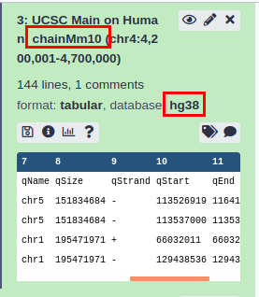

If you are trying to perform a function or use a tool on a data but that number is “unavailable” this means that you may have used an incorrect format. For instance for the Mouse Chain, I incorrectly did not set to “Bed Format” and so you would see:
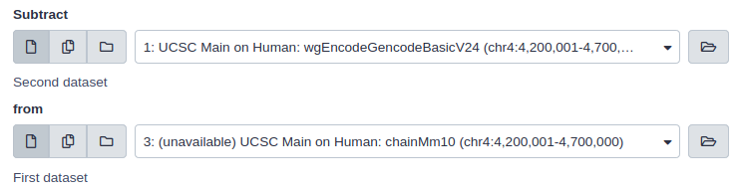

Correcting this shows:

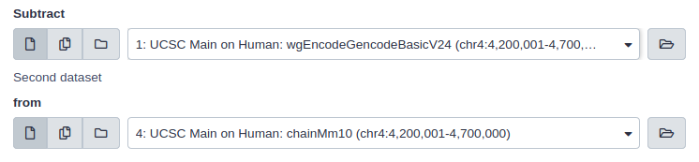

You can see the Galaxy tool parameters by clicking the circled info(i) button if you forgot which parameters you chose to run the tool.
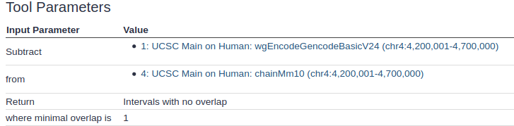
You can actually visualize results directly from Galaxy in IGV and UCSC.
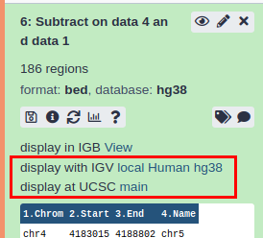

I think this linking from Galaxy to IGV only works if you have IGV installed in Windows as the link asks you to open up an application and IGV is only installed as an “application” in windows. On my Linux machine I have to start IGV with their shell script that comes with the download. For me I can only save the XML file and source it into IGV.

For the “Non-overlapping pieces of intervals” return, if there is an overlapping interval then the pieces of the interval that remains after subtracting will still be returned. For the “Intervals with no overlap” return, ff there is an overlapping interval then no interval will be returned after subtracting, i.e. you will have less regions returned from “Intervals with no overlap” than “Non-overlapping pieces of intervals”.
No overlap vs. Overlapping pieces
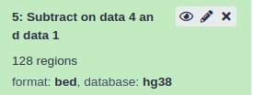
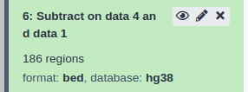

If you directly click the link from Galaxy to “display at UCSC main” you can see the User Track at the top by default and clicking “manage custom tracks” shows information about the track.
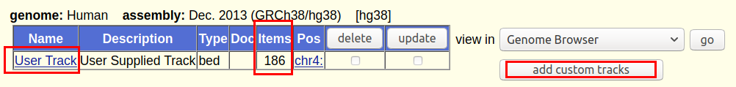

Clicking the name “User Track” link you would think you can change the name but no it’s greyed out. However it does show how to label your track like we did a few weeks back.
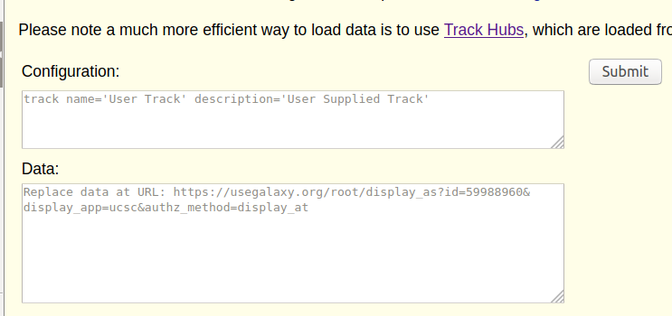

Adding a track is not that easy I found as uploading and writing in the configuration doesn’t work. Here are the steps for adding custom tracks.
1) Format file type as bed, wig, gff3, ect.
2) Add browser line(s), e.g.
browser position chr4:4200001-4700000
3) Add track name and description, e.g.
track name='Interval No Overlap (I AM ON LEFT)' description='Interval No Overlap (I AM IN REGION)'
Note it is the Description that shows in the region of the browser and the Name is the track name to left.
Warning be aware of your quotes. It works like code.
4) Don’t worry about step 4. Go back to “add custom tracks” upload and Submit
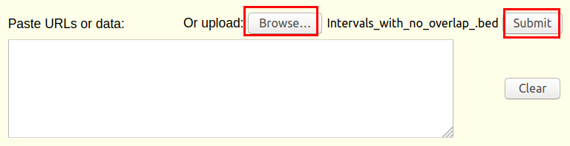

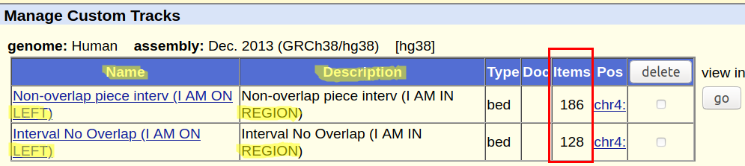

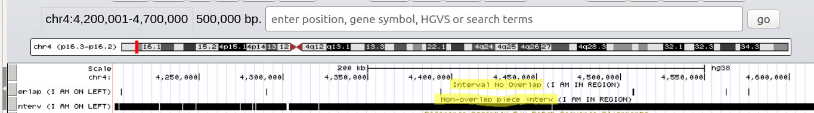

As you can see, allowing overlapping pieces (bottom track) instead of getting rid of any pieces that overlap even just by 1 base (top track) removes a lot of region in width but not necessarily the # of regions from the database that conserved with this region in Mouse.
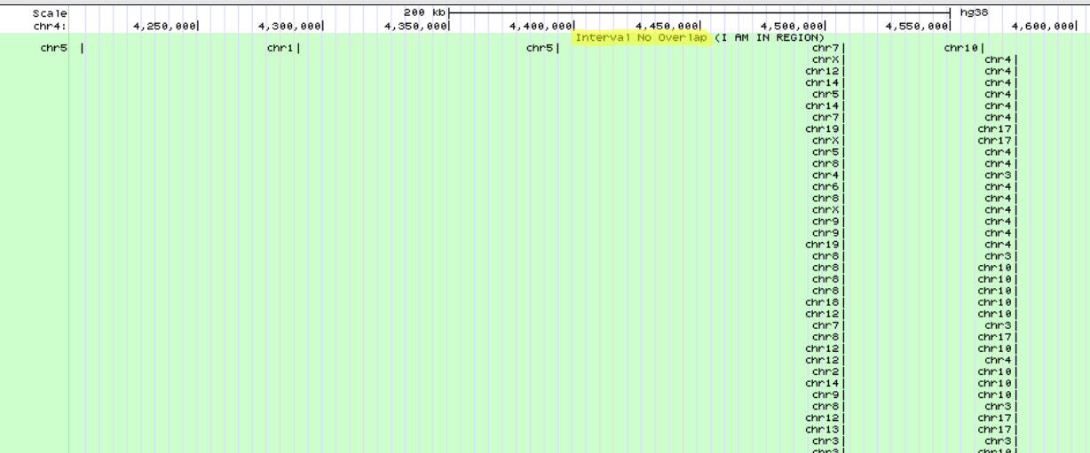

It’s much easier to upload to IGV. Below you will see in IGV with “Collapsed View” as well as “Expanded View”. It is also much easier to rename the track just by right-clicking.
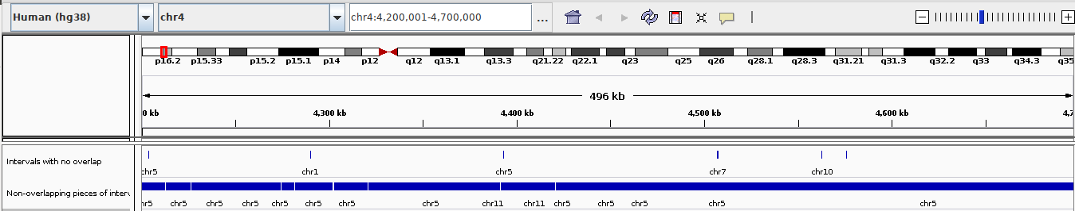
It’s these really long pieces in red that get removed when you select the return type “Intervals with no overlap”.
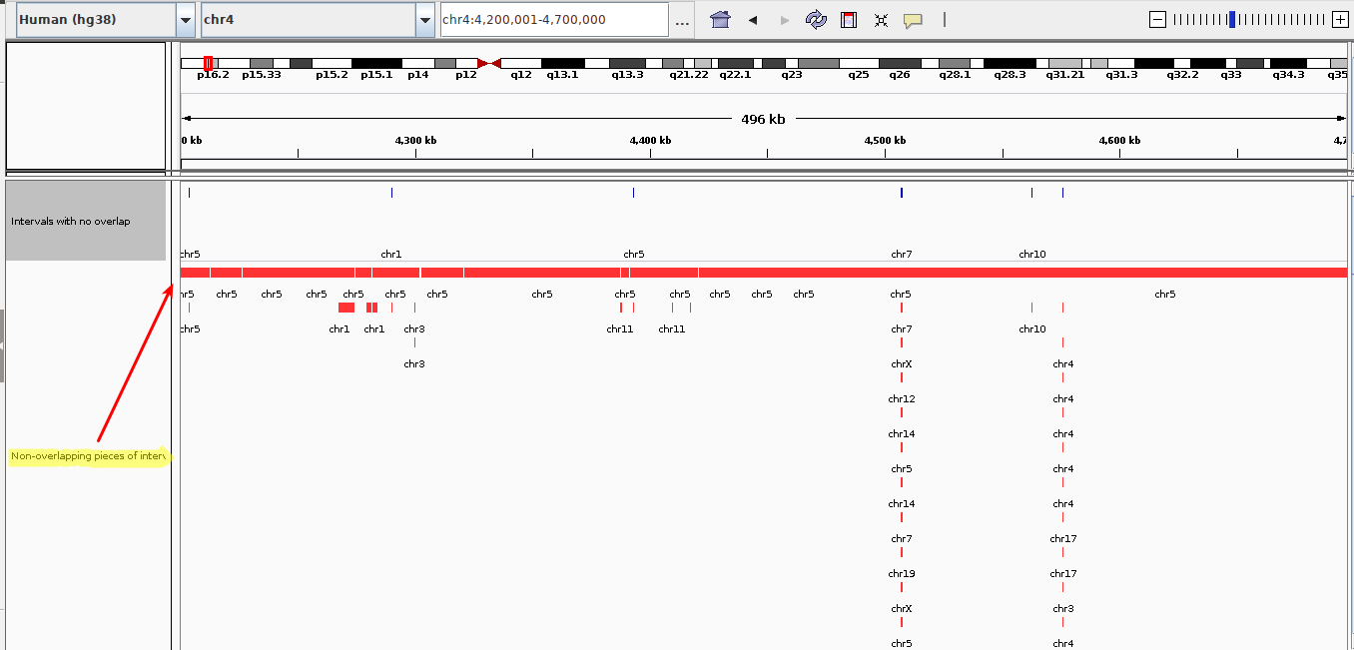
Also another interesting fact about IGV that Isabel elluded to with respect to Broad Institute developing the program for research related to The Cancer Genome Atlas (TCGA). One of the cool labs that is part of the Bioinformatics and Integrative Genomics (BIG) at Harvard University where Heng Li is associated with, the Stegmaier Lab works with Broad and one of her lab members works for the Cancer Data Science team at the Broad. I hope to write about my interest in this Data Science team in my BIG application.

Resources:
1. Kent WJ, Sugnet CW, Furey TS, Roskin KM, Pringle TH, Zahler AM, Haussler D. The human genome browser at UCSC. Genome Res. 2002 Jun;12(6):996-1006. doi: 10.1101/gr.229102. PMID: 12045153; PMCID: PMC186604.

Reviewed and posted issue with the "Histogram of a numeric column" tool in Galaxy.

The breaks functionality that backends with the R hist() function incorrectly calculates the start break of range for bins. If we set the total range to be the number of breaks, i.e a bin width of one, then bins 1 and 2 were being combined. I open a github ticket under galaxyproject /usegalaxy-playbook #309. As the ggplot() tool in Galaxy is not very customizable, I exported to R and plotted with ggplot2. The script is also available on github at file galaxy_ggplot.R.

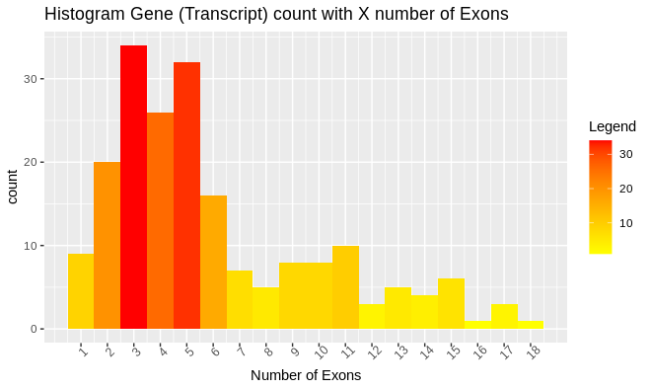

Week 6 - Single nucleotide and copy number variations

Compare information from Firehose IGV server dataset to the Broad GDAC Firehose website to learn more annotated information.
Noticing that there were different types of prefixes for Firehose data from servers datasets in IGV, I looked up the meaning of TP and TM on the Firehose website finding they stood for Tumor Primary and Tumor Metastatic respectively. I also looked up the samples for Copy Number datasets from Firehose from 2016 and found for the samples for SNP6 CopyNum, e.g. genome_wide_snp_6-segmented_scna_minus_germline_cnv_hg19 samples, where the SCNA stands for somatic copy-number alterations, was ran with the Affymetrix Genome-Wide Human SNP Array 6.0. Looking up information on this chip from Thermo Fisher website I found that of the 1.8 million genetic markers on this chip, 946,000 of the probes detect for CNV.
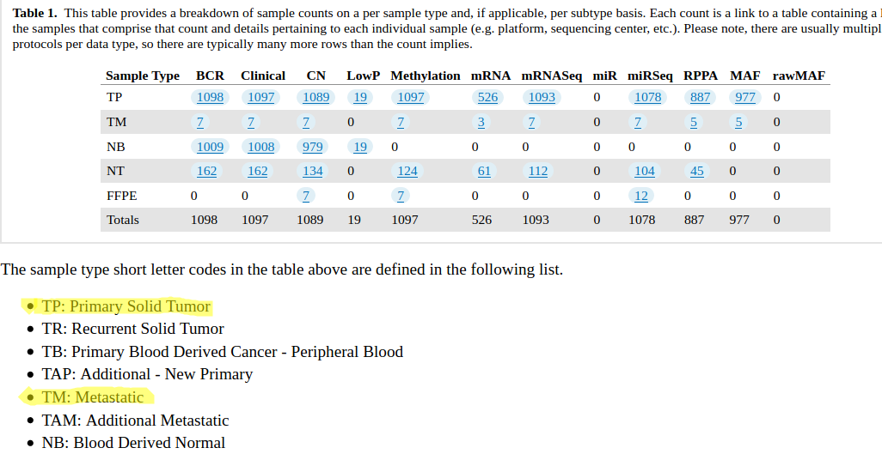

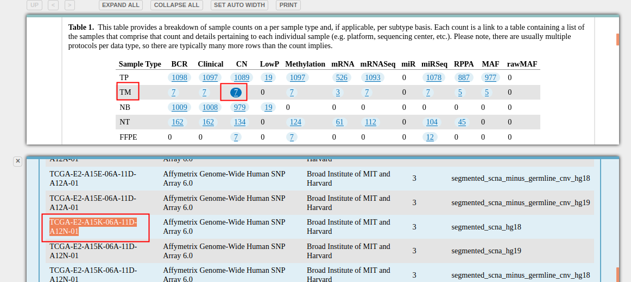

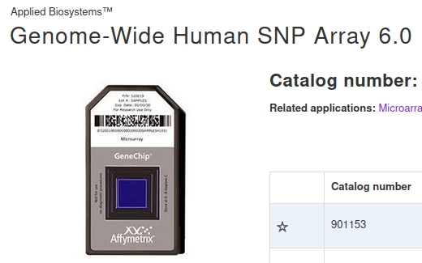
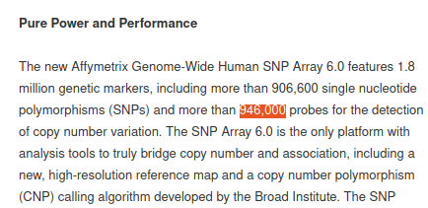

This also shows that the software used by Thermo Fisher included with the chip is developed by Broad.

Use IGV to visualize whole-exome sequencing GBR (British in England and Scotland) sample data with the data from NCBI dbSNP 147 database.
Part 3
Using IGV for hg19, load dbSNP 1.4.7 or newer (i.e. Available Datasets > Annotations > Variation and Repeats > dbSNP 1.4.7) and an exome sequencing track from the 1000 Genomes project (1000 Genomes > Alignments > GBR > exome > HG00096 exome). Go to the EPHX1 gene and zoom in on the exon #4.
a. (0.25 pts) How many SNPs overlap this exon and what are the SNP IDs?
b. (0.25 pts) At which SNP(s) in part a does this individual appear to be heterozygous? What is the sequence count for each nucleotide at this(these) position(s)
The sample HG00096 is a Bam (Binary alignment map) file with the results of runs from whole-exome sequencing (WES) on human B-lympocytes from a donor from the United Kingdom as part of the 1000 Genomes project. I found that there were too many SNPs to count, even on 1 exon of EPHX1, and so I used the UCSC Table Browser, track All SNPs(147) primary table snp147, with the coordinates of exon 4 of EPHX1 gene, obtained from NCBI Genome Data Viewer and confirmed with the GenBank record (see 7J section under “Be a Teacher”) to obtain an output of all the SNPs listed on this track in IGV. Exporting from the table browser was then able to read into R to print out nicely in the script galaxy_ggplot.R.
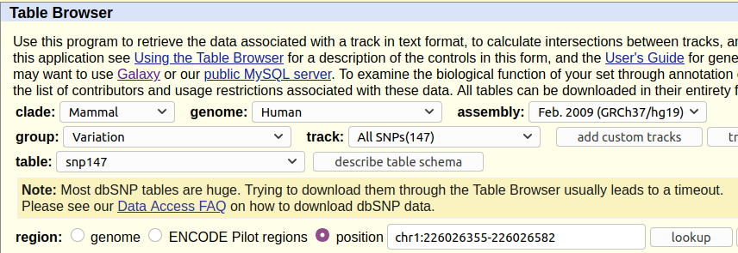
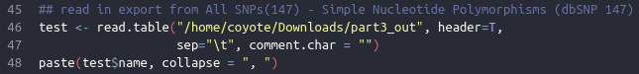

As a class through discussion on Slack we discovered there were more than just one type of variation from the dbSNP database and that in addition to SNPs, there were other classes of variation list in red box below.
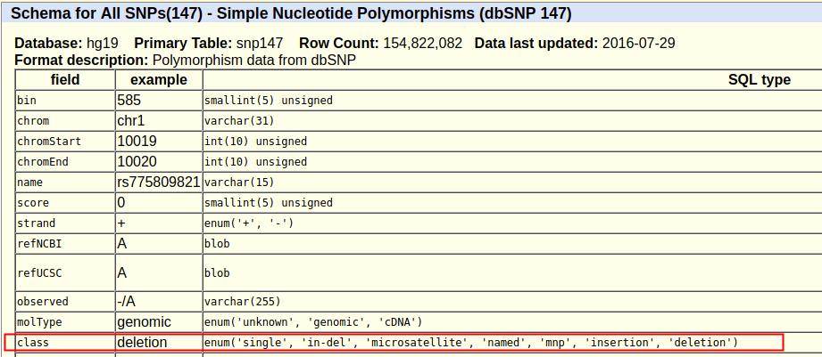
Next using the summary track for Bam file for sample HG00096, found which specific SNP the sample was heterozygous for. Another student and I found from help page for AlignmentData for IGV at Broad that “if a nucleotide differs from the reference sequence in greater than 20% of quality weighted reads, IGV colors the bar in proportion to the read count of each base (A, C, G, T).” (Broad Institute)
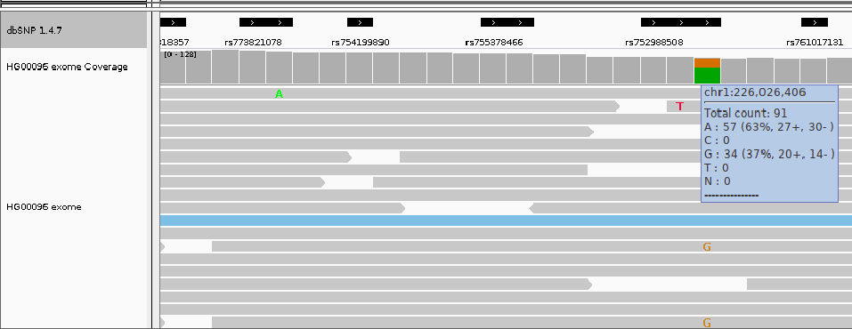

Use NCBI ClinVar and Ensembl to look up information on structural variants of a protein coding gene.
As a follow to my paper on the A712T mutation of the high-voltage Cav2.1 Voltage-dependent P/Q-type calcium channel subunit alpha-1A (Cavα1) in Protein Bioinformatics regarding to the structural implications of the variant on epileptic pathologies, the goal was to complete a meta-analysis study to quantify the amount of variants for this large (>2500 residue) protein.
First use ClinVar to determine the amount of deletion type variations and of those how many were classified as being pathogenic.
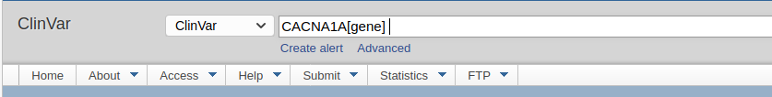
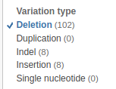
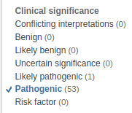

As a follow to my original paper, the p.A712T variant was also listed in ClinVar and in dbSNP. These NCBI databases usually will have to links to eachother, if in ClinVar, the dbSNP rs id entry will indicate this next to “Clinical Significance”, and if in dbSNP, the ClinVar entry will have the dbSNP link to the rs id next to “Links”. However neither of these entries have the valid link to eachother despite the variant being in both databases.
dbSNP:
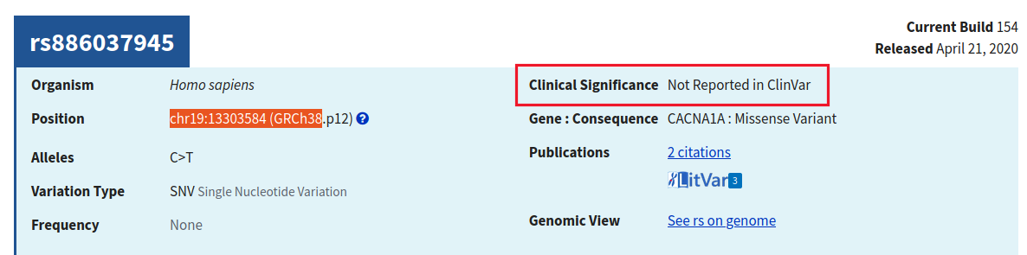
ClinVar:

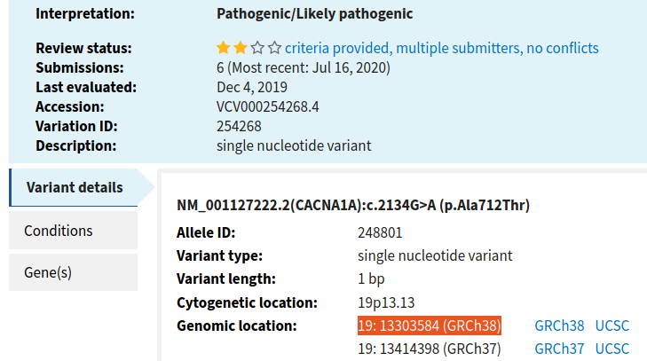

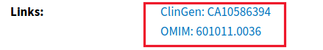

Finally, use Ensembl to count the structural variants as well as how many of the structural variants are listed in the dbVar at NCBI. We can then export and/or read into R to filter for columns based on database study, e.g. dbVar, Database of Genomic Variants Archive (DGV), etc. and the variant class, e.g. CNV, insertion, etc.
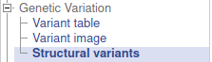

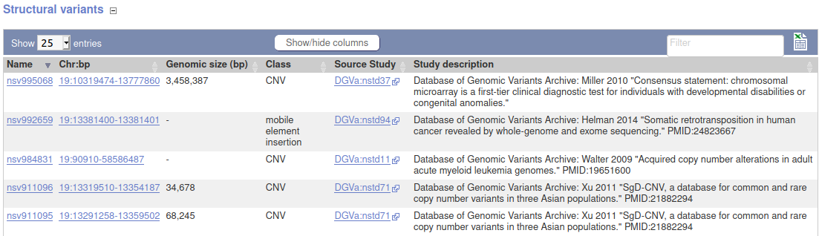

4.7. Week 7 - Unit 7: Genomic data file formats and manipulation tools

SNP Project
SIFT, Poly-Phen2, Genome Data Viewer, Ensembl variation, dbSNP, ClinVar, Variant Annotation Integrator

Issues
This section describes unique issues that arise from using tools, communication and teaching between students, and opportunity for …

“Be a Teacher. Please, please, please be a teacher... Even if you’re not a teacher, be a teacher” (Tim Minchin)
This section, maybe the longest one of them all, is inspired by the commencement speech by Tim Minchin to give a list of experiences where I could act as teacher to help my fellow students. This includes discussions, threads on slacks, and e-mails. I also include links to 3 of my PowerPoint presentations in which I felt a lot of passion during presenting those to my fellow classmates. Each entry or teaching experience is proceed by a letter starting with A) and going on to AA), AB) and so forth. Each entry briefly describes what the experiences entails.

A) During the course project, my teammate asked about why he/she was not able to find the join(..) statements for the CDS in a GenBank entry with the prefix NM. Here is my response:
Sometimes NM entries don't have the join. I saw this happen often or it will list the exons all as separate features so you can extract the exons however Biopython can do this with their parsing module with joins so separate features is not necessary. Mostly it's the "Gene" Genbank record that has the joins. So this mRNA entry has it here:
go to the
db_xref="GeneID:672"
in NM_007294.4. Then go to Genomic regions, transcripts, and products and select the GenBank link. It defaults to the region in genome:(edited)
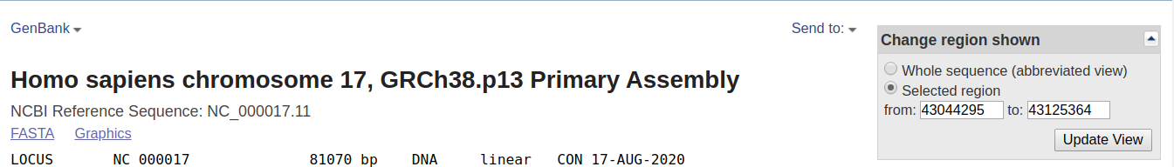
Then scroll down to CDSs (there are 5 of them) and confirm its the correct transcript variant in note:
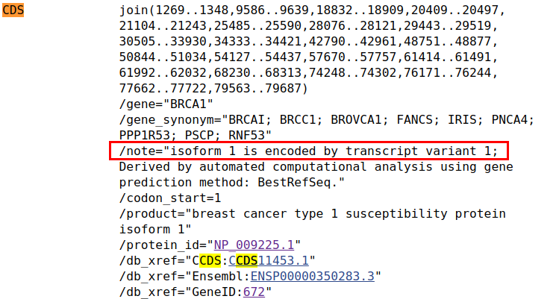

B) In discussions for connecting to a remote server at the University, our professors asked what are ways to download information. After realizing BlackBoard would require UN and PW here is my response:
Hey All,
FYI for peer collab unit 2. Under Part Four if you want to upload files to the server from blackboard, you need to provide wget with username and password to access downloads from blackboard. So for example after you make directories for "unit2" and subdirectory for "fastas" (optional) you can get the fastas for S. malt by the code below with user name being your email without @jh.edu and your password:
wget --user bwiley4 --password <your password> 'https://blackboard.jhu.edu/bbcswebdav/pid-8336676-dt-content-rid-91961117_2/xid-91961117_2' -O smaltprt.fasta
wget --user bwiley4 --password <your password> 'https://blackboard.jhu.edu/bbcswebdav/pid-8336676-dt-content-rid-91961111_2/xid-91961111_2' -O smaltprt.fasta
Then you can check if it worked with this and you should see same results:
wc -l smaltprt.fasta
# 93 smaltprt.fasta
wc -l smalt.fasta
# 69320 smalt.fasta

C) I talk about here while reviewing different bacterial gene prediction programs my experience seeing different start codons being supplied.

So interestingly for part 1 of peer collab, I was seeing start codons in FGENESB of 'TTG' for 2247, 3653 start and stop (+) and also a start codon of 'GTG' 8859, 9728 start and stop (+) and I found this paper that indicates that FGENESB will use TTG as a start codon. The brpA gene was predicted to have different start codons using FGENESB depending on the settings used; the alternative start codon TTG (leucine) was predicted using “generic bacterial”And this page indicates that GTG along with ATG are the most common start promoters. So I did not know that programs and research has shown that start promoters can be other than ATG so it is important to check the docs for the program.

D) After hearing a lot about Augustus and downloading and trying out myself here I indicate my excitement about the tool in relation to functionality of that to another tool.

As I have read so much about Augustus I decided to download it and they have a cool script (getAnnoFasta.pl) to extract the sequences from the output which if you see on their website is a gff format output. This script is like that of glimmer "extract" protocol. Here is 1 of the ouput files with the exons extracted.
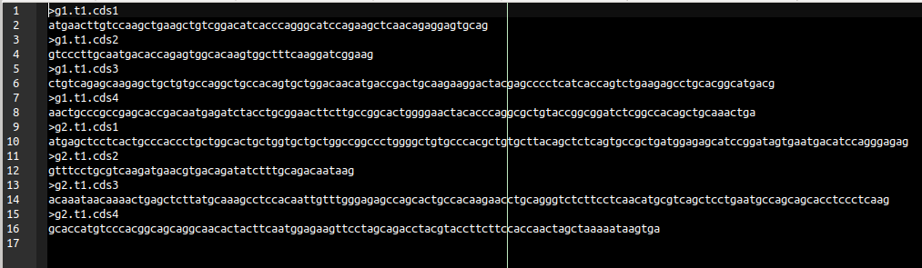

E) At the start of the week on Biomart, I am excited to off my help as I had a lot of experience and self teaching after learning and researching Bioconductor “biomarRt” package. I received a lot of questions which was exciting.

Hi All! Welcome to week 4. I was super excited to see Ensembl and Biomart as the topic. I have been working with the "biomaRt" library in R for the past year and profusely with my database class last week. I would consider myself extremely experienced in the R package if you need help you have questions about your output.

Question 1:
Hi Brian, I have been trying the initial steps to install and get used to the biomaRt package by following the user guide provided. I selected a dataset of homosapiens and then started to build biomaRt query. So when I put in "listFilters()" it shows me error. Can you help me with the same? I will attach a picture here. Am I missing a step?

My response:
useMart() returns a "mart" object and listFilters() takes a "mart" object so you pass your mart to listFilters(). Such as listFilters(ensembl). you can see which type of parameters a function takes with ?listFilters

Question 2:
@Brian Wiley Thanks! I keep running into proxy problems even if I use Sys.setenv("http_proxy" = "http://my.proxy.org:9999"). It keeps saying Ensembl site unresponsive, trying useast mirror
Error in curl::curl_fetch_memory(url, handle = handle) :
Could not resolve proxy: my.proxy.org

My response:
you should be able to just load library and use a mart. What happens if you go to a new R script and run:
library(biomaRt)
human.mart <- useMart(biomart = "ENSEMBL_MART_ENSEMBL",
dataset = "hsapiens_gene_ensembl",
host = "useast.ensembl.org")

interestingly in 4 years of R I have never used Sys.setenv()

Question 3:
Here another question Brian.... some of the filter functions are obvious but for the less obvious is there a quick way to find out about their function? How do we find a filter for a specific task? Hopefully it makes sense.…

My response:
I use grep...ALOT when looking for filters (this uses regular expressions if you want to learn more you can google regex in R). There two columns in return from listFilters(mart). They are name and description. You can search both columns, for instance:
filters <- listFilters(mouse.mart)
filters[grep("[Rr]ef[Ss]eq", filters$name), ]
filters[grep("[Rr]ef[Ss]eq", filters$description), ]
This will search the description column and return both columns (i.e. the rows since subsetting is first index [something, ]) where there is either "refseq" or "RefSeq" in the name or description. You can also do it for attributes.
attrs <- listAttributes(mouse.mart)
attrs[grep("[Bb]and", attrs$name), ]

Question 4:
Hi! I keep getting this error message when I try to run getBM
> getBM(attributes=c("ensembl_transcript_id", "hgnc_symbol"), filters="entrezgene_id", values="6928", mart=ensembl)
Error: failed to load HTTP resource
Does anyone know how to fix this issue? @Brian Wiley? Thank you in advance!!

My response:
how did you call useMart()
I think there could be issues if you use the general ensembl host because of location which is why I do "host=useast.ensembl.org"
also looks like server might be down https://www.ensembl.org/

F) After email NCBI support to ask about GenBank submissions, I advised students about tbl2asn for input files to sequin. Below are the response exchanges.

Student 1:
One thing that confused me for a while was that the command doesn't include a flag for specifying the feature table name. It has to have the same name as the fasta file and be in the same folder (and end with ".tbl"). I used the simple command given in this description: https://www.ncbi.nlm.nih.gov/genbank/tbl2asn2/ which was just "tbl2asn -t template.sbt -i x.fsa" (where "x" is whatever your .fsa and .tbl files are called)

My response:
yea so its this that needs to match (the second word after "Feature" in the feature table with the first word of sequence in fasta file

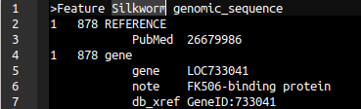
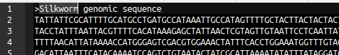

example:
>Feature Sc_16
with
>Sc_16 [organism=Saccharomyces cerevisiae]
ttt

The Sc_16 matches

Student 2:
@Brian Wiley I guess I will try tbl2asn because I can't quite get Sequin to work right and nobody else seems to have input on it. If you wouldn't mind detailing the process for tbl2asn, that would be awesome. Did you tbl2asn for peer-collaborating practice problem #1 for Unit 4?

My response:
sorry just seeing this now while working on portfolio, I used the tutorials at these links below:
https://www.ncbi.nlm.nih.gov/genbank/tbl2asn2/
# more on feature table format:
https://www.ncbi.nlm.nih.gov/genbank/tbl2asn2/#tbl
https://www.ncbi.nlm.nih.gov/Sequin/table.html

G) Here is a discussion I posted about prefixes for accession ids in NCBI

Thanks for the example. The graphics format shows both transcript variant 1 and 2 and their CDS respectively. It also shows RNA alignments. One is from mRNA in this GenBank entry for each variant NM_000162.5 and NM_033507.3. There are other alignments from other studies. The 'M' in NM is an mRNA entry. 'NG' prefix like in your example is incomplete genomic region, 'NC' complete genomic region, etc. See prefixes here. The NM_001354800.1 alignment is from this entry and the NM_033508.3 is from this entry. Many NG and NC entries are going to have other NM entries in the graphics under alignments I assume.

[EDIT] Just found another great resource for prefixes from Sequin.

H) This discussion talks about RNA-seq software I have used, a few annotation file formats, as well as an alignment software.

Thanks for the post. I have not come across seeing WIG file with "auxillary" probability scores or GC content. I guess you may see this with really large step sizes. The only experience I have with WIG files is in this tutorial for RSEMwhich is a tool for RNA-seq analysis. It comes with a script to convert BAM to WIG called 'rsem-bam2wig'. I would also like to add two more format files that we will see coming up that are closer to the representation of BED files. They are GTF and GFF3. Like BED which has many optional columns they have many columns which are required, each has 9 columns. I have posted links to the most formal and extensive descriptions I have seen for these files.
GTF: https://mblab.wustl.edu/GTF22.html
GFF3: https://learn.gencore.bio.nyu.edu/ngs-file-formats/gff3-format/
The Hisat2 tutorial for building index can also use GTF files to create exons and splice sites to incorporate in building index. Here is link: http://daehwankimlab.github.io/hisat2/howto/. It gets the GTF for human Hg38 assembly here http://ftp.ensembl.org/pub/release-84/gtf/homo_sapiens/

I) Instead of writing a post on reading for one of the modules, I decided to post an applied summary of the material that combines the use of Galaxy, UCSC Genome Browser and IGV. This is posted under Week 5 which was the most appropriate location for it.

J) For a particular exon of a gene we were to list all the SNPs listed in the dbSNP 147 database for the hg19 assembly. A fellow student was getting way more SNPs then myself and another student.

Student 1:
For part 3, writing all the SNPs that are in the exon, does anyone have a faster way than just writing them all down manually? There are a lot of SNPs and it's going slowly, I keep losing my place and it's very tedious. I tried exporting features to a BED file, but when I do that it just has the ranges, with no names. I also tried going to Ensembl and exporting the SNPs from dbSNP in the 4th exon of the gene to an excel file. It seems like this basically matches up but I wish there was some way to verify...

My initial response to student 1:
I used UCSC "All SNPs(147)" on the region for transcript variant 1 exon #4 coordinates for the hg19 asssembly. Exported to table, read into R and printed with paste(data$variant_ids, sep=",")

Student 2:
Hey, how do you specify the exon? I just put in the location and got 204 results in the table browser

My response to student 2:
I looked at coordinates for exon #4 for the main transcript variant 1. If you zoom in close enough in NCBI Genome Viewer you can hover to see exons. Then you can either zoom in more (to the base level) to get the coordinates
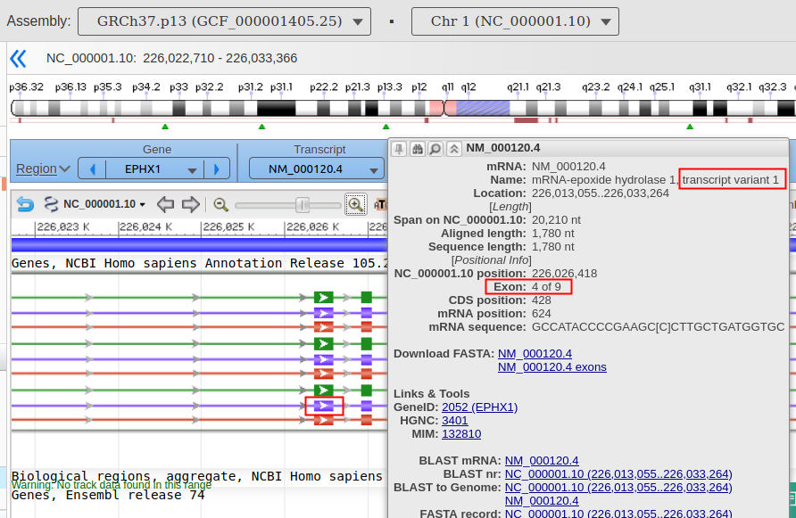

Alternatively you can go to the GenBank record: NC_000001.10 (226,013,055..226,033,264) > Select full view > Look for transcript 1 > go to the 4th mRNA join and add those positions to first position of gene

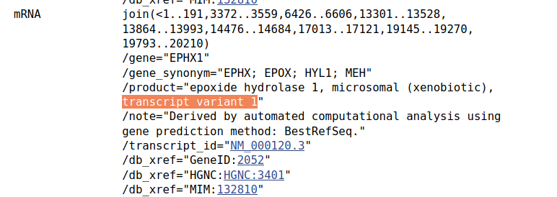

Student 2:
My bad, I misspoke. I got 225997776-226033264 from IGV but when I put that region into the table browser, I get way more than 44 SNPs

My response:
I see you hovered over the Gene in IGV. Try looking a little more closely and also see how many NM_** there are? I usually check the shortest NM first to confirm its transcript variant 1

Student 2:
oh wow, the collapsed view messed me up. I didn't realize the transcripts were all on top of each other and the first set of coordinates in IGV are for the whole gene. I got it now, Thank you!

K) Post about Variant Annotation Integrator

Future Opportunity & Outlook

