This week we begin a 3-part discussion (in this module, Module 8 and Module 9) in which we design a database as a class.

- This week we focus on defining user and community needs and on our plan for getting the information we need and developing the database. See the Course Database Project Module and Module 5 for ideas and guidance.
- We’re going to design a database that deals somehow with proteins. We can explore some different ideas for what we’d like the database to contain, and then discuss what types of questions people would like to answer with the database.
- Next week we’ll be looking at using data from tools, so our database can include predicted data from any tool or tools we like.
- Please post ideas you have for what we can put in our protein database and any user/community needs or questions by Thursday.
- Then respond with additional ideas, needs/questions by Sunday.
- You can also discuss a plan for how to gather information or how to plan for the database.
- Feel free to bring up potential issues as well that need to be addressed to enable the user/community needs/questions to be handled properly. Module 5 discussed additional issues, so be sure to review the Module 5 Lecture Content PDF for these. Also this week's Lecture Content PDF (Module 6) discusses various issues.

I am hoping the need I describe will not be incredibly hard to implement. I believe on a small scale it would need some sort of recursive algorithm to deliver to need. There are two really good pathways databases, KEGG and Reactome. At a high level they both include maps of pathways between proteins but they will also include gene and non-protein molecules (such as Saccharopine an intermediate in Lysine metabolism plus another 100 molecules in the pathway). After doing presentation of PPAR delta nuclear receptor for fatty acid oxidative metabolism in Huntington’s disease I wrote about an isomerase protein involved in peroxisomal beta oxidation pathway, EHHADH. When searching this protein in KEGG pathways you will get 16 pathways including those between intermediate molecules that are “non-protein” pathways as well as protein pathways. Searching in Reactome pathway broswer you can also visually see pathways for EHHADH as well as get a list of the interactors (bottom) showing from the top right red circle.

The need can best be described with an example in which I did a presentation on TSC2 based on the JHU Tech Transfer site where inventors described up and down-regulation of TSC2 to regulate mTORC1 complex and the benefit in could provide in immunotherapy. An interesting paper describes there are 10 possible feedback loop scenarios in mTOR signaling with proteins upstream and proteins downstream.

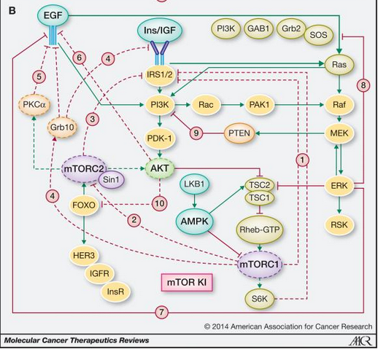

From a drug targeting perspective it would be valuable to know if my drug up-regulates/down-regulates a target I want to know all the possible upstream/downstream effects this will could have so I can analyze adverse drug effects or possibility of need for another drug in the regimen. The specific need would be to search for a protein drug target and give a number “N” return all the possible pathways that are “N edges” meaning N proteins away in the pathway up and downstream (really a tree is a graph with only parent and children edges).

For instance we have these 2 pathways and each protein in these pathways are involved in many other pathways:

Pathway 1
A (-) regulates B
B (-) regulates C
C (+) regulates D
D (-) regulates E
E (+) regulates F
F (-) regulates (G)

Pathway 2
H (-) regulates T
T (-) regulates M
M (+) regulates C
C (-) regulates L
L (+) regulates A

I search ‘protein C’ with N=2 and returns:

1st return:
A (-) regulates B
B (-) regulates C
C (+) regulates D
D (-) regulates E

A – reg B – reg C = A + reg C (A positively regulates C)
C + reg D – reg E = C – reg E (C negatively regulates E)

2nd return
T (-) regulates M
M (+) regulates C
C (-) regulates L
L (+) regulates A

T – reg M + reg C = T – reg C (T negatively regulates C)
C – reg L + reg A = C – reg A (C negatively regulates A)

An then we see that C has a downstream negative feedback mechanism to A. A + regulates C until C is up-regulated so much that is negatively regulates A and therefore itself.

By returning all possible pathways of a protein target, if we increase N we get more possible adverse reactions to drug against but from a naive perspective these adverse reactions are not as potent if we assume every depth of the tree the reaction, effect decreases. When we decrease N we see closer relations and more potent effects. Maybe we just cut out the upstream return and only return downstream but from the perspective of loops it would be beneficial to have both.

References:
1. Rozengurt, E., Soares, H. P., & Sinnet-Smith, J. (2014). Suppression of feedback loops mediated by PI3K/mTOR induces multiple overactivation of compensatory pathways: an unintended consequence leading to drug resistance. Molecular cancer therapeutics, 13(11), 2477–2488. https://doi.org/10.1158/1535-7163.MCT-14-0330
2. Kanehisa, M; Toward understanding the origin and evolution of cellular organisms. Protein Sci. 28, 1947-1951 (2019)
3. Jassal B, Matthews L, Viteri G, Gong C, Lorente P, Fabregat A, Sidiropoulos K, Cook J, Gillespie M, Haw R, Loney F, May B, Milacic M, Rothfels K, Sevilla C, Shamovsky V, Shorser S, Varusai T, Weiser J, Wu G, Stein L, Hermjakob H, D'Eustachio P. The reactome pathway knowledgebase. Nucleic Acids Res. 2020 Jan 8;48(D1):D498-D503. doi: 10.1093/nar/gkz1031.

