Demonstrate

Kinase

(P17612) PRKACA (PKA) 2 and Down
- Sub protein name search kinase
- DB07995, IQB
- N-[2-(4-BROMOCINNAMYLAMINO)ETHYL]-5-ISOQUINOLINE SULFONAMIDE
- Kinase inhibitor
- HASPIN

ABL1 (BCR-ABL), P00519, Drugs [STI, P16, 1N1]
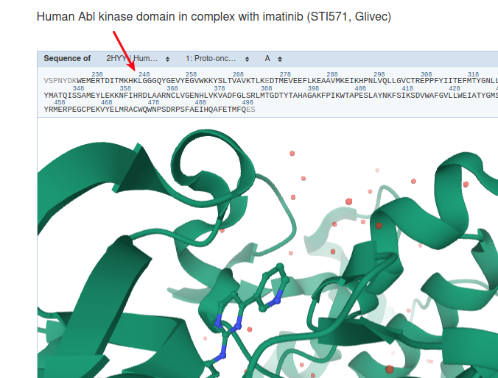

Peptidase
BACE1,
SELECT * FROM merops_select m
WHERE m.proteaseName LIKE '%Beta-secretase 1%';

SQL:
SELECT proteaseUniprot, proteaseName,
proteaseGenePreferred, count(*)
FROM
(SELECT DISTINCT proteaseUniprot, proteaseName, substrateUniprot,
proteaseGenePreferred
FROM protTest.merops_select) AS sel
GROUP BY proteaseUniprot
ORDER BY count(*) DESC;
P51124(granzyme M) (Traversal N=2 DOWN in Neo4j)

IntAct
CHEBI from IntAct (BCL2L1 - Apoptosis regulator Bcl-X) Q07817 (sort by ‘Sub UniProt ID’)

Example for Swiss-Model:
# uniProtID, organism, geneNamePreferred
'E9Q5F9', 'Mus musculus', 'Setd2'

Examples Neoj queries:

First Sub with path [FIXED] then remove path
GAB1, VIL1

1. Storage of multiple entries in Neo4j is Set (so unique) of SortedJsonMaps
//Match Single Interaction
MATCH (a)-[i:INTERACTION]->(b)
UNWIND i.entries as entry
WITH *, apoc.convert.fromJsonMap(entry) as e
WHERE e["interactionID"] = "EBI-9818329"
RETURN a, b, a.uniprotID, b.uniprotID, e

2.
Favorite: Match CHEBI Interactions
name:RCC1 organism:Homo sapiens taxid:9606 uniprotID:P18754
name:virA organism:Shigella flexneri taxid:623 uniprotID:Q7BU69

3.
Favorite: Substrates ROWS

At the END: Multiple Protein Search
Subs with path [FIXED] show both directions

