**User Documentation**

Krab Klashers

Ms. Krabs

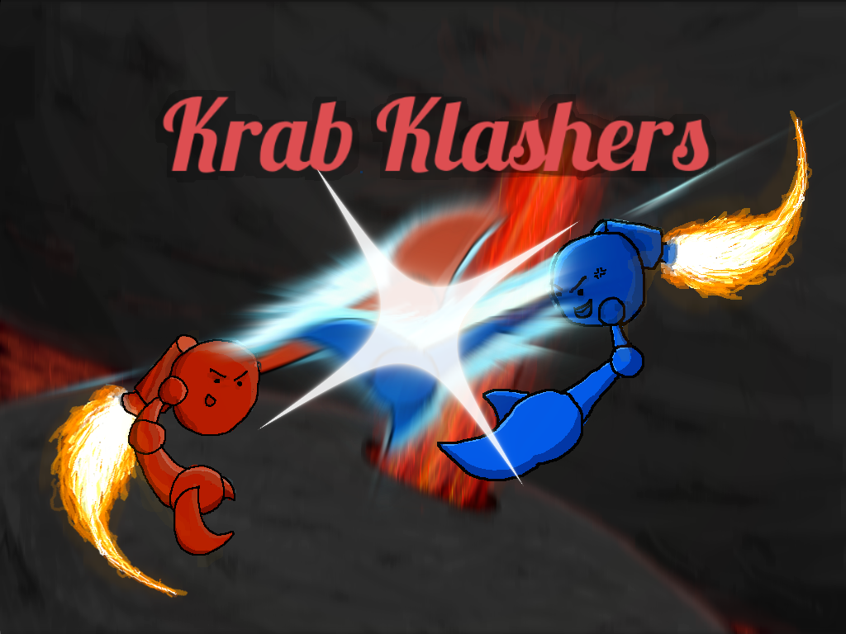

Krab Klashers a 3D multiplayer, arena-style, combat game that pits players against each other in fast paced krab klashing action. Krab Klashers can be played on either Mac or Windows machines.

**Contents**

**Installation…………………………………………………………………………….. pg. 3**

**Controls………………………………………………………………………………... pg. 4**

**Tutorial………………………………………………………………………………..... pg. 5**

**Troubleshooting……………………………………………………………………… pg. 6**

**Installation**

* (Note) For optimal gameplay experience, players should be using a mouse in companion with the keyboard, though players can still play the game with a laptop’s touchpad.
* (Note) Since Krab Klashers is a multiplayer game, play on an internet source that is either a wireless router, or eduroam (UCSC).

1. To run Krab Klashers, run the .exe file (Windows), or the .app file (Mac) of Krab Klashers that is given to you, or download from the link:haydenplatt.me/krabklashers and continue to running the .exe file or .app file.
2. Upon running the file, the game will open.

**Controls**

W A S D: move forward, left, backward, right

Space: jump

Left Mouse click: basic attack (two-klaws)

Right Mouse click: dash attack (one-klaw)

Shift: view scoreboard

**Tutorial**

Objective:

* The objective for players is to be the first to kill ___ other players, and to have a blast doing so.

Set-up:

* On start-up, the game will enter the main screen where players can set their in-game name, pick a color for their krab, create or join a game room, and select the level of the room.
* Upon joining the room, players spawn into the level and can begin fighting other players.

Combat:

* In Krab Klashers, it only takes one hit to kill another player. This can be done with the left mouse click (basic attack), or the right mouse click (dash attack).
* The basic attack is a two handed single strike attack.
* The dash attack is a one handed attack that dashes a player in the direction they are facing. Players are propelled in the direction they are facing at high speed. They can be grounded or in the air to use the dash attack. If the player uses the dash attack correctly, it allows for a quick strike on their opponents.
* If two players dash attack each other head on, they will deflect/parry off each other.
* The dash attack can be useful not only for combat, but for evasion.
* Use the movement controls to traverse the map and dodge other players.

Scoreboard:

* Every time you kill a player, you can see your number of kills on the scoreboard.
* Every time you die, you respawn in a random spawn-point in the level, and can see your number of deaths on the scoreboard.
* The player that reaches the kill-count wins the game.

Levels:

* There are currently 4 levels in Krab Klashers. Each level features a different theme or combat style.
* Some are larger, other are smaller.
* Some are multi-story, others are flat.
* In some levels, player can die by contact with environmental hazards such as lava.
* In some levels, player can use boosters to launch them across the map.
* In some levels, the terrain can be slippery if icy.
* In some levels, players can fall to their death if they fall off the level.

**Troubleshooting**

* If the game does not run, make sure that you are running the .exe on Windows machines, and the .app on Mac machines.
* As of now, multiplayer will not work on cruznet wireless at UCSC.
* If you cannot find your friends online, make sure you are NOT on cruznet
* If the game freezes, restart the file and run again.
* If for some reason you cannot attack other players, check your mouse/touchpad or restart the file and run again
* if a problem occurs that is not stated above, restart the file and run again, or contact Ms. Krabs.