3.0.0

Table of Contents

1 Introduction 3

2 CPF Administration 3

2.1 Concepts 3

2.1.1 Paging Lists 3

2.1.2 Collapsible Boxes 3

2.2 Site Map 4

2.3 CPF Application Config Properties 5

2.3.1 Supported Config Properties 5

2.3.2 Supported Value Types 5

2.3.3 Fields 6

2.3.4 Config Property List Page 7

2.3.5 Config Property View Page 7

2.3.6 Config Property Add Page 7

2.3.7 Config Property Edit Page 8

2.4 Module Administration 8

2.4.1 Module Config Properties 8

2.4.1.1 Fields 8

2.4.1.2 Module Config Property List Page 9

2.4.1.3 Config Property View Page 9

2.4.1.4 Config Property Add Page 9

2.4.1.5 Config Property Edit Page 10

2.5 User Accounts 10

2.5.1 Fields 10

2.5.2 User Account List Page 11

2.5.3 User Account View Page 11

2.5.4 User Account User Group List Page 12

2.5.5 User Account Add Page 12

2.5.6 User Account Edit Page 12

2.6 User Groups 12

2.6.1 Fields 13

2.6.2 User Group List Page 14

2.6.3 User Group View Page 14

2.6.4 User Group User Account List Page 14

2.6.5 User Group Add Page 15

2.6.6 User Group Edit Page 15

3 Tuning Guide 15

# Introduction

# CPF Administration

The CPF Administration application is a web based application that can be used to manage the CPF application and business application modules.

## Concepts

### Paging Lists

The CPF uses paging lists of records for some of the list pages. A paging list only shows 25 records at a time. If there is more than one page of results then the page navigation bar is shown (see below). The < link will display the first page. The > link with display the last page. The current page number is highlighted in bold. The three previous and next page numbers (if they exist) are shown as links to those pages. The pager also shows the current record numbers (251-255 of 325).



Searching or custom sort orders are not currently supported.

### Collapsible Boxes

## Site Map

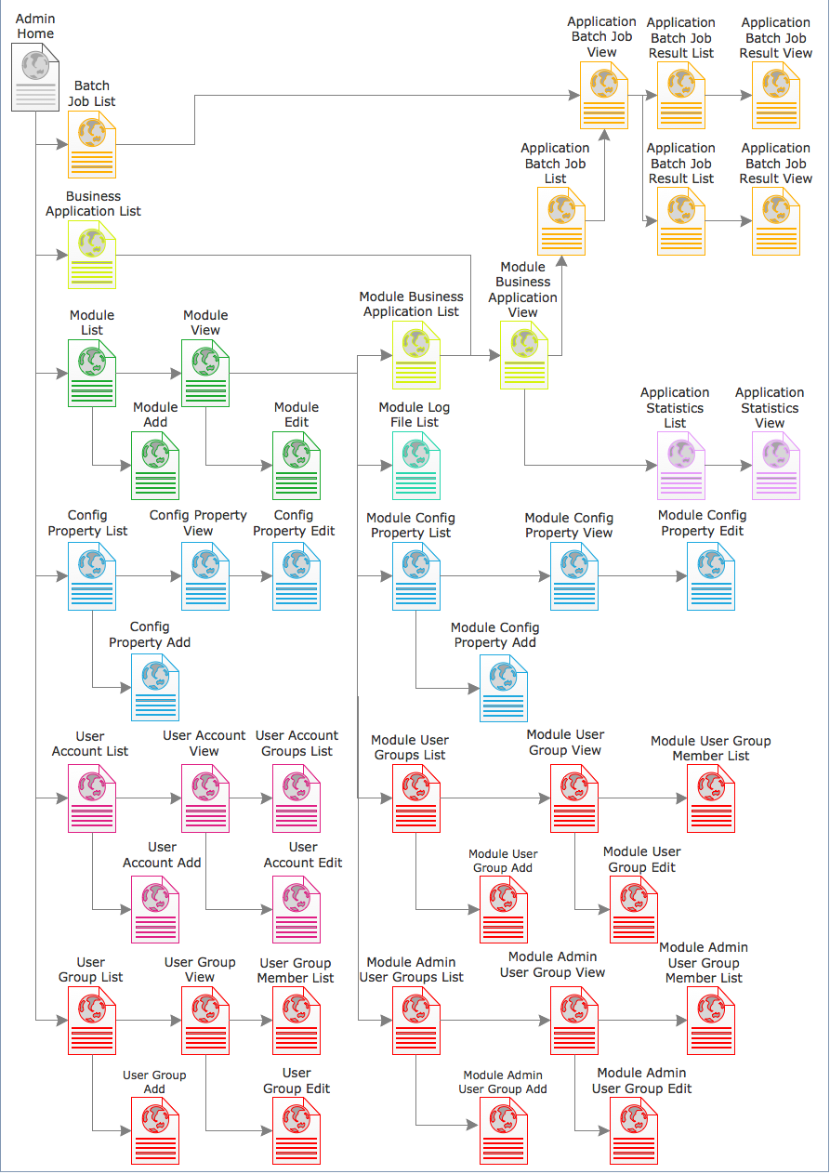

## CPF Application Config Properties

The Config Property pages can be used to override the default values for CPF application configuration properties. See the Module Config Properties section for Business Application Module specific configuration properties. All config property pages and the Config Properties menu link are only visible to members of the ADMIN user group.

The CPF has the following module names.

|  |  |
| --- | --- |
| Group Name | Description |
| **CPF** | Configuration properties for the CPF web application and scheduler. The environment name is not used for these properties. |
| **CPF_WORKER** | Configuration properties for a CPF worker application. The environment name can be used to set different configuration properties for different worker instances. The worker will need to be restarted when a configuration property is changed. |

The following Config Property administration pages are available.

### Supported Config Properties

| Module Name | Property Name | Value Type | Default | Description |
| --- | --- | --- | --- | --- |
| CPF | batchJobService.fromEmail | String | noreply@localhost | The email address used in the From header of emails sent by the system. |
| CPF | mailSender.host | String | localhost | The SMTP server to send emails via. |
| CPF | removeOldBatchJobs.daysToKeepOldJobs | int | 7 | The number of days to keep a job after the results has been created. The process runs at midnight each day. |
| CPF | multipartResolver. maxUploadSize | long | 20000000 | The maximum size in bytes of a HTTP multipart Form request that can be uploaded. |
| CPF_WORKER | cpfWorker.maximumPoolSize | int | 100 | The number of threads to use to process requests on a worker instance. Increasing this number in isolation will not necessarily increase the number of requests that can be processed. |

### Supported Value Types

The CPF Configuration Properties support the following value types. The string value in the database is converted to the appropriate Java object based on the Value Type specified.

| Value Type | Label | Description |
| --- | --- | --- |
| string | String | Unicode character string |
| boolean | Boolean | Boolean (true or false). |
| long | Long | 64-bit signed integer. |
| int | Int | 32-bit signed integer. |
| short | Short | 16-bit signed integer. |
| byte | Byte | 8-bit signed integer. |
| double | Double | 64-bit IEEE 754 floating point number. |
| float | Float | 32-bit IEEE 754 floating point number. |
| decimal | Big Decimal | Big decimal value with no size constraints. |
| integer | Big Integer | Big integer value with no size constraints. |
| QName | Qualified name | An XML qualified name (e.g. {http://www.example.com}Element). |
| anyURI | URI | Any URI/URL. |
| date | Date (YYYY-MM-DD) | A YYYY-MM-DD date |
| dateTime | Date + Time (YYYY-MM-DDTHH:MM:SS) | A YYYY-MM-DDTHH:MM:SS date & time value. |
| Geometry | WKT Geometry | Any EWKT[1] geometry. |
| Point | WKT Point | Point EWKT geometry. |
| LineString | WKT LineString | LineString EWKT geometry. |
| Polygon | WKT Polygon | Polygon EWKT geometry. |
| GeometryCollection | WKT Geometry Collection | Any EWKT geometry collection. |
| MultiPoint | WKT Multi-Point | Multi-Point EWKT geometry. |
| MultiLineString | WKT Multi-LineString | Multi-LineString EWKT geometry. |
| MultiPolygon | WKT Multi-Polygon | Multi-Polygon EWKT geometry. |

### Fields

| Field | Description |
| --- | --- |
| Id | The unique surrogate primary key for the config property |
| Environment Name | The name of the environment the configuration property should be applied to. The value default can be used to apply property to any environment which does not have the property value defined. |
| Module Name | The name of the component to apply the config property to. The following values are supported.   * **CPF** - The CPF main application. * **CPF_WORKER** - A CPF worker application. |
| Component Name | The name of the component within the module to apply the config property to. The value GLOBAL is used for these config properties and cannot be changed. |
| Property Name | The name of the config property to set. See 2.3.2 Supported Value Types for a list of the supported configuration properties. |
| Value | The value of the config property. |
| Value Type | The data type the config property will be converted to. |
| Created By | The user who crated the record. |
| Creation Time | The date/time the record was created. |
| Modified By | The user who last modified the record. |
| Modification Time | The date/time the record was last modified. |

### Config Property List Page

The Config Property List page shows a paging list of the config properties in the CPF system. The page can be accessed using the Config Properties link on the side menu.

The following fields are displayed.

* Id - Link to the Config Property View page.
* Environment Name
* Module Name
* Component Name
* Property Name
* Value
* Value Type

The page includes an Add button to link to the Config Property Add Page.

### Config Property View Page

The Config Property View page shows the attributes for a config property.

The following fields are displayed.

* Id
* Environment Name
* Module Name
* Component Name
* Property Name
* Value
* Value Type
* Created By
* Creation Time
* Modified By
* Modification Time

The page includes an Edit button to link to the Config Property Edit Page

### Config Property Add Page

The Config Property Add page can be used to add a new Config Property to the CPF or CPF_WORKER modules.

**NOTE: You will need to either restart the CPF web application or CPF worker application for the config properties to take affect.**

The following fields are displayed.

* Environment Name
* Module Name
* Property Name
* Value
* Value Type

Click the Save button to save any changes. Click the Cancel button to return to the Config Property View Page.

### Config Property Edit Page

The Config Property Edit page allows the fields for a config property to be updated

**NOTE: You will need to either restart the CPF web application or CPF worker application for the config properties to take affect.**

The following fields are displayed.

* Environment Name
* Module Name
* Property Name
* Value
* Value Type

Click the Save button to save any changes. Click the Cancel button to return to the Config Property View Page.

## Module Administration

### Module Config Properties

The Module Config Property pages can be used to override the default values for CPF Business Application Module. All config property pages and the Module Config Properties menu collapsible box are only visible to members of the ADMIN user group or the ADMIN_MODULE_<MODULE_NAME>_ADMIN group for the module.

**NOTE: The list of supported configuration properties must be described in the module's readme.txt or Admin User Guide for each module.**

#### Fields

| Field | Description |
| --- | --- |
| Id | The unique surrogate primary key for the config property |
| Environment Name | The name of the environment the configuration property should be applied to. The value default can be used to apply property to any environment which does not have the property value defined. |
| Module Name | The module name is set automatically by the system to the name of the module. |
| Component Name | The component name is automatically set to MODULE_BEAN_PROPERTY. |
| Property Name | The name of the config property to set. See the module's readme.txt or Admin User Guide for the module to see the config properties supported. |
| Value | The value of the config property. |
| Value Type | The data type the config property will be converted to. |
| Created By | The user who crated the record. |
| Creation Time | The date/time the record was created. |
| Modified By | The user who last modified the record. |
| Modification Time | The date/time the record was last modified. |

#### Module Config Property List Page

The Module Config Property List page shows a paging list of the config properties for the module. The page can be accessed using the Module Config Properties collapsible box from the Module View page.

The following fields are displayed.

* Id - Link to the Module Config Property View page.
* Environment Name
* Property Name
* Value
* Value Type
* Actions
  + Delete

The page includes an Add button to link to the Module Config Property Add Page.

#### Module Config Property View Page

The Module Config Property View page shows the attributes for a module config property.

The following fields are displayed.

* Id
* Environment Name
* Module Name
* Component Name
* Property Name
* Value
* Value Type
* Created By
* Creation Time
* Modified By
* Modification Time
* Actions
  + Delete

The page includes an Edit button to link to the Module Config Property Edit Page

#### Module Config Property Add Page

The Module Config Property Add page can be used to add a new Config Property to the module.

**NOTE: You will need to restart the module for the config properties to take affect.**

The following fields are displayed.

* Environment Name
* Property Name
* Value
* Value Type

Click the Save button to save any changes. Click the Cancel button to return to the Module Config Property View Page.

#### Module Config Property Edit Page

The Module Config Property Edit page allows the fields for a module config property to be updated

**NOTE: You will need to restart the module for the config properties to take affect.**

The following fields are displayed.

* Environment Name
* Property Name
* Value
* Value Type

Click the Save button to save any changes. Click the Cancel button to return to the Module Config Property View Page.

## User Accounts

The CPF maintains user accounts for the users that can access the CPF web services, CPF admin application and CPF internal web services. All user accounts pages and the User Accounts menu link are only visible to members of the ADMIN or ADMIN_SECURITY user groups.

The CPF supports the following types of user account.

|  |  |
| --- | --- |
| User Account Class | Description |
| **CPF** | A CPF user account created using the admin application. This can be used to create user accounts for applications as opposed to real users (e.g. for BC Geocoder). |
| **BCGOV** | A proxy user account that is automatically created for each IDIR or BCEID Government account that has logged into CPF via the BC Government Common Login page (Siteminder). The user must login for the account to be created. There is no functionality to search the IDIR or BCEID directories. |

The following User Account administration pages are available.

* User Account List Page
* User Account View Page
* User Account User Group List Page
* User Account Add Page
* User Account Edit Page

### Fields

| q | Description |
| --- | --- |
| Id | The unique surrogate primary key for the user account |
| Consumer Key | The consumer key is a unique textual identifier for a user account that can be used to login using OAuth or Digest Authentication. For CPF accounts this is the same as the User Account Name. For BCGOV accounts this is the type of user account (idir, bceid, vin, ind) followed by a colon (:) and the users BC Government user name. (e.g. idir:jdoe). All consumer keys are in lower case and are case sensitive. |
| User Account Class | The type of user account. |
| User Account Name | The user name is the external user name that the user account is a proxy for. For CPF accounts the account is not a proxy and this will be the same as the Consumer Key. For BC Government accounts this will be the user's GUID. |
| Active | Flag indicating if the user is active. If the user is not active they will be disabled from logging into CPF. |
| Created By | The user who crated the record. |
| Creation Time | The date/time the record was created. |
| Modified By | The user who last modified the record. |
| Modification Time | The date/time the record was last modified. |

### User Account List Page

The User Account List page shows a paging list of the user accounts in the CPF system. The page can be accessed using the User Accounts link on the side menu.

The following fields are displayed.

* Consumer Key - Link to the User Account View page.
* User Account Class
* User Account Name
* Active
* Actions
  + Delete - This will only be available for the CPF user account class.

The page includes an Add button to link to the User Account Add Page.

### User Account View Page

The User Account View page shows the attributes for a user account.

The following fields are displayed.

* Id
* Consumer Key
* User Account Class
* User Account Name
* Active
* Created By
* Creation Time
* Modified By
* Modification Time
* Actions
  + Delete - This will only be available for the CPF user account class.

The page includes an Edit button to link to the User Account Edit Page. This will only be available for the CPF user account class.

### User Account User Group List Page

The User Account User Group List page shows a list of all the User Groups the User Account is a member of. The user can be removed from a group using this page. A user cannot be added to a group from this page. That must be done via the User Group Page.

The following fields are displayed for each user group.

* Name - The name of the group linked to the User Group View page
* Module Name
* Description
* Active
* Actions
  + Delete - Remove the user from the group.

### User Account Add Page

The User Account Add page can be used to add a new User Account. This will only be available for the CPF user account class.

The following fields are displayed.

* Consumer Key
* Consumer Secret
* Active

Click the Save button to save any changes. Click the Cancel button to return to the User Account View Page.

### User Account Edit Page

The User Account Edit page allows the fields for a user account to be updated. This will only be available for the CPF user account class.

The following fields are displayed.

* Consumer Key
* Consumer Secret
* Active

Click the Save button to save any changes. Click the Cancel button to return to the User Account View Page.

## User Groups

The CPF maintains user groups to grant permission to the CPF admin application, CPF internal web services and for secure resources. All user group pages and the User Groups menu link are only visible to members of the ADMIN or ADMIN_SECURITY user groups.

The CPF has the following special user groups.

|  |  |
| --- | --- |
| Group Name | Description |
| **ADMIN** | The group of users who are global administrators in the CPF admin application. They can perform any admin function. |
| **WORKER** | The group of users who are permitted to use the CPF Internal Web Services |

The CPF user groups are associated with one of the following modules.

| Module Name | Description |
| --- | --- |
| **ADMIN** | The module containing the ADMIN user group. |
| **WORKER** | The module containing the WORKER user group. |
| **GLOBAL** | Global user groups can be created within the CPF that are shared across all business application modules. Permissions can be granted within a module to members of the group. The group name must start with GLOBAL_ and be in upper case (e.g. GLOBAL_CONTRACTORS). |
| **USER_TYPE** | Each authentication service can create custom USER_TYPE groups that contain different types of user. The list of users within the group is implied by the authentication service and cannot be modified using the CPF admin application. Permissions can be granted within a module to members of the group. For example:   * **BCGOV_ALL** - All BC Government users * **BCGOV_INTERNAL** - All internal (IDIR) BC Government users * **BCGOV_EXTERNAL** - All external (BCEID) BC Government users * **BCGOV_BUSINESS** - All external (BCEID Business) BC Government users * **BCGOV_INDIVIDUAL** - All external (BCEID Basic/Individual) BC Government users * **BCGOV_VERIFIED_INDIVIDUAL** - All external (BCEID Verified Individual) BC Government users |
| **<Module Name>** | For each business application module custom user groups can be created for restricting access to resources within the business application plugins. The group name must start with <Module Name>_ and be in upper case (e.g. BSOE_PARTNERS). |
| **ADMIN_MODULE_**  **<Module Name>** | For each business application module an ADMIN_MODULE_<Module Name>_ADMIN and ADMIN_MODULE_<Module Name>_SECURITY user group are automatically created to restrict the users who can administer the module or just the security groups and permissions for the module. |

The following User Group administration pages are available.

* User Group List Page
* User Group View Page
* User Group User Account List Page
* User Group Add Page
* User Group Edit Page

### Fields

| q | Description |
| --- | --- |
| Id | The unique surrogate primary key for the user group |
| Module Name | The module the user group is for. |
| Name | The unique name of the user group. |
| Description | The user name is the external user name that the user Group is a proxy for. For CPF Groups the Group is not a proxy and this will be the same as the Consumer Key. For BC Government Groups this will be the user's GUID. |
| Active | Flag indicating if the user group is active. If the user group is not active then permissions will not be granted to the group. |
| Created By | The user who crated the record. |
| Creation Time | The date/time the record was created. |
| Modified By | The user who last modified the record. |
| Modification Time | The date/time the record was last modified. |

### User Group List Page

The User Group List page shows a paging list of the user groups in the CPF system. The page can be accessed using the User Groups link on the side menu.

The following fields are displayed.

* Name - Link to the User Group View page
* Module Name
* Description
* Active
* Actions
  + Delete - This will only be available for the user groups in the GLOBAL module.

The page includes an Add button to link to the User Group Add Page.

### User Group View Page

The User Group View page shows the attributes for a user Group.

The following fields are displayed.

* Id
* Module Name
* Name
* Description
* Active
* Created By
* Creation Time
* Modified By
* Modification Time
* Actions
  + Delete - This will only be available for the CPF user Group class.

The page includes an Edit button to link to the User Group Edit Page. This will only be available for groups in the GLOBAL module.

### User Group User Account List Page

The User Group User Account List page shows a list of all the User Accounts that are members of the User Group. User Accounts can be added or removed as members of the User using this page.

The page includes a Username search field. Search for a user by typing 3 or more consecutive characters from any part of the Consumer Key or User Account Name. The matching users will be displayed in a pop-up list. Select the required user and click the Add button. Not available for groups in the USER_TYPE module.

The following fields are displayed for each user account.

* Consumer key - The consumer key of the user account linked to the User Account View page
* User Account Class
* User Account Name
* Active
* Actions
  + Delete - Not available for groups in the USER_TYPE module.

### User Group Add Page

The User Group Add page can be used to add a new User Group to the GLOBAL module.

The following fields are displayed.

* Name
* Description
* Active

Click the Save button to save any changes. Click the Cancel button to return to the User Group View Page.

### User Group Edit Page

The User Group Edit page allows the fields for a user Group to be updated. This will only be available for groups in the GLOBAL module.

The following fields are displayed.

* Name
* Description
* Active
* Active

Click the Save button to save any changes. Click the Cancel button to return to the User Group View Page.

# Tuning Guide

The CPF provides configuration options to control

1. [http://www.postgis.org/docs/using_postgis_dbmanagement.html - EWKB_EWKT](http://www.postgis.org/docs/using_postgis_dbmanagement.html#EWKB_EWKT)