Brian Knotten

Professor Adriana Kovashka

CS1675

13 September 2018

Homework 2 – Report

Results:

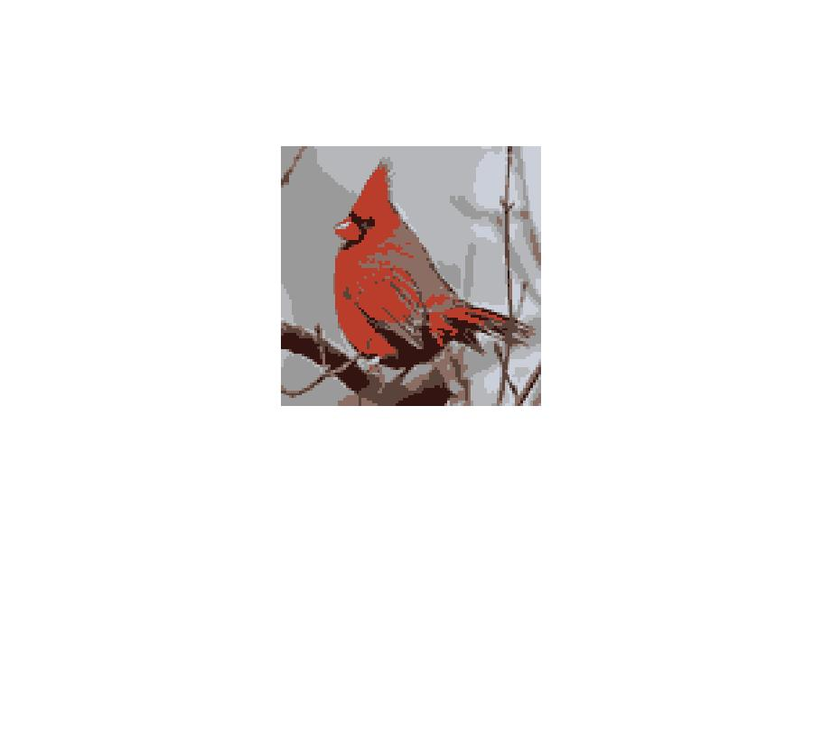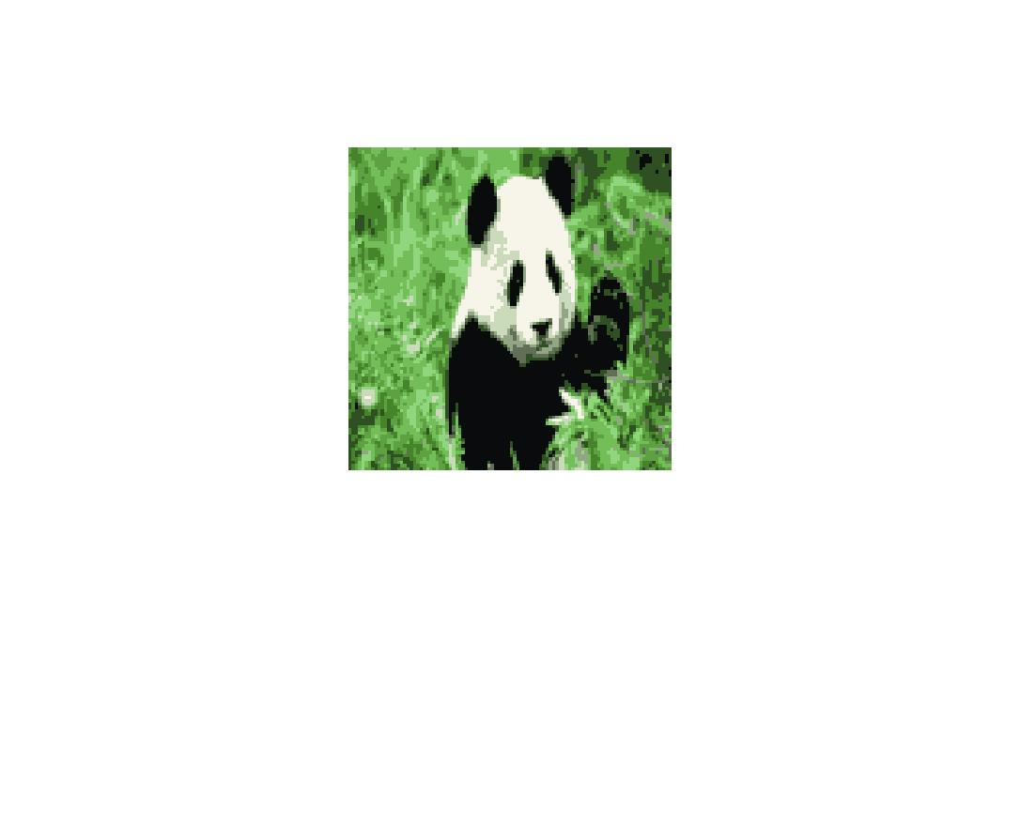k = 10, iter = 5, R = 3:

K = 5, iter = 5, R = 3:

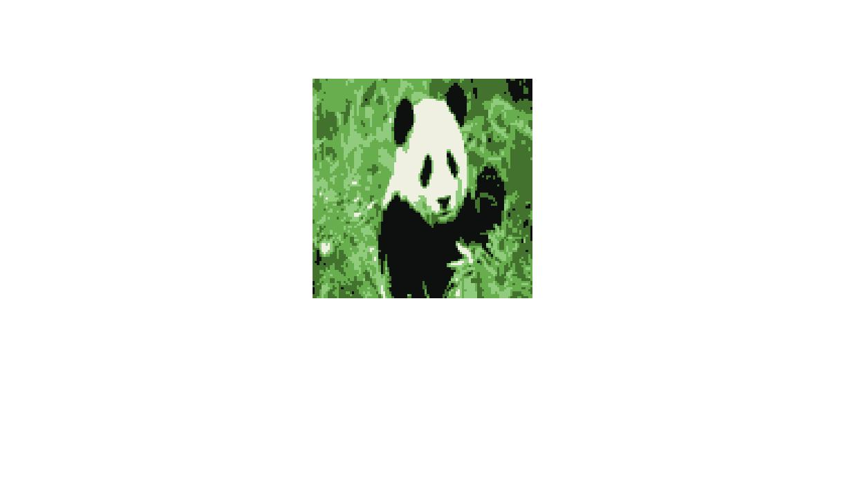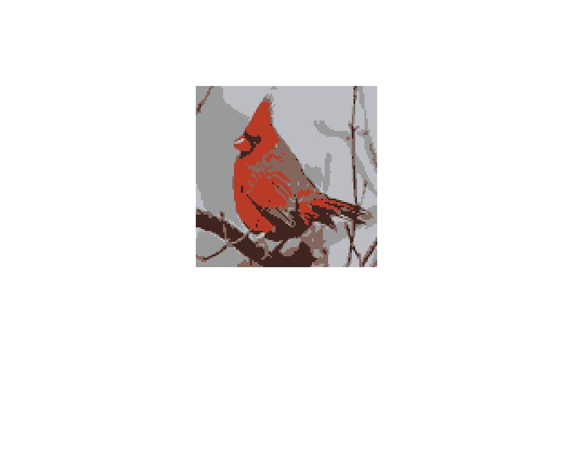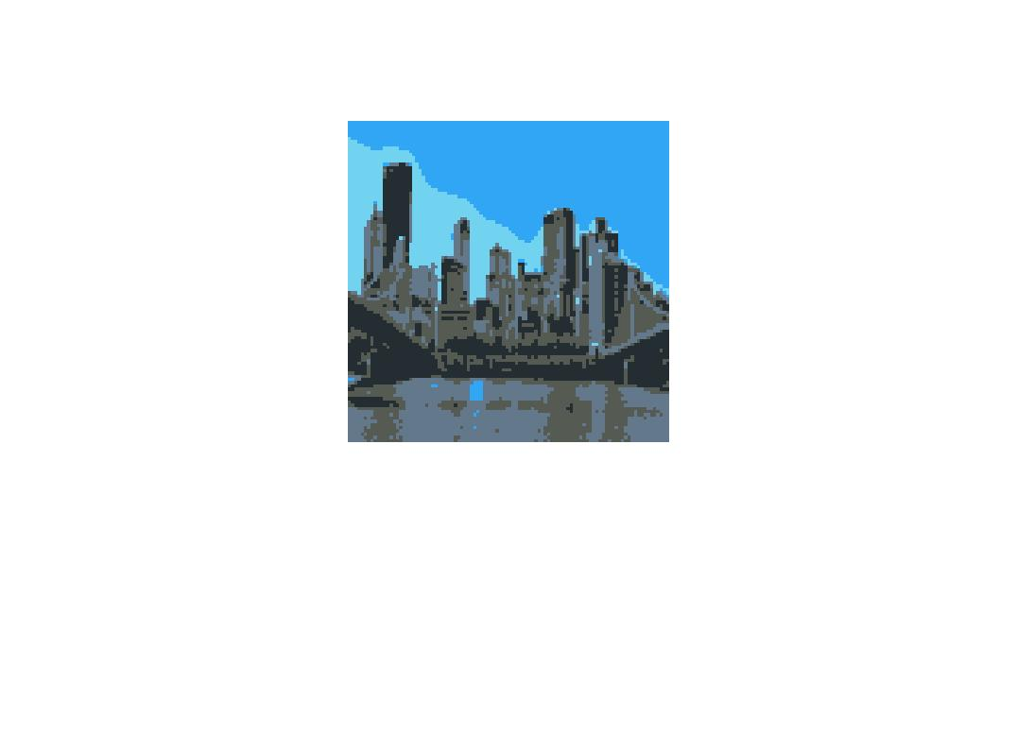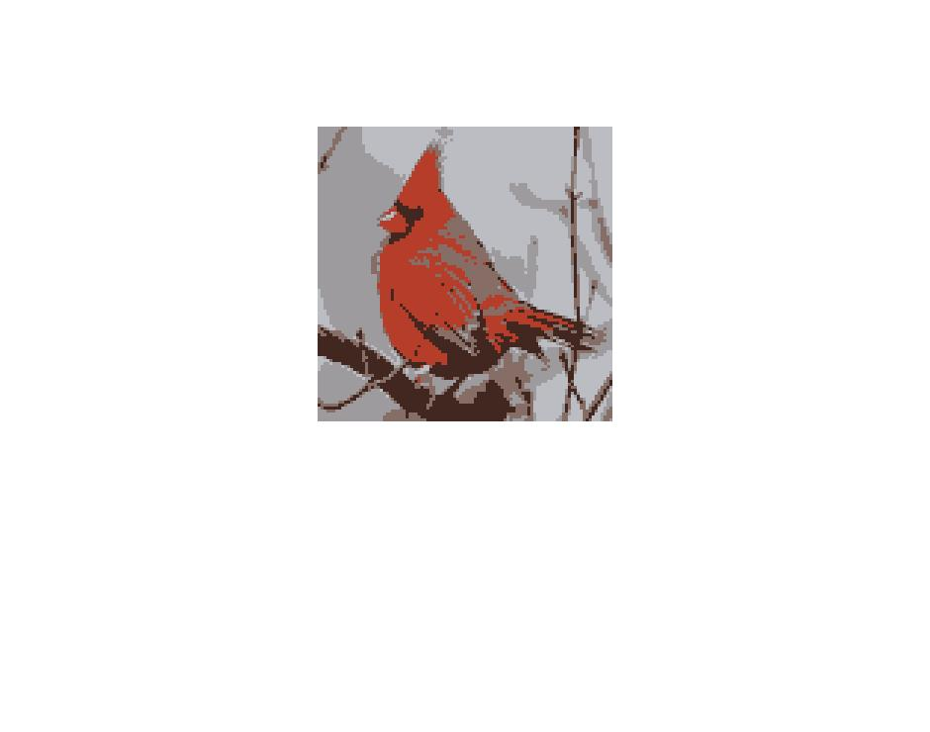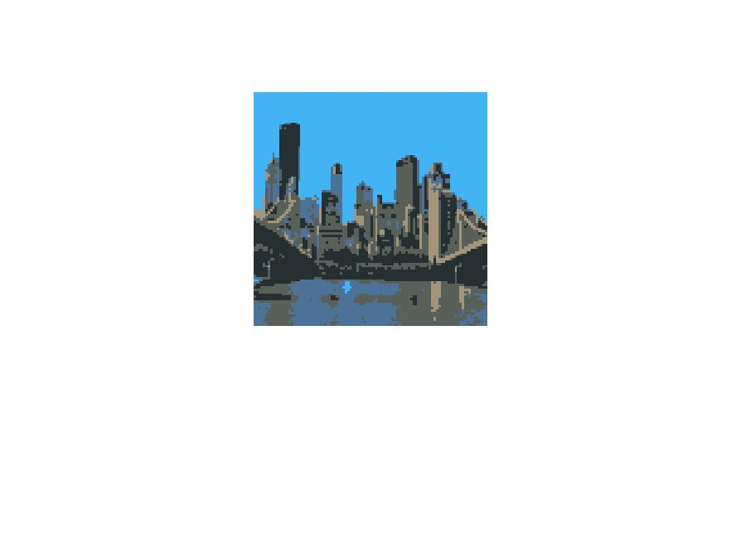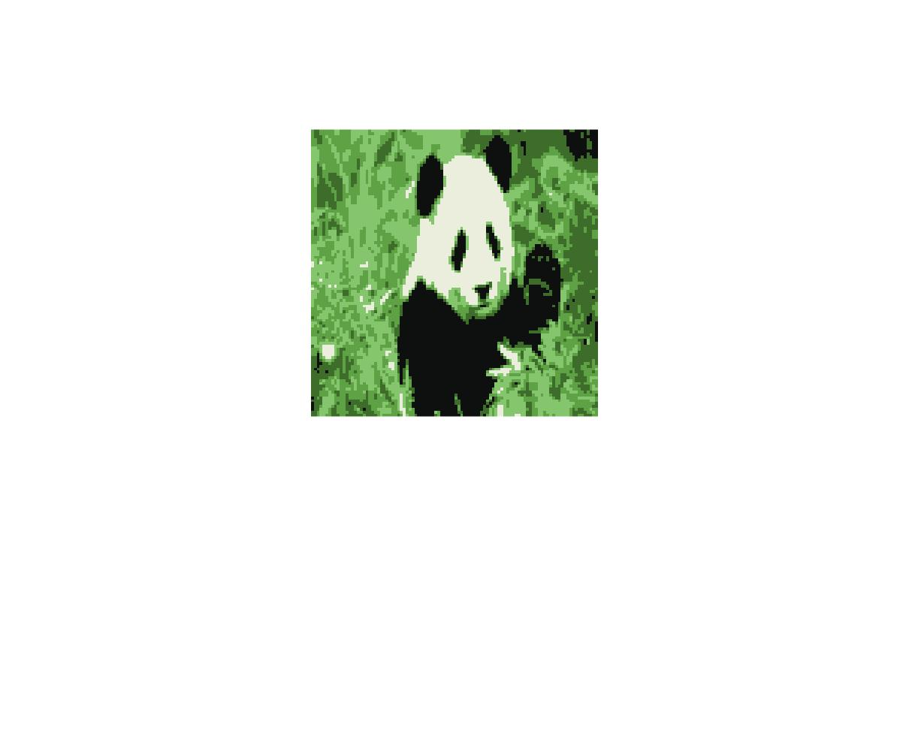K = 5, iter = 10, R = 5:

K = 10, iter = 3, R = 5:

K = 12, iter = 3, R = 5:

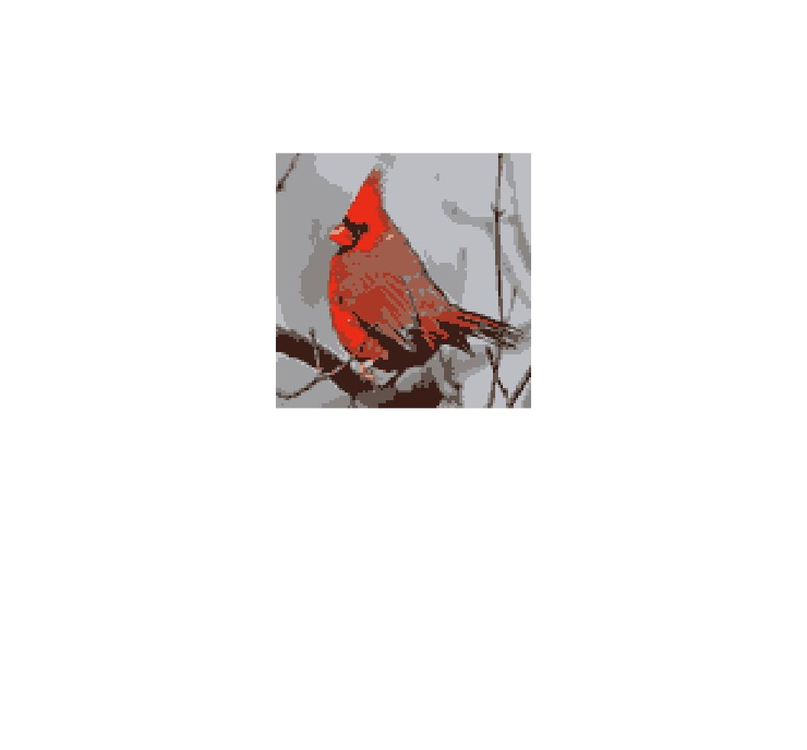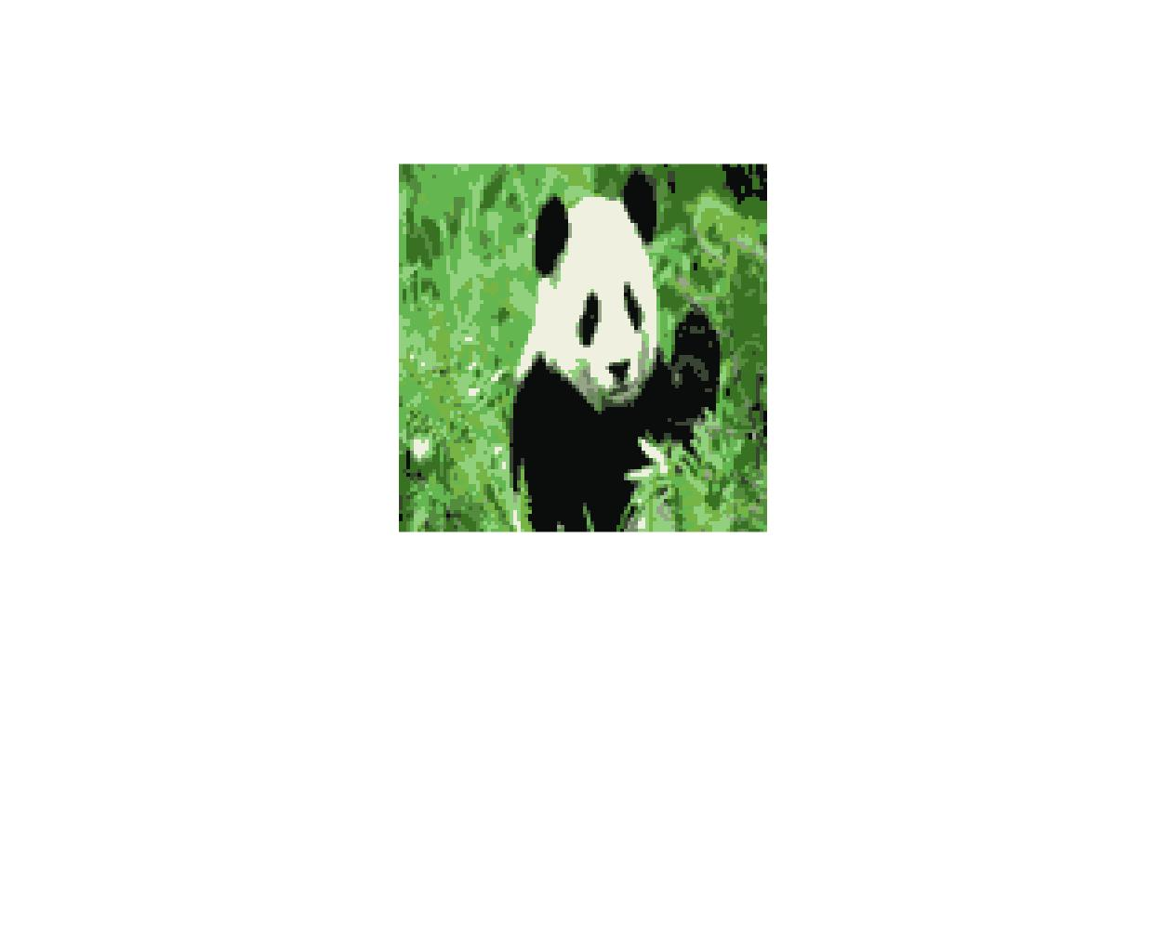

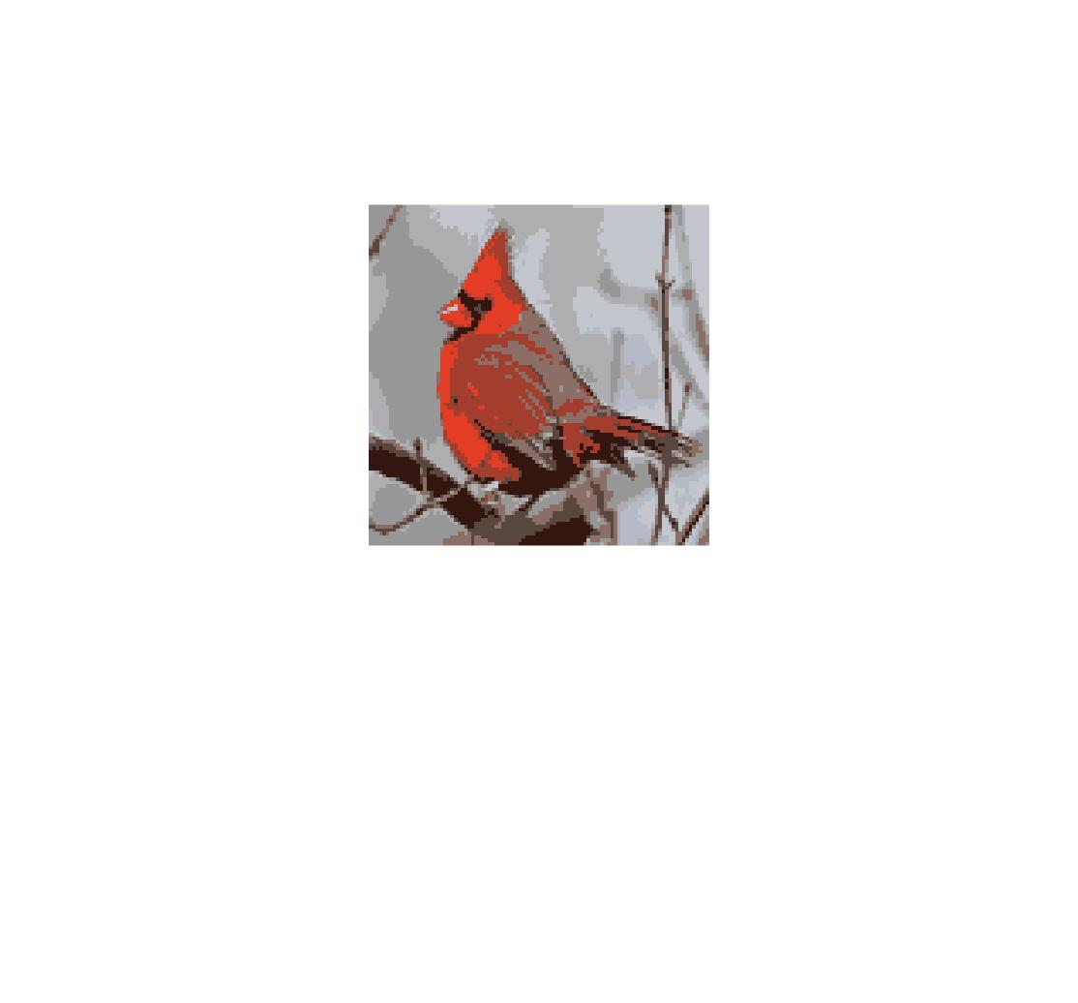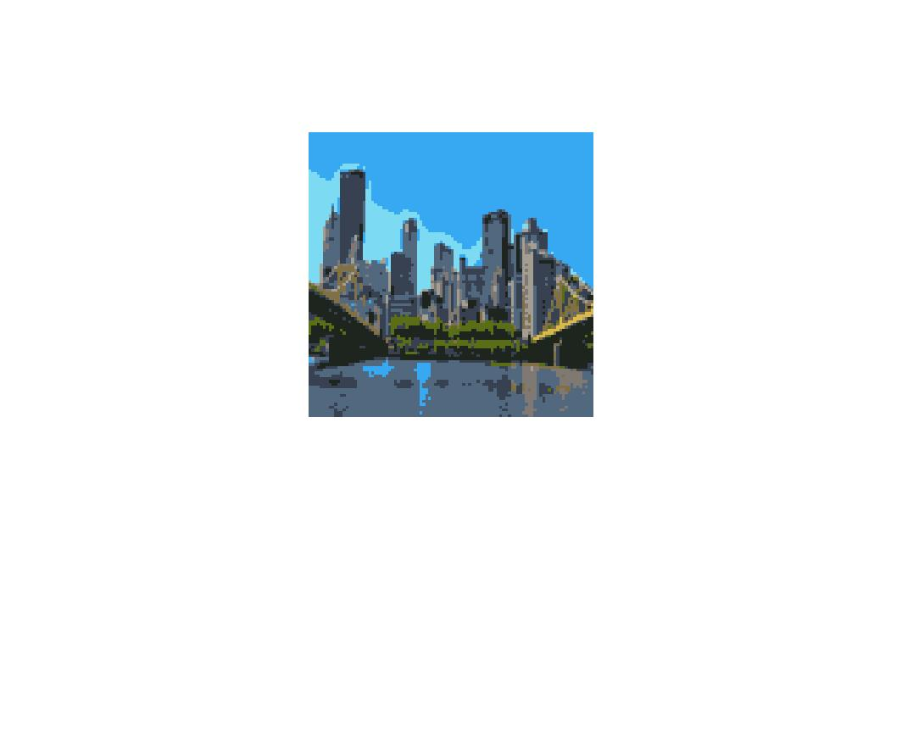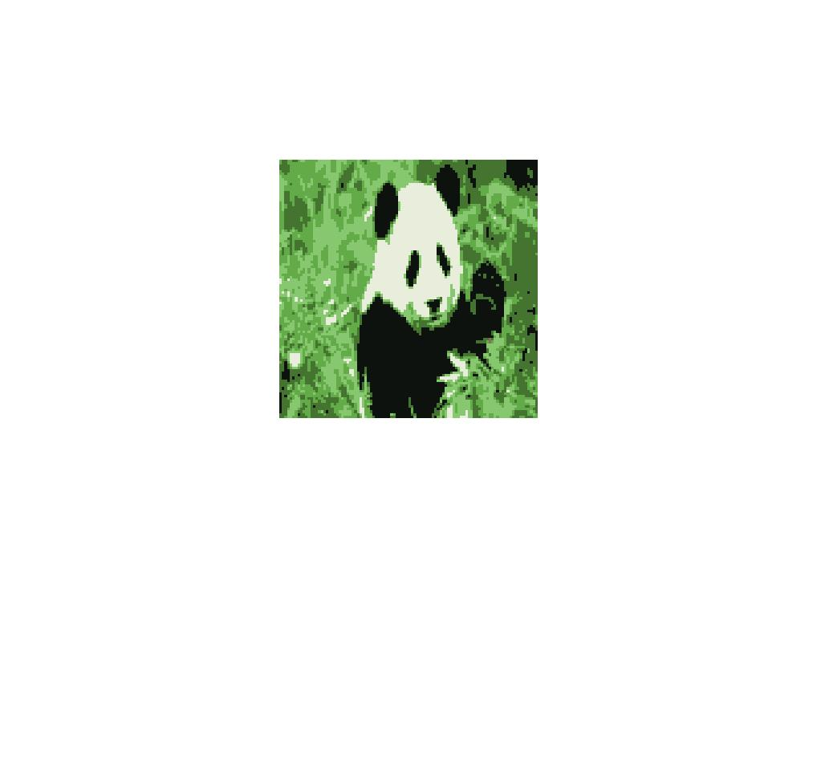

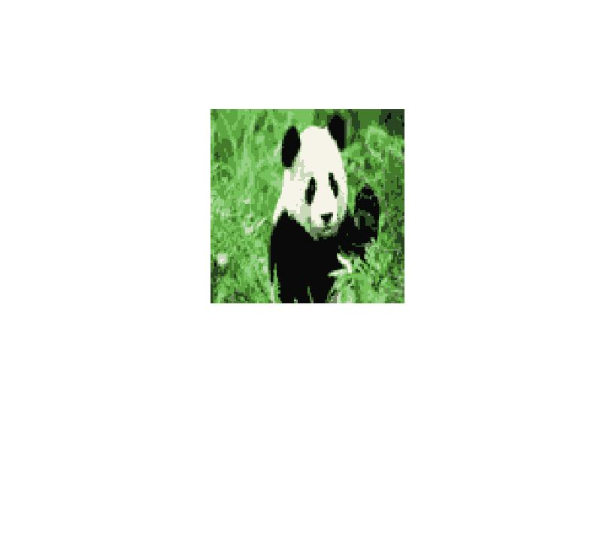K = 12, iter = 6, R = 6:

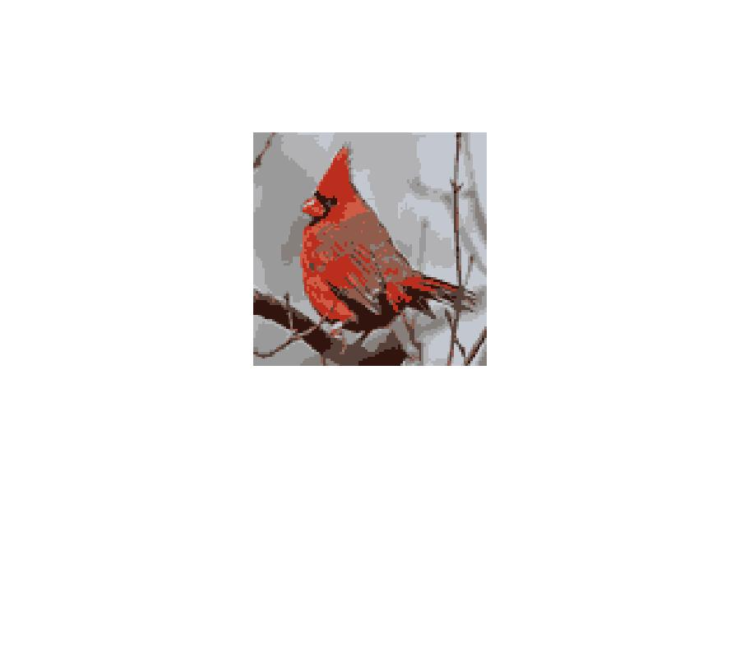

* Looking at the difference between the first two sets of pictures, it is obvious that more clusters will generally mean more detail – the shadows on the panda, the details of the buildings, sky, and water in the Pittsburgh photo, as well many of lines of the bird were all displayed more accurately and with brighter colors when the algorithm was ran with more clusters.
* Running with more iterations and random restarts seemed to produce greater details between the second and third sets of pictures – the shadows on the panda and sky/building details in the Pittsburgh photo in particular – yet it also seems to wash out the colors greatly in the Pittsburgh photo. This makes sense, as the number of clusters (colors) hadn’t increased, yet the amount of time for the colors to average had increased.
* More clusters with fewer iterations between the third and fourth set reinforces the previous results: more details with brighter colors as the clusters have had less time to average
* Increasing the number of clusters again between the fourth and fifth picture sets again increases the amount of detail in the resulting images
* Doubling the number of iterations and adding a random restart between the fifth and sixth sets of pictures seems to dull the colors a little (the bird’s head and added shadows on the panda’s face and smooth out some of the rougher edges (as seen on the left bridge and water in the pitt picture).