Brian Knotten

Professor Adriana Kovashka

CS1675

5 October 2018

Homework 4 – Report

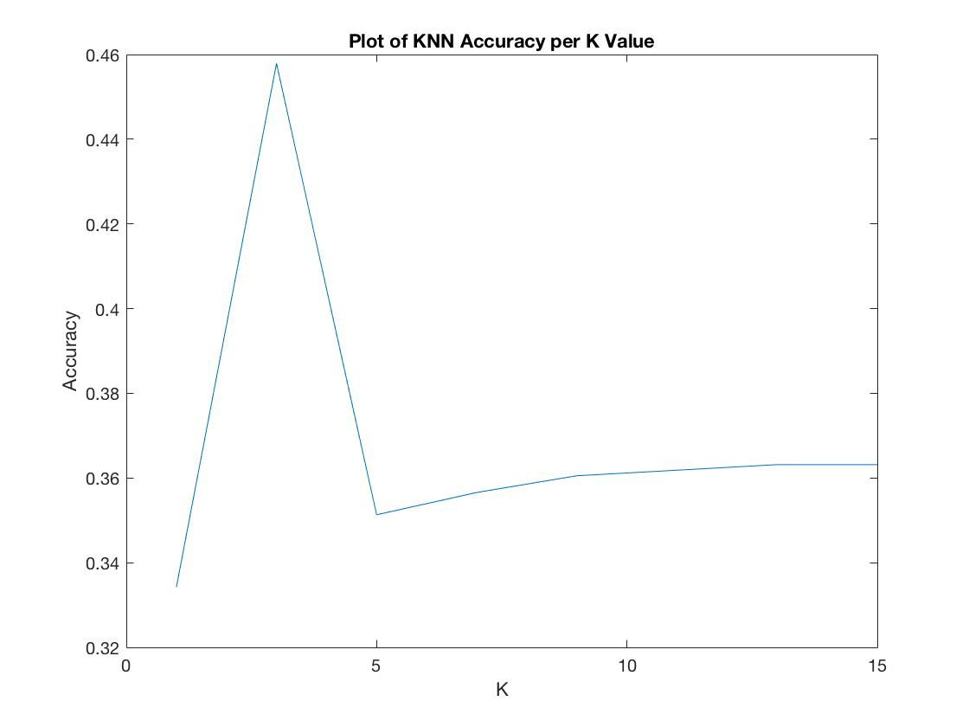KNN Accuracy plot (Part III Step 4):

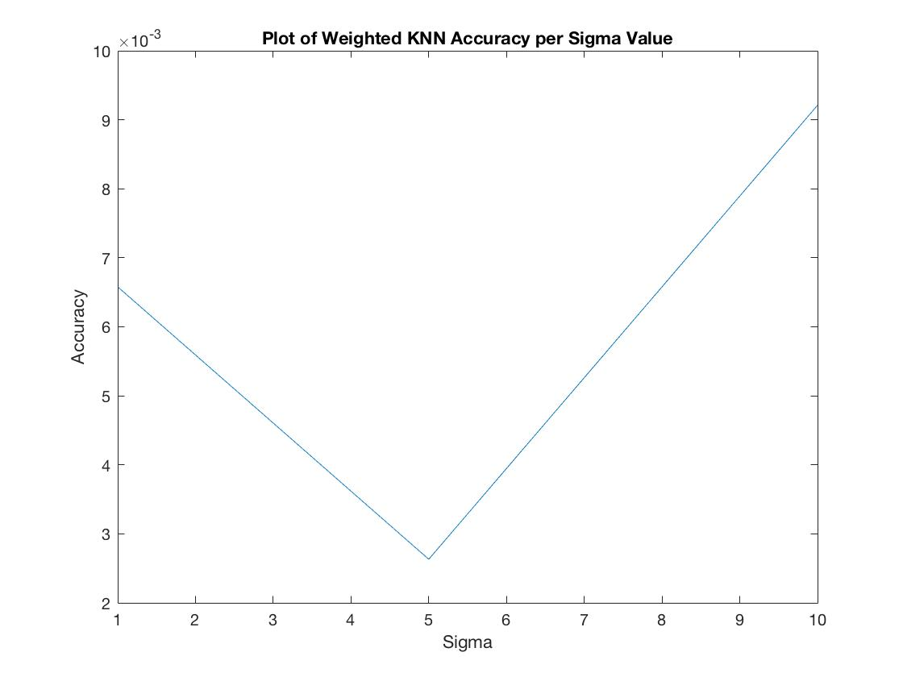Weighted KNN Accuracy plot (Part III Step 5, Sigma = 10, 5, 1):