Brian Knotten

Professor Adriana Kovashka

CS1675

16 October 2018

Homework 5 – Report

Perceptron Iteration 1 Output Plot:

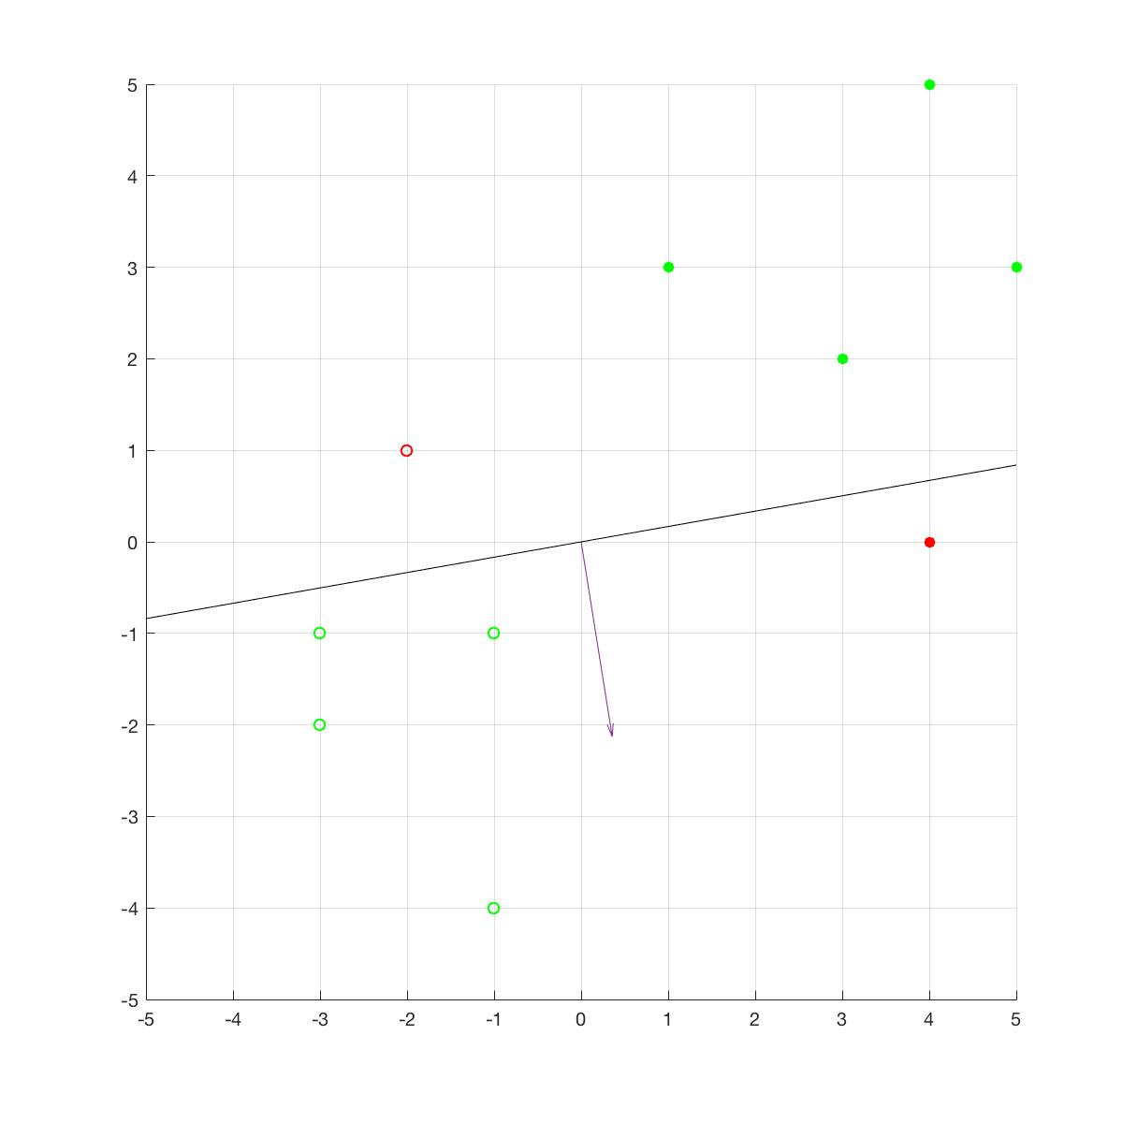

Perceptron Iteration 2 Output Plot:

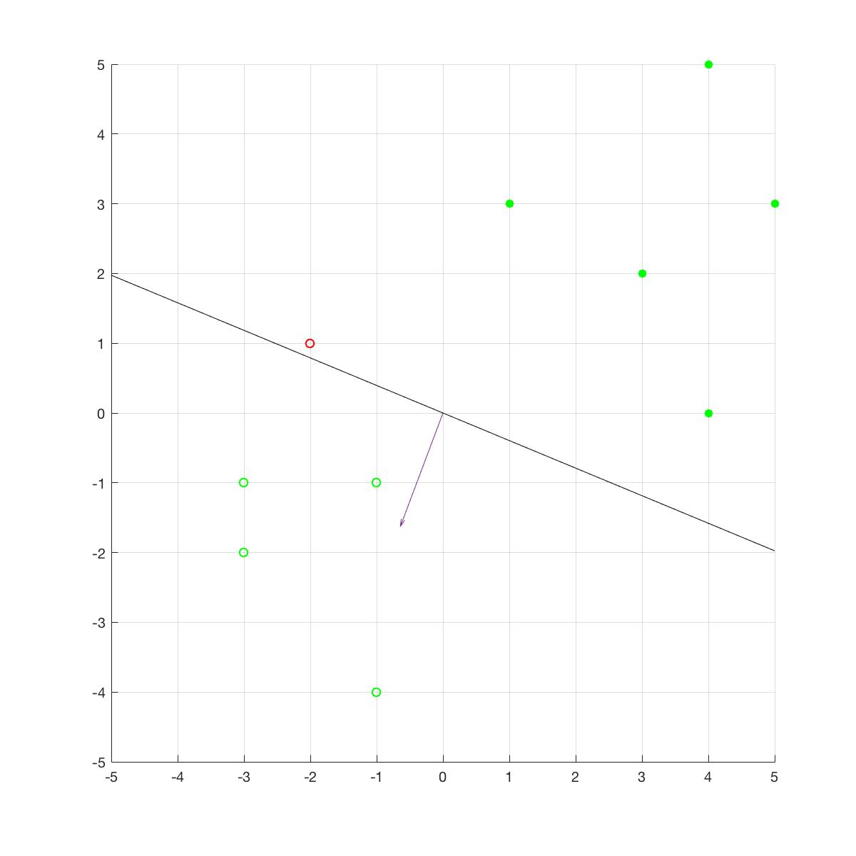

Perceptron Iteration 3 Output Plot:

