Brian Knotten

Professor Adriana Kovashka

CS1675

15 November 2018

Homework 7 – Report

Part I:

Part III:

* Root mean squared error between the predicted and ground truth labels with a learning rate of 0.01: 0.708557

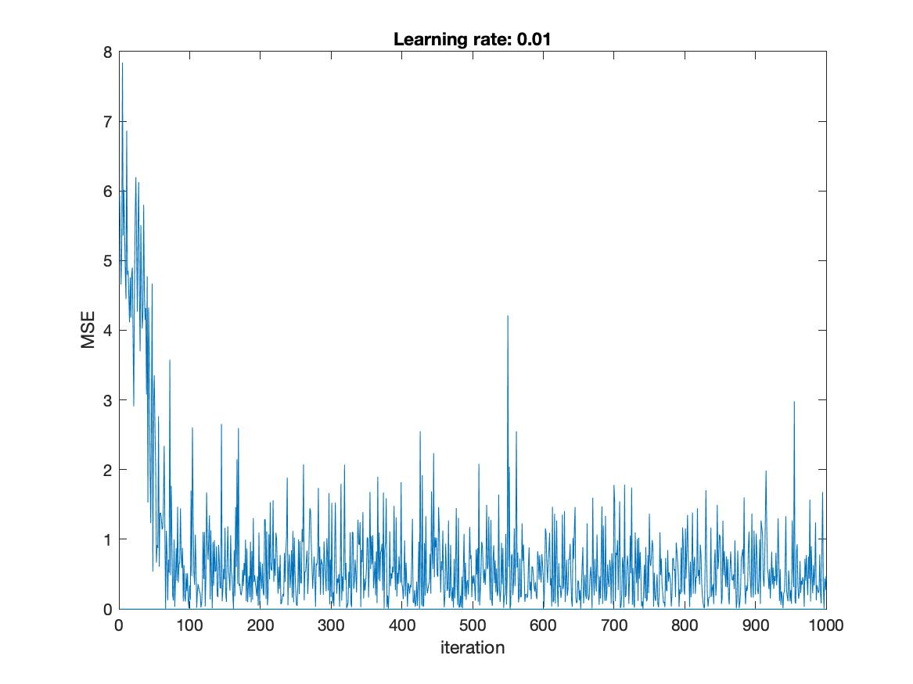

* Root mean squared error between the predicted and ground truth labels with a learning rate of 0.03: 0.716838

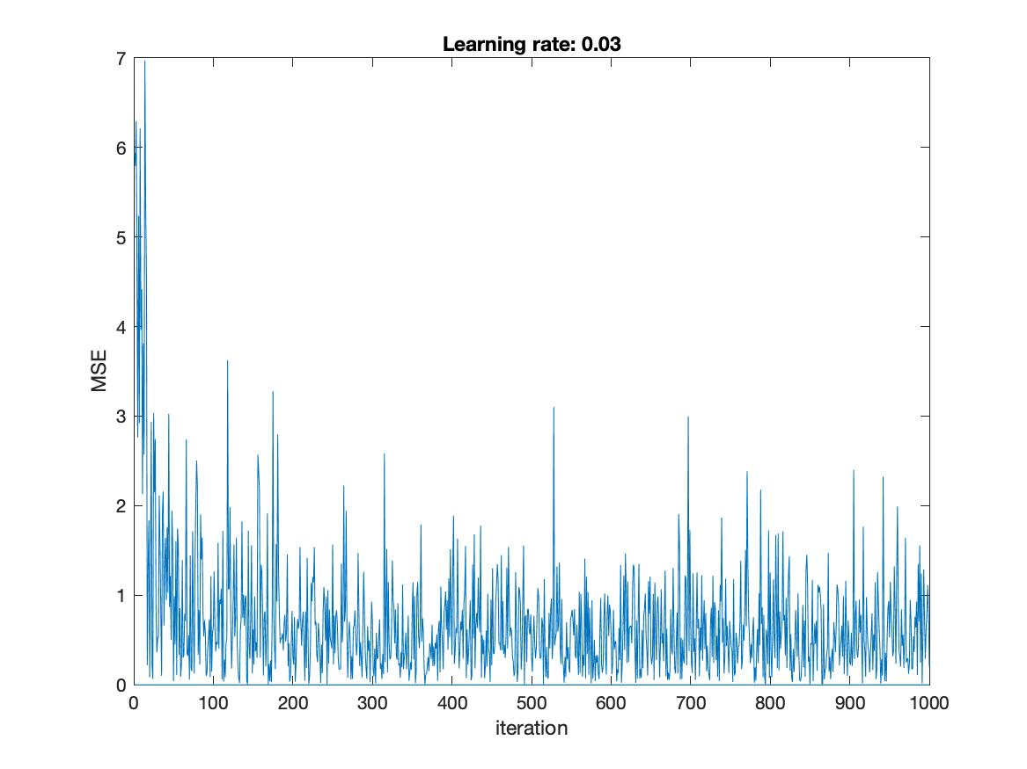

* Root mean squared error between the predicted and ground truth labels with a learning rate of 0.05: 0.955722

A close up of a mans face

