--- A Entrance ---

Lost? Scan this

code on our app!



--- B Entrance ---

Lost? Scan this

code on our app!



--- C Entrance ---

Lost? Scan this

code on our app!

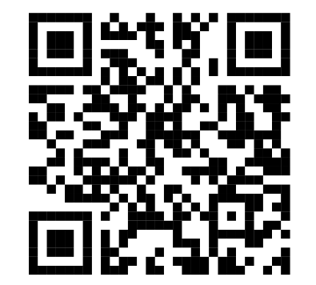

--- Canteen ---

Lost? Scan this

code on our app!

