1. **Company profile**

**1.1 Formation of company**

Aqmenz Automation Private Limited is a private incorporated on 15th October 2018. It is  classified as Non-Govt Company and is registered at Registrar of companies, Bangalore.

**1.2 Brief history of company**

Aqmenz Automation Pvt Ltd (AAPL) was started on October 2018. It is situated in northern  part of Bangalore, RT Nagar Karnataka. AAPL provides Mechanical Design & Automation solutions to their client companies. AAPL also involved in Open source Robotics and devel oped different varieties of Robots.

Aqmenz also started INDOSKILL, a separate platform for the students to get training and work on various Real Time Industrial Projects. Indoskill offers skill-oriented hands ontraining through an online platform.

Field of Expertise: Open-source Robotics, Industrial Automation, Product Design, Python and Deep Learning and Embedded Systems.

**1.3 Major Milestones:**

We have under gone many industrial projects. Our major clients are BIAL (Bangalore International Airport Limited), GE (General Electric) and Amics technologies.

**1.4 Vision and mission**

Our Motto and Vision are to create awareness & training young generation to current and future  jobs demands and also help to current and future jobs demands; meanwhile help the students  and employees to meet the mandatory necessities of future human resources and skill  demands. We are in the 4th industrial revolution. The technological revolution is catastrophic  like never before, hence continues awareness for the up-gradation environment is much  essential. Aqmenz Automation Pvt. Ltd. is working to help and enhance the potential of studentsand employees. So that future human resources will be very beneficial, purposeful and profitable to the nation.

**1.5 Objectives**

• AAPL had a trust in Skill India mission & vision, hence our utmost priority is to add skill to the young Generation and make them Profitable and productive for the  nation.

• We aim in Providing Industrial Automation Training Skill module kits to Institution University’s & Collage Lab Facilities with Lowest Possible Price for Benefits of Technical Students.

• Identifying young entrepreneurs and motivate, training them to establish Start-up to  create Employment as well as prosperity for the nation.

• Consultation, Sourcing and supplying highly skilled Manpower to Industry for better efficiency and productivity.

• Providing low cast & precise industrial automation solutions.

• Very eager to fetch solution for most complex industrial problems in a mode.

**1.6 About the company**

Organization structure The organization structure is having three different departments such as design  department, software department and sales and marketing.

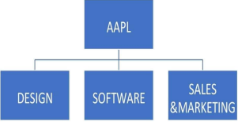

figure 1.1 Organisation structure

* 1. **Services offered**

• Embedded solutions to companies like GE

• We conduct technical skill-oriented training programs to engineering colleges.

• We also provide robotics and automation lab equipment’s for colleges.

Number of people working in company and their responsibilities.

There are 20 persons in this company, out of which:

• Shamanna Mohan, Chief Executive Officer (CEO)

• Mohammed Azhar Hussain, Chief Technology Officer (CTO)

**1.8 Ongoing projects**

• Automation related projects

• CNC Machines

• Open-source Custom Robots

• Garment Industry slider project

**2. Introduction**

Rapid development in the retail industry both in structure and growth in online-business is  becoming the current marketing trends. Sales forecasting is an important aspect of many  business organizations today. Sales forecasting is an essential task for the management of a  store. Sales prediction is used to predict sales of products at various stores and outlets of a big  retail mart companies in different cities. Forecasting store sales can be categorized into: (i)  forecasting existing store sales for distribution, setting target sales and its viability and  controlling the finance and (ii) forecasting potential sales for the analysis of new store site  selection. Predictive analytics is concerned with the prediction of future probabilities and  trends. With predictive analytics, retailers are trying to enhance their product offerings, pricing  models and service levels to create and enhance sustainable competitive advantage. Intelligent  forecasting can play significant role in the world of sales management. Intelligent forecasting  uses the information of publicity of retail sales to forecast the effective media of advertising  and thus predicting the growth of sales in terms of sales prediction. Though the process of  forecasting tends to be a complex, it is a straight forward technique to determine its accuracy.  Machine learning can help us discover the factors that influence sales and estimate the number  of sales that it will have in the near future. Many forecasting models use historical sales to  predict future sales During the promotion period, purchasing behavior of the consumer partially  influenced by the incentives offered through each promotion event. Consumers make their final  purchase decisions based on their perceived values for these promotion events. The efficacy of  promotion events depends on the duration of the advertisement medium and degree of  advertisement medium. Every promotional event may have a different effect on the consumer’s  decision to increase their purchase. Managers use analytical reports from sales to find market  opportunities and processes where they could increase volume and profit. By comparing the  result of positive and negative evaluations of comments of consumers, retailers can better  understand the outcomes from competitors’ analysis.

• In this Workshop program we have done a project.

• Project: Company Annual Sales Prediction and its deployment

• The software used in designing is Google Colab.

**3. Tools exposed**

**3.1 Jupyter notebook**

The juypter notebook app is a server-client application that allows editing and running  notebook documents via a web browser. The jupyter notebook app can be executed on a local  desktop requiring no internet access or can be installed on a remote server and accessed  through the internet. In addition to displaying/editing/running notebook documents, the  jupyter notebook app has a dashboard, a control panelshowing local files and allowing to open  notebook documents or shutting down their kernels.

A notebook kernel is a computational engine that executes the code contained in a notebook document. The jupyter kernelreferenced in this guide executes python code. Kernels for many  other language exist. When you open a notebook document the associated kernel is  automatically launched. When the notebook is executed the kernel performs the computation  and produces the results. Depending on the type of computations the kernel may consume  significant CPU and RAM. Note that the RAM is not released until the kernel is shut down.

The notebook dashboard is the component which is shown first when you launch jupyter  notebook app. The notebook dashboard is mainly used to open notebook documents and  manage the running kernels. The jupyter notebook extends the console based approach to  interactive computing in a qualitatively new direction, providing a web based application  suitable for capturing the whole computation process: developing, computing and executing  code as well as communicating the results. The jupyter notebook combines two components a web application and notebook documents.

A web application: A web browser based tool for interactive authoring of documents which  combine explanatory text, mathematics, computations and their rich media output. Notebook  documents: A representation of all content visible in the web application, including inputs and outputs of the computations, explanatory text, mathematics, images and rich media  representation of objects.

**3.2. Google colab**

Colaboratory or colab for short, is a product from Google research. Colab allows anybody to  write and execute arbitrary python code through the browser and is especially well suited to  machine learning, data analysis and education. More technically colab is a hosted jupyter  notebook service that requires no setup to use, while providing access free of charge to computing resources including GPUs.

Colab resources are not guaranteed and not unlimited, and the usage limits sometimes  fluctuate. This is necessary for colab to be able to provide resources free charge. Resources in  colab are prioritized for interactive use cases. We prohibit actions associated with bulk  compute, actions that negatively impact others as well as actions associated with bypassing the policies. Jupyter is the open source project on which the colab is based. Colab allows you to use and share jupyter notebooks with others without having to download, install or run  anything.

You can search colab notes using google drive. Clicking on the colab logo at the top left of the  notebook view will show all notebooks in drive. You can also search for notebooks that you  have opened recently by clicking on file and then open notebook. Google drive operations  can time out when the number of folders orsubfolders in a folder growstoo large. If thousands of items are directly contained in the top level “My drive” folder then mounting the drive will  likely time out. Repeated attempts may eventually succeed as failed attempts cache partial  state locally before timing out.

Colab is able to provide resources free of cost in part by having dynamic usage limits that sometimes fluctuate this means that overall usage limits as well as idle timeout periods, maximum VM lifetime, GPU types available and other factors vary over time. Colab does not  publish these limits in parts because they can vary quickly. This is necessary for colab to be able to provide access these resources free of charge. Colab works with most of the major browsers and is most thoroughly tested with the latest versions of Chrome, Firefox and Safari.

**4. METHOD AND APPROACH**

**4.1 General steps**

∙ Importing the necessary Libraries

∙ Read the data.

∙ Check for null values. (Drop or use imputation)

∙ EDA

∙ Standardize the data set

∙ Encode the dataset (Label or One-Hot encoding upon requirement)

∙ Preprocessing

∙ Model Building

∙ Deploy using gradio

∙ Start the app

∙ Input from the user

∙ Get the Result.

**4.2 MODELLING WITH ALGORITHM**

**4.2.1 Data set**

A data set is a collection of similar and related data or information. It is organised for better  accessibility of an entity. Data sets are used for data analytics as they provide related  information in a united form. It can be structured or unstructured.

**4.2.2 Linear Regression**

Linear regression is one of the easiest and most popular Machine Learning algorithms. It is a  statistical method that is used for predictive analysis. Linear regression makes predictions for  continuous/real or numeric variables such as sales, salary, age, product price, etc.

Linear regression algorithm shows a linear relationship between a dependent (y) and one or  more independent (y) variables, hence called as linear regression. Since linear regression shows  the linear relationship, which means it finds how the value of the dependent variable is  changing according to the value of the independent variable.

The linear regression model provides a sloped straight line representing the relationship  between the variables. Consider the below image:

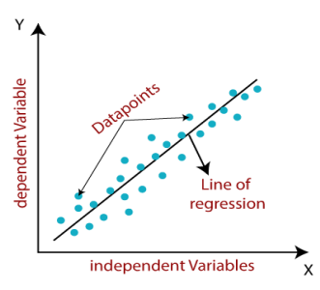

**5. Results**

**5.1 Dataset:**

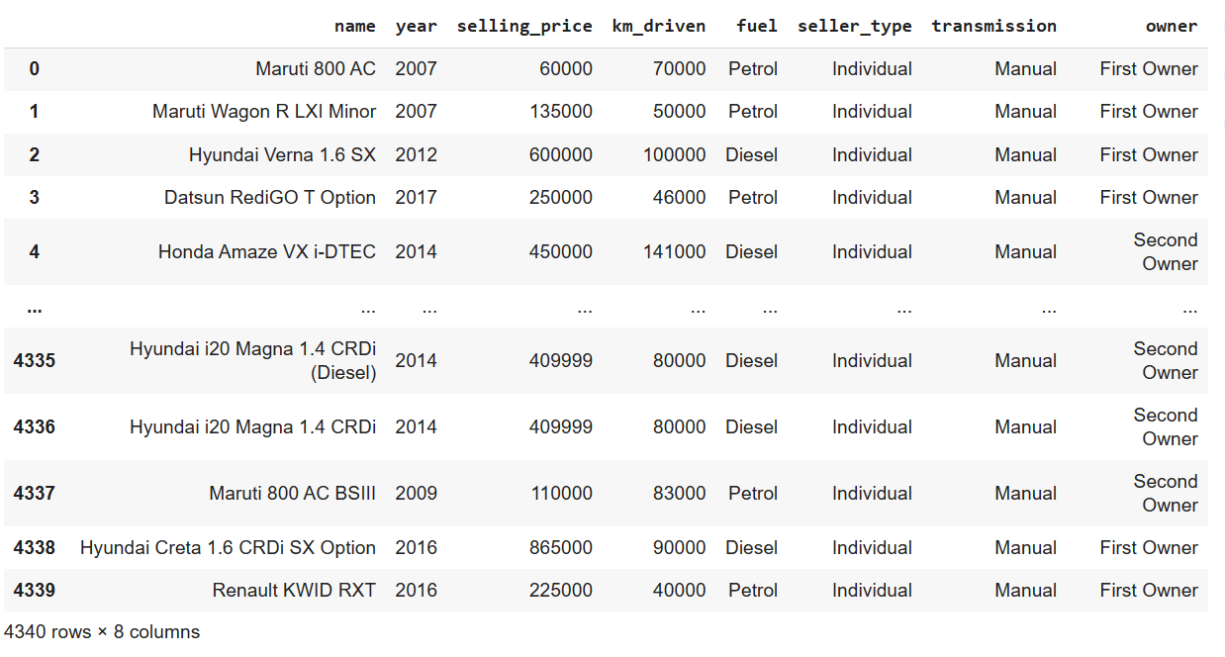

**5.2 Output Screens:**

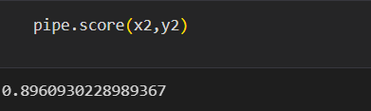

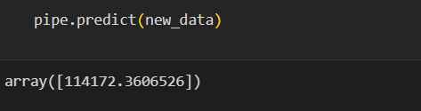

**6. Reflection notes**

**6.1 Skills acquired**

∙Understand, evaluate, design and implement artificial intelligence models. ∙Implement contemporary artificial intelligence techniques, from knowledge  representation, to deep learning, developing in demand skills and leadership qualities  for an exciting career in AI.

∙Apply the legal, ethical, social and philosophical context for practical AI projects.

∙Extend knowledge in artificial intelligence through research, experimentation and analysis.

∙Practical or hands on experience in training an ML model.

∙Gain expertise in technical drawing to visualize concepts.

**6.2 Technical outcomes**

• Machine learning involves computations on large data sets, hence we learnt strong basic fundamental knowledge such as computer architecture, algorithms and data structure complexity. Getting in depth into the python language and exploring new  commands.

• Synthesize visual perception skills along with drawing skills to visually communicate  ideas. Deconstruction of designs for its motives and inspirations. To learn to  synthesize data and make connections within the data points using the available  frameworks.

• To frame an appropriate actionable problem statement with reference to user needs  and contextual alignments.

• Data analysis of different data sets and to understand the concepts on a real world basis to implement and make use of AI/ML in our upcoming career.

• To train different models and to make sure the requirement of the respective clients and make to implement a model according to their requirements.

**6.3 Time management**

Time management helps you allocate time for the most important tasks. When we follow a  schedule we don’t have to spend time and energy on what to do. Instead we can focus on what matters and do well. The quality of the work will suffer if we are constantly worrying about  meeting the deadlines. Time management helps to prioritize the tasks, so we can have enough

time to focus on each project to put in the effort and produce high quality outcomes.

Many software companies have to work against tight timelines. Proper time management will  allow us to allocate enough time to meet each deadline. Planning ahead also keeps us calm and think freely to work more in an efficient way.

**6.4 Personality development**

Personality development is referred to as a process of developing and enhancing one’s personality. It helps one to gain confidence and high self esteem. It is essential to think positive and don’t get upset over minor things, to be a little flexible and always look at the broader  perspectives of life. Do not think of harming others and share whatever you know. Always  help others. Be a patient listener and never interrupt when others are speaking. Try to imbibe  good qualities of others.

Confidence is the key to a positive personality. Exude confidence and positive aura wherever you go. Personality development teaches you to be calm and composed even at stressful  situations. Never over react. Avoid finding faults in others. Learn to be a little broad minded  and flexible.

**7. Conclusion**

In conclusion, this workshop has been a very useful experience for me. I can safely say that my  understanding of the job environment has increased greatly. However, I do think that there are some aspects of the job that I could have done better and that I need to work on. I have built more confidence in usage of software tools. The two main things I learnt after my experience in this  firm are time management and being self-motivated. I have gained new knowledge and skills and met new people. Usage of charts, maps, other visual representations of data to help present  your findings in an easy-to-understand way. Improving the data visualisation skills often means  learning visualisation software. I have demonstrated in detail how to apply linear regression  using stats model for predicting ice cream sales from the sales data. By carefully selecting the right  variables, preparing and cleaning the data, and selecting an appropriate regression model,  businesses can accurately predict sales from advertising ads.