# Question A: Providing motivation for suitable solution for KhumaloCraft:

***Introduction***:

In today's digital era, the success of e-commerce platforms heavily relies on technological infrastructure, scalability, and user experience. KhumaloCraft Emporium, with its ambitious vision of connecting global artisans with a discerning audience, requires a robust and scalable solution to realize its dream. This report presents a comprehensive solution leveraging cloud computing to address the challenges and capitalize on opportunities for KhumaloCraft Emporium.

***Comparing KhumaloCraft Current Workflow with the Proposed Solution***:

***Current Workflow***:

KhumaloCraft is currently facing difficulties in global accessibility, scalability, and user experience due to its traditional platform.

***Proposed Solution***:

Adopting a cloud-based e-commerce platform will revolutionize KhumaloCraft's workflow. It will offer seamless global accessibility, enhanced scalability, and improved user experience through modern features and functionalities.

***Benefits of Using Cloud Computing***

1. ***Cost-Efficiency***: Cloud computing eliminates the need for upfront infrastructure investment, reducing operational costs.
2. ***Flexibility and Scalability***: Easily scale resources up or down based on demand, ensuring optimal performance.
3. ***Reliability and Availability***: Cloud providers offer high availability and uptime, minimizing downtime and ensuring business continuity.
4. ***Security***: Cloud providers implement advanced security measures, protecting data and ensuring compliance with regulations.
5. ***Innovation and Agility***: Rapid deployment of new features and services, keeping KhumaloCraft competitive and adaptable to market trends.

***Scalability:***

Cloud computing offers unparalleled scalability, allowing KhumaloCraft to accommodate growth without compromising performance or incurring significant costs. As the platform grows and attracts more artisans and customers, resources can be easily scaled up to meet increasing demand, ensuring a seamless shopping experience for users worldwide.

***Accessibility***:

A cloud-based platform ensures global accessibility, breaking down geographical barriers and reaching a broader audience. KhumaloCraft's handcrafted products will be accessible to customers worldwide, enhancing brand visibility and expanding market reach. Additionally, accessibility features can be tailored to cater to diverse user needs, ensuring inclusivity and enhancing user satisfaction.

***Services Provided Through Cloud Computing***:

* ***Infrastructure as a Service (IaaS)***: Provides virtualized computing resources, allowing KhumaloCraft to build and manage its infrastructure flexibly.
* ***Platform as a Service (PaaS)***: Offers a complete development and deployment environment, streamlining application development and deployment processes.
* ***Software as a Service (SaaS)***: Access to software applications over the internet, enabling KhumaloCraft to leverage advanced e-commerce solutions without managing software maintenance and updates.
* ***Serverless Computing***: Enables KhumaloCraft to run applications without managing server infrastructure, reducing operational complexity and costs.
* ***Data Storage and Management***: Cloud-based databases and storage solutions ensure efficient and secure management of product information and user data, supporting KhumaloCraft's growth and compliance requirements.

***Conclusion***:

# KhumaloCraft Emporium made the strategic decision to embrace cloud computing to realize its vision of becoming a global e-commerce platform for handcrafted goods. The proposed approach provides a scalable, accessible, and intuitive platform that meets KhumaloCraft's requirements and addresses its current challenges. KhumaloCraft may use cloud computing to broaden its market reach, improve operational efficiency, and provide customers with a world-class shopping experience.

# Question B: Develop a web application:

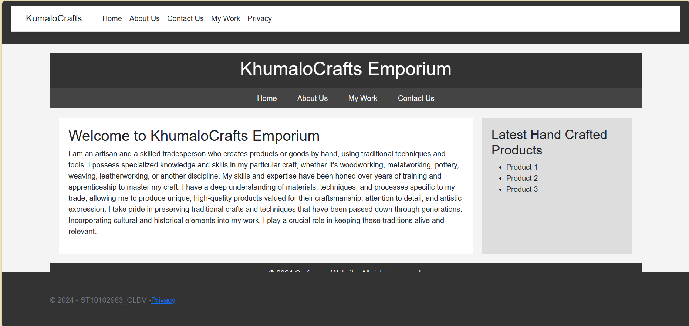

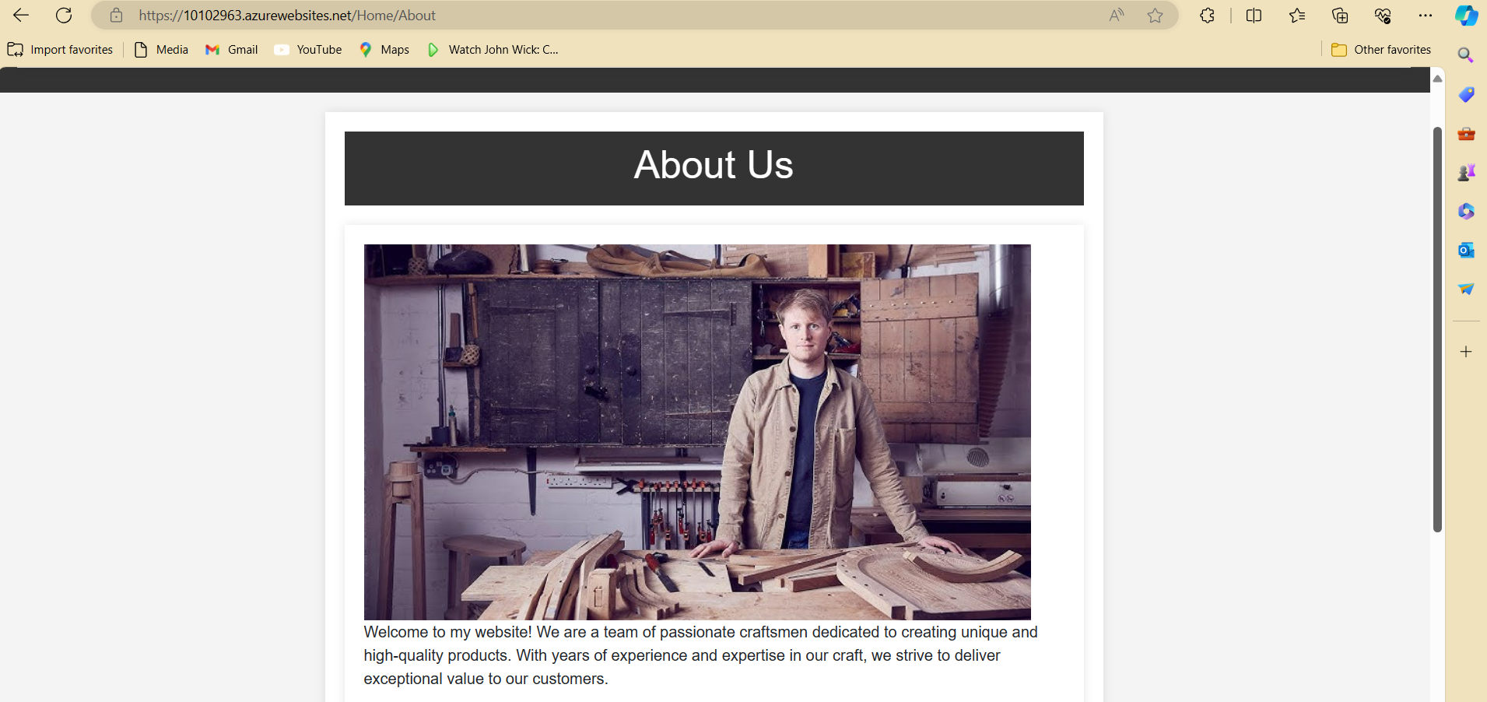

# Question C: Deploy your Web Application to an Azure App Service:

<https://10102963.azurewebsites.net>