**Problem 1**

**Facts:**

furniture(desk,1,window2,chair,corner4).

furniture(wardrobe,1,wall4,door,corner1).

furniture(door,1,wardrobe,wall2,no_corner).

furniture(bookshelf,1,chair,wall2,no_corner).

furniture(bed,1,chair,wall2,corner3).

furniture(window,1,desk,bed,no_corner).

furniture(window,2,nothing,desk,no_corner).

furnitures([door,window,desk,chair,wardrobe,bookshelf,bed]).

**Rules:**

how_many(X,Y):-

findall(_,furniture(X,_,_,_,_),L),

length(L,Y).

where_is(X,M,N):-

furniture(X,_,Y,Z,_),

string_concat("Right side of ",Y,M),

string_concat("Left side of ",Z,N).

what_is_at(X,Y,Z):-

findall(M,furniture(M,_,X,_,_),Y),

findall(N,furniture(N,_,_,X,_),Z).

at_corner(X,Y):-

findall(M,furniture(M,_,_,_,X),Y).

**Query:**

1. Which furniture is in the room?.

?- furnitures(Z).

Ans:- Z=**Z** = [door, window, desk, chair, wardrobe, bookshelf, bed]

1. How many window?.

?- how_many(window,X).

Ans:- **X** = 2

1. Where is desk?

?- where_is(desk,X,Y).

Ans:- **X** = "Right side of window2",  
 **Y** = "Left side of chair"

1. What is at wall4

?:- what_is_at(wall4,X,Y).

Ans:- **X** = [wardrobe],  
 **Y** = []

1. What is at Corner 1?.

?:- at_corner(corner1,X).

Ans:- **X** = [wardrobe]

**Problem 2**

**Facts:**

animal(dog).

human(marry).

love(marry,dog).

**Rules:**

what_does_do(X, Y, Z):-

human(X),

animal(Y),

love(X, Y),

string_concat(X, ' Feeds The ', M),

string_concat(M, Y, Z).

**Query:**

?- what_does_do(marry,dog,Z).

Ans:- Z = "marry Feeds The dog"

**Problem 3:**

**Facts**

man(john).

man(mike).

man(peter).

woman(sarah).

woman(emily).

woman(lisa).

woman(kate).

father(john, peter).

father(john, sarah).

father(peter, emily).

father(mike, kate).

mother(sarah, emily).

mother(sarah, kate).

mother(lisa, sarah).

**Roule**

parent(P, C) :- father(P, C) ; mother(P, C).

parents(F, M, C) :- father(F, C), mother(M, C).

child(C, P) :- parent(P, C).

son(S, P) :- child(S, P), man(S).

daughter(D, P) :- child(D, P), woman(D).

grandfather(GP, GC) :- father(GP, P), parent(P, GC).

grandmother(GM, GC) :- mother(GM, M), parent(M, GC).

grandchild(GC, G) :- grandparent(G, GC).

brother(B, SB) :- man(B), B \= SB, parents(F, M, B), parents(F, M, SB).

sister(S, SB) :- woman(S), S \= SB, parents(F, M, S), parents(F, M, SB).

uncle(U, N) :- brother(U, P), parent(P, N).

aunt(A, N) :- sister(A, P), parent(P, N).

ancestor(A, X) :- parent(A, X).

ancestor(A, X) :- parent(A, Z), ancestor(Z, X).

descendant(D, X) :- child(D, X).

related(X, Y) :- ancestor(A, X), ancestor(A, Y), X \= Y.

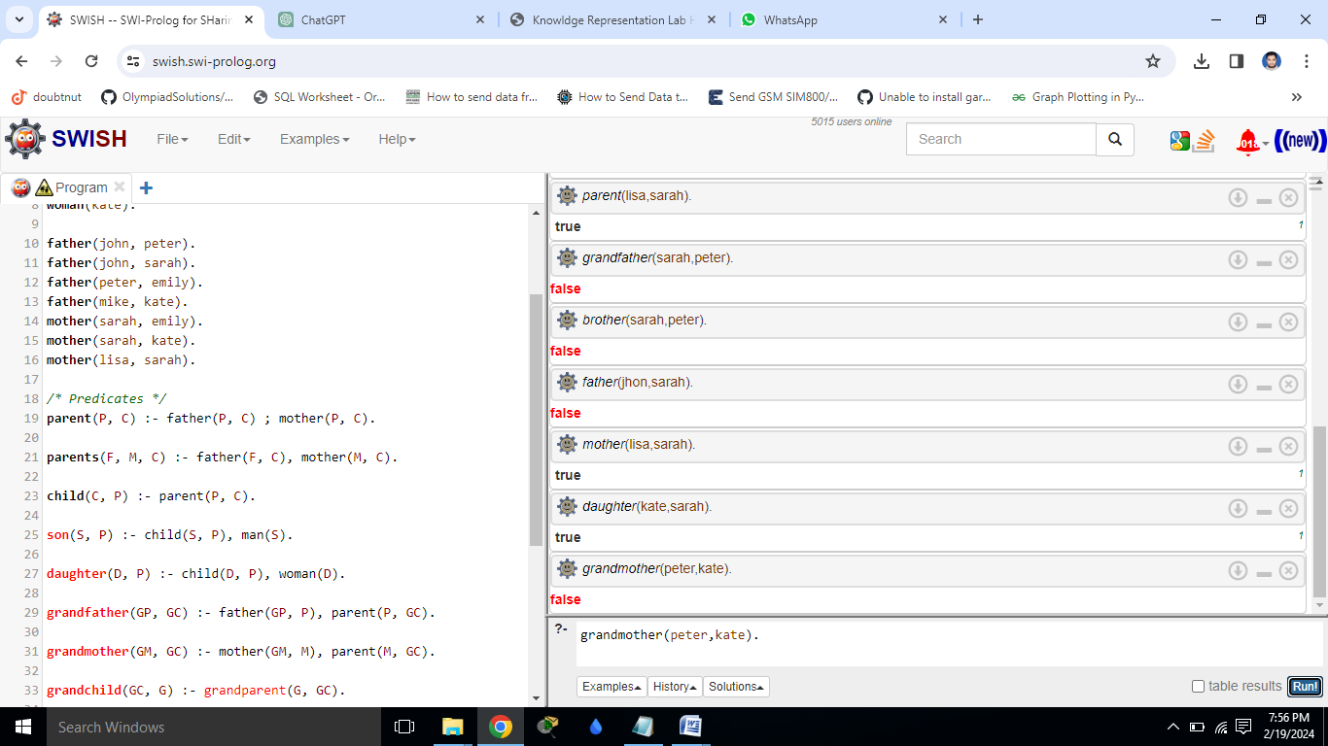**Query and answer:**