Computational Solid Mechanics Final Project Report

12110908 黄锦松

1. Problem Description

Strong form:

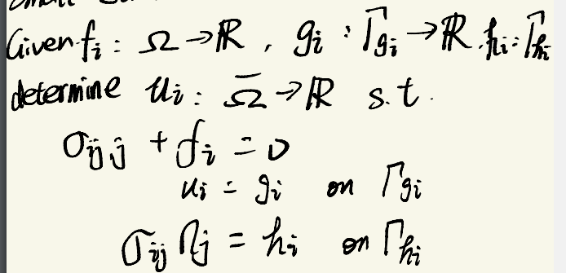Weak form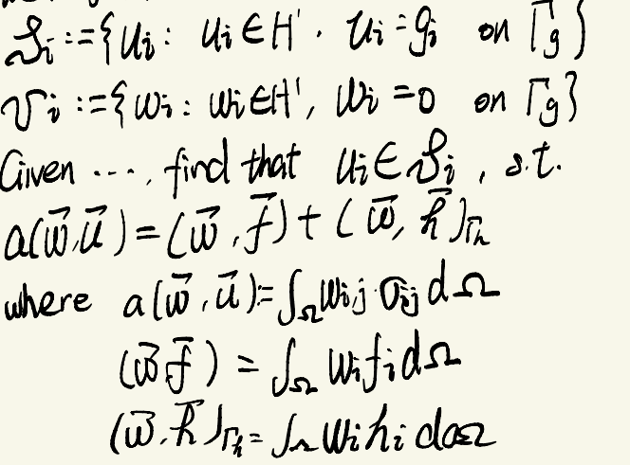Galerkin formulation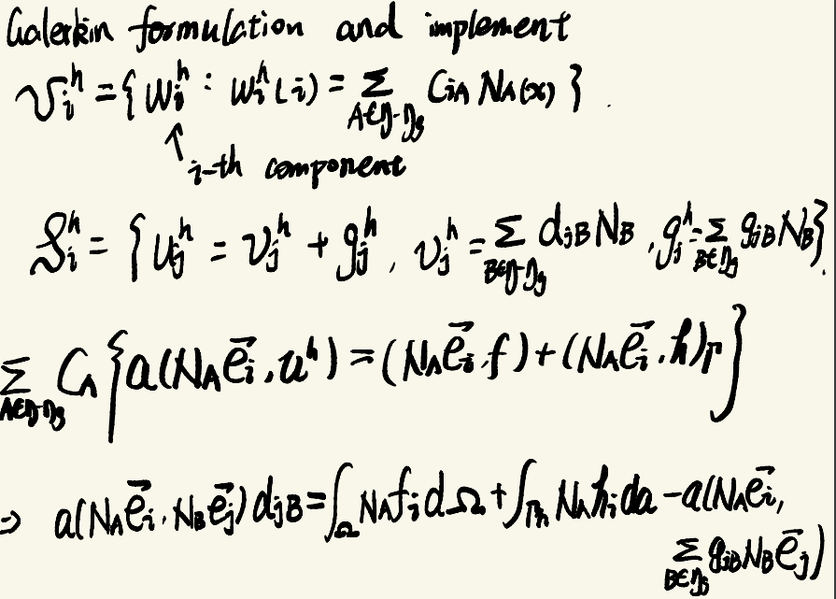

Boundary condition

For the outer surface, there are Dirichlet BC (e.g. g = 0) and Neumann BC (e.g. h = T). For inner hole, the BC is h = 0. For symmetry surface, the BC is like this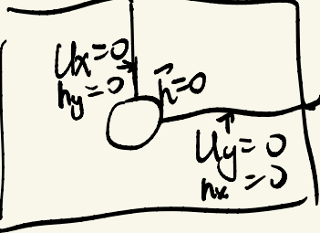

1. The implementation of the element stiffness matrix

I choose $B_{a}^{T}DB_{b}$ implementation. Calculate B matrix first, then get $k^{e}$ by matrix calculation. That is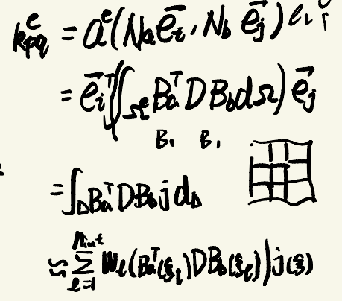

1. Manufactured solution

With given Tx = 10kpa, I calculate 3 stresses at each nodes as manufactured solution, then transfer the polar coordinates into Cartesian coordinates with equations below

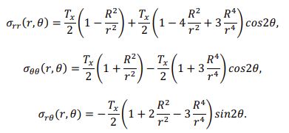

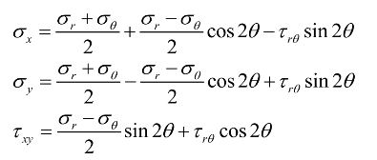

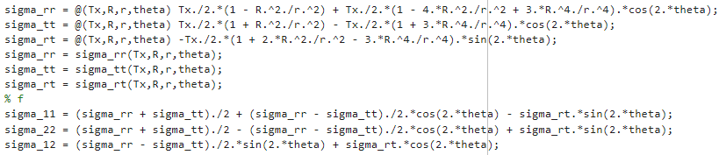

1. The codes are in driver.m. For the case I calculate, I define the right surface to be Dirichlet Boundary condition. I first load the .msh mesh data from gmsh and construct node coordinates and IEN array.

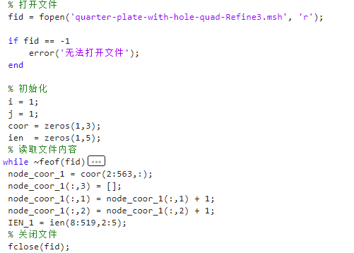

Then I calculate D matrix

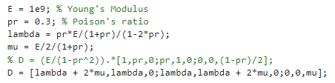

Then construct ID and LM array. Notice that there is 2 degrees of freedom

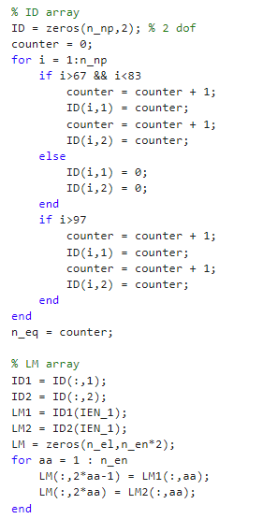

Then I begin the numerical calculation part. There are 3 for loops. The biggest one is element loop. The second one is quadrature loop (I use quadrature rule provided in class for quadrilateral elements). The third one is element nodes loop. www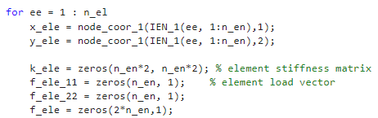

Initiate element k matrix and f load vector.

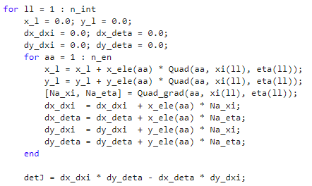

Calculate Jacobian determinant.

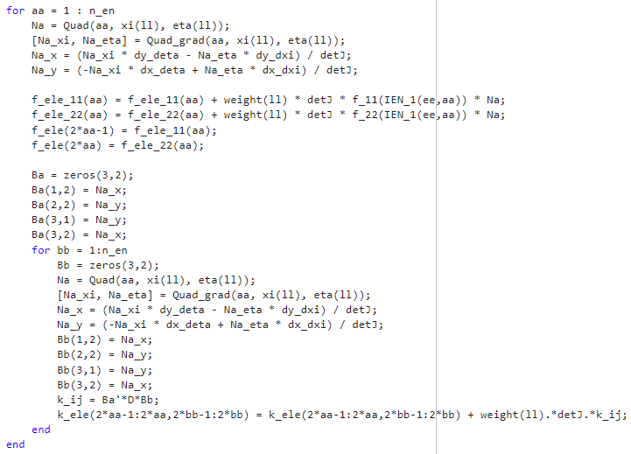

Calculate element k and f using B’DB implementation. (Notice that there are two components for each element node)

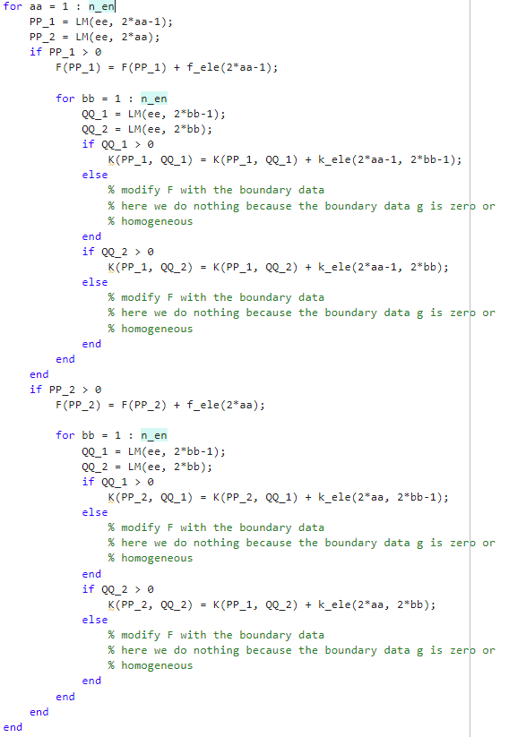

Assembly of big K matrix and F load vector. (Still, there are two components for each node. So compared to heat conduction problem, the size of K and F is twice as large.

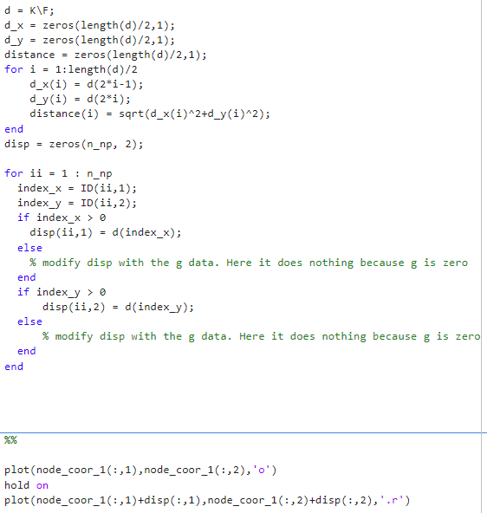

Then I solve the matrix and reconstruct the displacement vector with given boundary data. Then visualization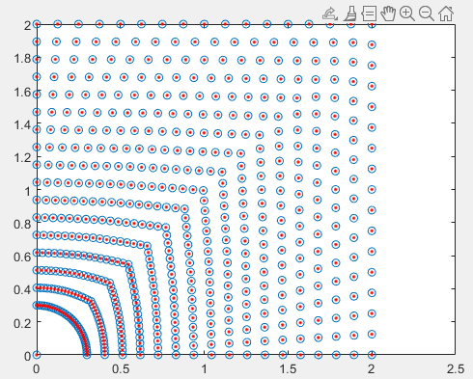

(Blue circle is initial nodes, red dots is the nodes after displacement)

The difference is too small to be observed