1.What are the two values of the Boolean data type? How do you write them?

**Answer:** Two Boolean data types are True and False.

2. What are the three different types of Boolean operators?

**Answer:** Three Boolean operators are AND, OR, NOT.

3. Make a list of each Boolean operator's truth tables (i.e. every possible combination of Boolean values for the operator and what it evaluate ).

**Answer:**

**AND**

|  |  |  |
| --- | --- | --- |
| **A** | **B** | **Output** |
| 0 | 0 | 0 |
| 0 | 1 | 0 |
| 1 | 0 | 0 |
| 1 | 1 | 1 |

**OR**

|  |  |  |
| --- | --- | --- |
| **A** | **B** | **Output** |
| 0 | 0 | 0 |
| 0 | 1 | 1 |
| 1 | 0 | 1 |
| 1 | 1 | 1 |

**NOT**

|  |  |
| --- | --- |
| **A** | **~A** |
| 0 | 1 |
| 1 | 0 |

4. What are the values of the following expressions?

(5 > 4) and (3 == 5) 🡪 False

not (5 > 4) 🡪 False

(5 > 4) or (3 == 5) 🡪 True

not ((5 > 4) or (3 == 5)) 🡪 False

(True and True) and (True == False) 🡪 False

(not False) or (not True) 🡪 True

**Answers are mentioned above inline.**

5. What are the six comparison operators?

**Answer:** Six comparison operators are : <, >, ==, !=, <=, >=

6. How do you tell the difference between the equal to and assignment operators?Describe a condition and when you would use one.

**Answer:**

**Equal to comparison operator** is used to compare whether both LHS and RHS are equal, it is denoted by double equals sign. Example: 1==2

**Equal to assignment operator** is used when we need to assign a particular value to a variable; it is denoted by single equals sign. Example: test=1

7. Identify the three blocks in this code:

spam = 0

if spam == 10:

print('eggs')

if spam > 5:

print('bacon')

else:

print('ham')

print('spam')

print('spam')

**Answer:**  Three blocks are mentioned in comments of below piece of code.

spam = 0

#FIRST IF BLOCK

if spam == 10:

  print('eggs')

#SECOND IF BLOCK

if spam > 5:

  print('bacon')

#THIRD ELSE BLOCK

else:

  print('ham')

  print('spam')

  print('spam')

8. Write code that prints Hello if 1 is stored in spam, prints Howdy if 2 is stored in spam, and prints Greetings! if anything else is stored in spam.

**Answer:**

if spam == 1:

  print('Hello')

if spam == 2:

  print('Howdy')

else:

  print('Greetings!')

9.If your programme is stuck in an endless loop, what keys you’ll press?

**Answer:** In colab, I am interrupting the cell by pressing Ctrl+M+I .

10. How can you tell the difference between break and continue?

**Answer:**

If a particular condition is met and we need to come out from a loop then the **break** statement is executed.

In below code snippet we can see that the execution of for loop stopped once the condition is met and break statement is executed.

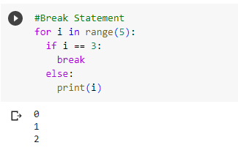

IF we want to continue a loop even if a particular condition is met we use **continue** statement.

In below code snippet we can see that the execution of loop continued even when the criteria is met for a particular condition. In below code we are just not displaying 3 we are continuing with the process post the number 3.

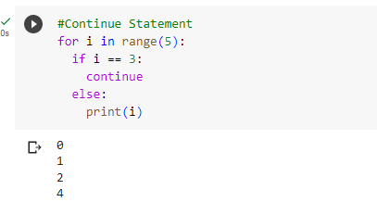

11. In a for loop, what is the difference between range(10), range(0, 10), and range(0, 10, 1)?

**Answer:**

**range(10)** - will print from 0 till 1 less than the number specified in braces i.e. it will print from 0 to 9.

**range(0, 10) -** will print from 0 till 1 less than the second number specified in braces i.e. it will print from 0 to 9. First number in braces tells from which number the series should start and the second number in braces tells where the series should stop, the series stops one number before the number specified in second position. If 10 is mentioned in second position then the series will stop at 9.

**range(0, 10, 1)** - will print from 0 till 1 less than the second number specified in braces i.e. it will print from 0 to 9. The last number in braces is the step size which tells which numbers has to be displayed. Here the step size is 1 so every numbers will be picked up till 9.

12. Write a short program that prints the numbers 1 to 10 using a for loop. Then write an equivalent program that prints the numbers 1 to 10 using a while loop.

**Answer:**

**For Loop Code Snippet:**

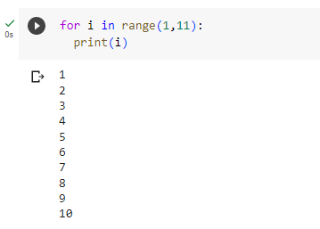

**While Loop Code Snippet:**

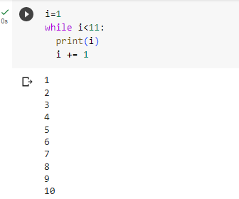

13. If you had a function named bacon() inside a module named spam, how would you call it after importing spam?

**Answer:**

Import spam

spam.bacon()