1. Why are functions advantageous to have in your programs?

**Answer:**

Functions help us declare a specified set of task to be carried out in one section and thereby leading to high code readability and maintenance. It also reduces the need of duplicity, suppose we need addition in multiple parts of our project so we can just call the function addition and get our task done rather than writing the logic again and again.

2. When does the code in a function run: when it's specified or when it's called?

**Answer:**

The code in a function runs when it's called.

3. What statement creates a function?

**Answer:**

The statement that creates a function is:

def function_name():

4. What is the difference between a function and a function call?

**Answer:**

**Function** is a set of code which is written in order to execute some specified set of task where as **Function Call** refers to the calling of a function i.e., when we call the function

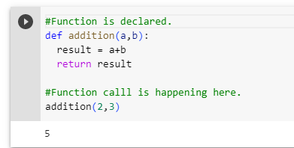

5. How many global scopes are there in a Python program? How many local scopes?

**Answer:**

There is one global and one local scope in Python Program

6. What happens to variables in a local scope when the function call returns?

**Answer:**

The variables in a local scope are disposed and cannot be used outside and again on the call of the function the value gets assigned and is confined to the scope of the function.

7. What is the concept of a return value? Is it possible to have a return value in an expression?

**Answer:**

We are invoking a function to carry out a specified set of task hence here comes the concept of return value which would return the output from the task.

Yes it is possible to have a return value in the form of an expression.

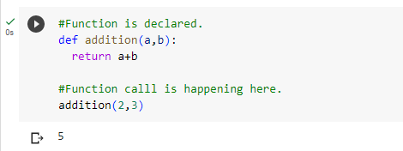

8. If a function does not have a return statement, what is the return value of a call to that function?

**Answer:**

If no return statement is available in a function, then it implies that nothing will be returned from the function. It returns None.

9. How do you make a function variable refer to the global variable?

**Answer:**

We can make a function variable refer to the global variable by declaring global in front of the variable.

10. What is the data type of None?

**Answer:**

NoneType

11. What does the sentence import areallyourpetsnamederic do?

**Answer:**

The sentence import areallyourpetsnamederic imports the library areallyourpetsnamederic.

12. If you had a bacon() feature in a spam module, what would you call it after importing spam?

**Answer:**

spam.bacon()

13. What can you do to save a programme from crashing if it encounters an error?

**Answer:**

We can use try-except-finally block and handle different error in different manner.

14. What is the purpose of the try clause? What is the purpose of the except clause?

**Answer:**

**Try** clause lets us write a set of code and check whether any error occurs rather than just crashing the code.

If any exception is caught then the **except** clause comes into picture which catches the exception from the piece of code written in try block and lets user decide what needs to be done with the exception occurred