1. What does an empty dictionary's code look like?

**Answer:** dict_a={}; where dictionary dict_a is an empty dictionary.

2. What is the value of a dictionary value with the key 'foo' and the value 42?

**Answer:** {‘foo’:42}

3. What is the most significant distinction between a dictionary and a list?

**Answer:** Dictionary is an unordered sequence of key-values pairs whereas lists is an ordered sequence of values which can be of any type.

The output of order in dictionary cannot be maintained whereas the output of order in list is always maintained.

4. What happens if you try to access spam['foo'] if spam is {'bar': 100}?

**Answer:** It will throw exception by stating that the key does not exist; KeyError error.

5. If a dictionary is stored in spam, what is the difference between the expressions 'cat' in spam and 'cat' in spam.keys()?

**Answer:** No difference.

6. If a dictionary is stored in spam, what is the difference between the expressions 'cat' in spam and 'cat' in spam.values()?

**Answer:** 'cat' in spam will check whether cat is available in the keys of the dictionary whereas the 'cat' in spam.values()will check whether cat is available in the values of the dictionary.

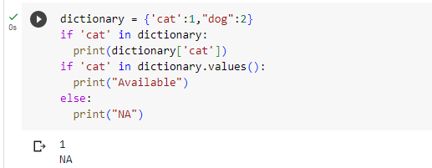

7. What is a shortcut for the following code?

if 'color' not in spam:

spam['color'] = 'black'

**Answer:** spam.setdefault(‘color’,’black’)

8. How do you "pretty print" dictionary values using which module and function?

**Answer:** We need to use pprint function of pprint module.

Syntax: ppprint.pprint()