20 May

Python Basic - 1

* 1. Q.1. What are keywords in python? Using the keyword library, print all the python keywords.

**Answer:**

Keywords in Python are reserved words that cannot be used as ordinary identifiers. They are used to define the syntax and structure of the Python language.

Printed in four different lines to view all the keywords.

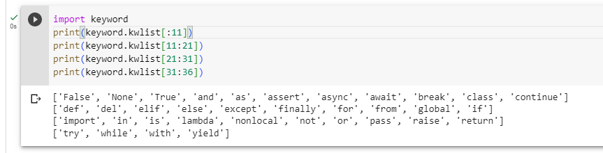

* 1. Q.2. What are the rules to create variables in python?

**Answer:**

Variables can be created with a set of rules such a variable name must be provided and the name must start with alphabets, irrespective of case or an underscore. It can never start with numbers and no special characters other than underscore can be used.

Post the variable name is declared then the assignment happens using = operator and then finally a value is assigned.

**Syntax:** test = 10; where test is a variable name, = is the assignment operator and the value is 10.

* 1. Q.3. What are the standards and conventions followed for the nomenclature of variables in python to improve code readability and maintainability?

**Answer:**

The nomenclature of variable is that it must start with alphabets, irrespective of case or an underscore. It can never start with numbers and no special characters other than underscore can be used.

* 1. Q.4. What will happen if a keyword is used as a variable name?

**Answer:**

If a keyword is used as a variable name then SyntaxError will be thrown. Out of all the 35 keywords none can be used as a variable name.

* 1. Q.5. For what purpose def keyword is used?

**Answer:**

def keyword is used to declare or define a function. def keyword is used in the beginning of the function and then the function name is given.

Syntax: **def** function_name():

* 1. Q.6. What is the operation of this special character ‘\’?

**Answer:**

The special character ‘\’ is used when we have to write multiline statements for better readability and understanding of the code.

* 1. Q.7. Give an example of the following conditions:

1. Homogeneous list
2. Heterogeneous set
3. Homogeneous tuple

**Answer:**

Homogeneous list 🡪 [1,2,3,4,5] 🡪 the list has only integers, i.e. it has only one type of data types.

Heterogeneous set 🡪 {1,2,’a’,3,’b’} 🡪 the set has both integers and strings, i.e. it has more than one type of data types.

Homogeneous tuple 🡪 (1,2,3,4,5) 🡪 the tuple has only integers, i.e. it has only one type of data types.

* 1. Q.8. Explain the mutable and immutable data types with proper explanation & examples.

**Answer:** Mutable data types are the types in which we can change any item. Example: List, set and dictionaries have mutable data types. In below screenshot we can see that we are changing the items in the list_a.

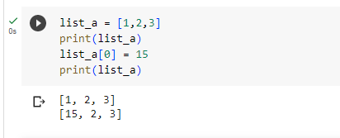

Immutable data types are the types in which we cannot change any item. Example: Tuple has Immutable data type. In below screenshot we can see that we cannot change the items in the tuple.

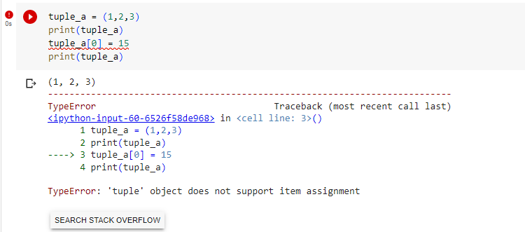

* 2. Q.9. Write a code to create the given structure using only for loop.

*

***

*****

*******

*********

**Answer:** Below attached is the code snippet

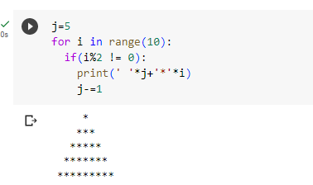

* 1. Q.10. Write a code to create the given structure using while loop.

|||||||||

|||||||

|||||

|||

|

**Answer:** Below attached is the code snippet

